**Exercise 4: Meiosis**

**Time:** Tuesday 7:30 – 10:30

**Name:**

**Meiosis**

**Meiosis** is a specialized type of cell division that **reduces the**[**chromosome**](https://en.wikipedia.org/wiki/Chromosome)**number by half**, creating **four**[**haploid cells**](https://en.wikipedia.org/wiki/Haploid_cells), each genetically distinct from the parent cell that gave rise to them. This process occurs in all [sexually reproducing](https://en.wikipedia.org/wiki/Sexual_reproduction) single-celled and [multicellular](https://en.wikipedia.org/wiki/Multicellular_organism) [eukaryotes](https://en.wikipedia.org/wiki/Eukaryote), including [animals](https://en.wikipedia.org/wiki/Animal), [plants](https://en.wikipedia.org/wiki/Plant), and [fungi](https://en.wikipedia.org/wiki/Fungi). Errors in meiosis resulting in [aneuploidy](https://en.wikipedia.org/wiki/Aneuploidy) are the leading known cause of [miscarriage](https://en.wikipedia.org/wiki/Miscarriage) and the most frequent genetic cause of [developmental disabilities](https://en.wikipedia.org/wiki/Developmental_disability).

In meiosis, [DNA replication](https://en.wikipedia.org/wiki/DNA_replication) is followed by **two rounds of cell division to produce four daughter cells, each with half the number of**[**chromosomes**](https://en.wikipedia.org/wiki/Chromosome)**as the original parent cell**. The two meiotic divisions are known as **Meiosis I and Meiosis II**. Before meiosis begins, during [S phase](https://en.wikipedia.org/wiki/S_phase) of the [cell cycle](https://en.wikipedia.org/wiki/Cell_cycle), the DNA of each chromosome is replicated so that it consists of two identical [sister chromatids](https://en.wikipedia.org/wiki/Sister_chromatids), which remain held together through sister chromatid cohesion. This S-phase can be referred to as "premeiotic S-phase" or "meiotic S-phase". Immediately following DNA replication, meiotic cells enter a prolonged G2-like stage known as meiotic [prophase](https://en.wikipedia.org/wiki/Prophase). During this time, [homologous chromosomes](https://en.wikipedia.org/wiki/Homologous_chromosome) pair with each other and undergo [genetic recombination](https://en.wikipedia.org/wiki/Genetic_recombination), a programmed process in which DNA is cut and then repaired, which allows them to exchange some of their [genetic information](https://en.wikipedia.org/wiki/Genetic_information). A subset of recombination events results in [crossovers](https://en.wikipedia.org/wiki/Chromosomal_crossover), which create physical links known as between the homologous chromosomes. In most organisms, these links are essential to direct each pair of homologous chromosomes to [segregate](https://en.wikipedia.org/wiki/Chromosome_segregation) away from each other during Meiosis I, resulting in two [haploid](https://en.wikipedia.org/wiki/Haploid) cells that have half the number of chromosomes as the parent cell. During Meiosis II, the cohesion between sister chromatids is released and they segregate from one another, as during mitosis. In some cases all four of the meiotic products form [gametes](https://en.wikipedia.org/wiki/Gametes) such as [sperm](https://en.wikipedia.org/wiki/Sperm), [spores](https://en.wikipedia.org/wiki/Spores), or [pollen](https://en.wikipedia.org/wiki/Pollen). In female animals, three of the four meiotic products are typically eliminated by [extrusion](https://en.wikipedia.org/wiki/Extrusion) into [polar bodies](https://en.wikipedia.org/wiki/Polar_bodies), and only one cell develops to produce an [ovum](https://en.wikipedia.org/wiki/Ovum).

Because the number of chromosomes is halved during meiosis, gametes can fuse (i.e. [fertilization](https://en.wikipedia.org/wiki/Fertilization)) to form a diploid [zygote](https://en.wikipedia.org/wiki/Zygote) that contains two copies of each chromosome, one from each parent. Thus, alternating cycles of meiosis and fertilization enable sexual, with successive generations maintaining the same number of chromosomes.

For example, [diploid](https://en.wikipedia.org/wiki/Diploid) human cells contain 23 pairs of chromosomes including 1 pair of sex chromosomes (46 total), half of maternal origin and half of paternal origin. Meiosis produces [haploid](https://en.wikipedia.org/wiki/Haploid) gametes (ova or sperm) that contain one set of 23 chromosomes. When two gametes (an egg and a sperm) fuse, the resulting zygote is once again diploid, with the mother and father each contribu reproduction ting 23 chromosomes. This same pattern, but not the same number of chromosomes, occurs in all organisms that utilize meiosis.

**Phases**

Meiosis is divided into meiosis I and meiosis II. Meiosis I and II are each divided into [prophase](https://en.wikipedia.org/wiki/Prophase), [metaphase](https://en.wikipedia.org/wiki/Metaphase), [anaphase](https://en.wikipedia.org/wiki/Anaphase), and [telophase](https://en.wikipedia.org/wiki/Telophase) stages, similar in purpose to their analogous subphases in the mitotic cell cycle. Therefore, meiosis includes the stages of meiosis I (prophase I, metaphase I, anaphase I, telophase I) and meiosis II (prophase II, metaphase II, anaphase II, telophase II).

**Meiosis I**

Meiosis I segregates homologous chromosomes, which are joined as tetrads (2n, 4c), producing two haploid cells (n chromosomes, 23 in humans) which each contain chromatid pairs (1n, 2c). Because the ploidy is reduced from diploid to haploid, meiosis I is referred to as a *reductional division*. Meiosis II is an *equational division* analogous to mitosis, in which the sister chromatids are segregated, creating four haploid daughter cells (1n, 1c).

**Prophase I**

Prophase I is typically the longest phase of meiosis. During prophase I, homologous chromosomes pair and exchange DNA ([homologous recombination](https://en.wikipedia.org/wiki/Homologous_recombination)). This often results in chromosomal crossover. This process is critical for pairing between homologous chromosomes and hence for accurate segregation of the chromosomes at the first meiosis division. The new combinations of DNA created during crossover are a significant source of [genetic variation](https://en.wikipedia.org/wiki/Genetic_variation), and result in new combinations of [alleles](https://en.wikipedia.org/wiki/Alleles), which may be beneficial. The paired and replicated chromosomes are called bivalents or tetrads, which have two chromosomes and four [chromatids](https://en.wikipedia.org/wiki/Chromatids), with one chromosome coming from each parent. The process of pairing the homologous chromosomes is called [synapsis](https://en.wikipedia.org/wiki/Synapsis). At this stage, non-sister chromatids may cross-over at points called chiasmata (plural; singular [chiasma](https://en.wikipedia.org/wiki/Chiasma_(genetics))).[[15]](https://en.wikipedia.org/wiki/Meiosis#cite_note-Freeman249-502-15) Prophase I has historically been divided into a series of substages which are named according to the appearance of chromosomes.

**Leptotene**

The first stage of prophase I is the *leptotene* stage. In this stage of prophase I, individual chromosomes—each consisting of two sister chromatids—become "individualized" to form visible strands within the nukleus. The two sister chromatids closely associate and are visually indistinguishable from one another. During leptotene, lateral elements of the [synaptonemal complex](https://en.wikipedia.org/wiki/Synaptonemal_complex) assemble. Leptotene is of very short duration and progressive condensation and coiling of chromosome fibers takes place.

**Zygotene**

The *zygotene* stage occurs as the chromosomes approximately line up with each other into homologous chromosome pairs. At this stage, the synapsis (pairing/coming together) of homologous chromosomes takes place, facilitated by assembly of central element of the [synaptonemal complex](https://en.wikipedia.org/wiki/Synaptonemal_complex). Pairing is brought about in a zipper-like fashion and may start at the centromere (procentric), at the chromosome ends (proterminal), or at any other portion (intermediate). Individuals of a pair are equal in length and in position of the centromere. Thus pairing is highly specific and exact. The paired chromosomes are called bivalent or tetrad chromosomes.

**Pachytene**

At this point a tetrad of the chromosomes has formed known as a bivalent. This is the stage when homologous recombination, including chromosomal crossover (crossing over), occurs. Nonsister chromatids of homologous chromosomes may exchange segments over regions of homology. [Sex chromosomes](https://en.wikipedia.org/wiki/Sex_chromosomes), however, are not wholly identical, and only exchange information over a small region of homology. At the sites where exchange happens, [chiasmata](https://en.wikipedia.org/wiki/Chiasma_(genetics)) form. The exchange of information between the non-sister chromatids results in a recombination of information; each chromosome has the complete set of information it had before, and there are no gaps formed as a result of the process. Because the chromosomes cannot be distinguished in the synaptonemal complex, the actual act of crossing over is not perceivable through the microscope, and chiasmata are not visible until the next stage.

**Diplotene**

During the *diplotene* stage the [synaptonemal complex](https://en.wikipedia.org/wiki/Synaptonemal_complex) degrades and homologous chromosomes separate from one another a little. The chromosomes themselves uncoil a bit, allowing some [transcription](https://en.wikipedia.org/wiki/Transcription_(genetics)) of DNA. However, the homologous chromosomes of each bivalent remain tightly bound at chiasmata, the regions where crossing-over occurred. The chiasmata remain on the chromosomes until they are severed at the transition to anaphase I.

In human fetal [oogenesis](https://en.wikipedia.org/wiki/Oogenesis), all developing oocytes develop to this stage and are arrested in prophase I before birth. This suspended state is referred to as the [*dictyotene stage*](https://en.wikipedia.org/wiki/Dictyotene) or dictyate. It lasts until meiosis is resumed to prepare the oocyte for ovulation, which happens at puberty or even later.

**Diakinesis**

Chromosomes condense further during the *diakinesis* stage. This is the first point in meiosis where the four parts of the tetrads are actually visible. Sites of crossing over entangle together, effectively overlapping, making chiasmata clearly visible. Other than this observation, the rest of the stage closely resembles [prometaphase](https://en.wikipedia.org/wiki/Prometaphase) of mitosis; the [nucleoli](https://en.wikipedia.org/wiki/Nucleolus) disappear, the [nuclear membrane](https://en.wikipedia.org/wiki/Nuclear_membrane) disintegrates into vesicles, and the [meiotic spindle](https://en.wikipedia.org/wiki/Spindle_apparatus) begins to form.

#### Metaphase I

Homologous pairs move together along the metaphase plate: As *kinetochore microtubules* from both centrosomes attach to their respective kinetochores, the paired homologous chromosomes align along an equatorial plane that bisects the spindle, due to continuous counterbalancing forces exerted on the bivalents by the microtubules emanating from the two kinetochores of homologous chromosomes. This attachment is referred to as a bipolar attachment. The physical basis of the [independent assortment](https://en.wikipedia.org/wiki/Independent_assortment) of chromosomes is the random orientation of each bivalent along the metaphase plate, with respect to the orientation of the other bivalents along the same equatorial line.[[15]](https://en.wikipedia.org/wiki/Meiosis#cite_note-Freeman249-502-15) The protein complex [cohesin](https://en.wikipedia.org/wiki/Cohesin)holds sister chromatids together from the time of their replication until anaphase. In mitosis, the force of kinetochore microtubules pulling in opposite directions creates tension. The cell senses this tension and does not progress with anaphase until all the chromosomes are properly bi-oriented. In meiosis, establishing tension requires at least one crossover per chromosome pair in addition to cohesin between sister chromatids.

#### Anaphase I

Kinetochore microtubules shorten, pulling homologous chromosomes (which consist of a pair of sister chromatids) to opposite poles. Nonkinetochore microtubules lengthen, pushing the centrosomes farther apart. The cell elongates in preparation for division down the center. Unlike in mitosis, only the cohesin from the chromosome arms is degraded while the cohesin surrounding the centromere remains protected. This allows the sister chromatids to remain together while homologs are segregated.

#### Telophase I

The first meiotic division effectively ends when the chromosomes arrive at the poles. Each daughter cell now has half the number of chromosomes but each chromosome consists of a pair of chromatids. The microtubules that make up the spindle network disappear, and a new nuclear membrane surrounds each haploid set. The chromosomes uncoil back into chromatin. Cytokinesis, the pinching of the cell membrane in animal cells or the formation of the cell wall in plant cells, occurs, completing the creation of two daughter cells. Sister chromatids remain attached during telophase I.

Cells may enter a period of rest known as [interkinesis](https://en.wikipedia.org/wiki/Interkinesis) or interphase II. No DNA replication occurs during this stage.

### Meiosis II

Meiosis II is the second meiotic division, and usually involves equational segregation, or separation of sister chromatids. Mechanically, the process is similar to mitosis, though its genetic results are fundamentally different. The end result is production of four haploid cells (n chromosomes, 23 in humans) from the two haploid cells (with n chromosomes, each consisting of two sister chromatids) produced in meiosis I. The four main steps of meiosis II are: prophase II, metaphase II, anaphase II, and telophase II.

In **prophase II** we see the disappearance of the nucleoli and the [nuclear envelope](https://en.wikipedia.org/wiki/Nuclear_envelope) again as well as the shortening and thickening of the chromatids. Centrosomes move to the polar regions and arrange spindle fibers for the second meiotic division.

In **metaphase II**, the centromeres contain two kinetochores that attach to spindle fibers from the centrosomes at opposite poles.

This is followed by **anaphase II**, in which the remaining centromeric cohesin is cleaved allowing the sister chromatids to segregate. The sister chromatids by convention are now called sister chromosomes as they move toward opposing poles.

The process ends with **telophase II**, which is similar to telophase I, and is marked by decondensation and lengthening of the chromosomes and the disassembly of the spindle. Nuclear envelopes reform and cleavage or cell plate formation eventually produces a total of four daughter cells, each with a haploid set of chromosomes.

Meiosis is now complete and ends up with four new daughter cells.

**Function**

Meiosis is a key event of the sexual cycle in eukaryotes. It is the stage of the [life cycle](https://en.wikipedia.org/wiki/Biological_life_cycle) when a cell gives rise to two haploid cells ([gametes](https://en.wikipedia.org/wiki/Gamete)) each having half as many [chromosomes](https://en.wikipedia.org/wiki/Chromosome). Two such haploid gametes, arising from different individual [organisms](https://en.wikipedia.org/wiki/Organism), fuse by the process of [fertilization](https://en.wikipedia.org/wiki/Fertilization), thus completing the sexual cycle.

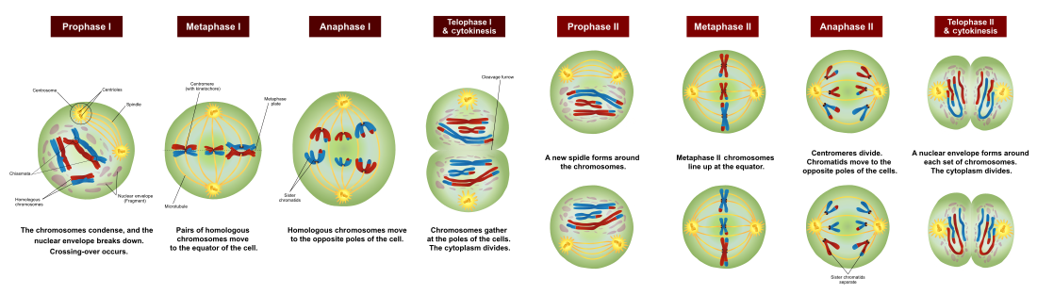

**Spermatogenesis**

**Spermatogenesis** is the process by which [haploid](https://en.wikipedia.org/wiki/Haploid) [spermatozoa](https://en.wikipedia.org/wiki/Spermatozoa) develop from germ cells in the [seminiferous tubules](https://en.wikipedia.org/wiki/Seminiferous_tubules) of the [testis](https://en.wikipedia.org/wiki/Testis). This process starts with the mitotic division of the stem cells located close to the basement membrane of the tubules. These cells are called [spermatogonial stem cells](https://en.wikipedia.org/wiki/Spermatogonial_Stem_Cells). The mitotic division of these produces two types of cells. Type A cells replenish the stem cells, and type B cells differentiate into spermatocytes. The primary spermatocyte divides meiotically (Meiosis I) into two secondary spermatocytes; each secondary spermatocyte divides into two equal haploid [spermatids](https://en.wikipedia.org/wiki/Spermatids) by Meiosis II.The spermatids are transformed into spermatozoa(sperm) by the process called [Spermiogenesis](https://en.wikipedia.org/wiki/Spermiogenesis).These develop into mature spermatozoa, also known as [sperm](https://en.wikipedia.org/wiki/Sperm) cells. Thus, the primary spermatocyte gives rise to two cells, the secondary spermatocytes, and the two secondary spermatocytes by their subdivision produce four spermatozoa.

Spermatogenesis takes place within several structures of the male reproductive system. The initial stages occur within the **testes** and progress to the epididymis where the developing gametes mature and are stored until ejaculation. The **seminiferous tubules** of the testes are the starting point for the process, where spermatogonial stem cells adjacent to the inner tubule wall divide in a centripetal direction—beginning at the walls and proceeding into the innermost part, or *lumen*—to produce immature sperm. Maturation occurs in the epididymis.

**Task 1: Testis histological structure**

1. Observe and draw the testicle structure

**Task 2: Spermatozoa observation**

1. Observe and draw spermatozoa in semen sample

Magnification: 100x100, use immersion oil

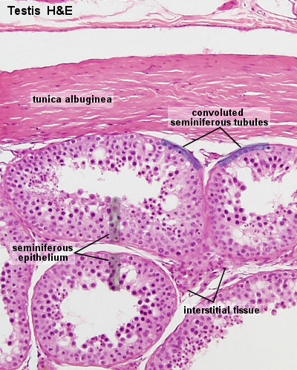

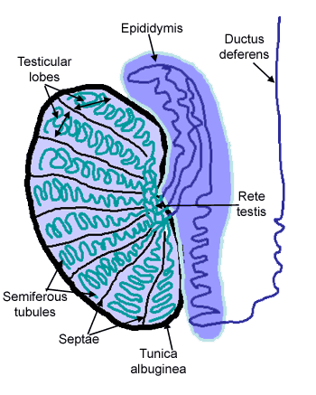

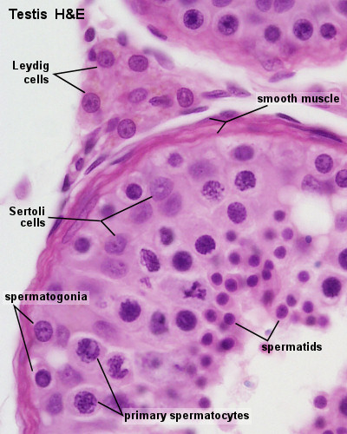

**Oogenesis**

In [mammals](https://en.wikipedia.org/wiki/Mammal), the first part of oogenesis starts in the [germinal epithelium](https://en.wikipedia.org/wiki/Germinal_epithelium_(female)), which gives rise to the development of [ovarian follicles](https://en.wikipedia.org/wiki/Ovarian_follicles), the functional unit of the [ovary](https://en.wikipedia.org/wiki/Ovary).

Oogenesis consists of several sub-processes: oocytogenesis, [ootidogenesis](https://en.wikipedia.org/wiki/Ootidogenesis), and finally maturation to form an ovum (oogenesis proper). [Folliculogenesis](https://en.wikipedia.org/wiki/Folliculogenesis) is a separate sub-process that accompanies and supports all three oogenetic sub-processes.

In humans oogenesis starts with the process of developing primary oocytes, which occurs via the transformation of [oogonia](https://en.wikipedia.org/wiki/Oogonium) into primary [oocytes](https://en.wikipedia.org/wiki/Oocyte), a process called oocytogenesis. Oocytogenesis is complete either before or shortly after birth. It is commonly believed that, when oocytogenesis is complete, no additional primary oocytes are created, in contrast to the male process of spermatogenesis, where gametocytes are continuously created. In other words, primary oocytes reach their maximum development at ~20weeks of gestational age, when approximately seven million primary oocytes have been created; however, at birth, this number has already been reduced to approximately 1-2 million.

### Ootidogenesis

The succeeding phase of ootidogenesis occurs when the [primary oocyte](https://en.wikipedia.org/wiki/Primary_oocyte) develops into an ootid. This is achieved by the process of meiosis.

However, although this process begins at prenatal age, it stops at [prophase I](https://en.wikipedia.org/wiki/Prophase_I). In late fetal life, all oocytes, still primary oocytes, have halted at this stage of development, called the [dictyate](https://en.wikipedia.org/wiki/Dictyate). After [menarche](https://en.wikipedia.org/wiki/Menarche), these cells then continue to develop, although only a few do so every [menstrual cycle](https://en.wikipedia.org/wiki/Menstrual_cycle).

#### Meiosis I

[Meiosis I](https://en.wikipedia.org/wiki/Meiosis_I) of ootidogenesis begins during embryonic development, but halts in the [diplotene](https://en.wikipedia.org/wiki/Diplotene) stage of prophase I until puberty.

#### Meiosis II

Immediately after meiosis I, the [haploid](https://en.wikipedia.org/wiki/Haploid) secondary oocyte initiates [meiosis II](https://en.wikipedia.org/wiki/Meiosis_II). However, this process is also halted at the [metaphase II](https://en.wikipedia.org/wiki/Metaphase_II) stage until [fertilization](https://en.wikipedia.org/wiki/Fertilization), if such should ever occur. When meiosis II has completed, an ootid and another polar body have now been created.

#### Folliculogenesis

#### During follicular development, primordial follicles undergo a series of critical changes in character, both histologically and hormonally. First they change into primary follicles and later into secondary follicles. The follicles then transition to [tertiary, or antral, follicles](https://en.wikipedia.org/wiki/Folliculogenesis#Primordial). At this stage in development, they become dependent on hormones, particularly FSH which causes a substantial increase in their growth rate. [The late tertiary or pre-ovulatory follicle](https://en.wikipedia.org/wiki/Folliculogenesis#Late_tertiary_and_preovulatory_.28the_follicular_phase_of_the_menstrual_cycle.29) ruptures and discharges the oocyte (that has become a [secondary oocyte](https://en.wikipedia.org/wiki/Secondary_oocyte)), ending folliculogenesis.

**Task 3: Ovarian histological structure**

1. Observe and draw the ovarian structure

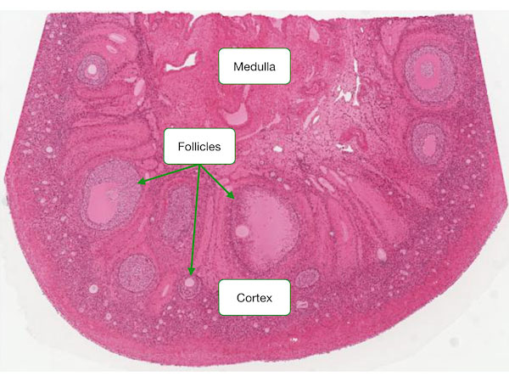

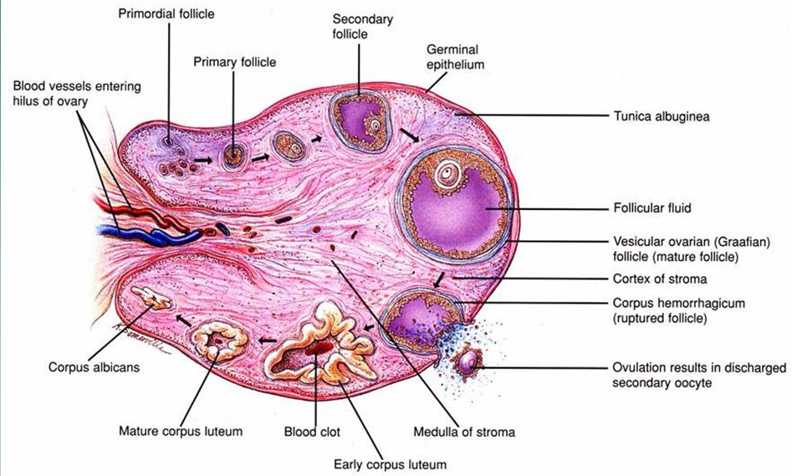

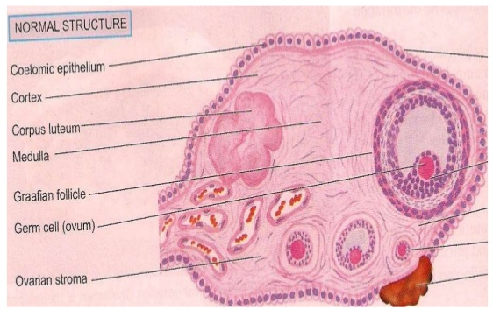

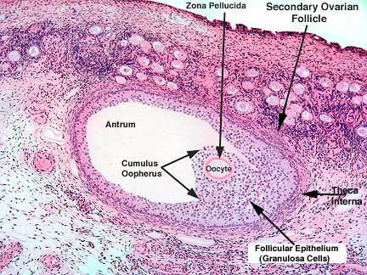

**Chromosome X inactivation**

X-inactivation (also called **lyonization**) is a process by which one of the copies of the [X chromosome](https://en.wikipedia.org/wiki/X_chromosome) present in [female](https://en.wikipedia.org/wiki/Female) [mammals](https://en.wikipedia.org/wiki/Mammal) is inactivated. The inactive X chromosome is silenced by it being packaged in such a way that it has a transcriptionally inactive structure called [heterochromatin](https://en.wikipedia.org/wiki/Heterochromatin). As nearly all [female mammals](https://en.wikipedia.org/wiki/Female_mammals) have two X chromosomes, X-inactivation prevents them from having twice as many X chromosome [gene products](https://en.wikipedia.org/wiki/Gene_product) as [males](https://en.wikipedia.org/wiki/Male), who only possess a single copy of the X chromosome (see [dosage compensation](https://en.wikipedia.org/wiki/Dosage_compensation)). The choice of which X chromosome will be inactivated is random in [placental mammals](https://en.wikipedia.org/wiki/Eutheria) such as [humans](https://en.wikipedia.org/wiki/Human), but once an X chromosome is inactivated it will remain inactive throughout the lifetime of the cell and its descendants in the organism. Unlike the random X-inactivation in placental mammals, inactivation in [marsupials](https://en.wikipedia.org/wiki/Marsupial) applies exclusively to the paternally derived X chromosome.

**Barr bodies**

DNA packaged in heterochromatin, such as the Xi, is more condensed than DNA packaged in [euchromatin](https://en.wikipedia.org/wiki/Euchromatin), such as the Xa. The inactive X forms a discrete body within the nucleus called a [Barr body](https://en.wikipedia.org/wiki/Barr_body). The Barr body is generally located on the periphery of the [nucleus](https://en.wikipedia.org/wiki/Cell_nucleus), is late [replicating](https://en.wikipedia.org/wiki/DNA_replication) within the [cell cycle](https://en.wikipedia.org/wiki/Cell_cycle), and, as it contains the Xi, contains heterochromatin modifications.

**Task 4: Barr body**

1. Perform buccal swab (smear)

2. Stain cells by Giemsa-Romanovski

3. Observe buccal cells and Barr body (if present)

Magnification: 100x100, use immersion oil

