**Brno**



Brno je druhé největší město České republiky. Je to politické a kulturní centrum.

Dominanta Brna je hrad Špilberk a katedrála svatého Petra a Pavla. Blízko centra je brněnská přehrada. Brněnské historické památky jsou:

Kapucínský kostel a krypta

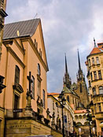

Katedrála svatého Petra a Pavla

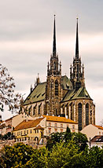

Vila Tugendhat

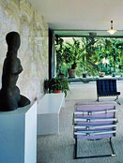

Stará radnice

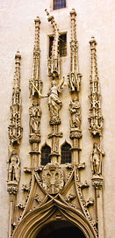

Mahenovo divadlo

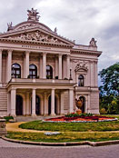

Zelný trh

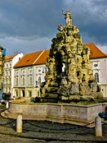

Hrad Špilberk

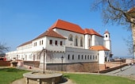

**Brno a vzdělání**

Město Brno je centrum vzdělání, má deset univerzit a 33 fakult a téměř 65 tisíc studentů. Masarykova univerzita je největší univerzita v Brně a druhá nejstarší a největší univerzita v České republice. Existuje od roku 1919. V roce 2002 začala konstrukce kampusu Bohunice.

Masarykova univerzita

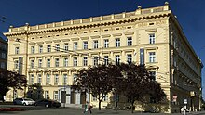

Kampus Bohunice

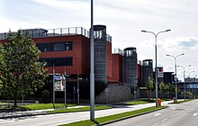

**Brno a legendy**

Dva symboly Brna: drak a kolo

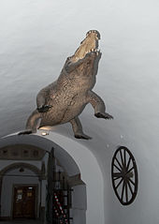

Legenda informuje, že velká bestie terorizovala město Brno. Lidé jí říkali drak. Potom jeden občan draka zabil. Drak je reálně krokodýl.

Druhý symbol Brna je kolo. Tesař z města Lednice (cca 50km od Brna) se vsadil, že za jeden den pokácí strom, vyrobí kolo a dostane ho do Brna. Sázku vyhrál.

Vocabulary:

Hrad castle

Svatý,á,é – saint

Brněnská přehraad _Brno water reservoir, dam

Památka – historical place, site

Vzdělání - education

Zelný trh – veggie market

Druhý, á,é – second

Největší – the largest

Nejstarší – the oldest

Začal (M), začala (F) – started

Velký,á,é- big

Město – city

Lidé – people

Říkali – called

Drak – dragon

Reálně- really

Kolo – wheel

Tesař – carpenter

Vsadil – he bet

Pokácet strom – to cut down a tree, pokácí – he will cut down

Vyrobit – make – vyrobí- he will make

Dostat – get – dostane – he will get

Ho – it

Sázka- bet (sázku = accusative form)

Vyhrál – he won

Up to you to lear more details from the English text below:

Další detaily anglicky:

There are several legends connected with the City of Brno. One of the best known is the Legend of the Brno Dragon.[[120]](https://en.wikipedia.org/wiki/Brno#cite_note-123) According to this legend, a terrible creature was terrorizing the citizens of Brno. The people had never seen this animal before, so they called it a dragon. They lived in fear of the dragon until one citizen managed to kill the monster by tricking it into eating a carcass filled with lime. In reality the dragon was a crocodile, the preserved body of which is now displayed at the entrance of the [Old Town Hall](https://en.wikipedia.org/w/index.php?title=Old_Town_Hall_(Brno)&action=edit&redlink=1).

Next to the "dragon" at the Old Town Hall is the town's second well-known emblem, a wagon wheel made from a tree found and cut down in Lednice 50 miles from Brno city. According to the legend, a local man made a wager that he could cut a tree, make a wheel out of it, and roll the wheel to the City of Brno, all within a single day. He managed to do so. But the achievement was deemed to be impossible by normal human means, the man was believed to have called on the devil for assistance, and died in poverty as a result.

Another local legend relates to the siege of the city by Swedish forces in 1645. The locals and the Swedish army were in a stalemate, and the Swedish general declared that he would withdraw if his army had not won by noon. The bell ringer at Petrov Cathedral tricked him by ringing the bell an hour early, and keeping his word, the general and his army left. As a historic tribute to the event, the bell at Petrov Cathedral still rings for noon an hour earlier, at 11 o'clock. At this time, the Brno astronomical clock also releases a glass ball as a souvenir.

Adapted from: wikipaedia