Animal Magnetism
C-tS C-W C--S3 C^V3 C-tO C--S3 C-'S3 C-t3 t^S3 C^3
The history of animal magnetism in Britain goes back at least to the seventeenth century, when the idea of sympathy as a healing principle was expounded by Robert Fludd, Sir Kenelm Digby, and other disciples of Paracelsus. The example most commonly remembered is their "weapon-salve" or "powder of sympathy," a gruesome mess for smearing not on wounds but on the objects that caused them. The idea of sympathy existing between objects or bodies was a natural and defensible one within their Hermetic world view. Sympathy or resemblance between the Above and the Below held together the entire cosmic hierarchy and was the archetype of the invisible bonds that permeated the phenomenal world.
In the later eighteenth century, with its confidence in experimental science, it seemed as if these bonds of occult sympathy might at last become manifest. Newton had gone as far as to quantify certain of them, with his theory of gravitation. He had also posited the ether as an insensible medium for influences, a premise that would survive until the time of Einstein.
To Newton's gravitation, the Austrian doctor Franz Anton Mesmer (1734-1815) added the concept of "Animal Gravity," a force that works on and in our bodies through substances more subtle than matter.¹ Mesmer's doctoral dissertation had taken as its subject the influences of the planets, treating them from a purely physical point of view but allowing that they may well influence the human body, just as the moon does the tides. As his medical practice developed, he became convinced that he was able to harness this force and employ it for healing. Sometimes he used magnets and other appliances, at other times simply his own hands, placed on the patient or waved in magnetic passes. In either case, he believed that the operative agent was an imponderable "fluid."
In 1778, Mesmer moved his practice to Paris and created sufficient interest for an official committee of the Royal Academy of Sciences to be
151


152 Animal Magnetism
formed for the investigation of his theories. The committee included Jean-Sylvain Bailly, Antoine Lavoisier, Dr. Guillotin, and Benjamin Franklin. Their report, published in 1784, was disastrous to Mesmer's reputation, for it implied that he was a quack. This was the inevitable conclusion from a point of view that considered only the physical theory (which could not be experimentally proven) and ignored the psychological dimension of his therapy. No depositions were accepted from the many patients of all classes who claimed to have been healed by Mesmer.
Today we can appreciate better the roles of Mesmer's personality, the atmosphere of his healing salon, the expectations of the patients, and the part played by imagination and suggestion in his cures. Their efficacy is taken for granted in a more psychologically aware era. But if we have this awareness, it is thanks to those who followed in Mesmer's footsteps and developed, in the teeth of the medical establishment, the techniques of hypnosis and the theory of the unconscious mind. No one had heard of those in 1784.
The Academy's condemnation did nothing to prevent the spread of Mesmer's theories and practices in England, beginning in 1785. They were first imported by a character who styled himself "Monsieur Ie Dr. John Bell, Member of the Philosophical Harmonic Society at Paris, Fellow Correspondent of Court de Geblin's [sic] Museum [. . .] and the only Person authorized by Patent from the First Noblemen in France to teach and practise that Science in England, Ireland, &c."² Bell had probably paid the hefty fee to learn Mesmerism from the master himself and sworn not to reveal its secrets. In both London and Dublin, he used an oaken tub, eight feet in diameter, standing on four glass insulators: evidently a copy of Mesmer's baquet, used to amplify the magnetic fluid and to feed it out to a circle of patients. Bell believed that any animate or inanimate body could be magnetized or "electrified," to increase its action, but counseled practitioners against trying to cure any of the more serious diseases.
As we know from earlier chapters, London in the 1780s was a happy hunting-ground for adventurers in the occult sciences, and no doubt Dr. Bell did as well as any of them. A second emissary from the Harmonic Society, Dr. de Mainauduc, made a proposal in 1785 for the foundation of a London "Hygeian Society" for ladies to be incorporated with the one in Paris.³ This was perhaps what emerged as James Graham's "Temple of Health" in Schomberg House, Pall Mall, with its Magnetic Throne and Celestial Bed (see Chapter Five).⁴ De Mainauduc himself arrived in England in 1787.⁵ He was a male midwife, and had been a pupil of Charles Deslon (or d'Eslon), one of the foremost French medical men to espouse Mesmer's doctrines. De Mainauduc's first advertisement was for twenty ladies to pay him fifteen guineas each for a complete "exhibition" and treatment. Such was his success that he was able to raise the price to

Animal Magnetism 153
between twenty-five and 150 guineas,⁶ thus emulating his teacher Deslon, who, it was said, had cleared 100,000 pounds.⁷
Those who learned the Mesmeric art from de Mainauduc also had to pay. George Winter joined his distinguished students (who included the painters Cosway and de Loutherbourg) by paying twenty-five guineas, plus five guineas for the use of the room, and signing a bond in the sum of 10,000 pounds with an affidavit not to reveal the secrets during de Mainauduc's lifetime.⁸ Winter was far from being a convinced disciple. While he accepted that the principles of sympathy and antipathy were part of God's system of nature, and that Mesmer had revived an ancient system of healing, the method taught by de Mainauduc was not a universal panacea. Winter kept a register of more than a hundred cures that he was unable to effect through animal magnetism, but which responded to conventional medicines.
We have already noted the success that de Loutherbourg had with magnetic healing in 1789, using no further apparatus than his own hands and will. Richard Cosway, never one to do a thing by halves, claimed to have attained a state of "somnambulistic lucidity," which enabled him to see a hole in a friend's liver; the story reached George III, who was much amused by it.⁹ Mention of "lucidity" takes us beyond the original Mesmerism to the developments of the Puysegur brothers. In 1784 the Marquis de Puysegur and his brother, Count Maxime, having learnt the master's techniques with mixed success, retired to their country estate at Busancy. In an atmosphere very different from Mesmer's physically and psychically overheated salon, they worked outdoors. Their subjects were not wealthy neurotics (not that all of Mesmer's were), but their own peasants; not people in search of new sensations, but ones who were genuinely ill. Moreover, they had no need or desire to make money.
Mesmer's healing process typically caused the patient to pass through a violent phase called a "crisis," for which a specially padded room was set aside. Nowadays one can also understand the therapeutic value of overcoming inhibition. But the Puysegurs' subjects, perhaps not so inhibited to begin with, entered instead into a calm, sleeplike condition. What made this truly extraordinary was that in this "somnambulistic" state they were able to speak with an authority unknown to them when waking, and to diagnose their own ailments. Moreover, somnambulism often brought extrasensory perceptions, hence its description as "lucid." Experiments along these lines led to far different results from anything that Mesmer had envisaged (he disliked what the Puysegurs were doing), soon crossing the borderline from medicine into the supernatural. From being patients, the somnambulistic subjects had become mediums.
John Bell had a garbled idea of the Puysegurs' methods: he wrote in 1792 that there was a kind of crisis called "luminous," named for the sect



154 Animal Magnetism
of Illumines.¹⁰ This was precisely the sort of association that blackened the whole practice in the public mind, as the 1790s ran their course and anything French and "enlightened" became anathema. For different reasons, Mesmerism was also eclipsed in France. The historian and psychical researcher Frank Podmore explains that it was tarred with the brush of the aristocracy and by the fact that many early adherents had also been disciples of Cagliostro.¹¹ Consequently, Mesmerism did not revive in either country until after the fall of Napoleon.
In Germany, in the meantime, mainly thanks to the apostolic enthusiasm of Lavater, Puysegur's version of Mesmerism had excited the Naturphilosophen such as Franz voň Baader, Johann Friedrich voň Meyer, and J. J. voň Górres. Baader, the most profound and influential of the group, concluded that in somnambulism or "magnetic ecstasy" one is in quite a different, magical relationship with the world. The ecstatic subject enters a different sphere of being, a higher and more universal condition of life, which follows different rules from those of the ordinary one; it relates to the bodily senses as an organic being compares with an inorganic one. In such a state, clairvoyance is not to be wondered at. Baader criticizes the skeptics and materialists who confuse the two states through basing them both on the same, physical foundations.¹²
There was a tension in Germany between those like Baader, who regarded somnambulism as a way of exploration of the soul-world, and those who fought to keep science clean of mysticism. For the Romantics, it was a gateway to another and a higher world; for the scientists, it was a question of fluids requiring further research. D. G. Kieser, of the University of Jena, reviewing Baader's work, urged his colleagues to preserve their intellectual freedom in the face of natural laws that have not yet been grasped, and not to give way to the pious sentimentality infecting all departments of life.¹³ This was understandable in 1817, when the recent "Holy Alliance" of the Russian, Prussian, and Austrian Empires seemed to threaten a revived theocracy and the suppression offreethought. Reviewing the situation in Europe three years later, in 1820, Prof. Eschenmeyer of Tubingen University found it very disappointing. In France, he says, there is no scientific research at all: all animal magnetism there is done by laymen. England and Italy are a tabula rasa, while in America there is nothing.¹⁴ In Prussia, however, a mesmeric hospital had already been operating in Berlin since 1815.¹⁵
The torch of Mesmerism in France was relit by J. F. P. Deleuze, Librarian and Professor of Natural History at thejardin děs Plantes and a pupil of the Puysegurs from prerevolutionary days. His Histoire critique du magnetisme animal (1813) emphasized the role played by the human will and introduced the ideas of what would today be called hypnotic and post-hypnotic suggestion.¹⁶ Deleuze brought Mesmerism back into the public

Animal Magnetism 155
forum, and eventually it was taken up again by the medical world. Experiments were tried at the Hotel-Dieu hospital in 1819-20, some of which succeeded in curing otherwise hopeless cases of "hysteria." In the following year a Dr. Recamier performed the first surgical operation on a mesmerically entranced subject. Somnambulists came to be employed in medical practices for diagnosing, while in trance, the ailments of others. Eventually the Royal Academy of Sciences agreed to a second official commission, whose report, published in 1831, at least did not outlaw animal magnetism, but encouraged further investigation. This lukewarm report was suppressed, being circulated only to the Academy members, but in 1833 an English translation, with 150 pages of commentary, was published byj. C. Colquhoun (died 1854), an advocate at the Scottish Bar.¹⁷
The revival of animal magnetism in England was due to another layman, Richard Chenevix, F.R.S. (died 1830), a chemist and mineralogist "of large fortune."¹⁸ Chenevix had encountered animal magnetism in Germany in 1803-04, but had become finally convinced of its reality by the experiments of Abbe Faria in Paris, which he witnessed in 1816.¹⁹ The Portuguese Faria was a flamboyant character who had traveled in India;
he did not believe in magnetic fluids, but in the will power of one person working on another. Spurning even the use of passes, he would simply order his patients to go to sleep.²⁰ Chenevix achieved numerous cures, at first of epileptic children in Ireland, then of patients in the Wakefield Asylum in Yorkshire.²¹ This hospital, incidentally, had been founded in 1818 through the efforts of Godfrey Higgins; I wonder whether it was he who facilitated Chenevix's experiments there, of all places. In 1829 Chenevix published "On Mesmerism, improperly denominated Animal Magnetism" in several numbers of the London Medical and Physical Journal and was allowed to demonstrate his methods in some of London's hospitals.²² He was able to mesmerize patients even from another room, and to make them carry out commands that he expressed only in his own thoughts. But his death in 1830 prevented further investigation of these marvels.
Colquhoun included in his translation of the French Commission's report an analysis of six states of animal magnetism by C. A. F. Kluge.²³ These were: (1) the waking state; (2) half sleep, or impending crisis; (3) magnetic sleep; (4) perfect crisis or simple somnambulism: the patient reawakened in a very peculiar connection with the external world; (5) self-intuition or clairvoyance: the patient can inspect him- or herself internally, and prescribe remedies; (6) lucid vision, leading to universal lucidity. Colquhoun found the higher states to be a powerful argument for the independence of the soul, and hence for its immortality.²⁴ He was a believer in the universal, subtle fluid as a link between soul and body, and found in it, as Ficino and the Renaissance Platonists had found in their spiritus, a reconciliation of religion and natural philosophy. Three years



156 Animal Magnetism
later, in 1836, he published Isis Revelata: An Inquiry into the origin, progress, and present state of animal magnetism. By a pleasing synchronicity, this work with its title meaning "Isis Unveiled" appeared in the same year as Higgins's Anacalypsis, which alludes to the same Egyptian goddess of Nature. Among the immense quantity of information on ancient and modern phenomena, Colquhoun remarks that clairvoyance (the fifth and sixth states) is not yet known or appreciated in Britain, whereas on the Continent of Europe it is almost universally admitted.²⁵
Two other mesmerizers who worked outside the medical profession in these years were friends ofBulwer-Lytton. In Chapter Six, I mentioned Chauncey Hare Townshend, a clergyman who lived mainly on the Continent. Lytton wrote of him: "He was a young man when I was a boy at school at St. Lawrence. He then lived with his father at Ramsgate. He had won a prize poem at Cambridge and later had a volume of poems. His beauty of countenance was remarkable at that time. Those who knew Byron said it was Byron with bloom and health. He grew plain in later life—an accomplished man—but effeminate and mildly selfish."²⁶ When Lytton went up to Trinity Hall, Cambridge, he found Townshend there on a visit, but was hurt when the older man showed no interest in him. Later their friendship was renewed, and they exchanged occasional letters on Mesmerism until the 1860s.
Townshend conducted experiments in Mesmerism at Cambridge in 1837, putting his patients into trance by staring fixedly at them with his hands on theirs, or on their knees, then moving his hands up and down in an ellipse; his book Facts in Mesmerism has charming illustrations of couples doing this. Like Colquhoun, he compares the backward and prejudiced attitudes of England to those of the Continent, especially Germany (he was writing from Innsbruck). The reasons were plain to him:
Mesmerism had been discovered by the wrong kind of person, lacking candor and philosophical strictness. If only a Newton or an Arago had discovered it!²⁷ The other misfortune, Townshend thought, was the erroneous assimilation of early Mesmerism to science, with the assumption that it had a specific and physical cause or power. Privately he added to Lytton:
"Of one thing I assure you—the subject possesses vast literary capabilities."²⁸ Lytton would make good use of this advice twenty years later, in A Strange Story.
The next mesmeric visitor from the Continent was another aristocratic amateur, Baron Jules Dupotet de Sennevoy (1798-1881). As a medical student, Dupotet had been one of the mesmerizers in the Hotel-Dieu experiments of 1820. He had served on the 1831 commission and succeeded in 1837 in getting permission to practice in England. He gave exhibitions in Wigmore Street, where many physicians practiced, and at University College Hospital. Earl Stanhope (the Fourth Earl, on whom

Animal Magnetism 157
more below) was instrumental in getting Dupotet a hearing, and it was to him that the Frenchman dedicated his Introduction to the Study of Animal Magnetism (1838), calling the Earl's voice the sole one raised in his defense.²⁹ It was probably these exhibitions that prompted Townshend to try his hand in Cambridge the same year.
Dupotet divides animal magnetism into three separate schools, of which he belonged to the third: (1) the original school of Mesmer in Paris, very Epicurean (in the materialistic sense), assuming a universal fluid; (2) the Lyon school of the Chevalier de Barbarin, together with the Swedish and German branches: Platonic in its philosophy, believing that phenomena are caused by the effort of the soul, hence called "spiritual-ists"; (3) Puysegur's school at Strasbourg: experimentalists who combine the treatment of the first school with the psychical teachings of the second. The schools differ in theory, he says, but all have the same results.³⁰ Having done his work in England, Dupotet returned to France, where he published a Journal du magnetisme from 1845 to 1860.
With Dupotet's departure, the torch of Mesmerism was left in the hands of Stanhope's friend John Elliotson (1791-1868). Besides a large private practice, Elliotson could style himself in 1832 "M.D. Cantab., F.R.S., F.R.C.P.; Physician to the Royal Hospital of St. Thomas and to the Royal Society of Musicians; President of the Phrenological Society, and Hon. Member of the Phrenological Society of Paris; Professor of the Principles and Practice of Medicine in the University, &c., &c."³¹ He had watched Chenevix's work in 1829 and was convinced that more than mere imagination was involved in it, but did not pursue it further until Dupotet arrived in England.³² Then he gave it his whole life.
Elliotson's first exhibitions, at University College Hospital, used as their subjects a pair of young Irish sisters, Jane and Elizabeth Okey (or O'Key), who were hospitalized for epileptic fits, spontaneous delirium, and catalepsy. A large part of his research had to do with how to magnetize them, in a misguided attempt to pin down the workings of the elusive fluid. For example, Elliotson would magnetize a coin by touch or passes, then the coin would be put with a group of untreated ones. As soon as the girl picked out the magnetized coin, she would go into a trance. The girls clearly exploited the situation. While magnetized, they whistled, gabbled in unknown languages, teased eminent visitors, and told unsuitable stories,³³ none of which redounded to the credit of the new therapy. One detail is interesting in view of the later spiritualists' craze for exotic spirit-guides: Elizabeth Okey, when asked questions she could not answer, would refer them to her "Negro" and report his answers.³⁴
For a while The Lancet, Britain's foremost medical journal, deigned to allow a lively discussion of Elliotson's work. But more rigid experiments began to cast doubt on the reality of the magnetic energy and this,


158 Animal Magnetism
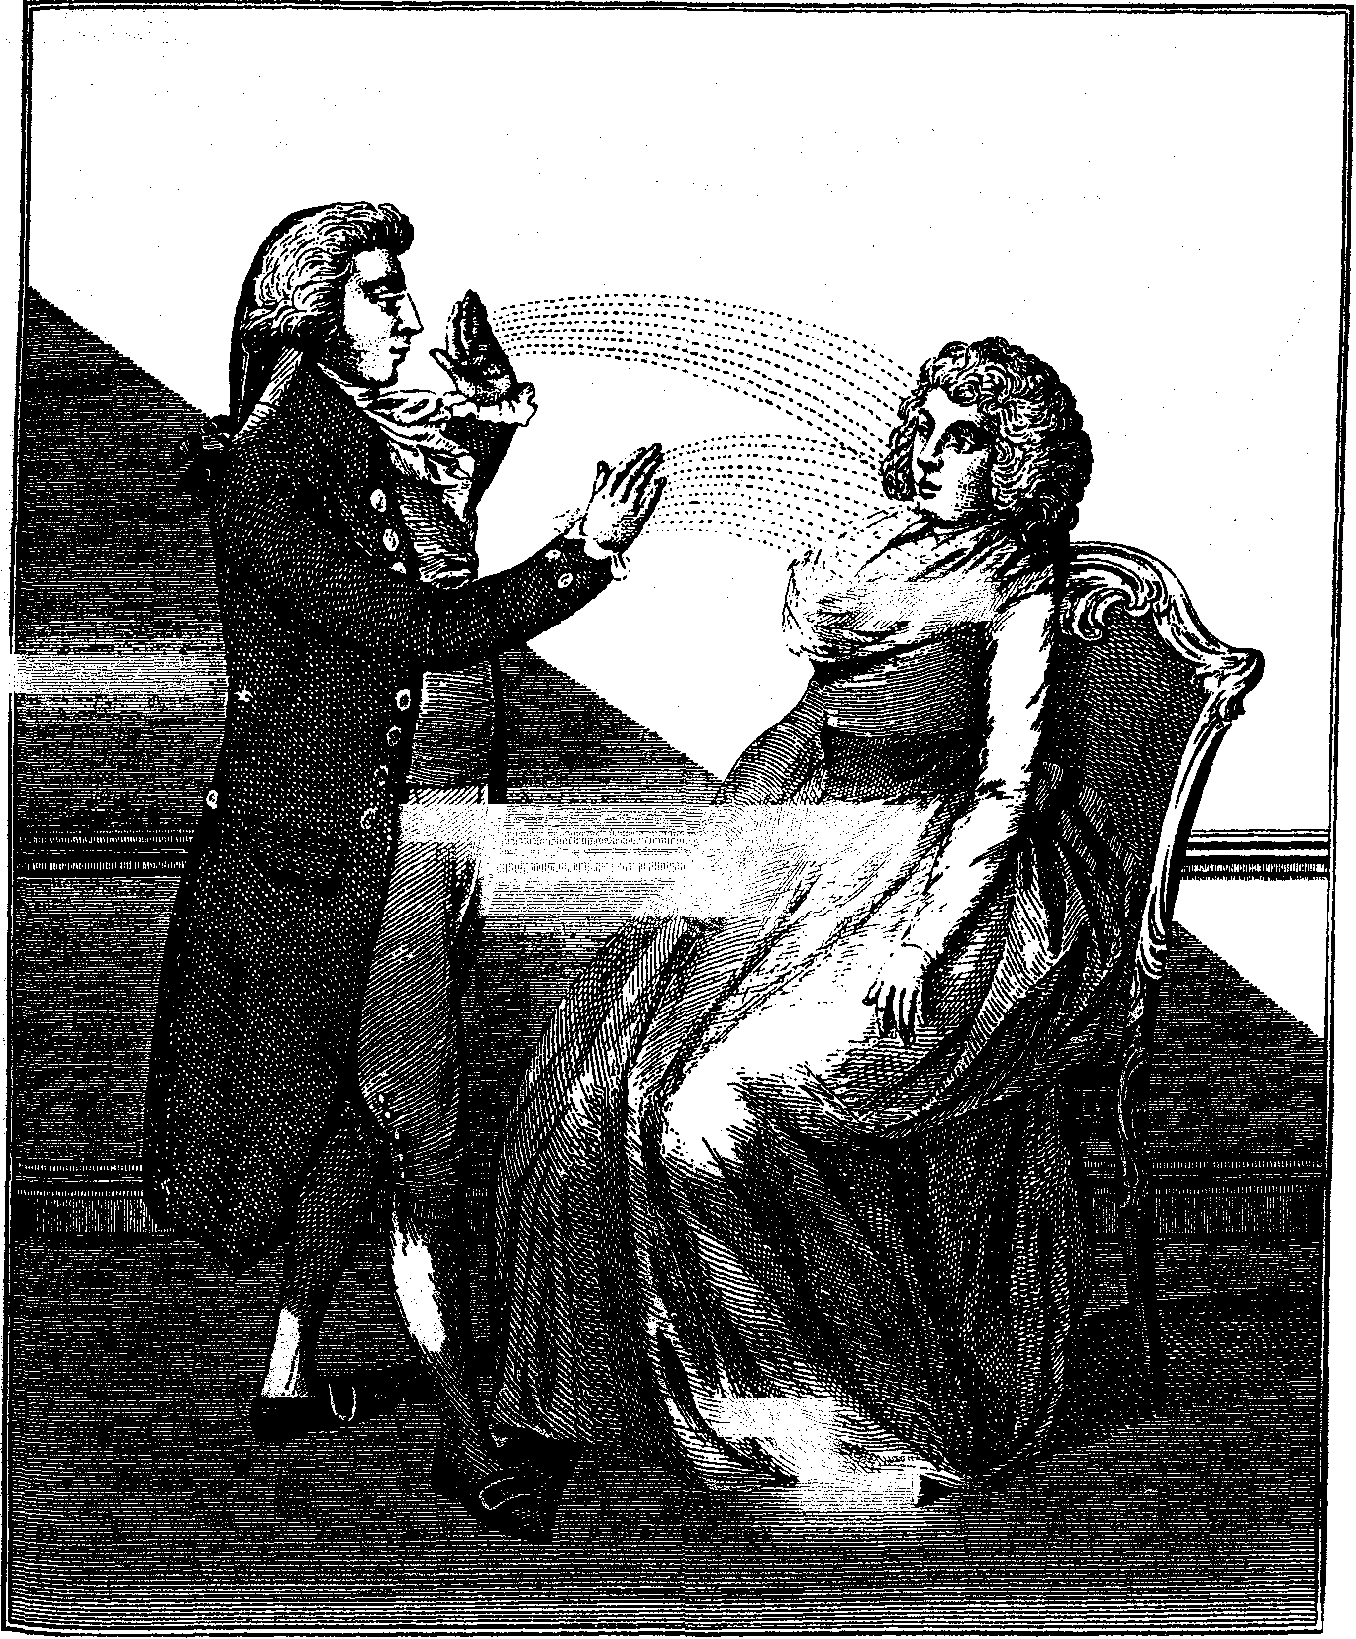
Figure 8.1. Animal Magnetism: The Operator putting his Patient into a Crisis. From E. Šibly, A Key to Physic and the Occult Sciences, 1814.
together with the girls' frivolity and cheating, caused the hospital to request Elliotson to stop his mesmeric work there. In 1838 he resigned from his academic and hospital positions. He worked henceforth as an evangelist for animal magnetism, as a private practitioner, and as the editor of a journal, The Zoist (1843-1856), which is a fascinating chronicle of its times.

Animal Magnetism 159
If, as Townshend said, Mesmerism was unfortunate in its founder, it was doubly so in having Elliotson as its chief proponent in the British medical world. He was a short, pugnacious man of great physical and moral energy, quick to anger and adept in mocking his opponents, whereas what was needed was a smooth diplomat. He was also antireli-gious at a time when most medical men paid at least lip-service to the established church, and keen to keep "mysticism" out of Mesmerism and its twin science, phrenology.
A word must be said here about phrenology, or as Elliotson called it, "cerebral physiology": the analysis of character through studying the shape of the skull. Branching out from Lavater's physiognomy, phrenology had been invented around 1800 by two German doctors, F.J. Gall and J. K. Spurzheim, and had come to England shortly afterwards. Elliotson himself was the founder of the Phrenological Society in 1824, and it is probably he who, in the opening article of his magazine, addresses the phrenologists thus:
We say to Cerebral Physiologists, grapple with nature, cease speculating on the unseen, the unknown, the unfelt, the chimerical. Limit yourselves to the consideration of practical questions and apply the knowledge you accumulate. Separate the conjectural and the plausible from that which is established truth, embrace the latter and defend your position regardless of the consequences. Be Philosophers. Cease drawling forth misereres over the fading remnants of spiritual theories; the offspring of infant brains; the vestiges of an intellectual chaos, a period of ignorance and superstition; and rejoice at the approaching indications of man's emancipation from the incubus of error.³⁵
However, Elliotson was not a simple secularist, but was only keen to keep science and religion from interfering with one another. This is why he rejoiced that his own University of London, unlike those of Oxford and Cambridge, did not require church membership.³⁶ He writes in 1845;
I have all my life sought for facts only, and never felt inclined to frame hypotheses [...]! have advocated the truth of phrenology only as far as I have ascertained the facts by careful observation: and have not defended, nay, have greatly doubled, much that passes current among phrenologists. He knows that on mesmerism I have never speculated:—never gone beyond the plain facts which I carefully observed. The same love of fact has made me advocate materialism. I see that the living brain thinks and feels; and I have never indulged in the hypothesis



160 A nimal Magnetism
that, not it, but a something altogether imaginary, called soul or spirit, thinks and feels and does all that our experience plainly tells is done by the brain, while we are being completely deceived by our fancied experience. The Spiritualist is a man of lively imagination and predilection for hypotheses. [. . .] I carefully shew that a materialist may believe in God and a future state, and that the evidence for the latter must be revelation not philosophy: and quote great divines of this last opinion.³⁷
In the same year, one R. R. Noel wrote to the Zoist from Rosawitz in Bohemia, to say that up to now the predominant view in Germany had been that the brain is the instrument of an immaterial mind, but that materialism and necessity were beginning to be seen as the only true and consistent views for scientists.³⁸
Like many secularists, Elliotson was a passionate humanitarian. He wrote vigorously against capital punishment and cruelty to animals. Public executions, he says, brutalize both executioner and audience. For murderers, he recommends perpetual imprisonment, but adds that those in solitary confinement should at least have an animal or bird for company, and books.³⁹ It was natural for such a person to be especially interested in Mesmerism as a painkiller and to be outraged at the refusal of the medical establishment to consider so humanitarian a resource.
A great impetus to this use of Mesmerism came in 1845 through the publication ofjames Esdaile's work in India. Esdaile was a young surgeon in charge of a charity hospital at Hooghly. Finding that he was able to put patients into mesmeric sleep, he began to use this for his operations. In six years, he performed 261 major operations, removing tumors of a size scarcely to be believed, and being rewarded by the survival of nearly all his patients.⁴⁰ Much of the Zoist is devoted to describing and discussing Esdaile's work, which was encouraged by the Governor-General of India, Lord Dalhousie, and by patrician Hindus such as the Tagores.⁴¹ Despite the official rejection in England of mesmerically induced anaesthesia, Elliotson could remark in 1847 on a new wave of openness, saying that an increasing number of surgeons and dentists were using Mesmerism to prevent the pain of operations.⁴²
Just as Mesmerism was riding this wave, a new kind of anaesthetic arrived in England from America: ether, which had the great advantage of being physical, quantifiable, instant and universal in its efficacy (its side effects were another matter). The medical profession could now ignore the claims of this too-mysterious Mesmerism with a good conscience. The Mesmerists seem to have reacted by turning their attention to the more occult aspects of their science. One of these was the clairvoyance that had been spontaneously demonstrated by Puysegur's patients and by many

Animal Magnetism 161
after them. In 1844 a young French clairvoyant, Alexis Didier, came to England and gave exhibition sittings over seven or eight years, making a substantial amount of money for himself and his mesmerizer, Marcillet.⁴³ Townshend was one of those who wrote to the Zoist to describe Alexis's wonders while in trance: he could read books blindfold, predict political events, detect thieves, etc.⁴⁴ Even the famous stage-magician Robert Houdin confessed himself baffled by what he witnessed in private sittings with Alexis, and Houdin knew more than anyone alive about how to produce apparent phenomena.⁴⁵ Alan Gauld, the historian of hypnotism, uses the Didier case to evaluate the whole question of "supernatural" powers, saying that if they can be discounted in Alexis's case, there is no point in considering them in any other case. After a careful analysis of the alter' natives, Gauld reluctantly concludes that magnetic somnambulists "did sometimes acquire and transmit information which they could not have come by in any of the ordinarily recognized ways."⁴⁶
It was in Germany that these psychical phenomena blossomed into mysticism. Heinrich Jung-Stilling (1740-1817) describes how, when subjects are able to be taken by repeated magnetizing or stroking beyond the passive, magnetic sleep, they enter a more elevated and very agreeable state; "The exaltation of the inner man rises in many persons to such a height, that they come into connexion with the invisible world, and they very frequently reveal hidden mysteries, and also remarkable things, which are taking place at a distance, or will shortly happen."⁴⁷ Jung-Stilling regarded this state as resembling, and in fact proving, the state of the soul after death, when it loses all connection with the sense-world and finds itself among beings of its own affinity: hopefully its friends, the Saints, and the Redeemer himself.⁴⁸ ;; ,;^ : i^ ;
Jung-Stilling was Professor of Political Economy at Heidelberg and Marburg Universities, and a friend of Lavater, Herder, and Goethe. His Theory ofPneumatology, which was published in English translation in 1834, was the work of a convinced Christian, written both as a rational analysis of psychical phenomena and as a warning against dabbling in them. "Animal Magnetism," wrote Jung-Stilling, "is a very dangerous thing. When an intelligent physician employs it for the cure of certain diseases, there is no objection to it; but as soon as it is applied to discover mysteries, to which we are not directed in this life, the individual commits the sin of sorcery—an insult to the majesty of heaven."⁴⁹
Beside the figure of Swedenborg, who was apparently able to visit the spiritual world without being magnetized, the Germans of the Romantic era had some striking examples of this type of soul-traveling. One was Anne-Catherine Emmerich, whose vaticinations were collected by the poet Clemens Brentano. Another was Friederike Hauffe (1801-1829), known as the "Seeress ofPrevorst," who was studied by the doctor-poet Justinus



162 Animal Magnetism
Kerner. He first magnetized her in 1826, in the attempt to cure her from convulsions and other ailments, which beset her throughout her short and sickly life, then stayed to listen to the awe-inspiring revelations that she gave when in trance.
The Seeress of Prevorst lived in familiarity with the phantasms of the dead. Many came to her for help in matters concerning their surviving relatives. Moreover, she was the focus of poltergeist activities: knocks, raps, and flying furniture. Lastly, she gave in trance a remarkable series ofcos-mological teachings, illustrated by charts of circles and wheels, with a text in an unknown script. This was supposedly the primordial language of mankind, which the Seeress (and other German somnambulists) would speak; Kerner perceived in it a kinship to Hebrew. As the psychical researcher Frank Podmore points out, important features of later Spiritualism and Theosophy are already present here: converse with the dead, raps, the revelation of a cyclical cosmology, and the r/r-language.⁵⁰
The story of the Seeress of Prevorst was published in English, in abbreviated form, by Catherine Crowe in 1845. But the cosmopolitan Mesmerists did not need to wait so long, being fully aware of developments on the Continent. This brings us back to Lord Stanhope,⁵¹ the patron of Dupotet, and to his peculiar foreign entanglements.
Philip Henry, the Fourth Earl (1781-1855) was the son of Charles "Citizen" Stanhope (the Third Earl), which was not an easy destiny. Just in case England should enjoy a revolution of the French type, Charles made his children learn useful trades or professions. The Medical Times reported that Philip had been apprenticed to a surgeon-apothecary in Canterbury; his obituary in the Zoistsaid that he had been a brickmaker and signed himself thus in the census.⁵² In any case, he was interested in medicine from his early years, as he himself told the members of Elliotson's London Mesmeric Infirmary.⁵³ In his youth he also knew Richard Cosway, whose pretentions as a healer were mentioned above.⁵⁴ Utterly incapable of getting along with his eccentric father, who kept him virtually imprisoned at the family seat ofChevening, Kent, he was helped by his half-sister Hester to escape in 1801. In 1806 there was a lawsuit between Philip (as Lord Mahon) and his father, as a result of which he was disinherited of all the Third Earl's disposable property.
Even after he succeeded to the family property and title when his father died, unreconciled, in 1816, Philip Henry Stanhope was beset by financial difficulties. A recent biography by Johannes Mayer has shown how he solved these by acting as a secret agent for the government of William Pitt. Mayer traces Stanhope's travels around Europe, particularly in the German states, and his involvement with the contested thrones of France and of Baden. Like his father, Philip joined many causes and tilted at many windmills, but entirely contrary ones. Whereas the Third Earl had

Animal Magnetism 163
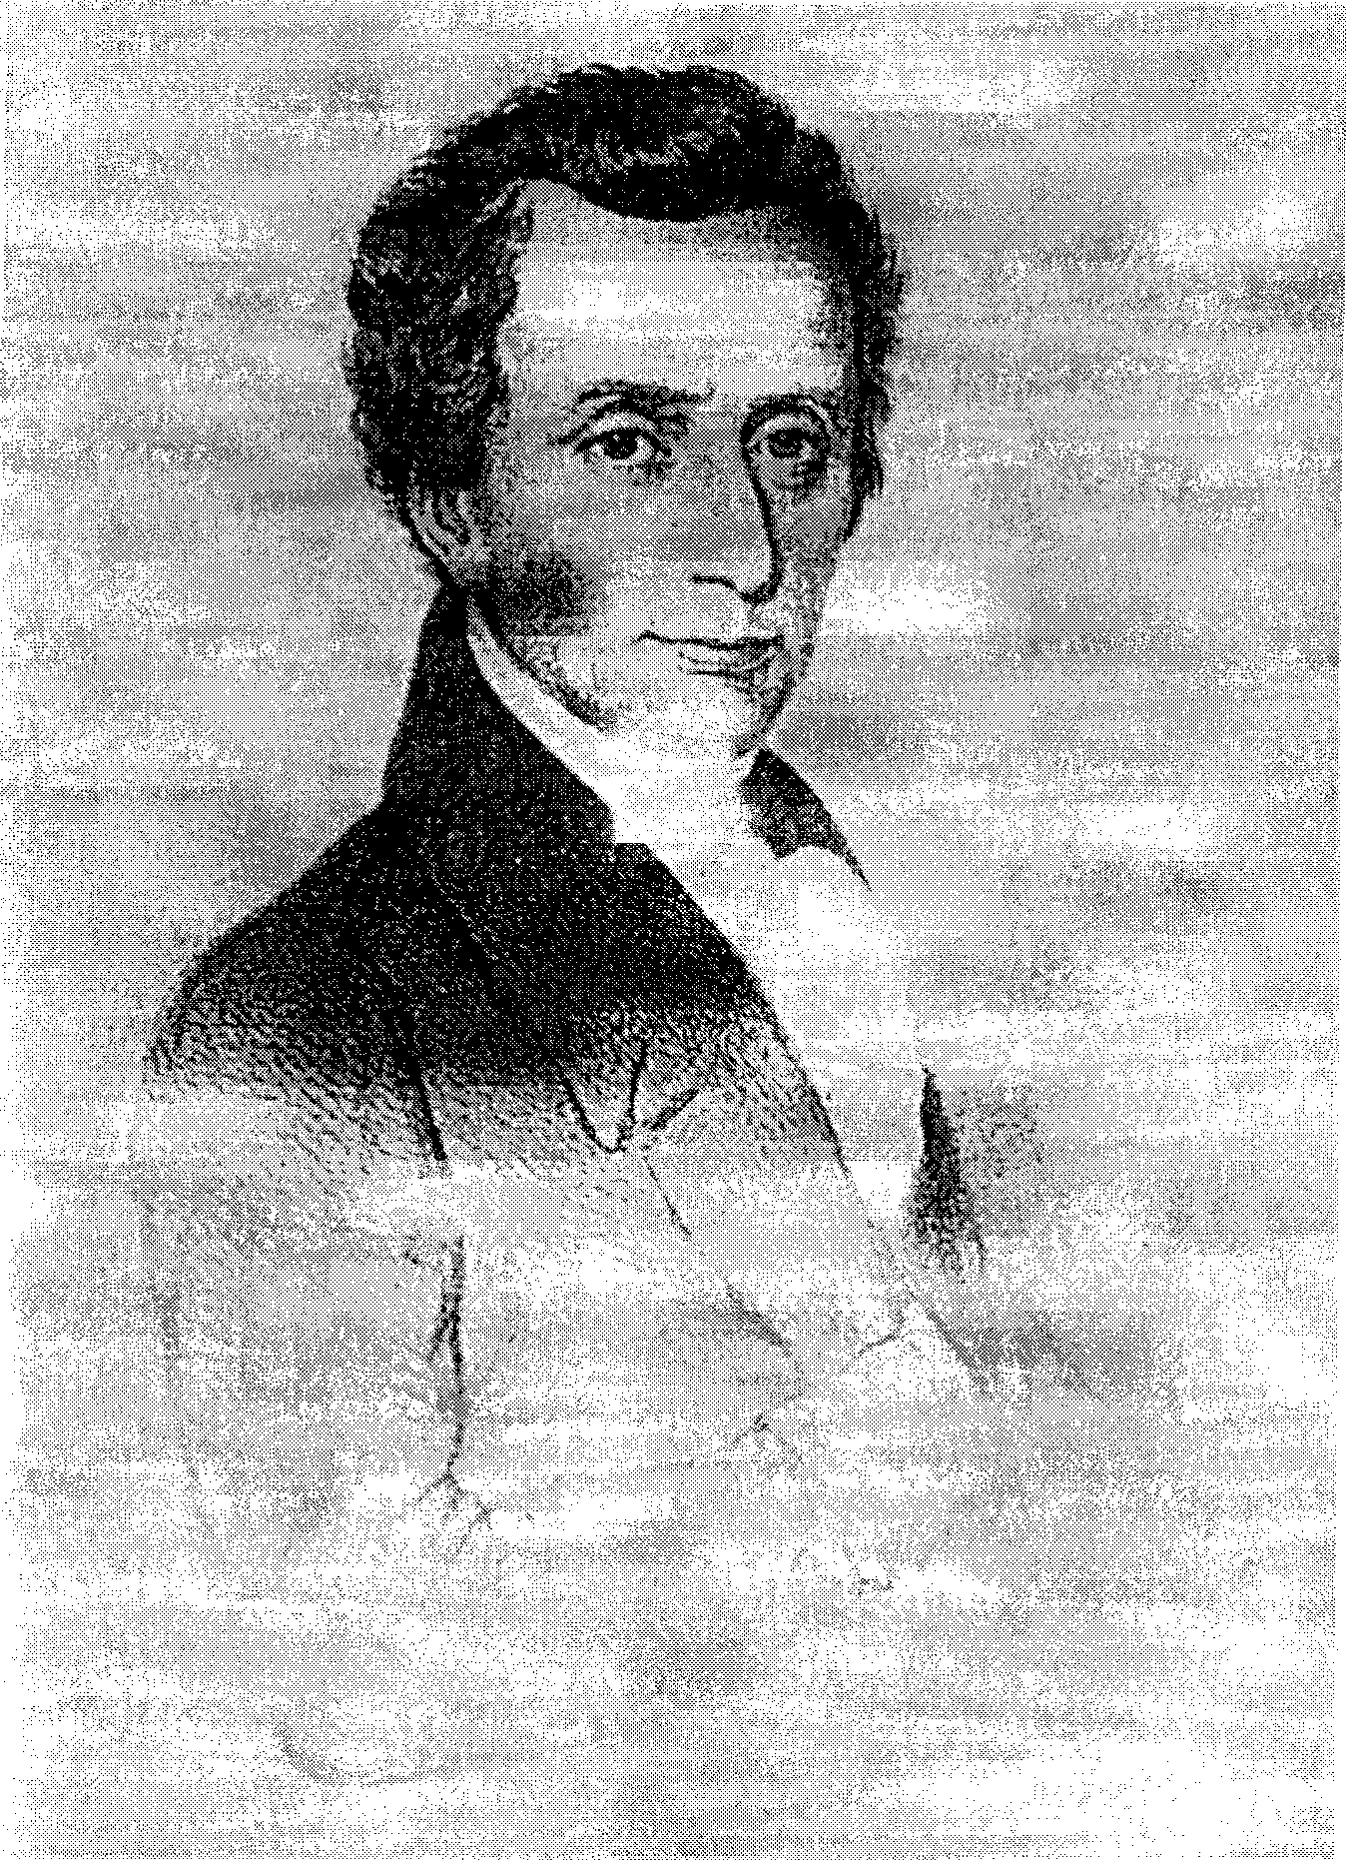
Figure 8.2. Philip Henry, Fourth Earl of Stanhope, (1781-1855).


164 Animal Magnetism
been a friend of the Orleans family and a supporter of Louis-Philippe, the Fourth Earl gave his allegiance to the Bourbons and the reactionary Charles X. He said of himself: "I am, as you well know, one of those old-fashioned Tories, who wish that Rights may be respected, all Property may be secured, and that ancient Institutions may be preserved."⁵⁵
Stanhope was anti-High Church, anti-Poor Law, anti-Catholic emancipation, anti-opium trade, and, to the disgust of his Kent neighbors, cared nothing for country sports. His enthusiasms included flying in balloons, teetotalism, and universal suffrage. He was Vice President of the Society of Arts and, like the Second, Third, and Fifth Earls, a Fellow of the Royal Society—giving him ample opportunity to meet most of the principals of our study. His interest in science and medicine led him to become President of the Medico-Botanical Society, to which he gave annual addresses from 1829 onwards. In the first one, he voiced the good Paracelsian idea that the Creator has stocked the earth with plants, and that it is up to us to find out their therapeutic uses.
As we have seen, Stanhope had watched Dupotet's trials at London University and felt that he must defend them against medical prejudice. He himself was a magnetic practitioner: he cured epileptics and gave a course of treatments to his servants and the village people at Chevening.⁵⁶ Aubrey Newman, the biographer of the Stanhopes, says that the Earl got into trouble through an over-generous nature. This is exactly what Philip would have wanted to hear about himself, but it cannot have been the only cause of his strange involvement with Kašpar Hauser.
Kašpar or Caspar Hauser (1812-1833) appeared in Nuremberg in 1826, apparently lost and unacquainted with every facet of normal life. Under the care and tutelage of several worthy citizens and professors, he eventually told of how he had spent his youth shut up alone in a cell and fed only bread and water; that he was finally taught a few words and how to sign his name, then set loose in the streets. This rare specimen of a "natural man" untouched by civilization was a godsend to theorists in the Rousseau tradition, and Kašpar attracted much attention. He had abnormally keen senses, and a passionate aversion to eating meat and to cruelty of any kind, gratifying believers in the moral superiority of the "noble savage." It was in October 1829 that Stanhope, traveling in Germany, heard about Kašpar and of an assassination attempt (some said a self-wounding) that had occurred a few days before. Stanhope First met him on 28 May 1831 and for a time was often in his neighborhood. In September the Earl returned to Nuremberg and for two months saw Kašpar daily. He took on an obligation to the city of Nuremberg to be responsible for Kaspar's safety and wanted to take him away as his ward. But instead, Kašpar was moved to Ansbach to become an apprentice, where after a time Stanhope ceased to visit him. Only after Kaspar's assassination (some said suicide)

Animal Magnetism 165
on 17 December 1833 did Stanhope return and speak to people who had known him. By now the Earl was convinced that Kašpar had not told the whole truth about himself and that he was in part an impostor. Kaspar's death a few days after receiving a stomach wound seemed to him to have been the result of suicide, caused by the fact that his story was beginning to break down. Stanhope's final opinion was that Kašpar had been a journeyman tailor or glover from the Austrian side of the River Salzbach.⁵⁷
The account from which this is summarized was written by Stanhope soon after Kaspar's death in response to a book by Anselm voň Feuerbach (1775-1833), formerly Stanhope's friend. As President of the Court of Appeals in Ansbach, Feuerbach took responsibility for Kaspar's welfare. He came to believe in the rumor that the boy was the heir to the House of Baden, abducted in the cradle, and replaced by a sickly baby who died shortly afterwards. Everything he observed in Kašpar served to confirm this belief, whereas to the Earl much of what Feuerbach reported about the boy was simply wrong.
Stanhope's efforts to adopt Kašpar Hauser only increased his reputation among his fellow Mesmerists for "philanthropy and Christian kindness."⁵⁸ We will meet him again in the next chapter, as an old man still prying into mysteries. But after the Earl's death in 1855, Kaspar's guardian and tutor G. F. Daumer published his own "revelations," in which he virtually accused Stanhope of conspiracy to murder. Daumer's theory was that the boy was probably from an aristocratic English family that had connections in Hungary, or vice versa; that he was in Hungary as a young child when it was decided to abduct him and let him die of privation, no doubt for the sake of a great inheritance that would go to someone else. But the plan went wrong. He did not die, and his captors, unwilling actually to murder him, brought him to Germany and turned him loose in Nuremberg, expecting him to disappear into the lower classes or the army. As publicity and researches about Kašpar grew, the conspirators became worried, and when he gave signs of remembering his youth (recognizing Hungarian words, for instance), they decided to act. Daumer notes that Stanhope was in the city when the first attack was made on Kašpar, and that he may well have been in Ansbach at the time of the murder. The most Daumer will allow the Earl is that he was perhaps not acting in his own interest, but in that of a relation or friend who was the original criminal.⁵⁹
Daumer's thesis was taken up by Jacob Wassermann, author of a popular historical novel: Caspar Houser, the Enigma of a Century (first published in German, 1908). Wassermann devotes many pages to misrepresenting Stanhope (whom he confuses with the Earl of Chesterfield) as a monster of depravity, who having squandered his family fortune was reduced to murdering inconvenient heirs. His account was accepted by


166 A ramaí Magnetism
*


Anthroposophists because Rudolf Steiner, the founder ofAnthroposophy, accorded to Kašpar Hauser a major role in the spiritual history of Europe.⁶⁰ I will digress on this here, because of the bearing it has on the theories of occult conspiracy to be introduced in Chapters Ten and Eleven.
Johannes Mayer, an Anthroposophical scholar whose recent book examines every facet of Stanhope's and Hauser's relationship, proves beyond reasonable doubt that Hauser was really born in 1812 as the son of Stephanie von Baden, nee Beauharnais, and her husband the Grand Duke of Baden.⁶¹ He suggests that the motive for the abduction and faked death was that this boy was the son of Napoleon's adopted daughter, hence the French Emperor's possible heir. The Bourbons (eventually restored as Louis XVIII and Charles X) would have had most to gain from the removal of the child. By the time Kašpar appeared in Nuremberg, his father's line had been succeeded by that of his uncles, whose legitimacy was in turn under challenge from the neighboring kingdom of Bavaria. A true male heir to the Grand Duchy of Baden would have inconvenienced both of these factions.⁶² Stanhope's circumstantial involvement with all of these people, and his constant traveling around Germany, put him at the center of the intrigues around the mysterious youth.
The political center of Rudolf Steiner's theory concerning Kašpar Hauser is that it was he, and not William I of Prussia, who was to have been the collaborator with Bismarck in the unification of Germany. "Was to have been" presumes a plan behind European history; Kaspar's imprisonment and untimely death presumes its frustration by earthly powers. These are two very large presumptions. But prince or not. Kašpar was no ordinary Bursche. There are many contemporary witnesses to his beautiful personality, unspoilt by his cruel treatment. G. F. von Tucher, his first guardian, wrote: "Everything I have found in him, including his natural piety and freedom from self-consciousness, gives most fully the picture of the first human beings in Paradise before the Fall." His teacher Daumer called him "the heavenly appearance of an angelically-beautiful, angelically-pure soul."⁶³ The descriptions of Kaspar's purity of soul and his unjaded appreciation of the beauty of the world put one in mind of the youthful German Romantics such as Novalis, the painter Philipp Otto Runge, and Franz Schubert.
But what became of that impulse? One could almost say that it died with Kašpar Hauser in 1833. Steiner seems to have thought that if a German Romantic, rather than a Prussian soldier, had acted as midwife to a united Germany, that precious germ of Romantic spirituality might have lived and flourished. The Anthroposophist Paul Alien remarks: "in the spiritual individuality of Caspar Hauser we are confronted with a higher Being who doubtless had a task of greatest importance to accomplish

Animal Magnetism 167
upon earth," and one whose murder had incalculable consequences. Alien adds: "It becomes ever clearer that had Caspar Hauser, born under the sign of the Archangel Michael, 'the fiery Prince of Thought,' been able to unfold those spiritual impulses necessary for the progressive development of mankind, the dagger plunged by Hitler into the heart of Middle Europe, with all its catastrophic consequences for humanity, might have been averted."⁶⁴
Steiner does not actually accuse Earl Stanhope of complicity in Kašpar Hauser's murder, as Daumer and Wassermann did, but he hints at a rivalry behind the scenes between the esotericists of Central Europe and the Anglo-Saxons. He says that the latter had been grimly determined since about 1600 to dominate their spiritual epoch (the "Fifth Post-Atlantean," in Steiner's system) and to act as nurses for the succeeding epoch, which was destined to be that of the Slavic peoples. Steiner said in a lecture of 1916: 'Just as the Romans were the wet nurse in spiritual connection to Western and Central Europe, so the Anglo-Saxons were to be the wet nurse for the Eastern European peoples and lead them over to their later spiritual life."⁶⁵ Evidently Steiner felt that this Anglo-Saxon hegemony had been a disaster, because it had led first to spiritualism, with its false teachings about the soul's destiny, then to a Theosophical Society that spurned Christianity in favor of the East. But since Steiner himself was a Central European occultist, a Christian supremacist, and a disillusioned member of the Theosophical Society, he is hardly a disinterested witness.
Conspiracy theory is anathema to the historian, but indispensable to the history of occultism. It is of the very essence of the occult world view that earthly events are not the result of material cause and effect alone, but that they are influenced by other levels of being. The occultist automatically seeks for a "higher" cause, both in the great happenings that change the course of world history, and in small happenings such as the Kašpar Hauser episode that lack a normal explanation. By raising Hauser to a figure of cosmic significance, Rudolf Steiner unites the two types.
Animal magnetism, in turn, is of the essence of occult conspiracy theory, which hinges on the possibility of deliberate action at a distance and the implanting of ideas in people's minds. There is no need here for the clumsy apparatus of mundane conspiracy theory, such as the Abbe Barruel and John Robison attributed to the network of Illuminati and Freemasons. The occult adept is imagined to work directly on the minds of leaders, who only appear to be directing the destiny of nations. If the destinies in question are not as tidy, or as benevolent, as this scenario would suggest, the reason is plain: evil adepts also possess these powers. The wars on earth then reflect a "war in heaven."



C-^3 C/TO C-tS C-T3 C-tS C-^-3 C--S3 C-^3 C/S3 C^SO
NINĚ
Visions in the Crystal
e-ta c--p3 e«^3 c-^a c-t3 c-^a c-^a c/sa c-^s) e-»s3
One of the themes of Chapters Seven and Eight was the way in which the occultists of the post-Napoleonic period picked up the threads that had fallen in disarray in the 1790s. This chapter traces another of these threads: that of divination through the crystal, or scrying. It is one of the most widespread forms of occultism, practiced since antiquity in almost every known culture.' The English tradition has the famous examples of Roger Bacon, whose magic mirror and brass head were the wonders of a superstitious age, and John Dee, with his "shew-stones" of various types, at least one of which is now in the British Museum. After Měřic Casaubon's expose of Dee's angelic conversations, there were surely those who, rather than mocking the Doctor, sought to emulate him. The works of the astrologer William Lilly and of John Aubrey, the collector of gossip and strange lore, describe or illustrate scrying crystals adorned with the names of archangels, as used in the later seventeenth century.
Like ceremonial magic, with which it was closely linked, scrying persisted even in the era of rationalism. The sale of Thomas Britton's magical collection (see Chapter Five) included a "solid round Christal glass," as well as apparatus for the reputedly more perilous method of evoking spirits by means of a magic circle. One of the "Dr. Rudd" manuscripts in the British Museum, transcribed by Peter Smart between 1699 and 1714, illustrates a mirror whose back is inscribed with Hebrew names, and whose purpose was the invocation of the Nine Hierarchies of Angels to visible appearance.² Raphael, the leader of the nineteenth-century astrological revival, preserves an "Extraordinary narrative of a celebrated astrologer of the last century."³ The unnamed author tells that he once lodged in the house of a watchmaker's widow in Little Britain (a small district of the City of London), where an astrologer had formerly lived. The tenant had a dream vision of his predecessor and felt a dreadful shaking of the room. He then discovered a cabinet which he had seen in his dream, with a
169

170 Visions in the Crystal
secret drawer containing the astrologer's manuscripts bound in vellum. They showed that he had once studied geomancy, the crystal, conversing with spirits, the use ofsigils, and foretelling by a magic mirror. In 1750, however, he had given up everything but astrology. The secret drawer also contained sigils, mystical jewels, and thin plates of gold and silver inscribed with angelic names in Greek and Hebrew. There was in particular a case of solid gold one inch square, with seven Chaldaic names bordering a large clear crystal, accompanied by instructions on vellum, "A Call to the Crystal." It is very likely that this narrative gave Bulwer-Lytton one of the themes of his splendid ghost-story, The Haunted and the Haunters. Crystal-gazing was at the center of the occult revival of the early nineteenth century. It was the perfect occult science for a certain type of investigator. Unlike alchemy, it did not require daily work in an expensive laboratory. Unlike astrology, it needed no mathematics. It was less challenging to the nerves than evocation in a magic circle, and its equipment was more easily concealed. But it was far more exciting than geomancy or the other "mancies, and, at least as it had developed in England, it seemed to offer no affront to Christian faith.
Although this chapter deals only with the scrying of named individuals, mostly active in London and in touch with each other, there must have been more crystal-gazing going on in the provinces than ever came to light. As a single example that may be the tip of an iceberg, there is a report from 1866 of the practice among the working classes in Lancashire:
glass balls the size a hen's egg were sold in Manchester, and much used by women to see what their husbands were up to.⁴ The "Mr. P." who reported this to the Spiritual Magazine was headmaster of a national school in Lancashire. He had discovered that the local sexton and his son were seers, but that they had not told him because they thought a schoolmaster would never believe in it. They even had a book telling the planetary spirits which presided over the days of the week.
In the metropolis, scrying became popular in the early nineteenth century among the Mercurii and the friends of Francis Barrett, whose Magus had included instructions.⁵ We know that Barrett consecrated crystals for the use of his pupils (see Chapter Six), and that it was Barrett's circle—taking this in the broadest sense—that initiated the most persistent crystallomancer of the century, Frederick Hockley (1808-1885).⁶
The circumstances of Hockley's birth and parentage are unknown, but like many devotees of the occult sciences, he began his studies and practices at a young age: by his own admission, he was given a crystal and began scrying at fifteen or sixteen, in 1824. Hockley evidently did not go to university; he earned his living as a partner in a firm of chartered accountants in the City.⁷ Before becoming established in that profession, he worked for Denley the bookseller, copying manuscripts and doubtless

Visions in the Crystal 171
doing other jobs.⁸ In Chapters Five and Six, we noted in passing that he was the copyist of Sibly's Rotalo (dated 1824) and of Randolph Oxiey's manuscript on crystal-gazing. All his life, Hockley made beautiful copies of magical works, sometimes illuminated, which can be seen in various libraries.⁹ He wrote down all his own conversations through the crystal, preserving them in thirty volumes (of which six are known to survive), which he would show to very select friends. He was an avid collector of books and manuscripts, acquiring from Denley the manuscripts of Eben-ezer Šibly and of Barren's Magus, and also those ofBacstrom mentioned in Chapter Six (now in the libary of the late Manly P. Hall in Los Angeles).¹⁰
Hockley was not clairvoyant. Like John Dee, Cagliostro, and Max Theon, he had to collaborate with a "speculatrix" or scryer, to whom he dictated questions to be put to the spirits that the scryer could see in the crystal. He approached his work in the most pious and Christian frame of mind, always prefacing and closing it with long prayers as a safeguard against contact with evil spirits.
Hockley believed that use of the crystal had originated with the Jews, who were given it by divine command under the appellation of the Urim and Thummim (Exodus 28:30).^{n} He disagreed strongly with the equation, pursued by some skeptical writers in the Zoist, of what is said by spirits in the crystal with what is said by mediums in mesmeric trance. The latter, says Hockley, is mere suggestive dreaming, in which the magnetizer's thoughts are picked up by the medium. Surely John Dee was not so besotted (says Hockley) as not to have noticed, over twenty years' scrying, if the responses had been merely the embodiment of his own thoughts. On the contrary, the phenomenon has a much closer connection with the spiritual world than the rationalists of the present day like to think. Hockley had no doubt that some of the spirits were real, departed human beings. He became quite familiar with one of them, a Spanish monk who had been tried for sorcery and burnt in 1693. Another communicator purported to be a living man, Captain Anderson, who was in the Crimean War and had a crystal with him through which he told Hockley of his misadventures.
Hockley found it reassuring that the spirits tended to keep the same prejudices and religious beliefs in the spirit-world as they had had on arth: if they all said they'd become Roman Catholics, or Anglicans for jhat matter, there would be something to worry about! Hockley envisaged the soul as embarking on a long period of further education in the spirit world, "and when it becomes illumined by the divine mind, and capable of solving our doubts, being placed beyond the reach of mortals however magnetic."¹² Such a one was the "Crowned Angel of the Seventh Sphere," a very communicative Spirit whom Hockley contacted in 1854 through


172 Visions in the Crystal
Emma Louise Leigh, the daughter of his landlord in Croydon who worked for Hockley from the age of thirteen until she died at twenty.¹³ The "C.A." dictated a complete metaphysical and cosmological system—much of it now lost—and converted Hockley from Unitarianism to a more traditional belief in the Trinity and the Virgin Birth of Christ. Apparently even the "illumined" spirits preserve their doctrinal prejudices.
This is how Hockley conceived of the mechanics of scrying:
The writing which is seen in the Mirror is done by the Spirit forming the letters in his mind as each word passes through his mind, so they take the form of a reality and appear—the Seer who sees and the Spirit through whose mind these ideas pass, are for the time one, but they are united by so slight a cord that the least thought jars it, when it is jarred the writing appears small, and when quite severed the writing disappears until the bond is again completed—they see with the Spirit's eyes, and they read what is impressed upon the Spirit's mind.¹⁴
This exactly resembles the process by which the "Mahatma Letters" (see Chapter Fifteen) are said to have been conveyed from Koot Hoomi and Morya to the early Theosophists. In the Mahatmas' case, the process entailed a further stage of "precipitation" onto paper by the "seer," who was not a medium but an initiate in training.¹⁵
Hockley's long experience brought him into contact with most of the people of his age who were interested in the art of scrying. On the scientific side, he collaborated with the Fourth Earl Stanhope,¹⁶ who paid an optician to make Hockley two artificial crystals made from powdered rock crystal and brass.¹⁷ Hockley in return gave Stanhope a black mirror, which made objects and writing appear larger, but was "in some degree injurious to the eyes."¹⁸ He himself had most success using the traditional "crystal ball," a pure spherical rock-crystal.
Hockley was discreet, keeping his crystal manuscripts under lock and key but not unwilling to talk about his unusual pursuit to serious researchers. He made representations to the Zoist in the 1850s and gave an interview to the London Dialectical Society during their investigation into Spiritualism in 1869. He showed them a crystal in a silver ring, mentioned that he had about 1,000 books on occult science, and told them his favorite story:
Some time ago I was introduced to Lieutenant Burton by Earl Stanhope, and he wished me to get him a Crystal, with a spirit attached. I also gave him a black mirror as well, and he used that in the same manner as you would a crystal. You invoke the person whom you wish to appear, and the seer looks in and

Visions in the Crystal 173
describes all, and puts questions and receives answers. Lt. Bur-ton was greatly pleased and went away. One day my seeress called him into the mirror. She plainly recognized him, although dressed as an Arab and sunburnt, and described what he was doing [. . . Later, Burton] assured me it was correct in every particular and attached his name to the account I had written down at the time, to certify that it was true.¹⁹
Richard Francis Burton (1821-1890) had contacted John Varley after being sent down from Oxford in 1841 and was fascinated by the astrologer's theories.²⁰ In 1842 he went to India for six years and became invoved in yoga, drugs, and magical eroticism (he later translated the Arabian Nights). Burton wanted a crystal because his plan, which he actually carried out in 1853, was to penetrate the forbidden city of Mecca, disguised as an Indian magician from Alexandria.²¹
The "attaching" of a spirit to a crystal, mentioned in the above quotation, was the same ritual referred to by Barrett as "consecrating." Crystals were dedicated to different types of spirits, usually classified after the seven planetary angels, according to the type of information desired. For finding hidden treasure, Jupiter might be of assistance; for seeing one's beloved, Venus, etc. Hockley also made use of free or unconsecrated crystals.
Hockley kept severely aloof from any form of black magic, but he knew all about it. He disclosed certain spells to one of his friends, a Church of England clergyman, who not only tried it out but published the fact in his anonymous book of memoirs, The Great Secret (1896), adding that even now, the terror he felt was still palpable.²²
From 1853 to 1855 Hockley had a long correspondence with Robert Owen. The social reformer, whom we met fulminating against religion in Chapter Three, was now a convinced spiritualist, and had been publicizing his communications from various great men of the past. These came not through a crystal but through the more modern channel of a trance-medium, Mrs. Hayden. Foremost among Owen's advisers was his old friend the Duke of Kent (1767-1820), the father of Queen Victoria. Although Owen had already been scolded by Prince Albert, in 1848, for pestering the Queen with letters, he could not resist writing to her again about these conversations.
The Crowned Angel meanwhile told Hockley that Owen was utterly mistaken: that he was communicating not with the real Duke of Kent, but with an evil, earthbound spirit. The C.A. offered a form of exorcism with which to call its bluff and dismiss it. Hockley informed Owen of this; Owen thanked him for his advice, but persisted in believing his "Duke of Kent" to he genuine. Far from wanting to keep the matter secret, he published



174 Visions in the Crystal
his correspondence with Hockley in his The New Existence of Man Upon the Earth (1855),²³ but tactfully inserted blanks where the C.A. had named the evil spirit. This was none other than the Queen's jealous uncle Ernest Augustus (1771-1851), Duke of Cumberland and later King of Hanover, who had insulted Prince Albert and was even suspected for a time of having tried to poison the Queen.
In Hockley's crystal manuscripts, as copied (against his directions) by Francis and Herbert Irwin, there is a report that sheds further light on this episode, and on crystal-gazing in general. I have numbered the paragraphs for easy reference.
[1] Victoria Regina
[2] I very much wish to know whether I am to become a writing medium, as I wish to communicate with my father the Duke of Kent—Owen tells me he has heard him rap. [3] I have been informed by the C. A. that it is not your Fathers spirit but the evil Spirit of your uncle the late King of Hanover that visits him—
[4] Oh indeed then I should be very sorry to have anything to do with such things. My husband Prince Albert is also very anxious about the crystal—he has one in his possession but he does not thoroughly understand it—he would be very glad for you to give him any information about it—are you not acquainted with Mr I——g one of my pages
[5] "Yes and if Mr Gerding will give you my address I will give H.R.H. full instructions upon the subject or Earl Stanhope will give you my address upon your application to him." [6] I do not know Earl Stanhope he does not attend court [7] Oh then I will enquire about you when I return to Windsor Castle-and if I can find you out I will certainly send for you—
[8] I thank you
[9] Victoria Reigns [10] Victoria Reigns²⁴
Recent scholarship has poured cold water on the attempts made since the 1860s to enroll Queen Victoria to the spiritualist cause.²⁵ But this document, if taken at face value, seems to show her and Prince Albert in the thick of it. What is one to make of this? Having analyzed it at length elsewhere,²⁶ I propose the following scenario.
Hockley is holding a session with his seeress, Emma Leigh. Suddenly she announces the appearance in the glass of Queen Victoria [1]. The figure of the Queen speaks [2] into the medium's clairaudient ear, which the medium repeats verbatim to Hockley. He replies [3], and the Queen

Visions in the Crystal 175
asks for advice about Albert's crystal [4]. Now Hockley exercises discretion. The Crowned Angel has already put him on his guard against lying spirits, and besides, the protocol for personal contact with the monarch is to go through a courtier: one does not give the Queen one's address in a Croydon boarding house. Hockley does, however, know Earl Stanhope [5]—but the Queen does not [6]. In [7] the Queen's simulacrum announces that she is returning to Windsor; then the medium hears (or reads) the twice-repeated motto at the close [8-10].
If this is what happened, the whole episode may have been a projection from Hockley's unconscious mind, perceived clairvoyantly by the medium. Hockley knew already of Owen's letter to the Queen; he might have known a page at court, who could have told him of Prince Albert's owning a crystal. The Crowned Angel had given Hockley a priceless piece of gossip from the spiritual world, namely that the Queen's wicked uncle was masquerading as her noble father, and fooling a famous man like Robert Owen. Hockley must have been longing to tell her himself, but that was unthinkable. His bottled-up desire projected itself in the form of the flattering request to help the Sovereign and the Prince Consort in their occult researches, after which he must have sat back to await the summons to Windsor. Although it never came, he believed that he had had a real interview with Queen Victoria, and showed the record to the Irwins as one of his prize communications.
Even when deflated in this way—and I would not insist that this is the only explanation—the "Victoria Regina" episode remains full of historical and psychological interest.
Hockley was justly described by a friend as "the most all-round occultist" of his time.²⁷ His long magical career provides the link between the era of the Mercurii and that of the Golden Dawn sixty years later. Naturally, he was not the only one who took up scrying under the influence of Denley's bookshop and its familiars. Another was Lieutenant Richard James Morrison, R.N., (1795-1874), who became the foremost authority on astrology after the death of Robert Cross Smith in 1832.²⁸ Morrison had retired from the Navy on half-pay and married a baronet's daughter. As Ellic Howe says, "a highly-educated man with a wide range of rational and irrational interests, he became well known in London society and was welcomed in a good many fashionable houses. . . ,"²⁹ Writing under the name ofZadkiel (the Hebrew name for the angel of Jupiter), Morrison started publishing an annual almanac in 1830 (for the year 1831), at first called The Herald o/Astrology, later Zadkiel's Almanac, which followed Smith's example in varying the technical part (astrological tables and pedagogy) with an attractive icing of marvels and occultism.
Astrological tables are always calculated geocentrically, because they take the point of view of the earth's inhabitants, not those of the sun.

176 Visions in the Crystal
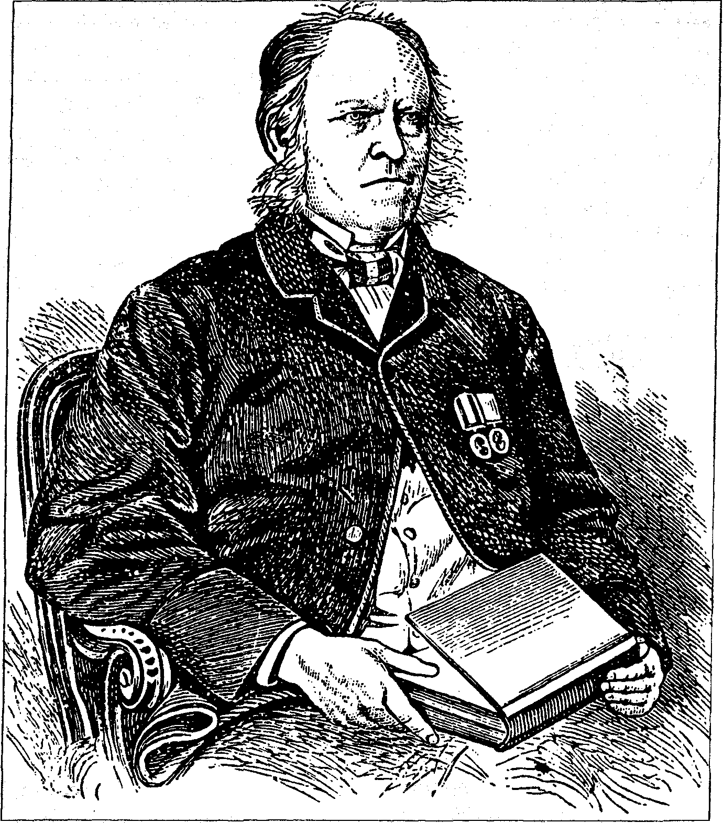
Figure 9.1. "Zadkiel" (Richard J. Morrison, 1795-1874).
When it comes to astronomy, however, the astrologers who use these tables are heliocentrists, like most people since the time of Newton. But there have been exceptions, and Morrison was one of them: he was certain that the earth does not move. To combat the system of Newton (condemned by Morrison as a man "bitten by Epicurian Atheism"³⁰), Morrison published a book in 1868 called The New Prindpia; or, True System of Astronomy. Like Tycho Brahe in 1600, Morrison believed that the sun and moon go around the stationary earth, while the other planets are centered

Visions in the Crystal 177
on the sun. He accepted Kepler's eliptical orbits, but rejected the astronomers' estimate of the planetary distances: the sun, he says with sanguine confidence, is 365,006 miles from the earth; the moon only 36,828 ^{l}/2.^{sl}
Morrison was a Christian supremacist of a strong but not a particularly bigoted type. He spurned the "puritanical, formal rites" like the Sabbath, as opposed to the "pure religion of the heart. "He hated the "atheism" of Robert Owen, the blasphemers, and the "revolting Malthusian philosophy" (a euphemism for birth control). But the idea of a community based on love of one's neighbor appealed to him; he found such principles in the work of Charles Fourier.³²
Given his psychological makeup, it is not surprising that Morrison was led far up the garden path when he started to play with Mesmerism and scrying. In his almanac for 1841 he gives a long report of discoveries made through "E.A.," a young woman of seventeen who answered questions while in mesmeric trance. She gave forth a whole cosmology, resembling Swedenborg's in that she could see the spirits of the dead, each dwelling in its appropriate planet. But whether because of the source, whatever it was, or because of the questions Morrison asked it, the revelations were far inferior to those of Hockley's Crowned Angel. Morrison was obsessed with knowing what had happened to various celebrities after their death. E.A. told him where such as Voltaire, Henry VIII, and the Buddha were now to be found, what they now looked like, and what their state of mind was. She also informed him that the tides are not caused by the moon, but by water expanding under the flow of electricity; that the Round Towers of Ireland were built for astronomical observation; and that the Millenium would come in about thirty years' time.³³
Ten years later, in his almanac for 1851 (now selling 57,000 copies), Morrison favored his readers with a long series of visions provided by a spirit called "Orion" through Lady Blessington's crystal. From this source the inquisitive Lieutenant learned much gratifying gossip. Naughty George IV was making good progress in the spirit world: since 22 May 1842, he had graduated from purgatorial Venus to heavenly Jupiter, but had yet to join "good old George III" in the highest heaven of the Sun. Alexander the Great was due to be released from his punishment "next Sunday." Judas appeared, looking very wretched, and asked to be let go from the crystal. Sir Isaac Newton promised that astrology would be taught in some of the colleges of England before twenty years had passed. King Solomon, when asked whether he had understood astrology, replied "Yes, but not so well as you do." Socrates appeared, wearing coarse, striped peg-top trousers, and recommended as the best means to obtain wisdom "Astrology, Phrenology, and Prayer." He said that he now accepted Jesus Christ as the Messiah, and wished the server a happy thirteenth birthday. As far as the future was concerned, Orion said that Louis Napoleon would


178 Visions in the Crystal
never be King of France: he would be assassinated, and the Comte de Paris would eventually reign. A dreadful three-year war was due to break out in 1855, 1856, or 1857, with America, France, Russia, Sweden, and Denmark on one side, England, Turkey, Germany, Hungary, and Norway on the other. England's side was (of course) going to win.³⁴
At the time of these consultations with Orion, there was great public interest in the fate of Sir John Franklin, the explorer who had departed on a search for the Northwest Passage and of whom nothing had been heard. Sir John himself appeared in the crystal on 4 February 1850 with the reassuring news that he was well, but short of provisions. Orion reported again on 1 March that the Franklin Expedition was doing well, and was now NW of Melville Island.³⁵ Unfortunately the discovery of the Franklin Expedition's diary and remains in 1859 showed that Sir John had died in 1847: he should already have been on a planet.
Given that the spirits in crystals of even the highest pedigree were liable to give out such rubbish, it may seem astonishing that anyone bothered with them. The same may be said of the revelations of young persons in a state of "somnambulistic lucidity": they often reflected the most un-examined prejudices of the gentlemen who were controlling them.
There were three intersecting circles of servers during the 1830s to 1850s. The first, of which we have had a sampling in Hockley and Mor-rison, were Christian servers in the Dee tradition who sought knowledge of the spiritual world. A second one consisted of socialites, centering on Lady Blessington's salon. It must have had offshoots in many upper-class houses where crystal gazing became an after-dinner entertainment, until the craze for Spiritualism and table turning took its place in the 1850s. The third circle was scientific and will be treated last.
Marguerite Gardiner, the Countess of Blessington (1789-1849), in some ways resembled Emma Hamilton and Maria Cosway: she too had come from an undistinguished background but managed, through a combination of beauty, charm, and intelligence, to become the central attraction of one of the great salons of her day. We met her briefly in Chapter Two, reporting her impressions of the aged Sir William Drummond. That was during her years of residence on the Continent. Before that, she had married the First Earl Blessington in 1818, and held court in the early 1820s in St. James's Square. John Varley was one of her familiar visitors there.³⁶ After the Earl's death, Lady Blessington took to novel and magazine writing to support herself in her accustomed style—much as Bulwer-Lytton was doing, and, on the other side of the Channel, the Baroness Dudevant (George Sand).
In 1836, Lady Blessington moved into Gore House, a grand Kensington residence that had belonged to William Wilberforce, on the site now occupied by the Albert Hall. It was here that Bulwer-Lytton, his friend

Visions in the Crystal 179
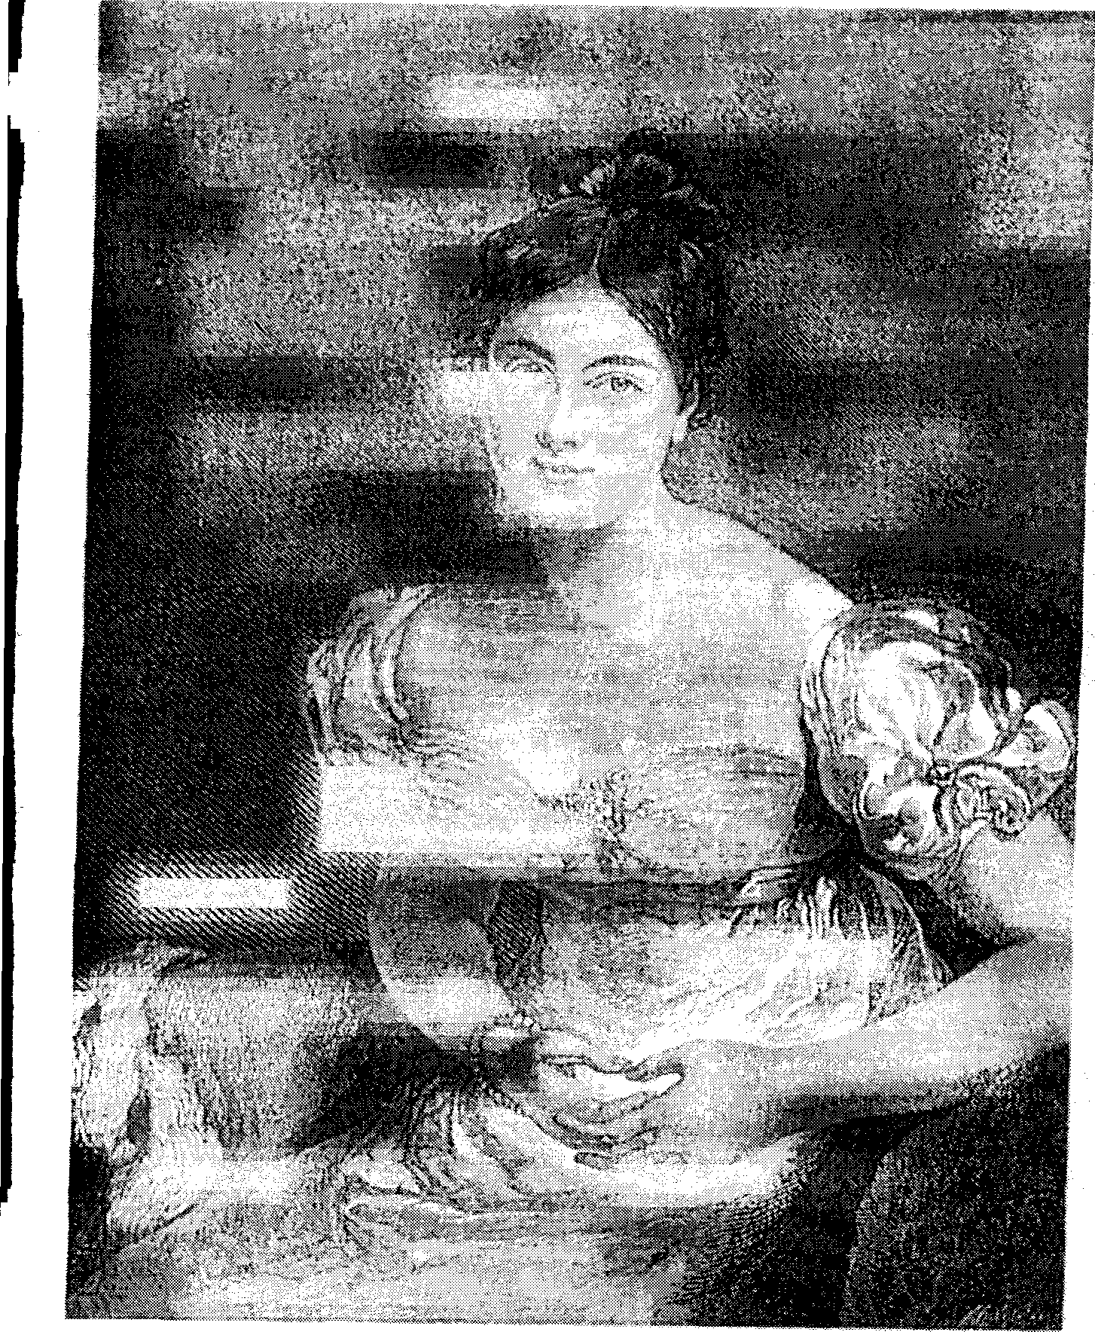
Figure 9.2. Marguerite, Countess of Blessington (1789-1849), after Sir Thomas Lawrence.

180 Visions in the Crystal
Benjamin Disraeli, the Fourth Earl Stanhope, John Varley, and many other luminaries gathered to dabble in the occult sciences. In the walled gardens was a pavilion where the exquisite Count Alfred D'Orsay lived and did his portraits, which (says Michael Sadleir)³⁷ made him just enough money to keep himself in gloves. One work of his that has survived is a fine drawing of his fellow dandy Bulwer-Lytton, done in 1837. Just as Lytton was responsible for the rule of black evening-dress for men (which caught on after his novel Pelham, 1828), so Lady Blessington started the fashion of having a centerpiece of fruit and flowers on the dining-table, instead of some silver or gilt monstrosity.
Lady Blessington was a voracious collector of every kind of object and, one might say, person. After her financial ruin and flight to France, the sale other effects by the bailiffs lasted twelve days.³⁸ Long afterwards, Bulwer-Lytton called her "his dearest friend."³⁹ Over a hundred of her letters to him survive, spanning the period from 1824 to 1849. They are intimate and consoling, and show a true friendship during the period when Lytton suffered miserably from Financial uncertainty, electoral defeat, and persecution by his estranged wife. a-^"
Soon after Lady Blessington started entertaining at Gore House,
A craze for occultism seized on the company. Headed by Bul-wer and Disraeli, they plunged into discussion and experiment. They listened entranced to Varley's stories of his extravagant friend William Blake; they debated the pros and cons of witchcraft and spiritualism; they even tried their hands at crystal-gazing with the help of a famous crystal given to their hostess by Nazim Pasha.⁴⁰ ^...-; , ; ;.
Nazim Pasha was presumably a high official of the Ottoman Empire. In 1835 he wrote to Lady Blessington in French, sending her a book on medicine and music composed by the Sultan.⁴¹ The famous crystal was a four-inch sphere of pure rock-crystal, consecrated to Michael, the archangel of the Sun.⁴² Among other notable visitors to Gore House was Louis Napoleon, Bonaparte's nephew, during his London exile in 1838-1840 and 1846-1848; he also visited Lytton at his retreat, Craven Cottage in Fulham. When Napoleon returned to France after the Revolution of 1848, his; court became a similar focus for society occultists, but he gave nothing to "poor Alfred Dorsay,"⁴³ who had nurtured such high expectations of him. Another foreign intimate of the Blessington-D'Orsay household was Prince Dwarkanath Tagore, grandfather of the poet Rabindranath, who came there in 1842.⁴⁴ He and his family were interested in Mesmerism, and all signed the petition to Lord Dalhousie to support the work of Esdaile at his Mesmeric Hospital in Calcutta.⁴⁵

Visions in the Crystal 181
The scrying of the Gore House set was not of the pious and prayerful type practised by Hockley or Morrison. While the presence ofVarley and others from the days of the Mercurii counted for something and provided the know-how, the socialites' interest was probably aroused by the lively discussion in literary magazines of the Account of the Manners and Customs of the Modern Egyptians (1836) by Edward Lane (1801-1876).
Lane's book contained a thrilling description of scrying through a boy-seer, staged by an Arab magician in Cairo. After receiving Lane and preparing talismans and incense, the magician called a boy off the street, drew the magic square of Saturn on the palm of the boy's hand, and poured a little ink into it. With the magician holding his hand (which, Lane remarks, reminds us of animal magnetism⁴⁶), the boy told of what he saw. The vision began with an apparently traditional sequence of events, including a sweeper, an army, a bull-slaughter, and a feast. Then Lane and his friends asked to see Lord Nelson, Shakespeare, and some of their friends, all of whom were described more or less satisfactorily. Nelson was missing his left arm, but that, said the magician, was because apparitions in the ink are reversed as in a mirror.⁴⁷
Several other Europeans visited the same magician shortly afterwards, including Lords Prudhoe (afterwards Duke of Northumberland), Lindsay, and Nugent, and were mostly rewarded with similar phenomena. Years later, Lane became skeptical, for he discovered that all the successful visitors to the Cairo magician had used the same interpreter: Osman Effendi, an ex-Scottish soldier converted to Islam. Lane suspected Osman of having made it all up—the visions of Shakespeare, etc.—to please his fellow Britishers.⁴⁸ This still did not explain how Lane himself, an Arabic scholar, could have been deceived.
Probably the most adequate definition of scrying is that of Theodore Besterman: "Scrying is a method of bringing into the consciousness of the scryer by means of a speculum [mirror] through one or more of his senses the content of his subconsciousness, of rendering him more susceptible to the reception of telepathically transmitted concepts, and of bringing into operation a latent and unknown faculty of perception."⁴⁹ Besterman, later a devoted Voltairean, did not come lightly to the last part of his conclusion. He found himself forced to it by the numerous cases in which something has been seen in the crystal that could have been neither in the scryer's mind, nor in that of the questioner's. The Hockley-Burton experiment is one of the most persuasive examples of this type, but the Morrison-Franklin incident shows how unreliable it is.
We come now to the third category of crystal-gazers, those motivated by scientific curiosity. The first prominent man of science to take scrying seriously was Stanhope's friend William Gregory (1803-1858), M.D.,


182 Visions in the Crystal
F.R.S.E., and Professor of Chemistry in the University of Edinburgh. With Gregory's entry onto the scene, the era of gentlemanly enthusiasm began to give way to that of dispassionate psychical research.
Gregory's fi rst interest was in animal magnetism, of which he learned in 1827 through a Dr. Coindet of Geneva, who lent him books on the subject. Being under the impression that it was a skill limited to a few individuals, Gregory did nothing about it until 1842 or 1843, when he tried to magnetize and found that he could do it himself. He could not deny the reality of the clairvoyance that sometimes occurred in magnetic sleep, but he needed a scientific basis with which to account for it. This he found in the theories of Baron von Reichenbach, proponent of the "Od" force. Gregory translated Reichenbach's weighty book from the German, and believed that this odic or odylic force, universally diffused, was the vehicle for clairvoyance and other phenomena. As a chemist, he was interested in the idea that certain substances could concentrate this energy or substance. Rock crystal was one such: Gregory guessed that it was the combination of its odylic influence with the effect of gazing that threw the subjects into a conscious magnetic state, and caused them to see visions in it. When he wrote his Letters to a Candid Inquirer, or Animal Magnetism to the Eighth Duke of Argyll in late 1849, Gregory knew of four such crystals that had the property of making children or young persons see visions: one of them was Lady Blessington's, which he says was now owned by Morrison; a second belonged to Lord Stanhope; and another was his own.
Given his chemical approach to the question, Gregory did not approve of artificial crystals, nor of the "magnetized" glasses made in England and sold at a high price to the ignorant. Generally, he says, these are no good except for females who see lovers in them. But he admits that the mere process of gazing renders one more or less lucid and may induce higher states such as exstasis.⁵⁰ A more effective substance was that of the smooth, black mirrors used in the Middle Ages, which Baron Dupotet had apparently rediscovered. These, says Gregory, were probably highly charged with odyle, and besides, the dark room, the odors of balsam and narcotics would naturally have led to visions. John Dee had one such mirror, made from jet; it had been owned by a former Duke of Argyll.⁵¹ Dupotet found that the most exciting visions arose in a mirror of charcoal. Others used water, as we have seen in the example of William Beckford (see Chapter Five); Hockley and Lord Stanhope both favored, for certain of their scryers, a spherical glass bottle of water such as Cagliostro had used. Then there was the Arab custom of using ink. Gregory's conclusion was that the whole phenomenon needed very much to be studied scientifically, just as light and electricity were being studied.

Visions in the Crystal 183
The only person known to have associated with all three of the crystal-gazing circles named above is Lord Stanhope. The Kašpar Hauser affair was now long behind him, but his interest in anomalies continued. He told William Gregory that he had experimented with three crystals, assisted by fifteen children of different ages and sex and by seven women, who had seen visions impossible to be attributed to memory, and who had no disposition to deceive.⁵² Stanhope was friends with Hockley; he visited Gore House. On 17 January 1853 he wrote to Gregory with a summary of his experiments and conclusions, which is so comprehensive and intelligent that I give it in full here.
I have deferred to write to you until I was able to communicate the conclusions which I have deduced from a careful and patient investigation, that has now been continued, with very little intermission, for many months, of the phenomena exhibited by Crystals. They are as follows.
1. A great number of persons, both Adults and Children, have seen in them Visions, some of which were of an extraordinary nature, and such as could not have been suggested by memory.
2. Those Visions differ in some instances very much from ordinary Dreams, by the length of their duration, by the vivid light and brilliant colours which are occasionally exhibited, and by the nature of the objects that are shewn.
3. Some persons, few in number, see in Crystals Figures of the human form, each of which when called by its Name exhibits always the same appearance. They are called Spirits.
Those Figures appear, at least in my Crystal, without using any particular Form, termed a "Call" or "Charge."
5. Writing in printed characters, are also seen by the same persons in Crystals as Answers to the Questions that are asked.
6. Those Answers are not the results of "Thought Reading" for they often differ from the opinions of those who ask the Questions.
7. In a few cases correct information has been obtained on events taking place at a distance, but this may have been the effect of spontaneous Clairvoyance, for Mesmerism has been carefully avoided.
8. The Visions and Writings that are exhibited cannot be explained by Mesmerism which has never been used, or by the influence of Crystals, for the same phenomena are shewn by a globular Bottle, made of thin and fine Glass, without any

184 Visions in the Crystal
defects and blemishes, filled with distilled Water. The Bottle which I use is 3 ³/•s: inches in diameter.
9. The appearance of those Visions and Writings is not to be explained by natural causes, and is therefore to be considered, in the strict sense of the term, as Supernatural.
10. No means have been yet discovered by me of ascertaining the truth or falsehood of the Answers when given.
11. No reliance can be placed on those Answers, as they have often been found to be erroneous, and even inconsistent with each other, and in some instances full of equivocation and evasion.
12. The Answers are not invented by my Seer who is a very artless, trustworthy, young woman, and who is often much struck by their incongruity, although she is quite unaccustomed to critical enquiries.
13. The Visions and Writings seen in Crystals are however important as they prove to persons who might not otherwise by. convinced the existence of a Spiritual World, though the Answers which are received may be undeserving of credit.
14. Those Visions and Writings have an objective, and not merely a subjective reality, for they are not seen except the eye is properly directed, and except the intensity of the light is accurately regulated.
15. It is very interesting to ascertain, if possible, the reasons,
a. that some persons have the faculty of seeing Visions and Writings, while most others do not.
b. that erroneous and contradictory Answers are returned, when those of a contrary nature would, in all respects, be far more suitable to the purpose.
and also to learn
c. the proper means of testing them when they appear.
d. from what beings the Answers proceed.⁵³
Stanhope sent Lytton a copy of this letter, at the same time lending him his artificial crystal and its stand, and urging him to keep them as long as he wanted. He gave Lytton the address of William Hockley, and recommended talking with him, "as he has been occupied for many years on subjects which excite your attention; but he can be seen only on Sundays, for he is engaged every week day in the City."⁵⁴
Stanhope also offered to lend his seer, Susan Cook, suggesting that she could stay in the London house of Stanhope's son, Lord Mahon, while working with Lytton. Apparently Hockley's "Crowned Angel" was among

Visions in the Crystal 185
the twenty or so spirits that spoke to Susan and displayed writings to her in the crystal. The peculiarity of the Crowned Angel's writing was that each letter was composed of blue and white dots with a red border.⁵⁵ Stanhope also urged Lytton to come and visit him at Chevening, promising to meet him whether he came by road or rail.
Lytton and Stanhope were both engaged in serious researches into crystal vision during the early 1850s, but that was only one wing of their activity. Another concerned the "modern spiritualism" of table-turning and raps, recently brought from America by Mrs. Hayden and witnessed by them both. This will be treated in Chapter Ten. The great question arising from both types of phenomenon, and also from the lucid visions of animal magnetism, was whether the communicating entities were truly what most of them claimed to be: the spirits of dead men and women.
Another very busy and well-connected occultist, Kenneth R. H. Mackenzie (1833-1886), was also researching into crystallomancy in the early 1850s. His conclusions are a little different from Stanhope's, but equally skeptical as to the communications from the dead. He gave them early in 1878, in a paper on "Visions in Mirrors and Crystals" to the British National Association of Spiritualists,⁵⁶ a group of serious and educated spiritualists whose activities more resembled psychical research than seances. Mackenzie told them that he had taken up crystal-gazing mainly because he was unable to attain clairvoyance in the normal waking condition, and thought trance clairvoyance undesirable. The crystallomancer, he went on, discovers a new and peculiar world with its own laws and order. These were the same in John Dee's time, in the time of William III,⁵⁷ and today in the reign of Victoria. The spirits do not pretend to be the highest authority. They are bound by "harmonic laws" and respectful of the Creator, and apparently live active and educative lives.
Mackenzie started his work with the crystal in 1851, after meeting a gentleman in a bookbinder's shop who took him to his home and showed him this new world of beauty. The seeress was a lady of about nineteen, of "average education," who looked into a silvered mirror; a few words spoken emphatically and sincerely were the only charm employed. The sessions lasted for two hours, during which different spirits would come and go. Mackenzie prepared questions, and collected over five thousand answers from her. But, like his instructor, he himself was unable to see anything.
Mackenzie's instructor was almost certainly Frederick Hockley. The younger man writes of "his friend's" vision of Captain Burton, afterwards confirmed; of his instructor's "several essays" dictated through crystals and mirrors, of remarkable philosophical interest but not infallible. Once, Mackenzie said, he went with a server to look in John Dee's crystal in the British Museum, and she saw the city of Prague! His years of unbiased

186 Visions in the Crystal
research led him to a definite idea of the spirit world and its inhabitants who, he insisted, were not the same as the "subhumans" or elementaries of the occultists.⁵⁸
Earth, Mackenzie explains, is surrounded by several luminous spheres that are interpermeable, with several conditions of spirit life. The lowest level is "unpurified" and bound to matter. Next come the elementary powers of nature, which are only half human. Then comes a luminous earth in which, like a mirror, a universal record of everything is preserved; it is there that our spirit-doubles go when they act on us in dreams, and thence that predictions come. Outside this sphere are the higher spirits, whom we can contact only when in a superior condition of being and able to pass what Lytton calls the Dweller of the Threshold, free from superstitious dread. These purified spirits are in general ignorant of us and our needs, but some of them work for us by warning, never preventing. They set no importance on creeds, knowing that in our future life errors will be corrected, and that "the universe, being infinite in expansion, allows space, or rather states in which all opinions may be held."⁵⁹ The spirits have no tolerance for sin, but they say that there is no eternal punishment. Mackenzie fears that his audience may think him too credulous, but tells them that he is simply reporting what he has heard, being unwilling to deny something just because it is inexplicable in the present state of knowledge.
A long book might be written about nineteenth-century crystallo-mancy. This chapter has concentrated on its role in the lives and thought of people active in the fields treated in other chapters. Crystal working clearly played a great part in their researches, providing them with a gateway to another world (in whatever sense), whether directly or through the use of a medium. It connected with animal magnetism and with the revelations of somnambulists, the main difference being in the apparatus or procedure used to induce clairvoyance. Sometimes the scryer was magnetized as a preliminary; in France, hashish was often used. When used with rituals and with the intention of communing with angels, scrying formed a branch of ceremonial magic in theJudeo-Christian tradition. It stimulated the scientific imagination, at a time when some "natural philosophers" were not quite ready to exclude incomprehensible phenomena from consideration. Lastly, to some experimenters it seemed to offer a channel of communication with the dead, hence a promise of their own survival.

