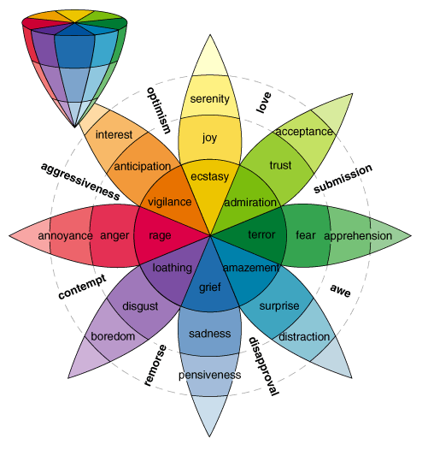

Plutchik's (1980) psychoevolutionary theory of basic emotions has ten postulates.
- The concept of emotion is applicable to all evolutionary levels and applies to animals as well as to humans.
- Emotions have an evolutionary history and have evolved various forms of expression in different species.
- Emotions served an adaptive role in helping organisms deal with key survival issues posed by the environment.
- Despite different forms of expression of emotions in different species, there are certain common elements, or prototype patterns, that can be identified.
- There is a small number of basic, primary, or prototype emotions.
- All other emotions are mixed or derivative states; that is, they occur as combinations, mixtures, or compounds of the primary emotions.
- Primary emotions are hypothethical constructs or idealized states whose properties and characteristics can only be inferred from various kinds of evidence.
- Primary emotions can be conceptualized in terms of pairs of polar opposites.
- All emotions vary in their degree of similarity to one another.
- Each emotion can exist in varying degrees of intensity or levels of arousal.

 | Basic Emotions | Basis for Inclusion
Plutchik | Acceptance, anger, anticipation, disgust, joy, fear, sadness, surprise | Relation to adaptive biological processes
Arnold | Anger, aversion, courage, dejection, desire, despair, fear, hate, hope, love, sadness | Relation to action tendencies
Ekman, Friesen, and Ellsworth | Anger, disgust, fear, joy, sadness, surprise | Universal facial expressions
Frijda | Desire, happiness, interest, surprise, wonder, sorrow | Forms of action readiness
Gray | Rage and terror, anxiety, joy | Hardwired
Izard | Anger, contempt, disgust, distress, fear, guilt, interest, joy, shame, surprise | Hardwired
James | Fear, grief, love, rage | Bodily involvement
McDougall | Anger, disgust, elation, fear, subjection, tender-emotion, wonder | Relation to instincts
Mowrer | Pain, pleasure | Unlearned emotional states
Oatley and Johnson-Laird | Anger, disgust, anxiety, happiness, sadness | Do not require propositional content
Panksepp | Expectancy, fear, rage, panic | Hardwired
Tomkins | Anger, interest, contempt, disgust, distress, fear, joy, shame, surprise | Density of neural firing
Watson | Fear, love, rage | Hardwired
Weiner and Graham | Happiness, sadness | Attribution independent
 | Basic Emotions | Basis for Inclusion
(This table is taken from Ortony and Turner, 1990.)

References
Ortony, A., & Turner, T. J. (1990). What's basic about basic emotions? Psychological Review, 97, 315-331.
Plutchik, R. (1980). A general psychoevolutionary theory of emotion. In R. Plutchik & H. Kellerman (Eds.), Emotion: Theory, research, and experience: Vol. 1. Theories of emotion (pp. 3-33). New York: Academic.

