FILM DVD ve ŠPANĚLŠTINĚ
« YOYES»
a fictionalized reconstruction of the life of Dolores González Catarain ("Yoyes"), a woman member of ETA, who was targeted by that organization upon her return to the Basque Country.
Režie: Helena Taberna
Délka: 104 min.
Žánr: Politická Drama
Baskicko. 2000
Místo: G24, FFMU
Čas: 19:10
Datum: 2011/03/28
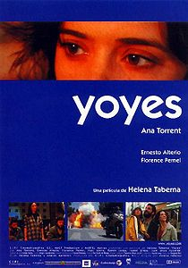

In the early 1970s, during the last years of Franco's dictatorship, ETA was group of Basque terrorists staging political actions in Spain under the leadership of Argi. Yoyes, a young independent woman, joins ETA in Ordizia, a small town in the Basque Country. She quickly plays an important role in ETA organization. Yoyes meets Joxean, a philosophy student and they start a relationship.

Eventually, Yoyes finds herself losing faith in the ETA's cause. Once the band began to murder civilians, she decides to leave after Argi dies during a bombing. Dropping out of terrorism, Yoyes goes underground, and moves to Mexico, where she goes back to college and receives a Ph.D.
A dozen years later, Yoyes is in Paris where her husband Joxean gets a teaching position with a French University. When Joxean decides to visit the Basque regions with their small daughter Zuriñe, Yoyes decides to join them, knowing it puts her at great personal risk.
When a newspaper prominently publishes the news of Yoyes’s return, her former ETA colleagues mistakenly believe that her presence there means that she has turned informant in exchange for permission to return home. Yoyes has tried to forget the past and be forgotten, wanting just to blend back into society. In autumn, her former comrades have condemned Yoyes to death. While in a local fair in Ordizia, Yoyes is shot in the head in front of her little daughter.

