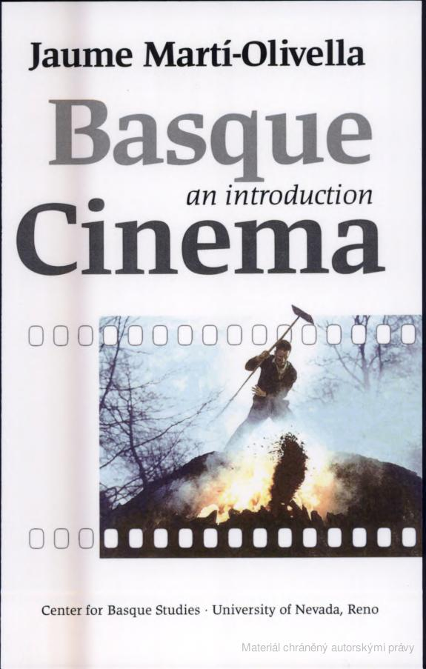   | « Souhrn  Výsledky hledání pro dotaz „basque cinema“  Strana 1  BASQUE CINEMA Jaume Marti-Olivella has two Licenciaturas from the Universitat Central de Barcelona, one in English Philology and the second in Catalan ...  Strana 3  Jaume Marti-Olivella Basque Cinema An Introduction Basque Textbooks Series Center for Basque Studies University of Nevada, ...  Strana 7  (Sommer, 42-47) In my own reading of Sommer's formulation and its possible application to the "foundational fictions" of Basque cinema, I substitute Eros ...  Strana 9  (Olea in Aldarondo, 76) I OPEN THIS introduction to Basque cinema with a film that not only is a historical allegory but clearly establishes symbolic ...  Strana 11  ... Unai (Patxi Bisquert) being taken into the inquisitional tribunal in Olea's Akelarre, one of the "foundational fictions" of Basque cinema. ...  Strana 18  (Amigo in Roldan, 2o4) To conclude my introduction, I would like to call attention to yet another central tenet of Basque cinema (commercially) inaugurated ...  Strana 20  Akelarre and the national allegories of Basque cinema's historical recreations. 4. Pedro Olea's (problematic) position within Basque cinema and its / his ...  Strana 23  First large-scale epic film sponsored by the Basque Government (Production cost: approximately $1oo dollars). 2. The Conquest of Albania in the context of ...  Strana 24  Alfonso Ungria's film and the creation of a star system and narrative casting in Basque cinema: Xabier Elorriaga : Escape from Segovia ( 1981 ), Mikel's ...  Strana 30  (Basque cinema in the eighties offers one of the most visible manifestations of the narrative change of the concept of "nation," a change, on the other hand ...  Strana 52  But the two films present opposing views of the rural world and the Basque Country. Basque cinema itself follows a thoroughly paradoxical tradition whose ...  Strana 53  ... yet their films are the clearest and most successful representations of that world in Basque cinema, proving once again its paradoxical nature. ...  Strana 56  ... such as Carlos Saura or Victor Erice, in order to create the most attractive new Basque cinema for export to national and international markets. ...  Strana 69  In fact, one might say that Uribe and his cinema constitute a perfect case study of the problematic of the migrant subject within Basque cinema. ...  Strana 70  ... Uribe has become an example of yet another paradox in Basque cinema: the outsider / insider trying to "engender / imagine" ETA and / in Basque politics. ...  Strana 75  (Despite questioning patriarchy's power and value system, the Basque cinema of the eighties does not dare to present a model of a new (wo)man more in tune ...  Strana 82  Marti-Olivella, Jaume: "Invisible Otherness: From Migrant Subjects to the Subject of Immigration in Basque Cinema." In William A. Douglass, Carmelo Urza, ...  Strana 91  5 • The female gaze and / in Basque cinema THE CENTRAL topic of this part of our course is the appearance of a "female gaze" in Basque cinema. ...  Strana 96  In doing so, they do succed in constructing a "female gaze" in Basque cinema. ...  Strana 105  Basque cinema has been analyzed mostly as a migrant subject from within and without. Its international projection in the current globalized cultural ...  Strana 109  This metonymic, almost rhizomatic way of social and cultural production promotes a split id / entity. Trigo, 8-9) BASQUE CINEMA marks the persistence of the ...  Strana 110  My claim in what follows is that the logic of the uncanny affects most areas of Basque cinema's visibility: from its economic organization to the specific ...  Strana 116  IT is, HOWEVER, in his original figuration of the spectral presence of ghostly enemies, the most recurrent of elements in Basque cinema, that The Day of the ...  Strana 117  With this film, moreover, Basque cinema enlists itself in a historical Spanish gesture that I have described elsewhere: "With the introduction of the ...  Strana 125  Basque cinema's first transatlantic (migrant) production. Spanish-Basque-Cuban co-production with the participation of Senel Paz, one of Cuba's best known ...  Strana 128  Basque cinema faces the representational risk of confronting the historical "contextual disorder" of its society. Cine-camera image from Photodisk, ...  Strana 129  One of the clearest and most successful illustrations of Basque cinema's double migrancy (Spain and Hollywood) and its local / global interface. 3. ...  Strana 130  Another recurrent element in Basque cinema is the spectral presence of the enemy at home. How does de la Iglesia play with that spectrality in his Satanic ...  Strana 150  Basque Language, Society, and Culture 7. Basque Cinema: An Introduction 8. Basque Diaspora Studies 9. Basque Gender Studies ...  Strana  Basque Cinema This is the first comprehensive textbook in English for the study of Basque film. It provides an introductory course that is structured ...

