**Pie Chart**

Here's a brief overview created by Randy Johnson of what percentage of different groups compose the whole of the Gothic population. The percentages are intended to give you a general idea, there are not any researched numbers behind it. It is not meant to be statistically accurate.

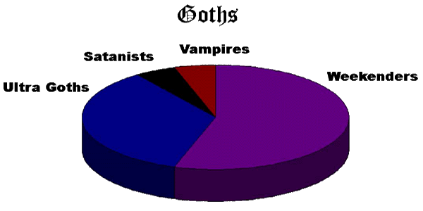

[Weekenders](http://www.gothicsubculture.com/definition.php#weekender) are the kids who are just going through a phase, following a trend, or doing it to be cool. They are the ones who like to dress up gothic on weekends and go out to the clubs, but are only familiar with the most superficial aspects of the culture. They are essentially the wannabes, and they eventually move on to something else.

[Ultra Goths](http://www.gothicsubculture.com/definition.php#ultra-goth) describes the more stable portion of the community. They have been in the scene for a long time. Usually, they are more extreme in appearance than others. There are [other definitions](http://www.gothicsubculture.com/definition.php#ultra-goth) for Ultra Goths. In its use here, it is meant to designate those people for whom gothic is who they are, not what they dress up as.

[Satanists](http://www.gothicsubculture.com/occult-satanist.php) includes some [Theatrical and Experimental Satanists](http://www.gothicsubculture.com/occult-satanist.php#theatrical-satanist) and some [Proclaimed Satanists](http://www.gothicsubculture.com/occult-satanist.php#proclaim-satanist). This is a very small percentage of Goths. Satanists can be found in almost any random group of people. They are not exclusively Goths.

[Vampires](http://www.gothicsubculture.com/vampire.php) also comprise a very small percentage of Goths. These are the people who are excessively fixated on vampires and want to look like a vampire and/or drink blood. There are many people who have an interest in vampires, but in this category we specifically mean those who are a little too enthusiastic.

