# The Importance of Subcultural Identity

**Introduction**

While currently studying a BA (Hons) degree in Music Management & Artist Development, i've been fascinated with some of the topics we've covered, especially subcultural analysis, trends and how these affect the interaction between the artist and the audience. Understanding subcultures helps to understand consumer behaviour, as well as the behaviour and ideology of your potential fans.  
  
For one of my assignments, we had a choice of questions to answer on a range of subcultural theory. I chose to discuss Subcultural Identity as, while it has always been important, there is a question to be answered as to whether subcultural theory is applicable in the present day as we no longer have such defined subcultural groups (see: Mods, Rockers, Punks, Hippies, etc), more a meld of past subcultural identities.  
  
For anyone who finds this piece interesting, please let me know by way of a comment below or an email.   
For anyone who uses this within an academic piece of work, please use the following reference within your bibliography and email me so I can read your work (this stuff fascinates me!):

*Winter, S (2014). 'The Importance of Subcultural Identity'.*

*Available: www.sunnystuartwinter.com. Last accessed: 2nd March 2015*

Subcultural identity allows identification of an individual into a particular social group within society; semiotically, behaviorally & ideologically. It “gives alternative interpretations and values to young people’s subordinate status; it reinterprets the social world” (Thornton, 1995, in, Gelder & Thornton, 1997: p.208).   
[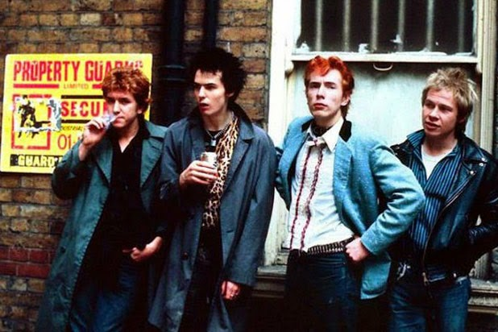](http://2.bp.blogspot.com/-neSfMnMiknw/U2jkz2th2YI/AAAAAAAAAzo/Rcxz-hwxcE8/s1600/punks.jpg)

The significance of a person’s clothing, behaviour or belief system is incredibly important when belonging to a particular group. “Every object may be viewed.. as a sign” (Eco, 1973 in, Hebdige, D, 1979: p.101). Whether it is someone wearing a denim jacket adorned with patches of their favourite punk bands or young adults in modified cars, playing drum and bass music; there are signifiers that give an idea of which subcultural group these people align themselves with, but are signifiers this clear in society today?  
  
Hebdige writes that “the communication of a significant difference… is the ‘point’ behind the style of all spectacular subcultures” (1979: p.102), that style is an intentional communicator. This also relates to Umberto Eco’s quote “I speak through my clothes” (Hebdige, 1979: p.100) in so far as to say that wearing a particular band t-shirt, for example, communicates that you ‘belong’ within a certain subcultural group, which has it’s own behaviours and beliefs.

[](http://1.bp.blogspot.com/-0ATQ946N1Sk/U2jlm2ri3iI/AAAAAAAAAzw/OZ4vxfSpteA/s1600/punks2.jpg)

However, in modern day subcultures, it could be argued that there are now overlaps between subcultural signifiers, be it stylistically or behaviorally. “Many accounts of post-war youth subcultures have also overlooked the dynamic quality to their styles” (Muggleton, 2000: p.49) and “are discussed as though they are immutably fixed phenomena” (Muggleton, 2000: p.50). Taking the previous example in the present day, it would not seem unusual for someone who identifies themselves as ‘punk’ to modify their car and play music; albeit punk music, not drum and bass music.   
  
Under past subcultural theory, this could question the authenticity of the punk within their subculture, but now within the post-subcultural realm, this act of mixing subcultures is becoming normal. In Polhemus’ “Style Surfing” he argues that the rules are there to be broken, “mixing sportswear with workwear, the old and the new, crossing traditional gender divides” (Polhemus, 1996) and more.  
[](http://2.bp.blogspot.com/-FdvW0WKRdIw/U2jmWI-kprI/AAAAAAAAAz4/0klWzDkSx1s/s1600/Hipster05.jpg)

Hipsters are a contemporary youth culture, typically aligned with the ‘underground’, who seek to “diverge from the mainstream and carve a cultural niche all for themselves” by means of their ‘unique’, vintage style and anti-mainstream ideology. (Granfield, 2011).  
  
Stylistically, hipsters adopt the styles of other cultures that they do not belong to, going against the mainstream, often into niche areas. Weinzierl (2001) in Muggleton & Weinzierl (2003: 170) describes this kind of subcultural hybridity as a ‘hybrid mainstream formation, which can hardly be demarcated from subcultural scenes’. Hipsters are known to fetishise and appropriate multiple aspects of multiple subcultures.   
  
Hipsters are apparent within multiple genres of music, regardless of whether it is heavy metal or indie, and constantly move between them. Under Evans’ theoretical discussions, subcultures “have in common the production of “fixed” identities, and this “knowledge” about sub-cultural identities merely targets them as something co-optable”. (Evans, 1997: p.180) This may have been relevant within the 1980’s rave scene of which she writes, but is not as fitting in the modern day, post-subcultural world where fluidity of identities are commonplace.

This could be a valuable example of Tribus, the ‘post-traditional’ concept by Michel Maffesoli, who identifies that “consumption patterns and practices enable individuals to create new forms of contemporary sociality” (Muggleton & Weinzierl, 2003: p.12); multiple identities, fluid involvements, rather than letting class, gender or religion dictate identity. This also means there is the ability for post-subcultures to take on new meanings, change and evolve due to their “dynamic quality” (Muggleton, 2000: p.49 )   
  
The main difference however, between hipsters and many other subcultures, is that hipsters do not readily identify themselves as hipsters. This is largely due to the negative connotations associated with being a hipster; the arrogance, the unwillingness to be associated with anything mainstream and their nihilistic attitude.   
  
As mentioned, tribus is a concept developed by Maffesoli, where a group identity is “no longer formed along traditional structural determinants like class, gender or religion” (Maffesoli, 1996, cited in Muggleton & Weinzierl, 2003: p.12) and where the single members of a group “do not foster their community as a priority but use the group to satisfy their individual needs” (Maffesoli, 1996, cited in Muggleton & Weinzierl, 2003: p.12). This is becoming more appropriate for modern youth cultures. With regards to Hipsters, it can be argued that there is no true group identity, as the individuals do not regard themselves as hipsters, let alone a subcultural group.   
  
The end of group mentality means hipsters, like those within other subcultures, can appropriate multiple other ‘tribes’, moving freely between them, encouraging “plural, fluid and part-time rather than fixed, discrete and encompassing group identities” (Maffesoli, 1996, cited in Muggleton & Weinzierl, 2003: p.12). Maffesoli goes on further to say that “social existence is conducted through fragmented tribes of humanity”. (Maffesoli, 1996, cited in Evans, 1997: p.171)

[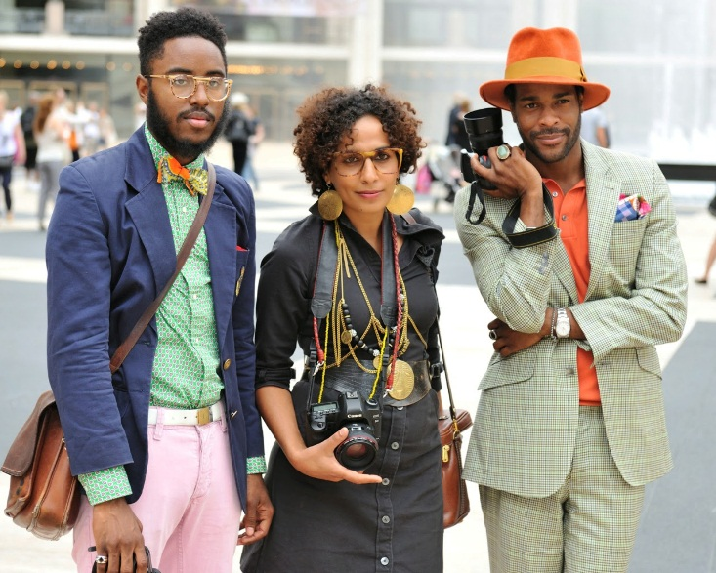](http://2.bp.blogspot.com/-QsWK9yHDYUg/U2jsHM8mH9I/AAAAAAAAA0Q/aM8N-Y4JJ8o/s1600/Hipster08.jpg)

This, again, would follow the post-subcultural theory that has more relevance in modern day cultures, rather than that of subcultural theory such as Evans’. As an extreme example, it just would not happen that a mod in the 1960’s was also a part of the rocker subculture at the same time; they had one identity, not multiple, so they could not exist within both subcultures. “We no longer resist through rituals but that we use these rituals to huddle round the fire in search of some form of social cohesion” (Evans, 1997: p.172).   
  
Whilst the use of safety pins and do-it-yourself clothing was to originally serve a function, to make a statement to revolt or of intent and then appropriated into the punk subculture, the style of clothes chosen by hipsters can not be deemed ”style in revolt” (Hebdige, 1979: 106), but more style as pastiche of past subcultures; satirically collaging, and re-appropriating former and current culture. Subcultures no longer have clear uniforms of style.  
  
Taste, one of the most vital aspects of identification within a subcultural group, is inherently linked with tribus and is a complex theory that can include the things you like, do not like, ‘should’ like but do not, guilty pleasures and more. The advent of the Internet has allowed people to access a wide array of culture, compared to the more limited resources of say, punks in the 1970’s; not to mention the speed of change within cultures.   
  
Whilst Evans’ subcultural identity is a functioning theory of subcultures, certainly in the twentieth century, twenty-first century post-subcultures have become unstable and fluid, no longer defined by factors such as class, allowing individuals to harness ‘multiple identifications’ resulting in them being harder to define, with Shields describing them as “the multiple masks of a postmodern “persona” who “wears many hats” in different groups and surroundings” (1992: p.16).   
  
With such a huge supply of culture and potential “subcultural capital” (Thornton, 1995: p.203), it is no surprise that self-identity is becoming harder to resolve. If we are born into a particular sociological, economical and cultural class as Louis Althusser suggests, but do not accept it or seek subcultural groups to align ourselves with, there is such an abundance of expansive choice and regular change that it is not surprisingly that we will carry these multiple identities, as discussed by Shields and Maffesoli.

[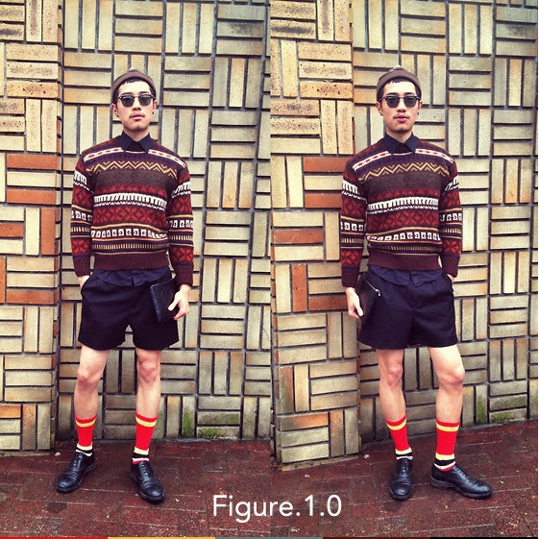](http://2.bp.blogspot.com/-7s8Y0zOxZas/U2jitAu79kI/AAAAAAAAAzE/clRDPTn2mOI/s1600/Hipster01.jpg)

The speed of change can also be seen in the “Shoreditchification” (Proud, 2014) of areas of London, like Shoreditch or Dalston, where young professionals were involved in the gentrification of houses in deteriorated urban neighbourhoods, seeking new communities to identify with, only for mainstream media to catch up, property prices to soar and the young professionals to move onto their next neighbourhood. This could be an example of “the fractured order” being “repaired” with the “conversion of subcultural signs” into the commodity form (Hebdige, 1979: p.94).   
  
Concepts of ‘consumer lifestyles’ suits the post-subcultural terrain more than Evans’ could in modern life. The idea raises the importance of consumerism in the identities of modern youth. Whilst Miles states that race, gender and upbringing are still important, he argues that young people “construct lifestyles that are as adaptable and as flexible as the world around them” (2000: p159).  
  
Identity could also be linked to performativity; the theory that identity is not natural or fixed but is rather something one acts and is fundamentally unstable. Barker says that “Subcultures do not exist as authentic objects but have been brought into being by subculture theorists” (Barker, 2000, p.322).   
  
In a post-subcultural terrain, where subcultural borders are blurred, it is becoming increasingly difficult to know if there is such a thing as the “real” you.

[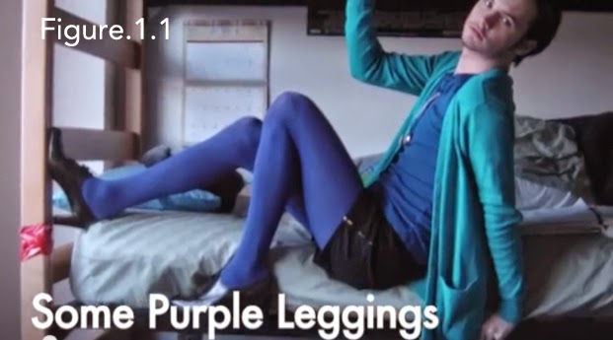](http://3.bp.blogspot.com/-JLRnXuyoo2c/U2jixbod3_I/AAAAAAAAAzM/tm0g1KYaIVQ/s1600/Hipster02.jpg)

Subcultural capital makes up an identity. Discussed by Pierre Bourdieu and expanded on by Sarah Thornton, it describes how a person’s taste is guided by the influence of their parents; that the social, economical and cultural position of the parents will guide their offspring’s identity and cultural taste. The result is a symbolic currency of subcultural capital that provides a status within both group and society. “Subcultural capital confers status on its owner in the eyes of the relevant beholder” (Cova, Kozinets & Shankar, 2007).   
  
The idea that “we are always already subjects” (Athusser, L QUOTE) by way of the life and upbringing we have been born into, can be illustrated in that a child, born of upper class parents, is probably more likely to take an interest in opera or horse racing than a child, born of lower class descent, who instead is more likely to be interested in hip hop music or skateboarding for example.  
  
With hipsters, the premise of subcultural capital is an interesting point. Their relationship with music, for example, changes if a band were to become exceptionally popular or “mainstream”. Whilst they may have followed a band whilst they were relatively unknown, they often disregard their fandom toward that band when they are appropriated into the mainstream.   
  
This ties in with Thornton’s study within the rave scene where the exclusivity in the subcultural capital of music is valuable and “must be prevented from being continually coveted and appropriated by the ‘mass’” (Thornton, 1995, in, Muggleton & Weinzierl, p.9)   
  
The PBS idea channel further discusses hipster behaviour, this time in opposition with geek behaviour, saying that “both groups are defined not only by what they enjoy… but also how they enjoy it” (PBS, 2013). Geeks are more likely to be honest about their fandom towards a book or game or type of music, whilst hipsters are known for ‘playing it cool about how much they like something’ (PBS, 2013).

[](http://2.bp.blogspot.com/-fHGKAJRlHFY/U2ji2AI0fJI/AAAAAAAAAzU/MRr6wgfB7eI/s1600/Hipster03.jpg)

This behaviour of “playing it cool” or renouncing a type of music due to it’s popularity by the masses exemplifies the changes in subcultural behaviour and ideology from the era in which Evans writes, to the present day of postmodernism.   
  
Subcultural capital can be gained by the things you own or the hairstyles you have. However, when the whole ‘point’ of hipsters is that they do not supposedly follow trends, be they societal or subcultural, and they seek to be unique, it is clear that subcultural identity and the multiple identities of tribus, is complex.   
  
It could be said that our culture ‘speaks’ to us in a white, middle class, heterosexual ‘voice’ and anything outside of that is deemed as “otherness”. The “other” can be “trivialized, naturalized, domesticated” where difference is denied, or as a “pure object, a spectacle, a clown’ (Barthes 1972, in Hebdige D, 1979, in Gelder & Thornton, 1997). Subcultures, certainly the hipster subculture, are eagerly appropriating “other” or past cultures, to try to appear different and stand out from the crowd.

The list of subcultural ephemera associated to hipsters is vast. Low V-neck tops, handlebar moustaches, vintage glasses despite having twenty-twenty vision, fashion that can include clashing colours or vintage wear (Figure 1.0), loafers without socks, topknot hairstyles, bow ties and at times, outfits that serve to blur the boundaries of sexuality whereby, males for example, will wear items of clothing mostly associated with women, such as tights. (Figure 1.1)   
  
Other subcultural ephemera includes riding a ‘fixie’ bike, veganism, their association with coffee houses such as Starbucks and the elaborate coffee concoctions chosen, all to promote their ‘uniqueness’ or ‘otherness’. (Figure 1.2)  
  
However, looking at this with regards to Strinati’s postmodernism, it could be said that hipsters ‘perform’ cool for the sake of cool as we “consume images and signs precisely because they are images and signs, and disregard questions of utility and value” (Strinati, 1995: p.225). Also, “consumption is increasingly bound up with popular culture because popular culture increasingly determines consumption” (Strinati, 1995: p.224).   
  
This postmodernist approach ties in with post-subcultural theory and how hipsters, “in their quest to be different, have wound up virtually identical” (Proud, 2014), and are very much a part of the mainstream consumer culture they have tried so hard to oppose.

Grief describes it as a “thwarted tradition of youth subcultures… which had tried to remain independent of consumer culture, alternative to it, and been integrated, humiliated, and destroyed” (Grief, 2010: p.6).

[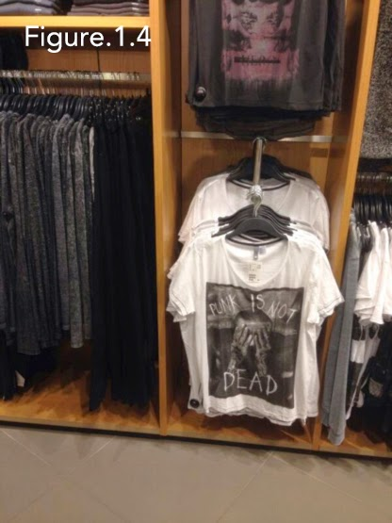](http://1.bp.blogspot.com/-gSCY2adAVWs/U2ji6TvWXRI/AAAAAAAAAzc/dzsnd13RpJY/s1600/Hipster04.jpg)

Perhaps this could be illustrated in the commodification of punk clothing in high street shops (Figure 1.3). Where once the torn jeans and tatty tops with emblazoned slogans held some cultural significance as a form of resistance, now they have merely been appropriated for consumption within consumerism. “The punks wore clothes which were the sartorial equivalent of swear words, and they swore as they dressed” (Hebdige, 1979: p.114), now this type of clothing is sold as mainstream fashion in mainstream shops.   
  
Whilst structural identification has previously been linked to deviant behaviour by Stanley Cohen, with “the focus… on how society labels rule-breakers as belonging to certain deviant groups” (Cohen, 1987: p.12), it could be questioned as to whether this model applies to all modern day, post-subcultural subcultures, when the boundaries have been blurred and multiple identities are the norm.   
  
Evans’ idea of “subcultural identity” being “theatrical” is not as obvious as it once was. The difference in the post-subcultural present day is that due to multiple identities, there are now also multiple displays, multiple shows and multiple facades to contend with.  
  
Whilst punks may have been the first subcultural group to use bricolage, mixing the old with the new to create a new language or dress code, it has rapidly become typical in modern day post-subcultures where self-identity is desperately sought.  
  
The break up of mass culture and melding of classes, where everyone could possibly now be deemed ‘middle class’, has left fewer groups to be ‘at variance with’, leaving subcultures ever complex.   
  
In closing, if “popular cultural signs and media images are taking over in defining our sense of reality for us” (Strinati, 1995: p225), and ‘style over substance’ continues to dominate, it is likely we will see a further, future departure away from Evans’ subcultural identity theory into a further blurring of subcultural lines.

**Bibliography**  
  
Barker, Chris. (2000): Cultural Studies: Theory and Practice. London: Sage p. 318-348.  
  
Bennett, A. (1999). Subcultures or neo-tribes?. Rethinking the relationship between youth, style and musical taste. 33 (3), 599-617.  
  
Cohen, S (1987). Folk devils and moral panics: the creation of the Mods and Rockers. London: Blackwell.   
  
Cova, B, Kozinets, R & Shankar, A (2007). Consumer Tribes. London: Routledge. p.96.  
  
Dangoor, R. (2010). Being A Dickhead’s Cool. Available: https://www.youtube.com/watch?v=lVmmYMwFj1I. Last accessed 20th March 2014.  
  
Evans, C (1997). Fashion Theory, Volume 1. 1st ed. Oxford: Berg.  
  
Gelder, K & Thornton, S (1997). The Subcultures Reader. London: Routledge. pages.   
  
Granfield, M (2011). HipsterMattic. New South Wales: Allen & Unwin. Accessed online at: http://www.theaustralian.com.au/arts/books/retro-types-in-pursuit-of-the-vacuous/story-e6frg8nf-1226203929858. Web. Last accessed 18th March 2014  
  
Grief, M (2010). What Was the Hipster?: A Sociological Investigation. London: HarperCollins.   
  
Hebdige, D (1979). Subcultures: The Meaning of Style. London: Methuen & Co. Ltd.  
  
Hesmondhalgh, D. (2006). Bourdieu, the media and cultural production. The Open University. 28 (2), 211-229.  
  
Hujic, Lida, 2006. ‘My name is Lida and I am a Hoxtonite’. The Guardian [online] Available at: http://www.guardian.co.uk/lifeandstyle/2006/mar/31/fashion [Accessed 19 Mar 2014]  
  
Kinzey, J (2012). The Sacred and the Profane. London: Zero Books.  
  
Miles, S (2000). Youth lifestyles in a changing world. Maidenhead: Open University Press.  
  
Muggleton, D (2000). Inside Subculture: The Postmodern Meaning of Style. 1st ed. New York: Berg. p.49-50.  
  
Muggleton, D &, Weinzierl, R (2003). Post-Subcultures Reader. Oxford: Berg.  
  
PBS Idea Channel. (2013). 'Are You A Hipster?'. Available: https://www.youtube.com/watch?v=f3xe-Wxio1o. Last accessed 20th March 2014.  
  
Polhemus, T (1996). Style Surfing: What To Wear in the 3rd Millennium. London: Thames & Hudson. Extract accessed online at: http://www.tedpolhemus.com/main_concept5%20467.html. Last accessed 18th March 2014.  
  
Proud, A. (2014). Why this 'Shoreditchification' of London must stop. Available: http://www.telegraph.co.uk/men/thinking-man/10561607/Why-this-Shoreditchification-of-London-must-stop.html. Last accessed 19th March 2014.  
  
Rayner, A. (2010). Why do people hate hipsters?. Available: http://www.theguardian.com/lifeandstyle/2010/oct/14/hate-hipsters-blogs. Last accessed 19th March 2014.  
  
Shields, R (1992). ‘Spaces for the subject of consumption’, in R. Shields (ed.), ‘Lifestyle Shopping’, London: Routledge.  
  
Strinati, D (1995). ‘An Introduction to Theories of Popular Culture’. London: Routledge. 225.   
  
Thornton, S (1995). Club Cultures: music, media and subcultural capital. Cambridge: Polity Press. p.98-105.

is such an abundance of expansive choice and regular change that it is not surprisingly that we will carry these multiple identities, as discussed by Shields and Maffesoli.

# <http://2.bp.blogspot.com/-7s8Y0zOxZas/U2jitAu79kI/AAAAAAAAAzE/clRDPTn2mOI/s1600/Hipster01.jpg> The Importance of Subcultural Identity

**Introduction**

While currently studying a BA (Hons) degree in Music Management & Artist Development, i've been fascinated with some of the topics we've covered, especially subcultural analysis, trends and how these affect the interaction between the artist and the audience. Understanding subcultures helps to understand consumer behaviour, as well as the behaviour and ideology of your potential fans.  
  
For one of my assignments, we had a choice of questions to answer on a range of subcultural theory. I chose to discuss Subcultural Identity as, while it has always been important, there is a question to be answered as to whether subcultural theory is applicable in the present day as we no longer have such defined subcultural groups (see: Mods, Rockers, Punks, Hippies, etc), more a meld of past subcultural identities.  
  
For anyone who finds this piece interesting, please let me know by way of a comment below or an email.   
For anyone who uses this within an academic piece of work, please use the following reference within your bibliography and email me so I can read your work (this stuff fascinates me!):

*Winter, S (2014). 'The Importance of Subcultural Identity'.*

*Available: www.sunnystuartwinter.com. Last accessed: 2nd March 2015*

Subcultural identity allows identification of an individual into a particular social group within society; semiotically, behaviorally & ideologically. It “gives alternative interpretations and values to young people’s subordinate status; it reinterprets the social world” (Thornton, 1995, in, Gelder & Thornton, 1997: p.208).   
[](http://2.bp.blogspot.com/-neSfMnMiknw/U2jkz2th2YI/AAAAAAAAAzo/Rcxz-hwxcE8/s1600/punks.jpg)

The significance of a person’s clothing, behaviour or belief system is incredibly important when belonging to a particular group. “Every object may be viewed.. as a sign” (Eco, 1973 in, Hebdige, D, 1979: p.101). Whether it is someone wearing a denim jacket adorned with patches of their favourite punk bands or young adults in modified cars, playing drum and bass music; there are signifiers that give an idea of which subcultural group these people align themselves with, but are signifiers this clear in society today?  
  
Hebdige writes that “the communication of a significant difference… is the ‘point’ behind the style of all spectacular subcultures” (1979: p.102), that style is an intentional communicator. This also relates to Umberto Eco’s quote “I speak through my clothes” (Hebdige, 1979: p.100) in so far as to say that wearing a particular band t-shirt, for example, communicates that you ‘belong’ within a certain subcultural group, which has it’s own behaviours and beliefs.

[](http://1.bp.blogspot.com/-0ATQ946N1Sk/U2jlm2ri3iI/AAAAAAAAAzw/OZ4vxfSpteA/s1600/punks2.jpg)

However, in modern day subcultures, it could be argued that there are now overlaps between subcultural signifiers, be it stylistically or behaviorally. “Many accounts of post-war youth subcultures have also overlooked the dynamic quality to their styles” (Muggleton, 2000: p.49) and “are discussed as though they are immutably fixed phenomena” (Muggleton, 2000: p.50). Taking the previous example in the present day, it would not seem unusual for someone who identifies themselves as ‘punk’ to modify their car and play music; albeit punk music, not drum and bass music.   
  
Under past subcultural theory, this could question the authenticity of the punk within their subculture, but now within the post-subcultural realm, this act of mixing subcultures is becoming normal. In Polhemus’ “Style Surfing” he argues that the rules are there to be broken, “mixing sportswear with workwear, the old and the new, crossing traditional gender divides” (Polhemus, 1996) and more.  
[](http://2.bp.blogspot.com/-FdvW0WKRdIw/U2jmWI-kprI/AAAAAAAAAz4/0klWzDkSx1s/s1600/Hipster05.jpg)

Hipsters are a contemporary youth culture, typically aligned with the ‘underground’, who seek to “diverge from the mainstream and carve a cultural niche all for themselves” by means of their ‘unique’, vintage style and anti-mainstream ideology. (Granfield, 2011).  
  
Stylistically, hipsters adopt the styles of other cultures that they do not belong to, going against the mainstream, often into niche areas. Weinzierl (2001) in Muggleton & Weinzierl (2003: 170) describes this kind of subcultural hybridity as a ‘hybrid mainstream formation, which can hardly be demarcated from subcultural scenes’. Hipsters are known to fetishise and appropriate multiple aspects of multiple subcultures.   
  
Hipsters are apparent within multiple genres of music, regardless of whether it is heavy metal or indie, and constantly move between them. Under Evans’ theoretical discussions, subcultures “have in common the production of “fixed” identities, and this “knowledge” about sub-cultural identities merely targets them as something co-optable”. (Evans, 1997: p.180) This may have been relevant within the 1980’s rave scene of which she writes, but is not as fitting in the modern day, post-subcultural world where fluidity of identities are commonplace.

This could be a valuable example of Tribus, the ‘post-traditional’ concept by Michel Maffesoli, who identifies that “consumption patterns and practices enable individuals to create new forms of contemporary sociality” (Muggleton & Weinzierl, 2003: p.12); multiple identities, fluid involvements, rather than letting class, gender or religion dictate identity. This also means there is the ability for post-subcultures to take on new meanings, change and evolve due to their “dynamic quality” (Muggleton, 2000: p.49 )   
  
The main difference however, between hipsters and many other subcultures, is that hipsters do not readily identify themselves as hipsters. This is largely due to the negative connotations associated with being a hipster; the arrogance, the unwillingness to be associated with anything mainstream and their nihilistic attitude.   
  
As mentioned, tribus is a concept developed by Maffesoli, where a group identity is “no longer formed along traditional structural determinants like class, gender or religion” (Maffesoli, 1996, cited in Muggleton & Weinzierl, 2003: p.12) and where the single members of a group “do not foster their community as a priority but use the group to satisfy their individual needs” (Maffesoli, 1996, cited in Muggleton & Weinzierl, 2003: p.12). This is becoming more appropriate for modern youth cultures. With regards to Hipsters, it can be argued that there is no true group identity, as the individuals do not regard themselves as hipsters, let alone a subcultural group.   
  
The end of group mentality means hipsters, like those within other subcultures, can appropriate multiple other ‘tribes’, moving freely between them, encouraging “plural, fluid and part-time rather than fixed, discrete and encompassing group identities” (Maffesoli, 1996, cited in Muggleton & Weinzierl, 2003: p.12). Maffesoli goes on further to say that “social existence is conducted through fragmented tribes of humanity”. (Maffesoli, 1996, cited in Evans, 1997: p.171)

[](http://2.bp.blogspot.com/-QsWK9yHDYUg/U2jsHM8mH9I/AAAAAAAAA0Q/aM8N-Y4JJ8o/s1600/Hipster08.jpg)

This, again, would follow the post-subcultural theory that has more relevance in modern day cultures, rather than that of subcultural theory such as Evans’. As an extreme example, it just would not happen that a mod in the 1960’s was also a part of the rocker subculture at the same time; they had one identity, not multiple, so they could not exist within both subcultures. “We no longer resist through rituals but that we use these rituals to huddle round the fire in search of some form of social cohesion” (Evans, 1997: p.172).   
  
Whilst the use of safety pins and do-it-yourself clothing was to originally serve a function, to make a statement to revolt or of intent and then appropriated into the punk subculture, the style of clothes chosen by hipsters can not be deemed ”style in revolt” (Hebdige, 1979: 106), but more style as pastiche of past subcultures; satirically collaging, and re-appropriating former and current culture. Subcultures no longer have clear uniforms of style.  
  
Taste, one of the most vital aspects of identification within a subcultural group, is inherently linked with tribus and is a complex theory that can include the things you like, do not like, ‘should’ like but do not, guilty pleasures and more. The advent of the Internet has allowed people to access a wide array of culture, compared to the more limited resources of say, punks in the 1970’s; not to mention the speed of change within cultures.   
  
Whilst Evans’ subcultural identity is a functioning theory of subcultures, certainly in the twentieth century, twenty-first century post-subcultures have become unstable and fluid, no longer defined by factors such as class, allowing individuals to harness ‘multiple identifications’ resulting in them being harder to define, with Shields describing them as “the multiple masks of a postmodern “persona” who “wears many hats” in different groups and surroundings” (1992: p.16).   
  
With such a huge supply of culture and potential “subcultural capital” (Thornton, 1995: p.203), it is no surprise that self-identity is becoming harder to resolve. If we are born into a particular sociological, economical and cultural class as Louis Althusser suggests, but do not accept it or seek subcultural groups to align ourselves with, there

The speed of change can also be seen in the “Shoreditchification” (Proud, 2014) of areas of London, like Shoreditch or Dalston, where young professionals were involved in the gentrification of houses in deteriorated urban neighbourhoods, seeking new communities to identify with, only for mainstream media to catch up, property prices to soar and the young professionals to move onto their next neighbourhood. This could be an example of “the fractured order” being “repaired” with the “conversion of subcultural signs” into the commodity form (Hebdige, 1979: p.94).   
  
Concepts of ‘consumer lifestyles’ suits the post-subcultural terrain more than Evans’ could in modern life. The idea raises the importance of consumerism in the identities of modern youth. Whilst Miles states that race, gender and upbringing are still important, he argues that young people “construct lifestyles that are as adaptable and as flexible as the world around them” (2000: p159).  
  
Identity could also be linked to performativity; the theory that identity is not natural or fixed but is rather something one acts and is fundamentally unstable. Barker says that “Subcultures do not exist as authentic objects but have been brought into being by subculture theorists” (Barker, 2000, p.322).   
  
In a post-subcultural terrain, where subcultural borders are blurred, it is becoming increasingly difficult to know if there is such a thing as the “real” you.

[](http://3.bp.blogspot.com/-JLRnXuyoo2c/U2jixbod3_I/AAAAAAAAAzM/tm0g1KYaIVQ/s1600/Hipster02.jpg)

Subcultural capital makes up an identity. Discussed by Pierre Bourdieu and expanded on by Sarah Thornton, it describes how a person’s taste is guided by the influence of their parents; that the social, economical and cultural position of the parents will guide their offspring’s identity and cultural taste. The result is a symbolic currency of subcultural capital that provides a status within both group and society. “Subcultural capital confers status on its owner in the eyes of the relevant beholder” (Cova, Kozinets & Shankar, 2007).   
  
The idea that “we are always already subjects” (Athusser, L QUOTE) by way of the life and upbringing we have been born into, can be illustrated in that a child, born of upper class parents, is probably more likely to take an interest in opera or horse racing than a child, born of lower class descent, who instead is more likely to be interested in hip hop music or skateboarding for example.  
  
With hipsters, the premise of subcultural capital is an interesting point. Their relationship with music, for example, changes if a band were to become exceptionally popular or “mainstream”. Whilst they may have followed a band whilst they were relatively unknown, they often disregard their fandom toward that band when they are appropriated into the mainstream.   
  
This ties in with Thornton’s study within the rave scene where the exclusivity in the subcultural capital of music is valuable and “must be prevented from being continually coveted and appropriated by the ‘mass’” (Thornton, 1995, in, Muggleton & Weinzierl, p.9)   
  
The PBS idea channel further discusses hipster behaviour, this time in opposition with geek behaviour, saying that “both groups are defined not only by what they enjoy… but also how they enjoy it” (PBS, 2013). Geeks are more likely to be honest about their fandom towards a book or game or type of music, whilst hipsters are known for ‘playing it cool about how much they like something’ (PBS, 2013).

[](http://2.bp.blogspot.com/-fHGKAJRlHFY/U2ji2AI0fJI/AAAAAAAAAzU/MRr6wgfB7eI/s1600/Hipster03.jpg)

This behaviour of “playing it cool” or renouncing a type of music due to it’s popularity by the masses exemplifies the changes in subcultural behaviour and ideology from the era in which Evans writes, to the present day of postmodernism.   
  
Subcultural capital can be gained by the things you own or the hairstyles you have. However, when the whole ‘point’ of hipsters is that they do not supposedly follow trends, be they societal or subcultural, and they seek to be unique, it is clear that subcultural identity and the multiple identities of tribus, is complex.   
  
It could be said that our culture ‘speaks’ to us in a white, middle class, heterosexual ‘voice’ and anything outside of that is deemed as “otherness”. The “other” can be “trivialized, naturalized, domesticated” where difference is denied, or as a “pure object, a spectacle, a clown’ (Barthes 1972, in Hebdige D, 1979, in Gelder & Thornton, 1997). Subcultures, certainly the hipster subculture, are eagerly appropriating “other” or past cultures, to try to appear different and stand out from the crowd.

The list of subcultural ephemera associated to hipsters is vast. Low V-neck tops, handlebar moustaches, vintage glasses despite having twenty-twenty vision, fashion that can include clashing colours or vintage wear (Figure 1.0), loafers without socks, topknot hairstyles, bow ties and at times, outfits that serve to blur the boundaries of sexuality whereby, males for example, will wear items of clothing mostly associated with women, such as tights. (Figure 1.1)   
  
Other subcultural ephemera includes riding a ‘fixie’ bike, veganism, their association with coffee houses such as Starbucks and the elaborate coffee concoctions chosen, all to promote their ‘uniqueness’ or ‘otherness’. (Figure 1.2)  
  
However, looking at this with regards to Strinati’s postmodernism, it could be said that hipsters ‘perform’ cool for the sake of cool as we “consume images and signs precisely because they are images and signs, and disregard questions of utility and value” (Strinati, 1995: p.225). Also, “consumption is increasingly bound up with popular culture because popular culture increasingly determines consumption” (Strinati, 1995: p.224).   
  
This postmodernist approach ties in with post-subcultural theory and how hipsters, “in their quest to be different, have wound up virtually identical” (Proud, 2014), and are very much a part of the mainstream consumer culture they have tried so hard to oppose.

Grief describes it as a “thwarted tradition of youth subcultures… which had tried to remain independent of consumer culture, alternative to it, and been integrated, humiliated, and destroyed” (Grief, 2010: p.6).

[](http://1.bp.blogspot.com/-gSCY2adAVWs/U2ji6TvWXRI/AAAAAAAAAzc/dzsnd13RpJY/s1600/Hipster04.jpg)

Perhaps this could be illustrated in the commodification of punk clothing in high street shops (Figure 1.3). Where once the torn jeans and tatty tops with emblazoned slogans held some cultural significance as a form of resistance, now they have merely been appropriated for consumption within consumerism. “The punks wore clothes which were the sartorial equivalent of swear words, and they swore as they dressed” (Hebdige, 1979: p.114), now this type of clothing is sold as mainstream fashion in mainstream shops.   
  
Whilst structural identification has previously been linked to deviant behaviour by Stanley Cohen, with “the focus… on how society labels rule-breakers as belonging to certain deviant groups” (Cohen, 1987: p.12), it could be questioned as to whether this model applies to all modern day, post-subcultural subcultures, when the boundaries have been blurred and multiple identities are the norm.   
  
Evans’ idea of “subcultural identity” being “theatrical” is not as obvious as it once was. The difference in the post-subcultural present day is that due to multiple identities, there are now also multiple displays, multiple shows and multiple facades to contend with.  
  
Whilst punks may have been the first subcultural group to use bricolage, mixing the old with the new to create a new language or dress code, it has rapidly become typical in modern day post-subcultures where self-identity is desperately sought.  
  
The break up of mass culture and melding of classes, where everyone could possibly now be deemed ‘middle class’, has left fewer groups to be ‘at variance with’, leaving subcultures ever complex.   
  
In closing, if “popular cultural signs and media images are taking over in defining our sense of reality for us” (Strinati, 1995: p225), and ‘style over substance’ continues to dominate, it is likely we will see a further, future departure away from Evans’ subcultural identity theory into a further blurring of subcultural lines.

**Bibliography**  
  
Barker, Chris. (2000): Cultural Studies: Theory and Practice. London: Sage p. 318-348.  
  
Bennett, A. (1999). Subcultures or neo-tribes?. Rethinking the relationship between youth, style and musical taste. 33 (3), 599-617.  
  
Cohen, S (1987). Folk devils and moral panics: the creation of the Mods and Rockers. London: Blackwell.   
  
Cova, B, Kozinets, R & Shankar, A (2007). Consumer Tribes. London: Routledge. p.96.  
  
Dangoor, R. (2010). Being A Dickhead’s Cool. Available: https://www.youtube.com/watch?v=lVmmYMwFj1I. Last accessed 20th March 2014.  
  
Evans, C (1997). Fashion Theory, Volume 1. 1st ed. Oxford: Berg.  
  
Gelder, K & Thornton, S (1997). The Subcultures Reader. London: Routledge. pages.   
  
Granfield, M (2011). HipsterMattic. New South Wales: Allen & Unwin. Accessed online at: http://www.theaustralian.com.au/arts/books/retro-types-in-pursuit-of-the-vacuous/story-e6frg8nf-1226203929858. Web. Last accessed 18th March 2014  
  
Grief, M (2010). What Was the Hipster?: A Sociological Investigation. London: HarperCollins.   
  
Hebdige, D (1979). Subcultures: The Meaning of Style. London: Methuen & Co. Ltd.  
  
Hesmondhalgh, D. (2006). Bourdieu, the media and cultural production. The Open University. 28 (2), 211-229.  
  
Hujic, Lida, 2006. ‘My name is Lida and I am a Hoxtonite’. The Guardian [online] Available at: http://www.guardian.co.uk/lifeandstyle/2006/mar/31/fashion [Accessed 19 Mar 2014]  
  
Kinzey, J (2012). The Sacred and the Profane. London: Zero Books.  
  
Miles, S (2000). Youth lifestyles in a changing world. Maidenhead: Open University Press.  
  
Muggleton, D (2000). Inside Subculture: The Postmodern Meaning of Style. 1st ed. New York: Berg. p.49-50.  
  
Muggleton, D &, Weinzierl, R (2003). Post-Subcultures Reader. Oxford: Berg.  
  
PBS Idea Channel. (2013). 'Are You A Hipster?'. Available: https://www.youtube.com/watch?v=f3xe-Wxio1o. Last accessed 20th March 2014.  
  
Polhemus, T (1996). Style Surfing: What To Wear in the 3rd Millennium. London: Thames & Hudson. Extract accessed online at: http://www.tedpolhemus.com/main_concept5%20467.html. Last accessed 18th March 2014.  
  
Proud, A. (2014). Why this 'Shoreditchification' of London must stop. Available: http://www.telegraph.co.uk/men/thinking-man/10561607/Why-this-Shoreditchification-of-London-must-stop.html. Last accessed 19th March 2014.  
  
Rayner, A. (2010). Why do people hate hipsters?. Available: http://www.theguardian.com/lifeandstyle/2010/oct/14/hate-hipsters-blogs. Last accessed 19th March 2014.  
  
Shields, R (1992). ‘Spaces for the subject of consumption’, in R. Shields (ed.), ‘Lifestyle Shopping’, London: Routledge.  
  
Strinati, D (1995). ‘An Introduction to Theories of Popular Culture’. London: Routledge. 225.   
  
Thornton, S (1995). Club Cultures: music, media and subcultural capital. Cambridge: Polity Press. p.98-105.