# EURIPIDES

**ŽIVOT**

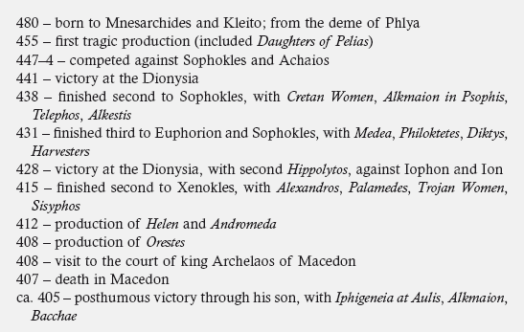

**DATACE DOCHOVANÝCH HER**

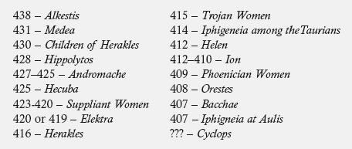

**BOHOVÉ U EURIPIDA**

*Those tales of chaining I never have and never will believe them. If a god is truly a god, then he needs nothing. The rest is just the lying tales of poets.*

*Herakles* (1345–1346)

“if gods do wrong, they are not gods” (fr. 292.7, *Bellerophon*)