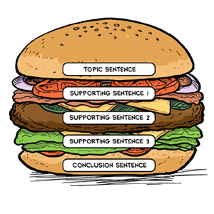

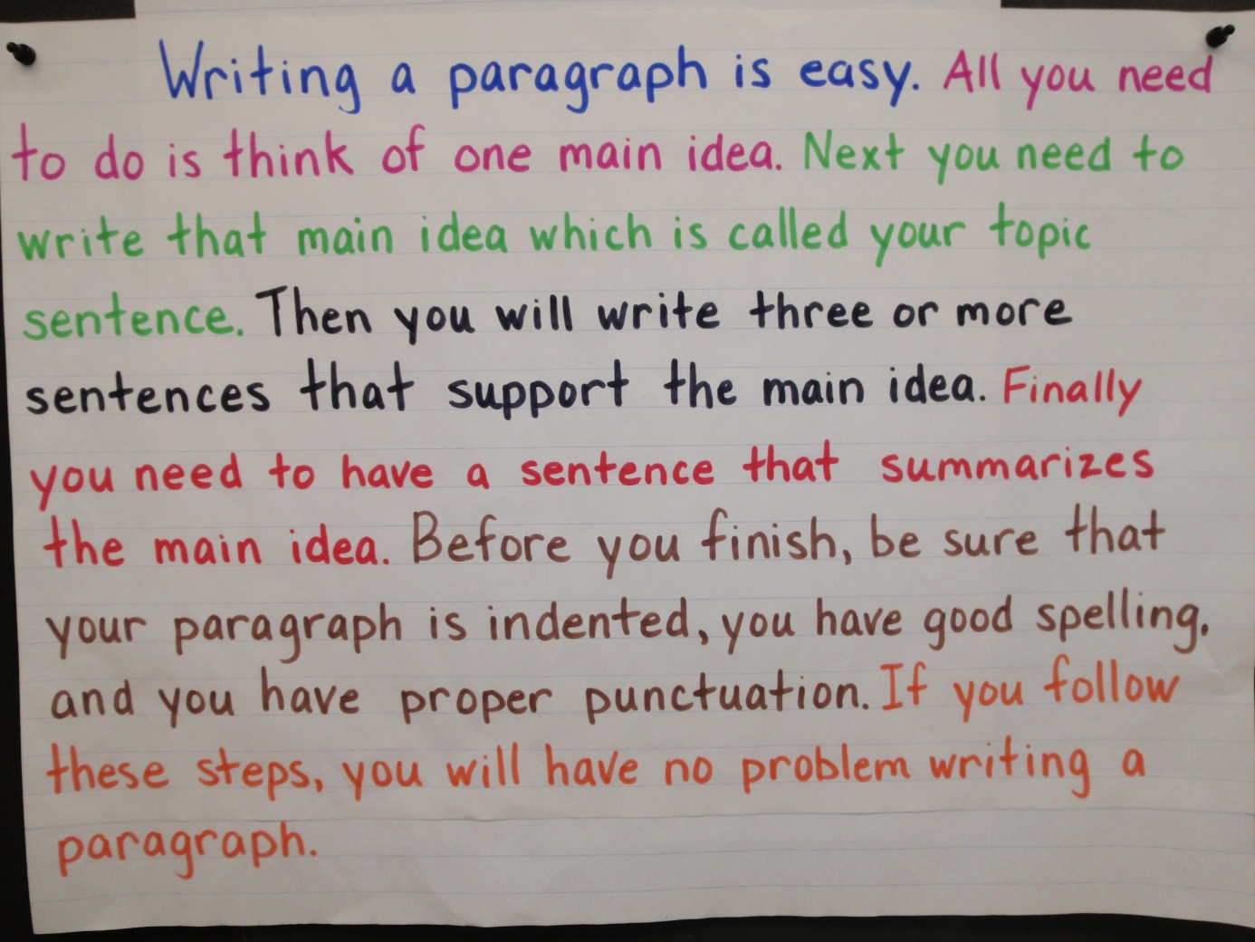

**On Paragraphs (https://owl.english.purdue.edu/owl/resource/606/01/)**

**Summary:**

The purpose of this handout is to give some basic instruction and advice regarding the creation of understandable and coherent paragraphs.

**Contributors:**Dana Lynn Driscoll, Allen Brizee  
**Last Edited:** 2015-07-07 10:28:52

**What is a paragraph?**

A paragraph is a collection of related sentences dealing with a single topic. Learning to write good paragraphs will help you as a writer stay on track during your drafting and revision stages. Good paragraphing also greatly assists your readers in following a piece of writing. You can have fantastic ideas, but if those ideas aren't presented in an organized fashion, you will lose your readers (and fail to achieve your goals in writing).

**The Basic Rule: Keep one idea to one paragraph**

The basic rule of thumb with paragraphing is to keep one idea to one paragraph. If you begin to transition into a new idea, it belongs in a new paragraph. There are some simple ways to tell if you are on the same topic or a new one. You can have one idea and several bits of supporting evidence within a single paragraph. You can also have several points in a single paragraph as long as they relate to the overall topic of the paragraph. If the single points start to get long, then perhaps elaborating on each of them and placing them in their own paragraphs is the route to go.

**Elements of a paragraph**

To be as effective as possible, a paragraph should contain each of the following: **Unity, Coherence, A Topic Sentence,** and **Adequate Development.** As you will see, all of these traits overlap. Using and adapting them to your individual purposes will help you construct effective paragraphs.

**Unity**

The entire paragraph should concern itself with a single focus. If it begins with one focus or major point of discussion, it should not end with another or wander within different ideas.

**Coherence**

Coherence is the trait that makes the paragraph easily understandable to a reader. You can help create coherence in your paragraphs by creating logical bridges and verbal bridges.

**Logical bridges**

* The same idea of a topic is carried over from sentence to sentence
* Successive sentences can be constructed in parallel form

**Verbal bridges**

* Key words can be repeated in several sentences
* Synonymous words can be repeated in several sentences
* Pronouns can refer to nouns in previous sentences
* Transition words can be used to link ideas from different sentences

**A topic sentence**

A topic sentence is a sentence that indicates in a general way what idea or thesis the paragraph is going to deal with. Although not all paragraphs have clear-cut topic sentences, and despite the fact that topic sentences can occur anywhere in the paragraph (as the first sentence, the last sentence, or somewhere in the middle), an easy way to make sure your reader understands the topic of the paragraph is to put your topic sentence near the beginning of the paragraph. (This is a good general rule for less experienced writers, although it is not the only way to do it). Regardless of whether you include an explicit topic sentence or not, you should be able to easily summarize what the paragraph is about.

**Adequate development**

The topic (which is introduced by the topic sentence) should be discussed fully and adequately. Again, this varies from paragraph to paragraph, depending on the author's purpose, but writers should be wary of paragraphs that only have two or three sentences. It's a pretty good bet that the paragraph is not fully developed if it is that short.

**Some methods to make sure your paragraph is well-developed:**

* Use examples and illustrations
* Cite data (facts, statistics, evidence, details, and others)
* Examine testimony (what other people say such as quotes and paraphrases)
* Use an anecdote or story
* Define terms in the paragraph
* Compare and contrast
* Evaluate causes and reasons
* Examine effects and consequences
* Analyze the topic
* Describe the topic
* Offer a chronology of an event (time segments)

**How do I know when to start a new paragraph?**

You should start a new paragraph when:

* **When you begin a new idea or point.** New ideas should always start in new paragraphs. If you have an extended idea that spans multiple paragraphs, each new point within that idea should have its own paragraph.
* **To contrast information or ideas.** Separate paragraphs can serve to contrast sides in a debate, different points in an argument, or any other difference.
* **When your readers need a pause.** Breaks between paragraphs function as a short "break" for your readers—adding these in will help your writing be more readable. You would create a break if the paragraph becomes too long or the material is complex.
* **When you are ending your introduction or starting your conclusion.** Your introductory and concluding material should always be in a new paragraph. Many introductions and conclusions have multiple paragraphs depending on their content, length, and the writer's purpose.

**Transitions and signposts**

Two very important elements of paragraphing are signposts and transitions. Signposts are internal aids to assist readers; they usually consist of several sentences or a paragraph outlining what the article has covered and where the article will be going.

Transitions are usually one or several sentences that "transition" from one idea to the next. Transitions can be used at the end of most paragraphs to help the paragraphs flow one into the next.