**Important Dates and Events in Paul McCartney’s Post-Beatles Career**

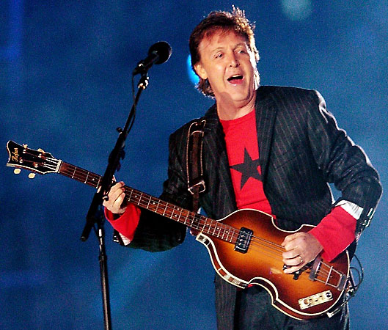

*1970-* Releases *McCartney,* first solo album where he played every instrument himself.

*1971*- Releases the album *Ram*, which has a song about Lennon called “Too Many People.” Forms a new band called **Wings** with his wife Linda.

*1973-*Released the album *Band on the Run*, the most popular album by Wings. Also wrote the song “Live and Let Die” for the James Bond movie of the same name.

*1976*-Wings goes on a very successful tour of America, and releases an album called *Wings Over America*.

*1976-79*- More successful albums and tours; Wings breaks sales records.

*1980*-Paul is arrested in Japan during a Wings tour for smuggling marijuana and spends a week in jail. After Lennon’s murder, he is severely shaken and cancels any live performances.

*1982-3-* Recorded a critically acclaimed album *Tug of War*, which contains the Lennon tribute “Here Today” and songs with Stevie Wonder (“Ebony and Ivory”). Also records songs with Michael Jackson (“The Girl is Mine” and “Say Say Say”); they become good friends until Jackson outbids Paul for control of the Beatles’ catalog in 1984.

*1989-90, 1992-93-*Embarks on successful world tours with more live and studio albums.

*1991-* Starts writing classical music, beginning with the *Liverpool Oratorio*.

*1997*-Becomes *Sir* Paul McCartney, after being knighted by Queen Elizabeth II.

*1998*-Linda McCartney dies in Arizona from breast cancer.

*2002-*Marries Heather Mills, a model and animal rights activist. Goes through a *nasty* divorce in 2008.

*2010-* Received the Library of Congress Gershwin Prize for Popular Song, the highest honor the US can give a popular musician. Performed at the White House for President Obama and sang “Michelle” to Michelle Obama. Marries Nancy Shevell, a New York socialite on Oct. 9, 2011 (on John Lennon’s birthday!)

Today McCartney is one of the richest musicians in the world, he continues to perform and tour regularly, and is the most successful songwriter of all time. He owns many song catalogs, including those by Harold Arlen (*The Wizard of Oz*) and Buddy Holly. He has 5 children (Heather, stepdaughter with Linda; Mary, Stella, and James with Linda; Beatrice with Heather Mills).