1. **Što će se dogoditi?**

 Padat će kiša.

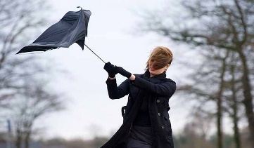

________________/____________________/___________________/_________________________

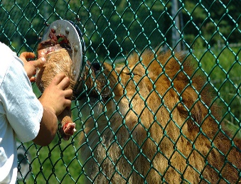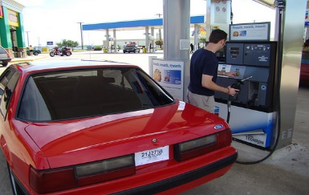

___________________/________________________/_____________________/________________

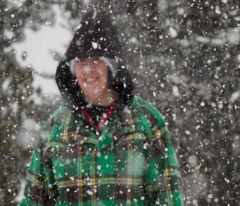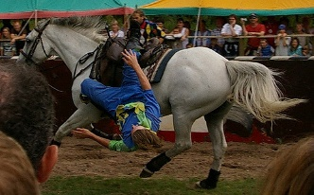

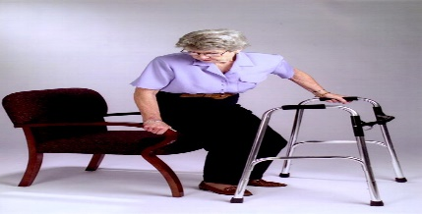

1. **Dovršite rečenice**

Sutra ______________________________________________________

Sljedeći tjedan _______________________________________________

U petak _____________________________________________________

Dogodine ____________________________________________________

Za tri mjeseca _________________________________________________

Kad završim fakultet ____________________________________________

