**Week 1: Introduction to the course**

Goal of this week: to develop our recognition of Japanese martial arts from figure 1 to 2.

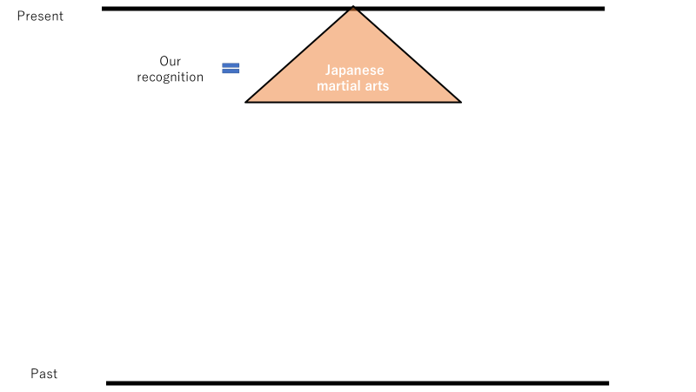figure1

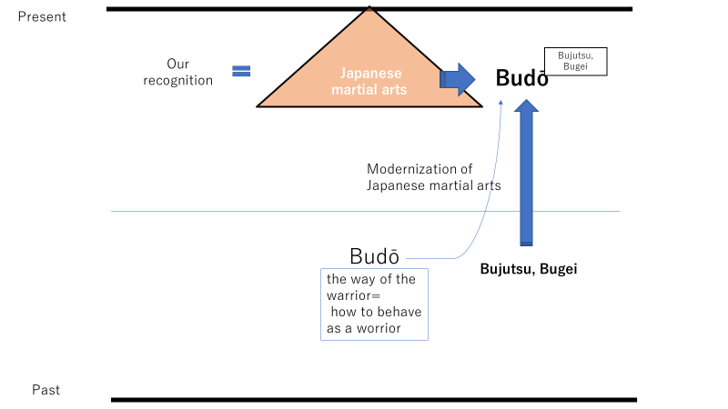figure2