## 1.2 ‘Budō’ ‘Bujutsu’ ‘Bugei’

Based on the purpose of the organization, we should assume Nihon Budōkan’s definition is a kind of **“branding”** of Japanese martial arts. (**“Branding”** is a marketing term which means to characterize something to appeal to the eyes of the targets. The idea of “branding” (cultural branding) can be useful when we talk about Japanese martial arts in pop culture later. To know more about “cultural branding”, see also:

<https://www.irishtimes.com/business/the-power-of-cultural-branding-1.585041>

another good example of “cultural branding”: <http://news.bbc.co.uk/2/hi/8419026.stm>)

So, they say “The definition of **Budō**” even in English version, and not “The definition of Japanese martial arts.”

What can it mean? Why is it important for them to use the word **Budō**, instead of **Bujutsu** or **Bugei**? What’s the difference?

Actually, this was one of the branding which the reformers of Japanese martial arts in early modern Japan carried out in order to give the feeling of renew.

To have more concrete image of the original meanings of each word, we would like to take a look at some old books.

The book in Figure 3 is titled *Budō Geijutsu Hiden Zue*, Shohen (*Illustrations of Secrets of the Art of the Way of the Warriors*, vol.1) published in 1855. (the whole book is available from:

<https://dl.ndl.go.jp/info:ndljp/pid/2560074?itemId=info%3Andljp%2Fpid%2F2560074&__lang=en> The explanations were written in classic Japanese, but almost of pages are with illustrations and it’s relatively short as a book. So, if you find it interesting, it’s good to take a look. And when there are some page interests you and wish to know what the description says, you can send me a message via Edmodo or email me, then I can post English translation of the page.)

From the title, we might expect the book is about the secret paths to be a strong warrior, however, surprisingly it says nothing about sword fighting or other combat skills.

For example, the right page of Figure 3 describes how to respond to an order from the lord.

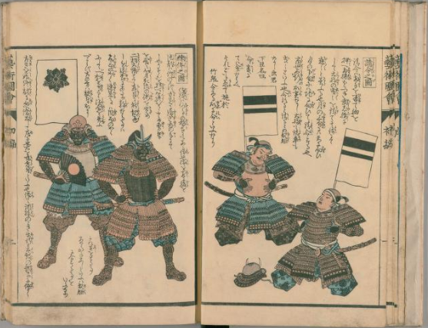

**Figure 3** *Budō Geijutsu Hiden Zue*, Shohen (vol.1, backside of sheet1)

The first sentence of the description says, “When you respond to an order, you say ‘Ow, ow’ with opened palm on your chest and both your knees on the ground after your lord says ‘Ei, ei’.” And the rest of the description is all about more detailed manners.

And the second volume of this book instructs how to conduct Teppō (gun) and Taihō (cannon) troops (effective usages of the weapons and strategical instruction).

The instruction about a close combat which is almost like what we call **Budō** nowadays finally appears in the third volume. Even though fighting on the horseback is the main topic of the volume, it contains ancestors of Kendō and Judō as seen in Figure 4 and 5.

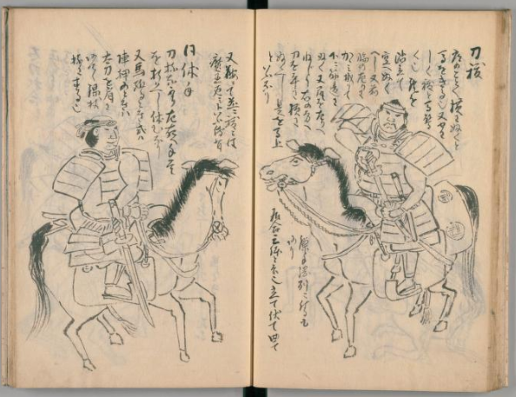

**Figure 4** Figure 3 *Budō Geijutsu Hiden Zue*, Shohen (vol.3, 23/41 on the website)

Let’s conclude this section.

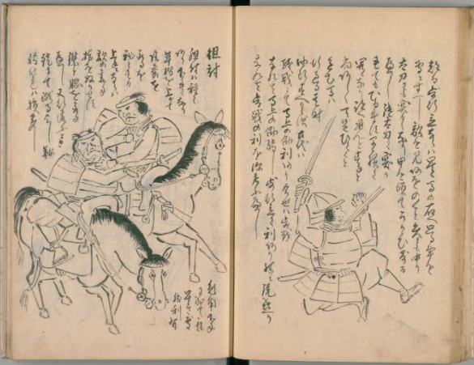

**Figure 5** *Budō Geijutsu Hiden Zue*, Shohen (vol.3, 30/41 on the website)

As we went over the book, Budō had more broad meanings like “how to behave correctly as a good samurai” and the usage as Japanese martial arts was nothing more than a part of it originally.

On the contrary, **Bujutsu** and **Bugei** specifically meant skills for close combats.

For example, in the illustrated book titled *Bujutsu Hyaku Yu-sen* (*A Selection of One-hundred Fighting Heroes*) published in 1870 (available from:

<http://shinku.nichibun.ac.jp/esoshi/picture_list.php?id=369&from=sr&pnum=1&disp=EN> ). (…unlike the title, there are only twenty heroes in the book…)

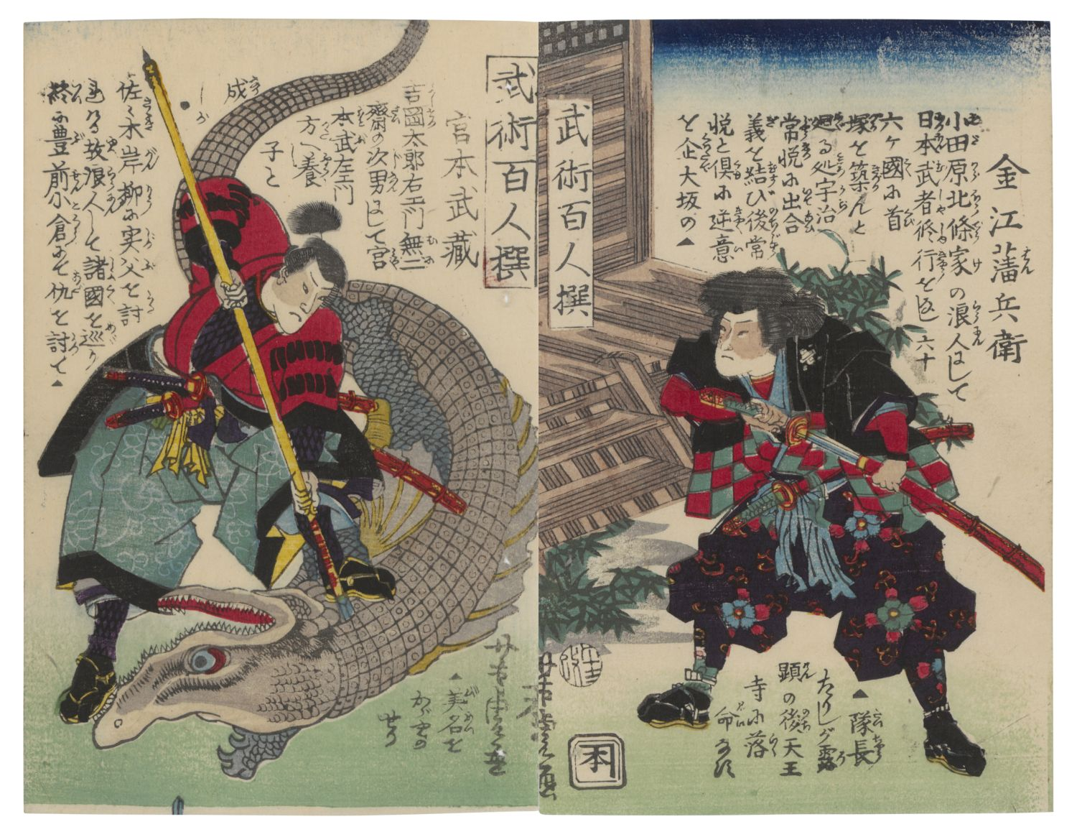

**Figure 6** *Bujutsu Hyaku Yu-sen* (7/12)

On the left page, it illustrates the famous Miyamoto Musashi. (In the illustration, he is fighting with a crocodile, but it doesn’t correspondent at all with the narrative which tells short Miyamoto’s biography, like who was his father and referred his rival, Sasaki Gabryu.)

Another example is a backgammon titled *Bugei Tatsujin Sugoroku* (*Great Martial Artists Boardgame*) published in 1847-1852. (available from:

<https://dl.ndl.go.jp/info:ndljp/pid/1310598>)

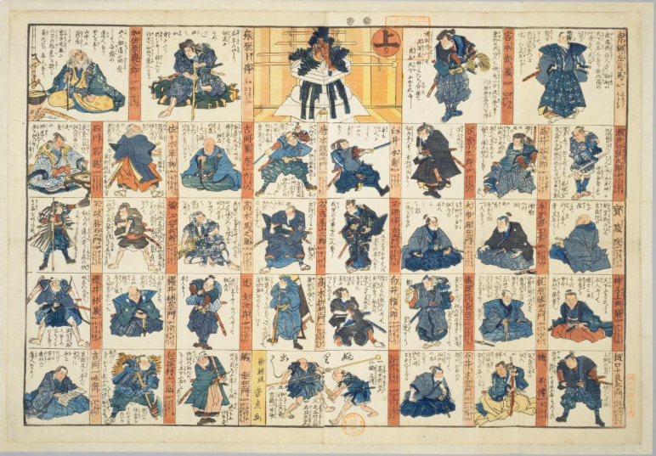

**Figure 7** *Bugei Tatsujin Sugoroku*

Backgammons were played on New Year’s Day in Edo period.

You start as a beginner of martial arts (in the lower center, Figure 8) and head to the goal (in the upper center, describing a martial arts dōjō on New Year’s Day.) passing by the frames as your dice tells. Each frame has a different great master of martial arts (Miyamoto Musashi is also in the right of the goal (Figure 9)).

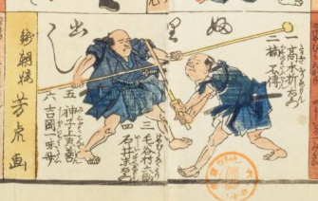

**Figure 8** Starting frame of *Bugei Tatsujin Sugoroku*

The characters are practicing with a wooden sword and a wooden spear.

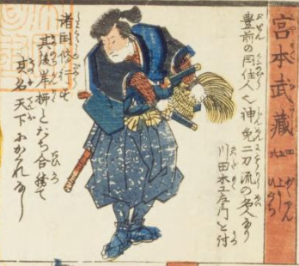

**Figure 9** Miyamoto Musashi in *Bugei Tatsujin Sugoroku*

So, now we know from the examples that the meaning of the word Budō had changed, and originally martial arts are just one of the things required to keep Budō, the way of the good samurai.

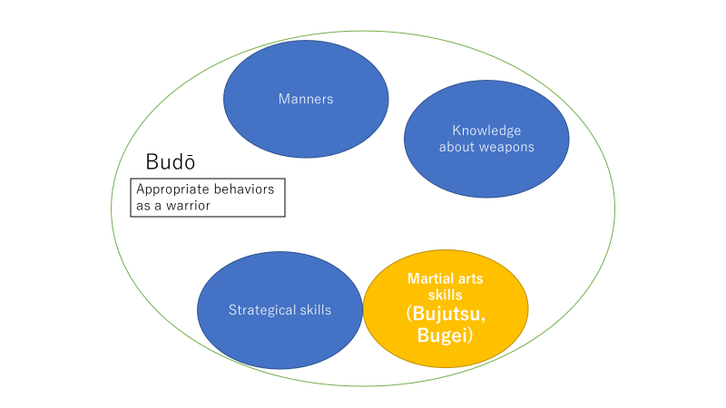

**Discussion 1.2: What kind of “branding” could be possible by using Budō for Japanese martial arts?**