Supplement: Adoration for samurai heroes and printing culture in Edo period

We’ve seen three books in the section 1.2 and all of them were printed books (only, Budō Geijutsu Hiden Zue contained some hand-copied parts.) which could be purchased in a reasonable price, and two of them featured warrior heroes.
The fact that they were printed means there were certain amount of demands among the people.
Warrior heroes were adored by the people and they were also curious about the samurai culture, even if it were detailed manners and strategies out of use (you can compare the weapons in Budō Geijutsu Hiden Zue published in 1870 with its contemporary weapons in the West, such as the descriptions of Crimean War in 1853-56 available from:
https://en.wikipedia.org/wiki/File:Panorama_dentro.JPG).

And such adoration was developed through the printing culture in Edo period.
Peace and unification of Japan in Edo period (1603-1867) gave space for a development of printing culture.
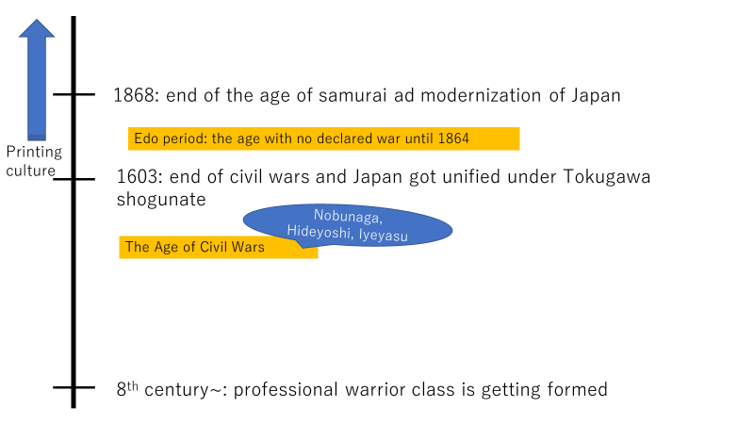
Figure 11

Until the unification of Japan by Tokugawa shogunate, Japan was contstantly in domestic wars.
It means cities and villages were frequently destroyed, and, because of a liquidity of classes in a state of war (like the well-known phrase from GoT, “Chaos is a ladder”), ambitious men joined in a war as combatant even if they were not from a samurai family.
When they unified Japan in 1603, what the shogunate did to stabilize the country was accelerating the fixation of social order, by disarming the warlords, making a ultimate contrast between samurai class and the commoners, monitoring the traffic of both the people and merchandise.
So, to be samurai or not became something out of your power (there were exception, of course) and permission to bear two swords was given only for samurai class.

Let’s move on to printing culture.
In the beginning of Edo period, people in the western urban areas like Kyoto and Osaka were kept busy to reconstruct their lives from the Civil Wars. There were huge demands for woods.
Therefore, the distribution system of woods was developed, making canals and hiring extra workforce (dismissed half-samurai-half-peasant men joined them. Such organizations were the ancestors of Yakuza!)
Once the demands got satisfied, the industry needed to cultivate a new business chance.

In urban areas, there were huge population with money and literacy, since the main population were merchants.
At that time, books were circulated via hand copy which made them extremely expensive and unreachable for the commoners. Therefore, books were a symbol of high status, not only richness but also high cultural levels.

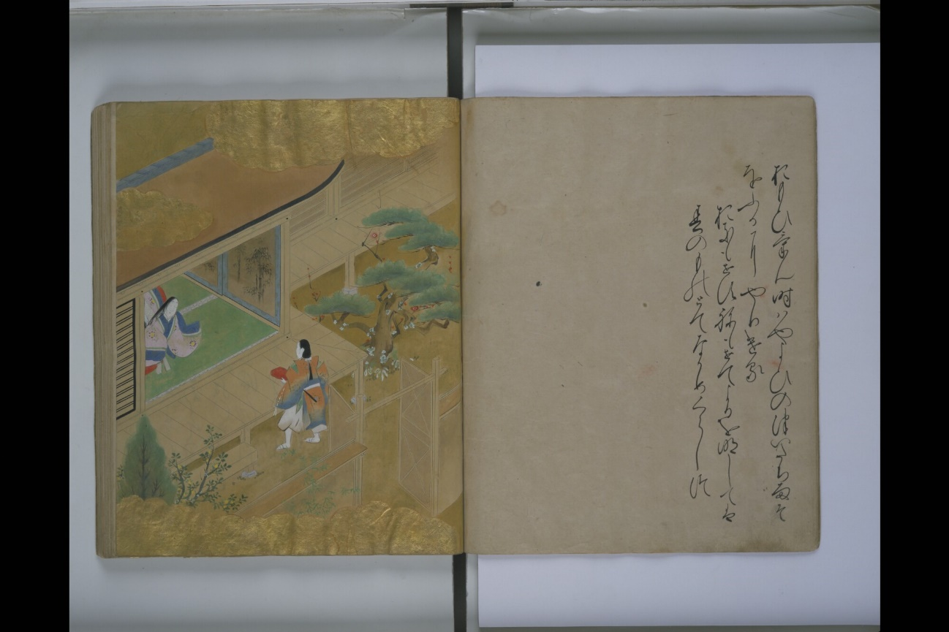
Figure 12 Ise Monogatari (Tale of Ise, 2/110 hand copied with illustration) created in 15th century. The golden clouds in the page left were painted with powdered gold! (Books at that time was really beautiful and worth to take a look. full view is available from here: https://rmda.kulib.kyoto-u.ac.jp/item/rb00013160 )

At the same time, as a part of fixation of social order, Tokugawa shogunate courage people to study Neo Confucianism which taught the virtues of filial piety and printed the texts in Kyoto and eastern part of Japan.
And there were Terakoya schools in the towns to teach people how to read (the dismissed samurais after the Civil Wars became teachers of such schools) and spread the study of Neo Confucianism.
The developed literacy and the enough space for intellectual curiosity among the people cultivated the field for publication industry.

Unlike the Western metal moveable types, Japanese printing technique utilized woodblocks, because the complicated writing system required flexibility.
There, the wood industry found their business chance.
In the mountains, cherry trees were left after the special demand of reconstruction, because fragility of cherry trees were not suitable for construction materials. However, the fragility meant also easiness to curve.

Of course, it wasn’t that delicate like the illustrated manuscripts, however, books were no longer a privilege only for the rich or high ranked people. (Figure 13 is an image of printed book in 1676 and Figure 13 is the printing blocks of the book.)

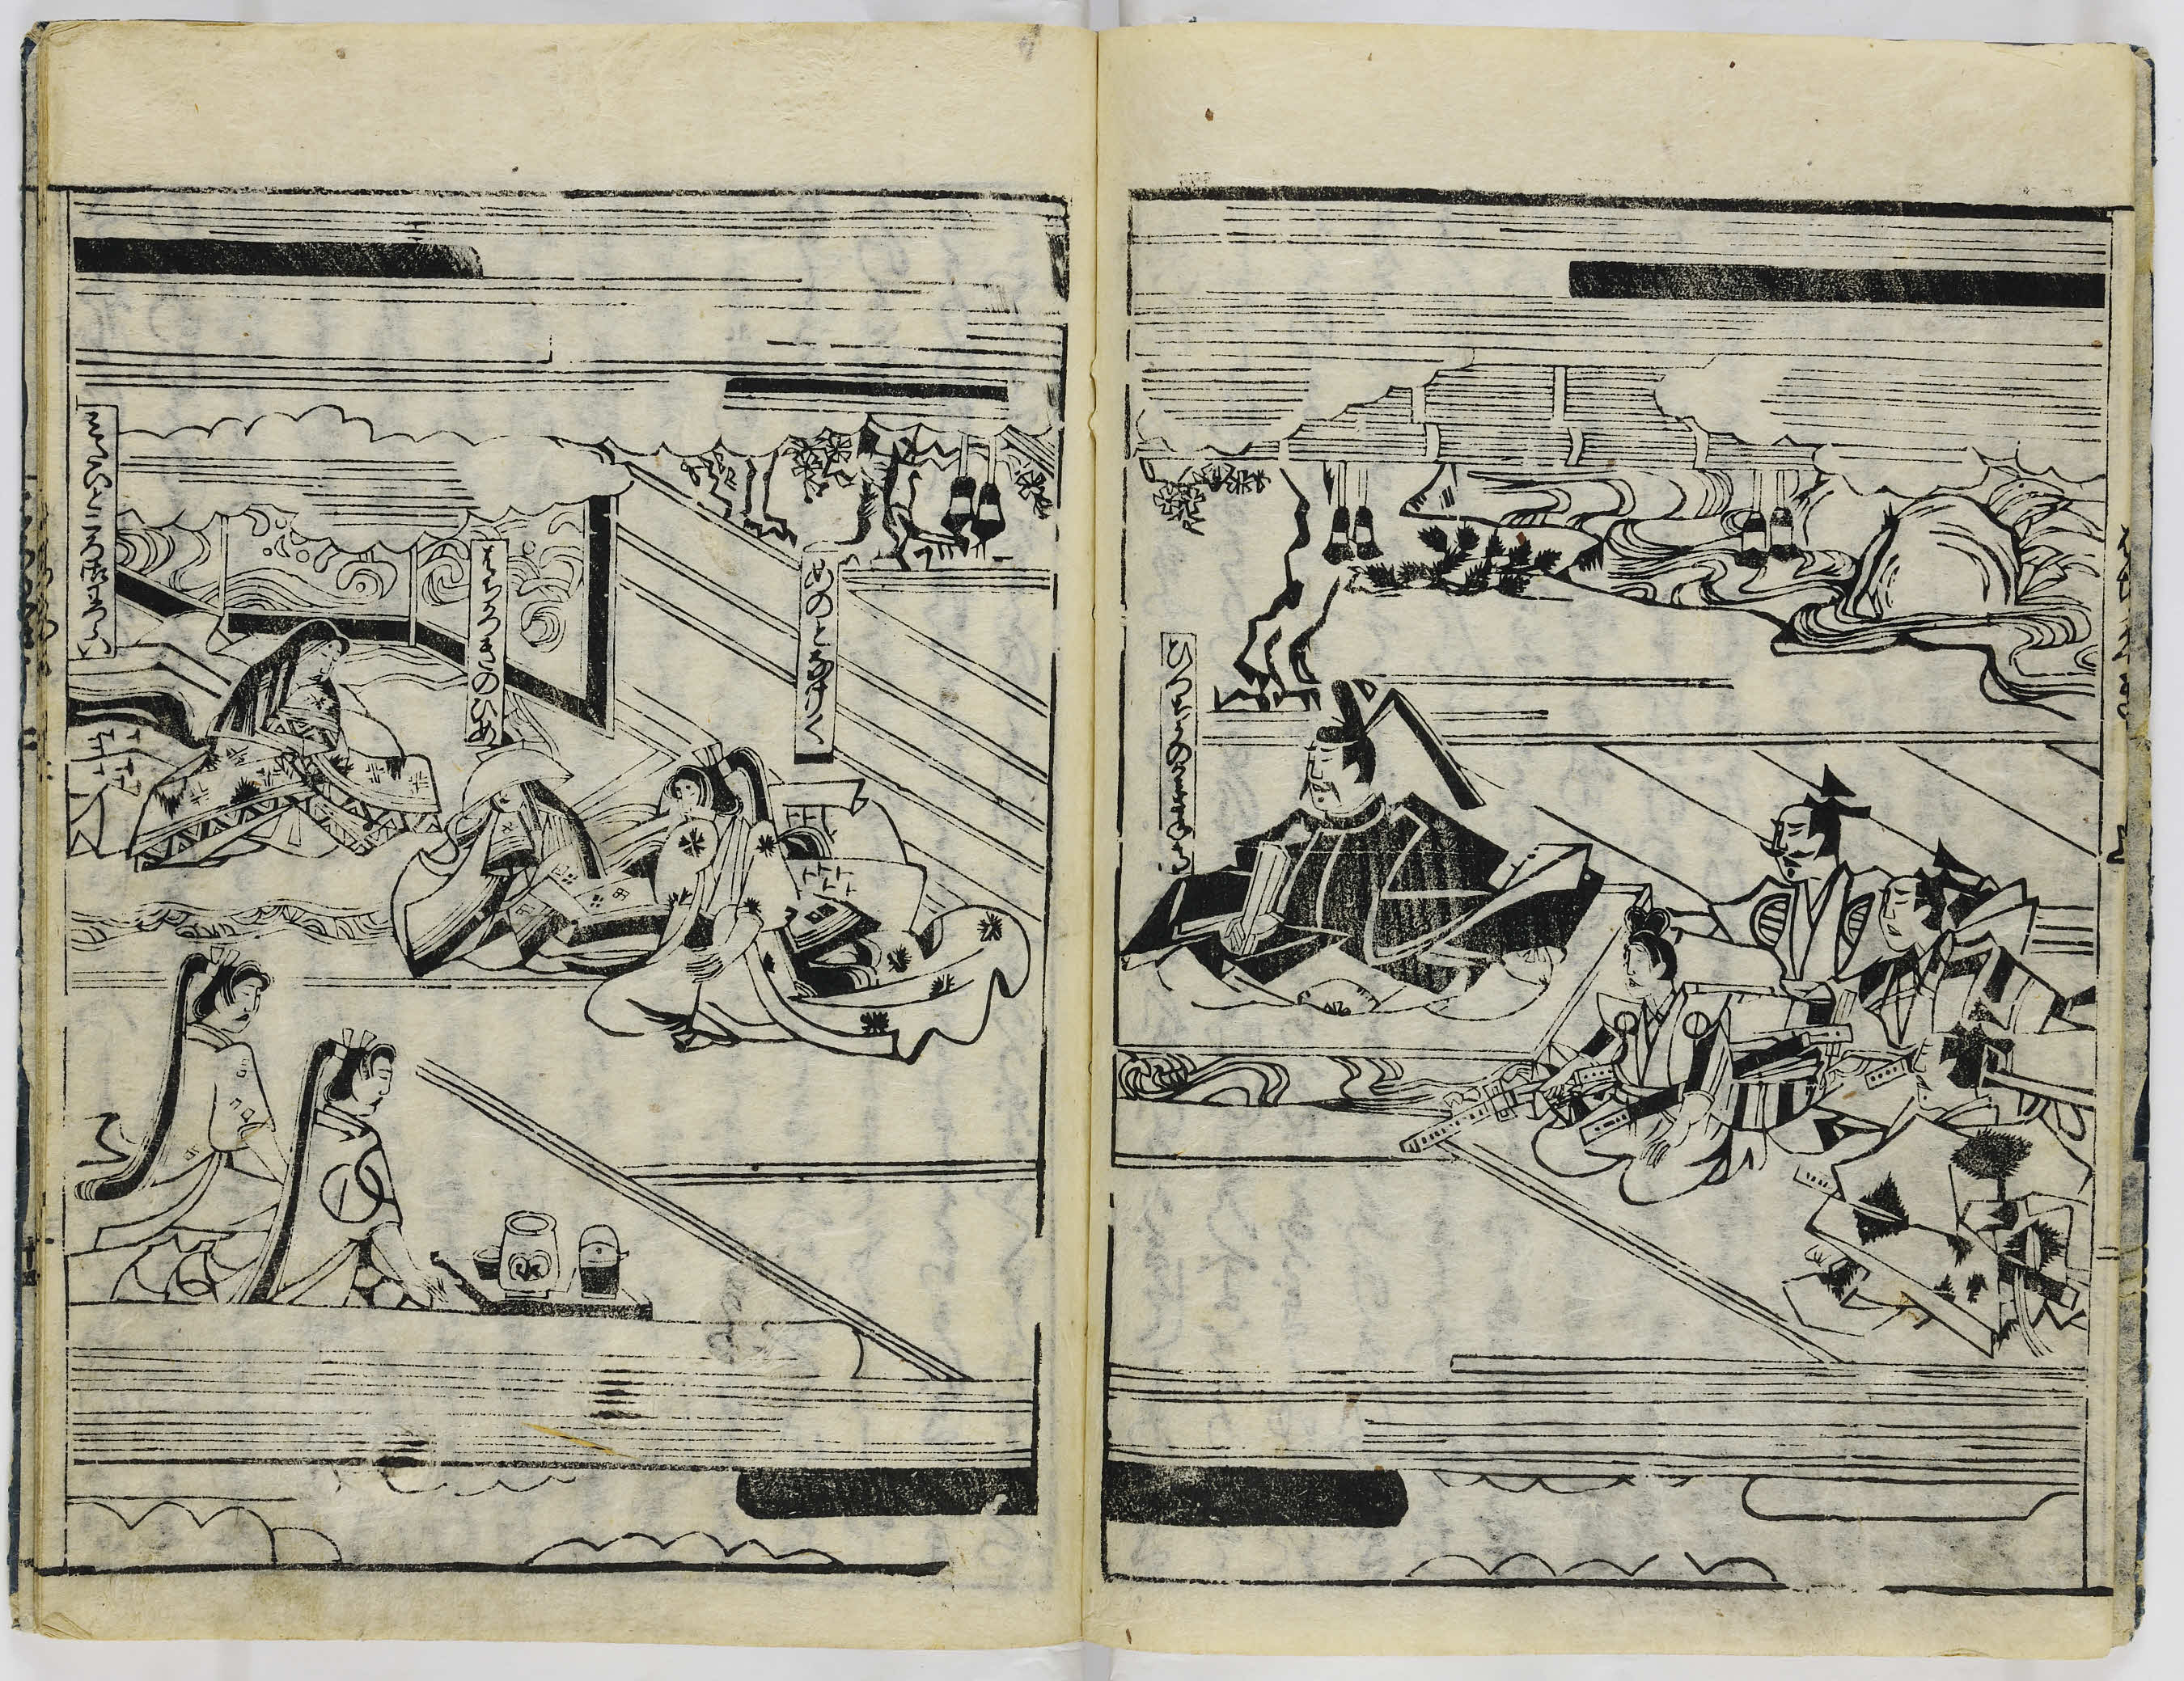
Figure 13 A double spread page (backside of sheet 2 and frontside of sheet 3) from Hachikazuki (The Bowl Bearer) published in 1676. (available from: http://www.dh-jac.net/db1/books/FSC-GR-780.807.01./portal/ )

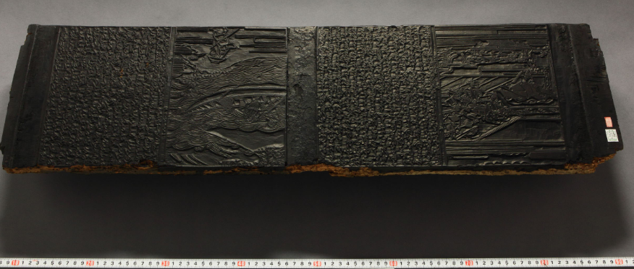
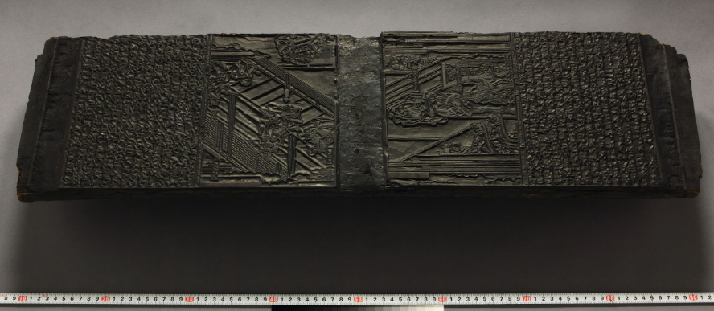
Figure 14 A printing block of a Cinderella-like fairy tale, Hachikazuki, sheet 2(above) and sheet 3 (bellow). To make such printing blocks, engraver needed to curve the manuscript in a mirror image. (available from here:
https://www.wul.waseda.ac.jp/kotenseki/html/he12/he12_05113/index.html )

About the Japanese printing culture in Edo period, see also Hioki Naoko’s article (available from: https://cool.culturalheritage.org/coolaic/sg/bpg/annual/v28/bp28-06.pdf)

When the printing technique was developed, they started also colour prints which can price a bit higher and make more profit.
Heroes were always the favourite motives for the woodblock-print artists and also for the customers, and a lot of series were created (like the backgammon sheet in section 1.2).

