# Week2:

In the branding of Japanese martial arts, tradition of samurai plays an important role.

However, do we understand correctly how samurai used the martial arts were used in battle fields?

## 2.1 Japanese martial arts as a part of strategy

In this section, we would like to take a look at how samurai were fighting in a battle field and how the martial arts were used.

In previous week, we examined the meaning of Budō, and it turned out that martial arts which we perceive as the whole meaning of Budō was just one of “the ideal ways of samurai” which the word originally referred to.

Before the meaning of the word itself had changed, the goal of Budō in modern Japan, “the way of the samurai”, head to had also changed after warfare became no longer a major part of samurai’s life in Edo period (1603-1867).

For example, we might expect samurai to be honest, honourable, and fair men even when they were in a fight like how it’s described in *Usagi Yojimbo* by a Japanese-American comic creator Stan Sakai that the bad guys don’t hesitate to assault somebody unexpectedly with multiple people to win whereas the good guys values also how they fight.

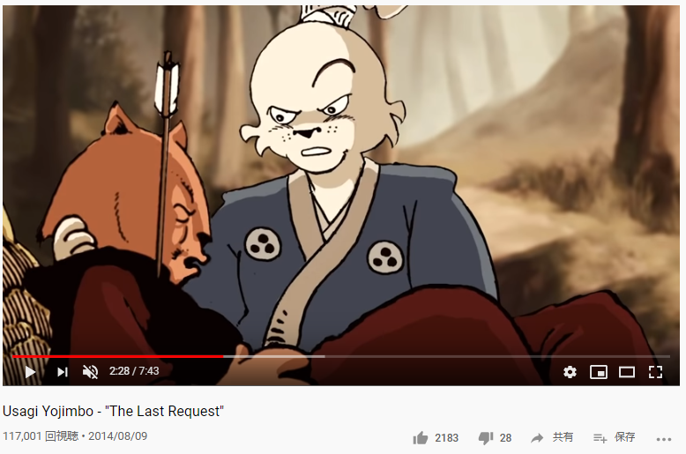

**Figure 1** pilot version of the animation of *Usagi Yojimbo* (2014), Usagi found his friend assaulted on the road by ninja

(video clip is available from: <https://www.youtube.com/watch?v=fxnmeHHEGeQ> )

However, the ways of samurai considered ideal when Japan was in the civil wars can feel contradicted with our expectations.

*Yoshisada Gunki* (*TheWar Chronicle of Yoshisada*, Figure 2) written in the 15th century is the earliest book dealt with “the way of the samurai” as something you should pursue throughout the life.

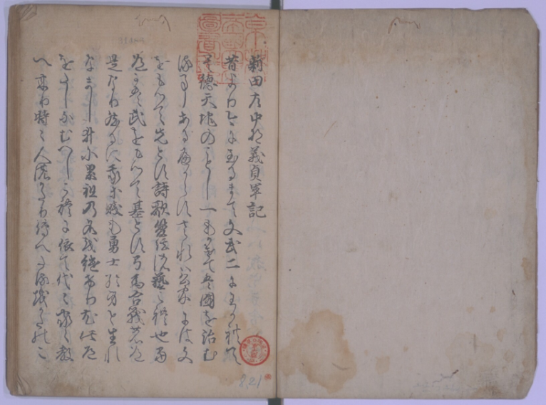

**Figure 2** *Yoshisada Gunki* is a war chronicle of the great warrior Nitta Yoshisada (1301-1338) who was a loyal warrior served for Emperor Godaigo and fought the hopeless war against Ashikaga Takauji. Yoshisada had been worshiped as a great model of samurai until the end of WWII (as seen in Figure 3).

(The image is from a wood-moveable-type printed copy stored by Kyoto University. Available from: <https://rmda.kulib.kyoto-u.ac.jp/item/rb00013410>)

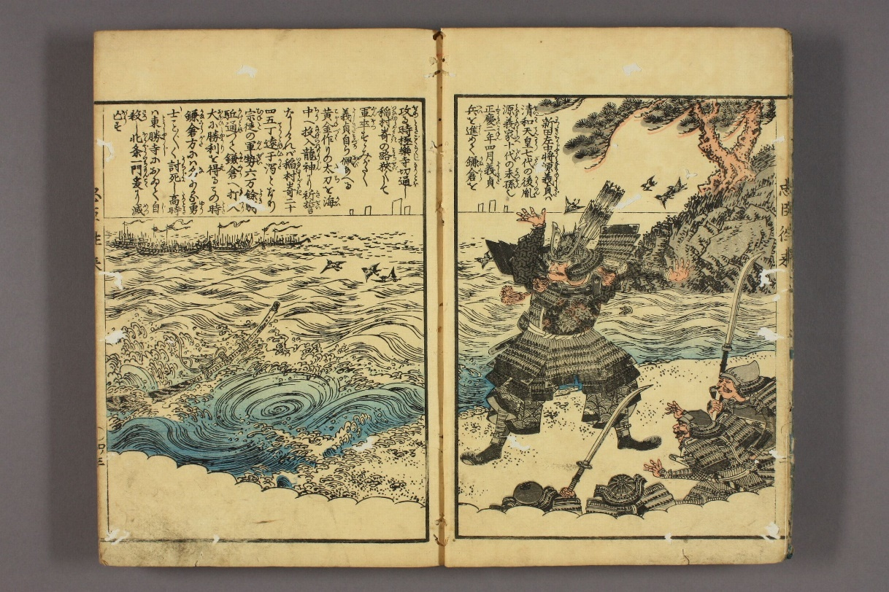

**Figure 3** An image of Nitta Yoshisada in *Nancho Chushin Orai* (*Textbook of Loyal Retainers of Southern Court*, late Edo period (1603-1867))

(available from: <http://www.dh-jac.net/db1/books/bunko30_g0248/portal/> )

In the opening paragraph, it said that what is the most important for a samurai is an honour of the clan, and you shouldn’t be reluctant to die and do whatever necessary for a victory which brings your family an honour.

More specifically, in the instruction on fighting in a battle field given by a veteran warrior Fujiwara Sanehira to a younger warrior Wada Yoshimori (1147-1213), Sanehira gave nine advices as follows (this instruction was recorded in *Genpei Josuiki* (*Chronicle of Rise and Fall of Genji and Heike*, late Kamakura period (1185-1333))):

1. Fight with your horse and yourself facing slightly left of your opponent.

2. Don’t waste arrows and should target the space between the armour plates.

3. Keep your forehead safe under your helmet and never make it naked in the eyes of the enemies.

4. When your opponent tries to shoot a second arrow, there can be a space between his armour plates. Never miss that chance.

5. Be careful not to give the same chance to the enemies by adjusting your armour.

6. If you can’t find the space between the armour plates of your opponent, shoot the abdomen of the horse and make the opponent fall. Shoot him while he is standing up.

7. Don’t target one enemy with many people.

8. Try to avoid killing each other (aiuchi) as much as possible.

9. In the case you have to fight in close, first wrestle on the horseback to make the opponent fall by Kumiuchi (predecessor of Judō), and then fight with your sword on the ground.

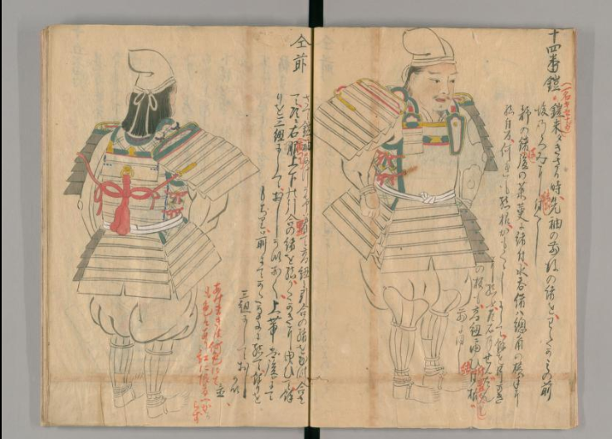

**Figure 4** An image of a samurai in an armour from *Yoroigi no Maki* (*Book of Wearing an Armour*, 13/48) which is an illustrated textbook for wearing an armour correctly. (available from: <https://dl.ndl.go.jp/info:ndljp/pid/2541608?itemId=info%3Andljp%2Fpid%2F2541608&__lang=en> )

From 1 to 7, they are all about fighting efficiently with a bow. (The introduction of guns to Japan was in the late 16th century, so this can be applied to battles prior to the encounter with this modern weapon.)

By facing slightly left of the enemy, your right arm can work more comfortable (1) and you shouldn’t work on one opponent with many (7) because it’s a waste of arrows and combatants, not for the sake of fairness.

The instruction shows which kind of skills were considered important for a victory and archery on a horseback played a primal importance and the close combat skills were in the second place.

So, if we summarize the role of Japanese martial arts in the real battle fields, it could be figured as follows.

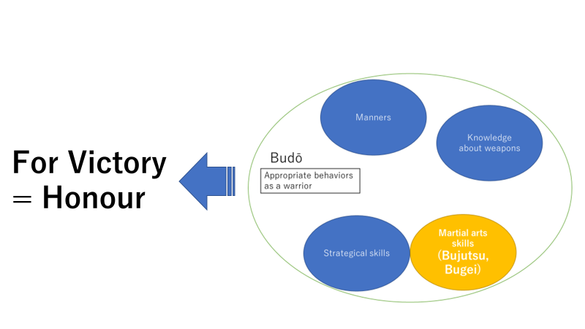

**Figure 5**

The ultimate goal of bushido (budō) was an honour, and a victory was the only thing which could bring an honour to a samurai in a war, and martial art skills were an important factor which could make one a competent warrior.

(How samurai fought was demonstrated in a series of events carried by Ninja Kingdam in Mie prefecture, the video clip of the event is available from here:

<https://www.youtube.com/watch?v=1NNK5FSKtZE&t> )

Discussion 2.1: We’ve seen that archery on a horseback was a standard fighting position for samurai, and moreover, another way to say bushido (budō) was “the way of archery and horse riding (kyuba no michi).” However, watching the promotion clips of videogames (for example Figure 6 and 7), fighting with sword seems to be made like a main stream of the fighting skill. What can be a reason for it? How do you analyse the effects?

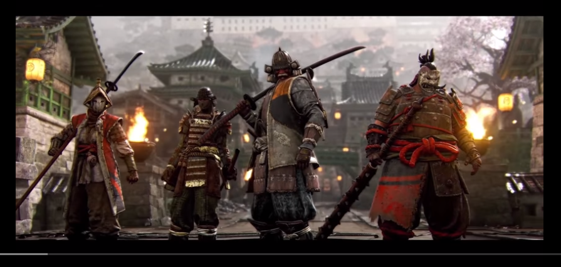

**Figure 6** Promotion video of *For Honor* (2017) (available from:

<https://www.youtube.com/watch?v=asm4zSmzUO4>)

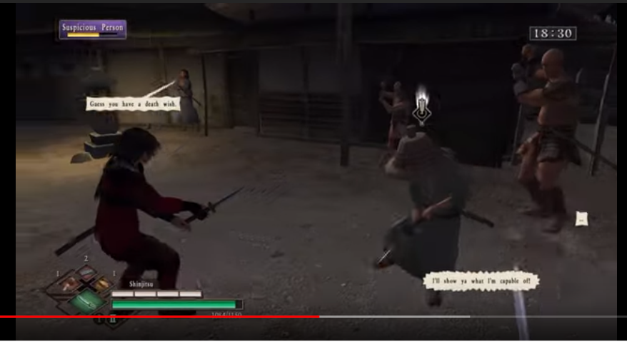

Figure 7 Fan-made video of *Way of the Samurai* (2008) (available from:

<https://www.youtube.com/watch?v=Z3rh6SdFcRw>)

## 2.2 The first radical change: Martial arts masters in the age without a war

After the age of the Civil Wars (Sengoku jidai), the unification of Japan and the foundation of the stable government was realized by Tokugawa shogunate.

As explained in Supplement for Week1, disarming the powerful warlords (daimyō) was one of the main policies taken by the shogunate to stabilize the country. Japan had been a feudal country until the end of Edo period, and in the beginning, each lord of the land still kept the well-armed castles, melee weapons, and enough combatant to threaten the tranquility of the country.

The disarming policy was done by charging a huge financial burden on the lords which left them only essential amounts of money to maintain weapons from the Civil Wars and samurai to manage the local society as bureaucrats.

Therefore, many of the lower ranked combatant in the Civil War had to maintain themselves as rōnins, master-less samurai, or as gōshi who were half-peasant and half-samurai class (more about the social system in Edo period, see also the article of E. Herbert Norman in Library of Week 2).

If they were competent and lucky enough, they could be employed as an instructor of martial arts by the shogunate or the lords or under the patronage of them, like the famous sword master and the author of *Gorin Sho* (*The Five Rings*)Miyamoto Musashi (1584-1647) in Figure 8 or Yagyu family which was the head of Yagyu Shinkage swordsmanship school and even promoted to a lord.

To show one’s competence, they had small scaled fights like a duel or a challenge against a well-known dōjō in which Musashi attained his fame.

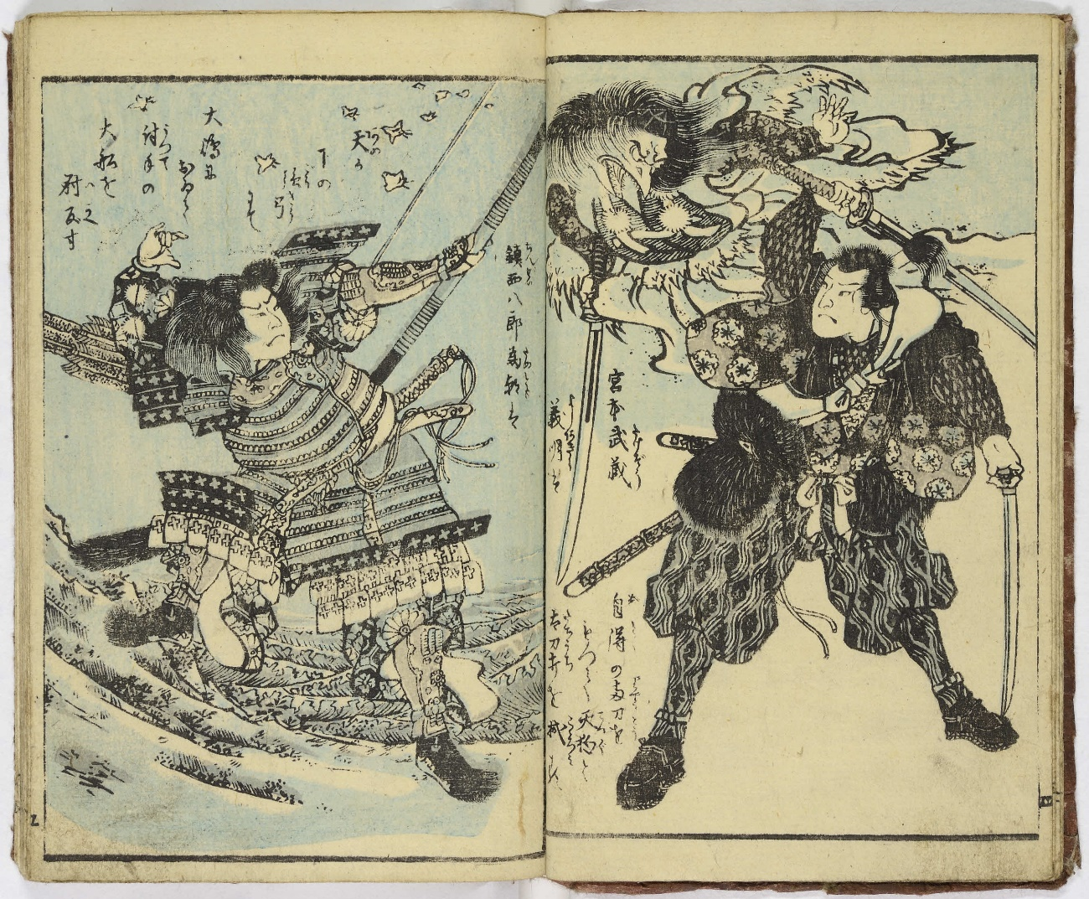

**Figure 8** Image of Miyamoto Musashi (in the left) from *Kokon Eiyu Musha Ryakudenki* (*A Brief Biograpgy of Fighting Heroes Now and Then*) in 1853 (available from: <http://www.dh-jac.net/db1/books/oniBK03-0002/portal/> ).

In the over 250 years of peace in Edo period, there was not any declared war and the shogunate strictly prohibited disputes between the clans of the lords.

It means martial art skill became just for a refinement for samurai and no longer a mandatory to be good at. So, if there was a job opportunity for a low ranked samurai (or a non-samurai competent man), it would be either a martial art instructor, a bodyguard, or a kind of police officer.

I mentioned the word dōjō which originally meant a place for Buddhist practice, but the core meaning of the word is a place where people pursue a profound “dō (道dao, the way)” together.

It was in Edo period when what we imagine as a dōjō, a place for martial arts training specifically, was formed.

Each master started their own schools and dōjō while Japanese martial arts started to proceed to another direction, as a refinement of samurai.

The training also needed to be changed to be more specialized and safer for trainees.

In the case of swordsmanship, they started to use bamboo practice swords called shinai which cause much less injuries, and wear face guards, hand guards, and abdomen guards.

## 2.3 Second and biggest change: the modernization of Japanese martial arts

In the previous section, it was explained that the practice of martial arts was largely influenced by the social structure. And when there was not an absolute necessity for martial arts, it became a refinement of samurai class and the training was redesigned for safety.

In this section, it will be discussed how the collapse of the Shogunate and samurai class influenced on Japanese martial arts.