3.1 Karate, a Japanese martial art?

**Questionnaire:** please answer the google form about your image about karate before you start reading 3.1.

<https://docs.google.com/forms/d/e/1FAIpQLSfadF00-qVs2w1xWcGgTBUYbMUBstIkSwcnKH0SKnGEnVjLiA/viewform?usp=sf_link>

Supposedly, the best-known karate character would be Ryu from Street Fighter series.

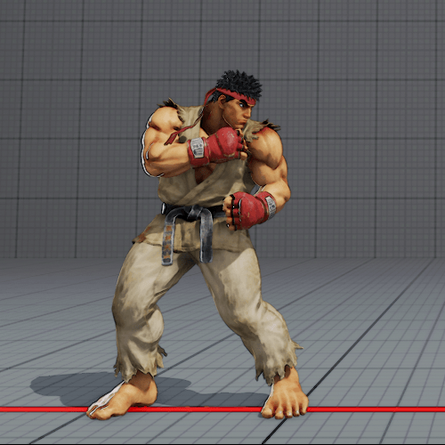

**Figure 1** Character graphic of Ryu from *Street Fighter* series (<https://game.capcom.com/cfn/sfv/character/ryu/costume>)

Let’s start this week with analysing Ryu in a framework demonstrated by Rachael Hutchinson (2006, the article is available from Library and the information system of the University) to figure out which kind of stereotypical images are used.

She examined the detailed profiles (genders, nationalities, heights and weights) and settings (character graphics, costumes, fighting styles, background graphics, background music, character narratives) of the characters of *Soul Calibour* series.

According to the official profile of Ryu, he is a male fighter from Japan with 175-180cm (highest in *SFI*) in height and 68-85kg in weight (heaviest in *SFV*). So, he is big as a Japanese man but in average in international standard.

His character design was changed a lot in *SFII*. The most noticeable changes can be the colour of his hair (red to black) and the shoes that he put a pair of kung fu shoes in *Street Fighter* although he fights with his bare foot in *SFII*. His posture also became more muscled with more worn karate training uniform. In some sequences of *Street Fighter*, his black belt has an embroidery of “風林火山 (Fu-rin-ka-zan, a motto of the warlord Takeda Shingen (1521-1573)” which means “quick like wind, quiet like a bush, invade like a fire, and stand still like a mountain.”

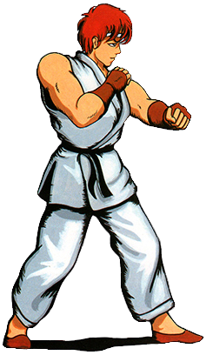

**Figure 2** Character graphic of Ryu from *Street Fighter* (1987) (<https://jp.ign.com/street-fighter-30-years/14146/feature/?utm_source=recirc>)

Character theme songs and respective background graphics was given also from *SFII*.

In the case of Ryu, his stage is on the rooftop of some Japanese castle (according to the official settings, the name is Castle Suzaku), and we see also two signboards says “風林火山 (Fu-rin-ka-zan.” And Japanese percussions like drums, handbells, and wooden clappers are in his theme song.

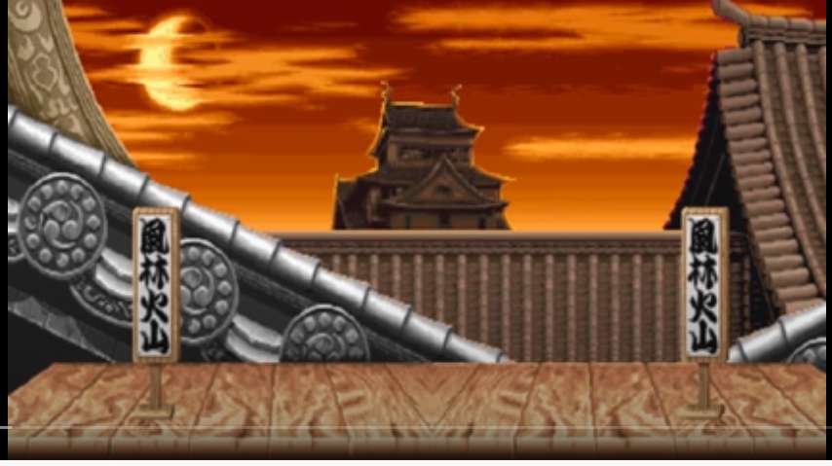

**Figure 3** Theme of Ryu and his stage (<https://www.youtube.com/watch?v=tEA-kf9utek&t=>)

In *Street Fighter II* (hereby, *SFII*) (1991), the nationalities of the characters played an important role in the character designs.

Yasuda Akira who was one of the game developers of *SFII* told in his interview in 2003 that:

When Nishitani [lecturer’s note: Nishitani Akira, the chief designer of *SFII*] was imagining the characters for SFII, he divided them into different nationalities and their respective fighting styles. First he would choose their country (India, Japan, USA etc), then he would figure out a fighting style that matched it, like sumo or boxing. After matching all those up, the only ones that were leftover were “Spain” and “Ninja”. He had wanted to use ninjas for Japan, but Japan already had karate and sumo. …

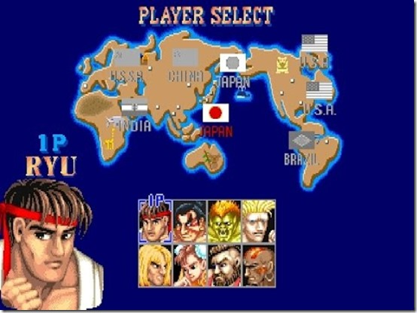

**Figure 4** Character select screen from *SFII*

There are two Japanese flags which means there are two playable Japanese characters (another playable character is a sumo wrestler E. Honda).

Although the fighting style of Ryu was already set as karate from *Street Fighter*, the character design was changed from *SFII* into the direction of emphasizing more his nationality.

Based on the concept of *SFII*, it can be also said that karate was more clearly branded as a Japanese martial art.

However, is it surprising for you if you find out karate was “exotic” for the Japanese in the beginning of the 20th century, and the uniform of karate became the current design coincidently?

**Discussion 3.1**: Try character analysis (ideally characters which use Japanese martial arts) and describe it in the comment.