3.2 Crisis of Japanese martial arts and its solution

In week 2, the crisis of Japanese martial arts was mentioned. The number of the martial art practitioners were dropped in the beginning of Meiji period because of the collapse of the former patrons, samurai class, and the decline of the social status.

Some of the martial art experts bitterly decided to make an entertainment performance with their trained skills, and, in the case of Judō masters, many of them maintained their dōjō by earning some money as chiropractors.

The dōjō where Kanō Jigorō (1860-1938), who reformed Jujutsu into Judō, was one of them.

Kanō was not in the lineage of samurai family nor martial art experts. He was from a prestigious merchant family which served directly for the shogunate, which means his family was very rich and permitted some of the privileges of samurai like bearing a sir name.

He was also not the type who was physically suited for martial arts, he wasn’t a build man and he had a fragile health. But that was also a reason why he started to learn Jujutsu in 1877 when he moved to Tokyo for his study. Before he started learning Jujutsu, he studied linguistics and philosophy in the University of Tokyo.

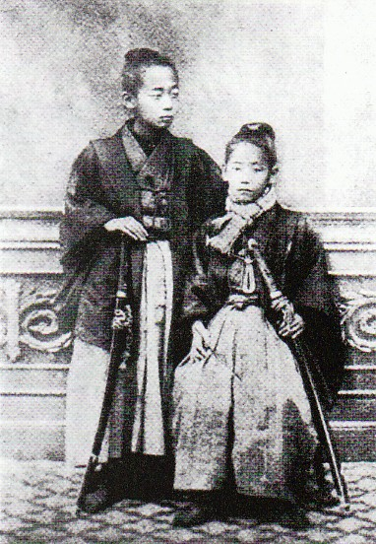

**Figure 5** Image of Kanō in his childhood (in the right) from *Kan*ō *Jigor*ō*: Watashi no Shogai to Jud*ō *(Kan*ō *Jigor*ō*: My life and Jud*ō*)* published in 1972

There were only a few dōjō surviving in Tokyo at that time. He finally found the dōjō of Fukuda Hachinosuke (1829-1879) who died just two years after Kanō’s entrance.

By the time Fukuda died in 1879, Kanō became an important figure of the dōjō because of his good education.

In 1879 when the former US president Ulysses S. Grant who had been the general of Union Army in the Civil War in America visited Japan, Kanō was asked to performance and explain about Japanese culture and Jujutsu to Grant. He had a possibility to make a change to Jujutsu into something international.

Therefore, although Kanō wasn’t the strongest in the combat, he was chosen by Fukuda as his successor when he was just 20 years old. He entered other famous dōjōs in Tokyo, including other martial arts like Kenjutsu and Bōjutsu to learn about dōjō administration and theorization of martial arts.

To make his school sounds standing out among the other schools, he started to call his Jujutsu as Judō from 1881.

His Judō was modernized by thorough rationalizing.

For example, to motivate the pupils, he made grading system more transparent for the pupils and introduced the belt system from Japanese board games, and then, he changed the training uniform in 1907 which was merely an opened and half-sleeved kimono previously. He found it “irrational, for the sake of safety.” (This remark is cited from *Sekai Judō-shi* (*History of Worldwide Judō*) by Maruyama Sanzō in 1967.)

By making Judō more understandable and safer, Kanō intended to shift it from the hobby for classical refinement to a national education for the real use. As he hoped, Judō started to be taught in Japanese Imperial Junior Military School from 1899.

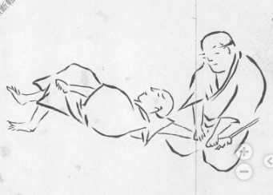

**Figure 6** Jujutsu uniform in Edo period from *Jujutsu Kata no Mokuroku* (*Catalogue of Kata of Jujutsu*) (full image is available from: <https://kotenseki.nijl.ac.jp/biblio/100065859/viewer> )

It was in this line that he introduced Karate from Okinawa in 1922 when Japan had experienced two modern wars, against China in 1894-1895 and against Russia in 1904-5, and education was considered important to train healthy good nationals and future soldiers.

Karate was firstly featured by a colonel of Japanese Navy which passed by Okinawa in 1909 or 1910 for it looked suitable for an exercise on board. Kata (solo practice) of Karate can be practiced both alone and in unison, it doesn’t need tatami mats nor uniforms, and with much less risks for injuries than Judō or Sumō. His troop had an instruction from an Okinawan Karate expert and junior-high teacher Funakoshi Gichin (1868-1957).

How the Japanese people in the mainland saw Karate shouldn’t have been the same as how it’s perceived now.

Until 1879, Okinawa was called Ryukyu Kingdom and was not completely a part of Japan although it was under domination of the shogunate.

As its geographical condition shows, Ryukyu had been under the huge cultural influence by China. The word Karate itself was also written as 唐手(lit. Chinese hands) originally not 空手(lit. empty hands) as it’s written nowadays, because Chinese immigrants brought this culture to Ryukyu by the 15th century.

So, even though it feels strange for us, Karate was something exotic and new for the mainland-Japanese at the time, just like how Swedish exercise was introduced to Japan in 1913.

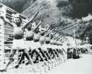

**Figure 7** Image of Swedish exercise practiced in Japan in 1919 (<http://www.pref.tottori.jp/kikakubu/kikaku/kenminnohi/panel%202.htm> )

**Discussion 3.2**: Funakoshi Gishin wrote several Karate instructive books. Until 1935, he only used 唐手 for Karate in his books (for example a book published in 1932: <https://iss.ndl.go.jp/books/R100000096-I004600731-00>), however it has suddenly changed in *Karatedō Kyōhan* (*Textbook of Karatedō* whose metadata is available from: <https://ndlonline.ndl.go.jp/#!/detail/R300000001-I000000791255-00>) and he started to use 空手 instead. What do you think about a historical context of this change? What could be possible effects, or intended effects?