3.3 From the perspective of Karate masters

Karate was practiced almost only in Okinawa until the 1920s when it was performed at the first Exposition of Physical Education and at Kanō Jigorō’s Judō dōjō in 1922.

The techniques of Karate were originally taught orally generation to generation amongst the clans.

For Okinawan people, to perform their Karate in the mainland had a certain meaning.

During the period of domination from the shogunate (1609-1872), they visited Edo (Tokyo) for occasional greetings and, more importantly, for a petition for securing the position of their kings. When Meiji government abolished the domain system and established prefectures, Okinawan tried to secure the position of their king.

However, the government decided to move King Shōtai to Tokyo in 1879. Therefore, for Okinawan people, Karate performance in front of the mainland celebrities was the thing which reminded them the power balance between the mainland and Okinawa.

By being merged into Great Japanese Empire, Okinawan people were also pressured to be Japanese, like King Shōtai and his courtiers were transmitted to Tokyo and started to have an education of the mainland.

For Okinawan people, it was firmly believed that to become a good Japanese citizen was the way to prove high cultural level of Okinawa.

Therefore, it was important to emphasize how Karate was desired by the mainland elites.

In the works of Funakoshi, he mentioned repeatedly that generals were interested in Karate and how Kanō was enthusiastic about inviting Karate experts to his dōjō.

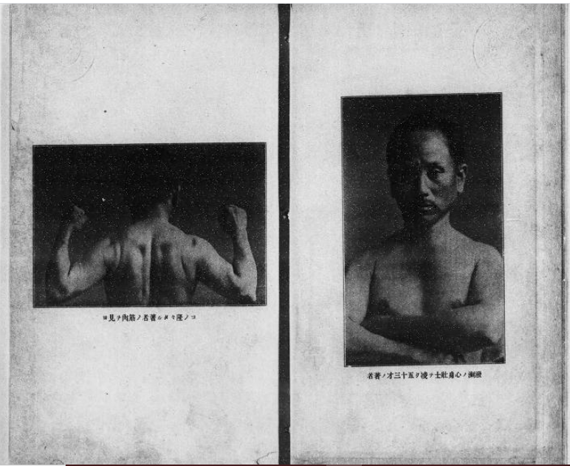

**Figure 8** Photographs of Funakoshi Gichin from his text book *Karate Ryukyu Kempō*

(the book is available from: <https://dl.ndl.go.jp/info:ndljp/pid/971654> ) published in 1922

However, it didn’t describe the realistic position of Karate at that time.

Both of the Karate performance in 1922, at the exposition and at Kanō’s dōjō, wasn’t that they were enthusiastically persuaded and desired, but they appealed the mainland authorities to give those opportunities.

So, it’s quite understandable that Funakoshi did his best for the performances not to be an embarrassment for Okinawa.

For the performance in Tokyo, Funakoshi prepared Karate training uniform by him self in the shape of Judō uniform which was already established at that time, purchasing white cotton cloth and sewing by himself.

At the same time, he was a humble person and intended to wear a white belt for the performance because he didn’t practice Judō and found himself not deserving wearing a coloured belt.

But this wasn’t allowed by Kanō who didn’t find any problem Funakoshi wearing a black belt.

After this performance, the design of Karate training uniform was settled and the interaction between Karate and Judō became more active.