3.4 Traveling Karate experts

It seems Karate is related somehow to internationality.

Ryu is traveling around the world to prove his mightiness by fighting famous fighters, and his best friend and rival is Ken Masters who has an American background. He appeared as a playable character from *SFII* as a representative fighter of the US although he was born and grew up in Japan (and actually his official nationality was Japan in *SFI*).

In addition, Bruce Lee answered a question regards to “Oriental fighting” which mentions Karate and Judō as a comparison for Kung Fu.

The international recognition of Judō is understandable because it was used in the public diplomacy of Japanese government from the beginning of the 20th century and its practice population was big enough to be approved as an official event of the Olympic Games.

However, Karate haven’t received the official patronage like Judō.

In this section, we approach the international recognition from the history of Okinawan immigrants.

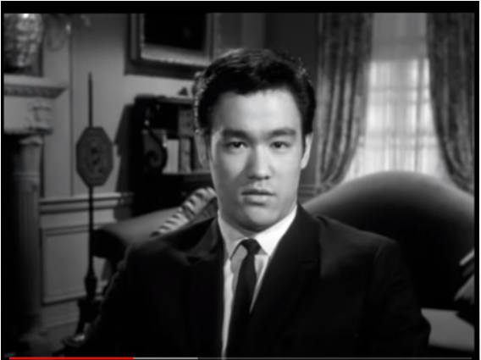

**Figure 9** Bruce Lee’s film audition in 1965

(<https://www.youtube.com/watch?v=k2BKNDc48N4&t=> )

Domination and the merge of Okinawa were done not only for enlarging Japanese territory but also for exploiting the profit of the trade with the mainland China and Taiwan.

Especially, Meiji government imposed quite heavy tax after the merge in 1879 to recover from the domestic war against the shogunate. The tax was so heavy that Okinawan people even couldn’t afford to buy a food and suffered from hunger.

At the same time, suffrage of Okinawan people was approved more than 10 years later than the mainland

Hoping for a better life, Okinawan people made their groups and migrated to Hawaii, North America, and South America. Although the population of Okinawa is only 1% of the population of Japan, the population of Okinawan origin people in Japanese immigrant society is as much as 10%.

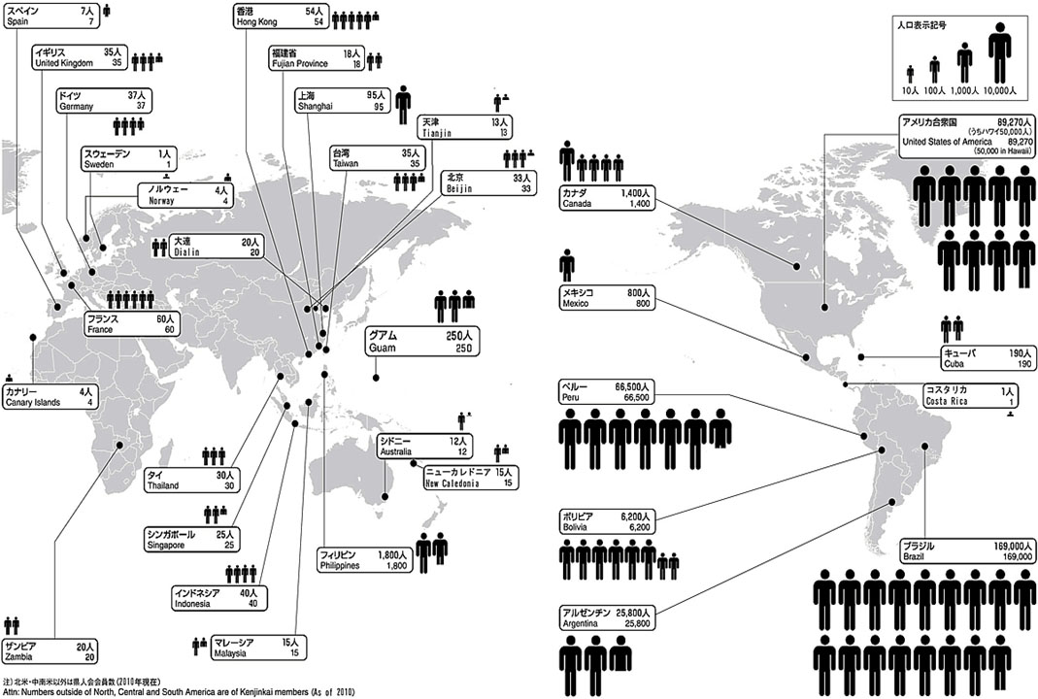

**Figure 10** The population of Okinawan origin immigrants (<http://www.discovernikkei.org/ja/journal/2015/8/18/okinawan-1/> )

Many of Karate experts also immigrated to all over the Pacific coast. They continued their practice and instruction of Karate and even demonstrated in front of the locals.

So, the international recognition of Karate was established by the ordinary in contrast to Judō which was encouraged to spread around the Western society by the government.

For the martial arts experts who didn’t have a patronage from the government, challenging against the local fighters or champions were the way to the success.

Not only Karate experts but also Judō and Sumō wrestlers had a betting match. When Japanese radical militarism gained more power in the 1930s, even this kind of fights started to be used for a propaganda.

Oyama Masutatsu (1923-1994) after whom Ryu was modelled after was also one of these ambitious fighters.

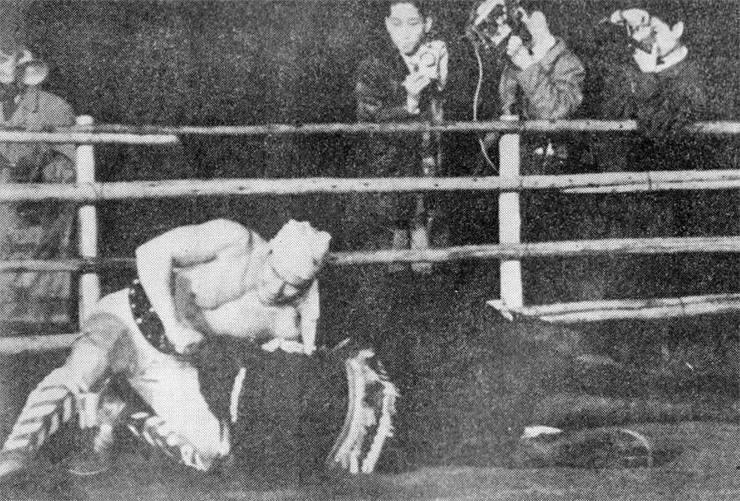

**Figure 11** Photograph of Oyama fighting with a bull in1954 (taken by Japan Sports Publishing)

He was a Korean man living in Japan and learned Karate to have a successful career in the Imperial Japanese Army, however, he failed the entrance exam for a military school and his ambition were not granted.

But he was a mighty Karate fighter who became a national champion in 1947 which was the first Karate tournament after the WWII. His Karate was specialized in combative skills and he proved its powerfulness by challenging against the fighters of different disciplines and even against an angry bull.

**Discussion 3.4**: Does hearing the historical and cultural context of Karate change the way how you perceive Ryu? Or do you think it also affect your experience when you play Ryu or other Karate characters in the video games?