4.1 Ninjutsu as a martial art and Ninja we imagine

**Questionnaire 4.1**: Before you start reading 4.1, please answer the questionnaire from the link in bellow. The questionnaire is equivalent to one attendance.

<https://docs.google.com/forms/d/e/1FAIpQLSffb9DkalPJqR8huaoeGuWFUv_X_F8lUpufHhq14KWBYl-0qQ/viewform?usp=sf_link>

So far, we have seen how the Japanese martial arts itself and its disciplines such as Judō and Karate had changed under the influence of historical events, social situations, and some reformers.

The topic of this week, Ninjutsu/Ninja, had greatly changed in time but in a quite unique way than the other disciplines.

Probably, the most popular Ninja character would be Naruto who knows how to use his chakra to make his doppelgangers and control a fire, water, and a soil, etc.

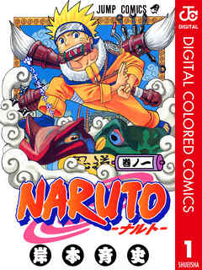

**Figure 1** The cover of *Naruto*, vol.I (by Kishimoto Tadashi, (2000), Shueisha Publishing : Tokyo) Do you recognise the similarity between Figure 1 and some of the illustrations in Questionnaire 4.1?

But it was not that Ninjutsu really enabled one to do something like Naruto. Such imagination was developed apart from the actual history, in the representations of popular culture in Edo period.

First, let’s take a look at the modern history of Ninjutsu/Ninja and feel their discrepancy.

It sounds very rational and understandable for us that Jujutsu and Kenjutsu was taught in the Imperial Military Schools of Japan. (Jujutsu/Kenjutsu was written as “-jutsu” and not as “-dō” in the curriculum which I’m mentioning (Figure 2). It’s already suggestive, isn’t it?)

But doesn’t it surprise you to know Ninjutsu was also seriously taught in Imperial Japanese Military School in Nakano (Tokyo) (hereby, the Nakano School) which was specialised in training for military intelligence before WWII?

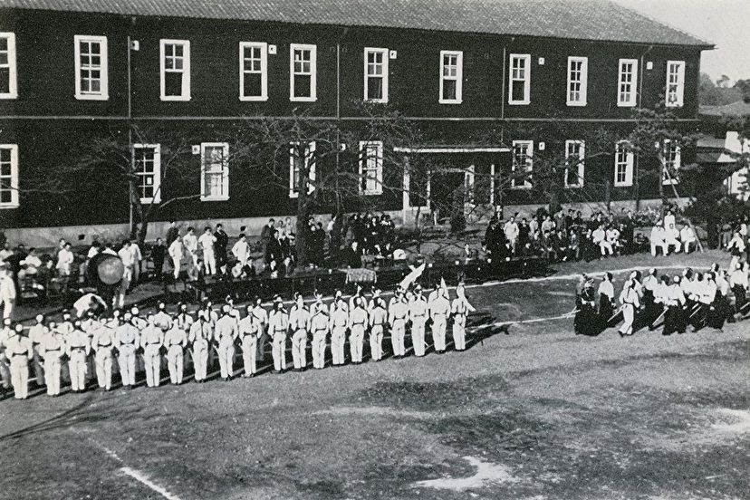

**Figure 2** Photograph of the Nakano School from *Rikugun Nakano Gakko* (ed. Alumni Association of the Nakano School, 1978, Hara Publishing: Tokyo)

The Nakano School which was one of the two secret organization of Imperial Japanese army (another one was 731 troop which dealt with bioweapons) had produced a number of secret agents and agents specialized in guerrilla tactics from 1938 to 1945, and Ninjutsu was taught for the first three years of the school.

According to the curriculum of the Nakano School, Ninjutsu course was categorised differently from other martial arts. The course was taught in classroom as a lecture and not in a dōjō, and the main topic was about the mindset of Ninja (in the same category, legal medicine can be found in the next to Ninjutsu).

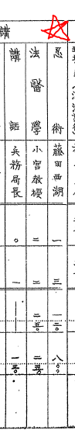

**Figure 3** A curriculum of the Nakano School in 1940. The lecture was planned for one day (120 minutes), but it turned out for three days (800 minutes)(the whole book is available from here (written in Japanese): <https://www.jacar.archives.go.jp/aj/meta/MetSearch.cgi> )

The lecturer Fujita Seiko (1898-1966) was the 14th successor of Kōga-ryu Ninjutsu along with other combative skills (of course, shuriken skill is found among them!) as a descendant of Oniwaban-shu which was a Ninja troop served for the shogunate.

He had published two books on medicine and a book on spiritualism before the opening of the Nakano School, and the books on Ninjutsu was published after the opening of the school.

Just like Kanō Jigorō modernized Jujutsu to Judō by making it suitable for education use, Fujita also wished to make Ninjutsu a working knowledge by sharing some secret lessons of Ninja as a necessary education for military intelligence.

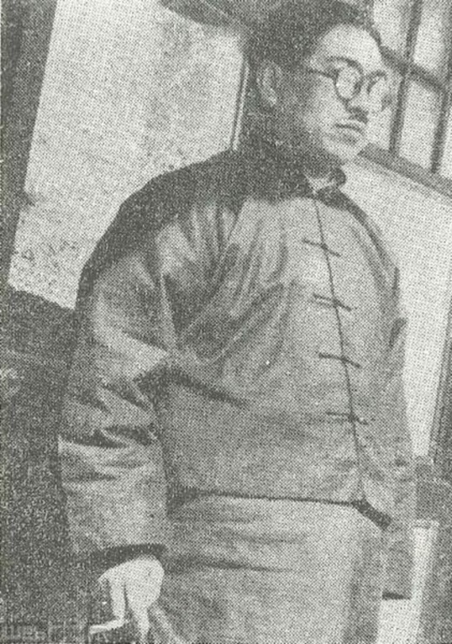

**Figure 4** Photograph of Fujita Seiko from his autograph *Saigo no Ninja Doronron* (*The Last Ninja Doronron*) published in 1958

In Fujita’s early works on Ninjutsu, *Ninjutsu toha* (*What is Ninjutsu*) published in 1938 and *Ninjutsu kara Supai-jutsu he* (*From Ninjtsu to Spy-jutsu*) published in 1942, he repeatedly denied that Ninjutsu is not about transforming into a rat, a dragon, or a toad, or making the hand signs to brow a fire or do something supernatural, and it had never been such kinds.

He explained the techniques of Ninjutsu should be used to explore a target location and grasp essential information like geography, economic system and nationality, and in wartime, to agitate the targeted people’s mind.

Because Fujita wished to exhibit Ninjutsu as something scientific and logical like the spy techniques of the West, to deny the supernatural fantasies over Ninjutsu as “grotesque” was necessary.

And instead, he defined Ninjutsu as a Japanese spy technique which resembled to the one in the West, however with a spirit of Bushidō which, in Fujita’s definition, doesn’t allow one to surrender even when he/she knows their defeats.

The fact that Fujita had to mention such fantasies over Ninjutsu/Ninja each time shows how such super natural image of it were wide spread and had a power over the people’s image in the 1930s.

In the next section, we’ll look over the trajectory of Ninjustu/Ninja from the medieval Japan.