4.2 Trajectory of Ninjutsu/Ninja

Although foreign spies from Korea and China were already documented over 1000 years ago, the first historical document on Japanese Ninja could be found in the war tale titled *Taiheiki* written in the 14th century.

In *Taiheiki*, Ninja (referred to as Shinobi) appeared in the scene where a warlord was having a difficulty with breaking into a castle. Then the warlord ordered “one superior Shinobi” to sneake into the castle and put a fire under the screen of the night and rain.

Originally Ninja meant a group of people who were specialized in breaking into a target location and carry out a mission secretly.

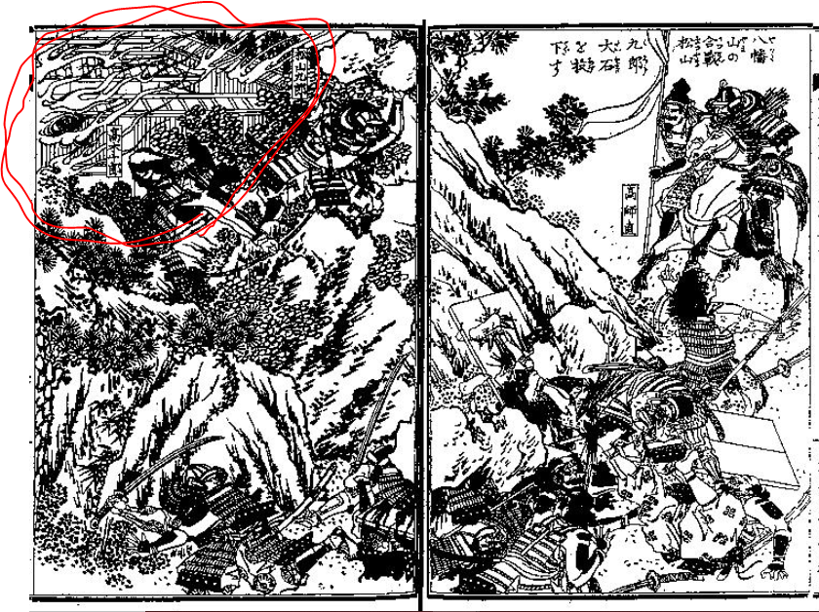

**Figure 5** A scene from *Taiheiki*, vol.XX. The circled area in the left is a castle put on a fire by a Shinobi (Ninja). (the whole book is available from: <https://dl.ndl.go.jp/info:ndljp/pid/878047>)

And in the illustrated books of *Taiheiki* like in Figure 5, we can’t find any Ninja is depicted. It could possibly mean that Ninja was totally a behind-the-scenes-job at the time.

Another historical document recorded similar kind job carried out by “Shinomi” (a corrupted form of Shinobi (= Ninja)) in the 16th century. In this case, the Ninja (Shinomi) disguised himself and put a fire on a fence of a castle secretly.

The core meaning of the word Shinobi (in kanji, it’s written 忍, the same as Ninja (忍者).) also indicates what was an original specialty of Ninja. The word meant “thieving someone’s property without forcing.”

They were specialists of disguising themselves, sneaking into, and carry out something doesn’t require an operation of force.

It seems it didn’t change for a while.

There is a collection of one hundred poems on the life of Ninja (in this book, still referred to as Shinobi) created in the 17th century, titled *Yoshimori Hyakushu* (*One Hundred Poems of Yoshimori*).

At the time when *Yoshimori Hyakushu* was created, Japan was in the middle of the Age of Civil Wars when Ninja should have been the most active under the warlords. And after the period, their activities became even more invisible since the shogunate banned the any conflict between the lords.

The collection tells us that Ninja was also a kind of Samurai but had a different kind of life and virtue from usual Samurai.

Among the poems, some encourage you to deceive your surroundings for a mission and never to feel ashamed of it, and others tell you that Ninja (Shinobi) doesn’t need to be strong but be smart and suggest you to avoid fighting with enemies for Ninjutsu is not a combative skill.

Of course, Ninja had fought if necessary, but they were not supposed to aggressively join a battle.

Therefore, the realty of Ninja could be quite different from the image we have about them.

And also, the reason why this section doesn’t have any illustration was because I couldn’t find anything depicted Ninja prior to Edo period. It indicates they were not focused and not popular among the people at the time.

In early Edo period when selected Ninja clans were hired by the shogunate as officers, a lengthy book explains the way of the Ninja appeared, which was titled *Bansenshukai* (*Ten Thousand Rivers Gathers to the Sea*, 22vols.).

As the title indicates, lessons and techniques of various Ninja clans were gathered in this book.

Normally, such essence of their clans had been kept only among the members of the clan via a hand-scroll, however, just like how the techniques of Jujutsu survived when they lost the patronage, to gather the knowledge and to document them was a way to preserve the tradition also for Ninja.

This book was only circulated via hand-copies, however, the fact that they shared such lessons even among limited communities proves that the value of the secrets of Ninja had dropped somehow in the time of peace in Edo period.

The book was even dedicated to the shogunate in 1789 which makes the knowledge public to the non-Ninja samurai.

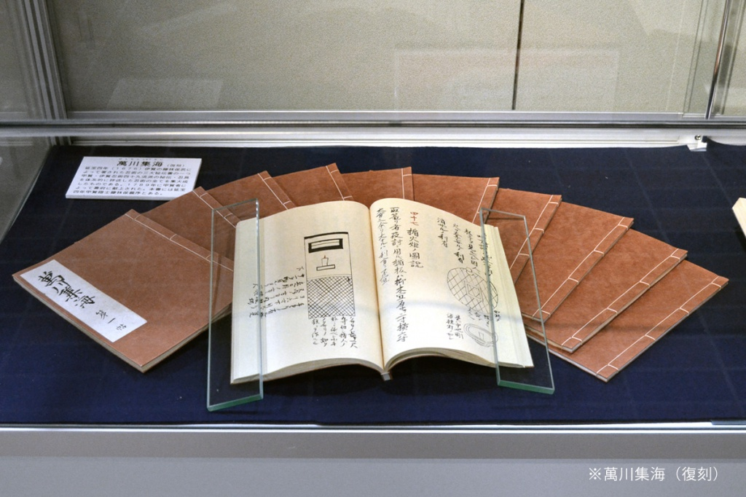

**Figure 6** Appearance of the Ninja textbook *Bansenshukai* (*Ten Thousand Rivers Gathers to the Sea*, 22vols.*)* written in 1676.

The book starts with the desirable mindset to become a good Ninja as a sense of justice, and it continues to the explanations on the usage of the Ninja items or the survival tips (not something peculiar, such as edible plants, recommended portable rations, and how to make a shelter), and then it starts to persuade you not to deceive the others throughout two volumes.

It also deals with assassination, but only one volume was given to this topic.

In comparison to the morals and survival tips, defeating a target had less importance for Ninja in Edo period.

It seems that the life of Ninja was much less spectacle in realty.

However, in our imagination, Ninja is fighting heroes who use some tricks and supernatural powers.

How had such image been created?

Discussion 4.2: We have seen how the required morals of Ninja had changed in time. And Fujita Seiko who was mentioned in the previous section taught the three necessary virtues to become a good Ninja as a sense of justice, intelligence, and an ability for measuring with eyes. Were there any change or morals interest you? If so, describe the reason why you find it interesting, and if not, try to speculate what influenced on the changes in the morals of Ninja.