4.3 Soecerers and Ninja

In the Questionnaire 4.1, I posted the four illustrations in bellow. Which one did you mark as a Ninja?

Actually, only one among them is an illustration of Ninja.

Let’s check the correct answer.

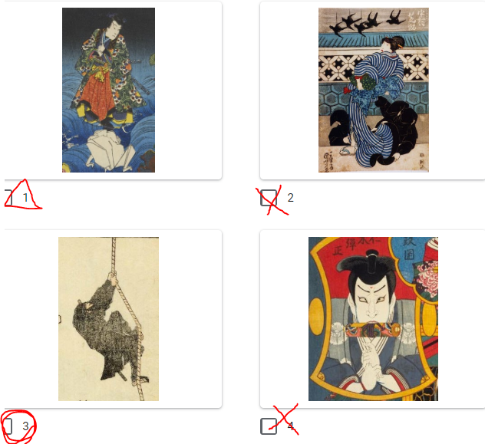

**Figure 7** Did you guess correctly?

**1=Jiraiya**

Some of you might recognise by his name because of Jiraiya in Naruto who was a great Ninja and could summon many kinds of toads using his hand-scroll.

Jiraiya in this illustration is a model for Jiraiya in Naruto, however, most importantly here, he wasn’t a Ninja originally but a sorcerer.

He was a quite popular fictious character and appeared for the first time in 1806 as a lone samurai and a chivalrous robber who could summon toads.

In later adaptations of the story, another storyline was added that Jiraiya were trained under a hermit, and his wife was Tsunade who summons gigantic slugs, and his rival was Orochimaru who summons serpents. (yes, they are all from the same story)

Just like when the Western art works depict a well-known person, the woodblock-prints also have attributes to indicate their subject. In the case of Jiraiya, a symbolic finger sign and a big toad under his feet was his attribute. (there is another character whose attributes are the same as Jiraiya, and he was also a sorcerer who was trained by a Christian (further information on Tenjiku Tokubei:

<https://en.wikipedia.org/wiki/Tenjiku_Tokubei>)).

**2=Kuroko (a behind-the-scenes-supporter)**

Kuroko is a name of a profession, an actor-assistant of Kabuki stage dressed all in black.

How they dress themselves resembles to Ninja, but they have no skills of intelligence agents. They were on the stage to assist an actor with changing his costume quickly on the stage or to hand items to an actor.

The reason why they dressed all in black was not simply because it doesn’t stand out on the stage, but also because it meant that “they are invisible.” And this is also the reason it has been considered as a typical Ninja costume.

Then let’s try with another example.

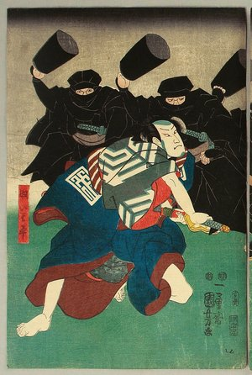

**Figure 8** A scene from the kabuki stage of *Tenjiku Tokubei* (1851-1853)

(<https://ja.ukiyo-e.org/image/artelino/40372g1> )

Are they Kuroko? Or Ninja?

In this case, they can be judged as Ninja because they bear swords in the sashes.

But it was not that Ninja was walking around in this style. In a town or village, this all in back costume would rather stand out. In realty, hey dressed quite normally like the commoners, only, they wore a reversible kimono.

The disguise which was recommended in *Bansenshukai*, the Ninjutsu manual mentioned, was a monk, a medicine vender, an illusionist, a mountain priest, a dance performer.

**3=Ninja**

It’s how Hokusai, the greatest woodblock-print artist, illustrated Ninja in his *Hokusai Manga*.

**4=Nikki Danjo**

Nikki is a villain in a successful kabuki repertoire titled *Meiboku Sendaihagi*.

He was a high ranked retainer of a lord, and at the same time, he was a sorcerer who could transform himself into a rat (into a small one when he wants to collect some secrets, into a gigantic one when he has a fights).

In many cases, he was depicted with a hand-scroll, a symbolic finger sign, and with a rat.

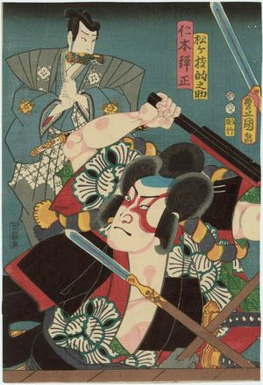

**Figure 9** A man in the back is Nikki

(<https://ja.ukiyo-e.org/image/mfa/sc165917> )

So, we can see that among what we recognise as features of Ninja, there are many elements added by the people’s imagination and quite some of them came from the characteristics of Japanese sorcerers.

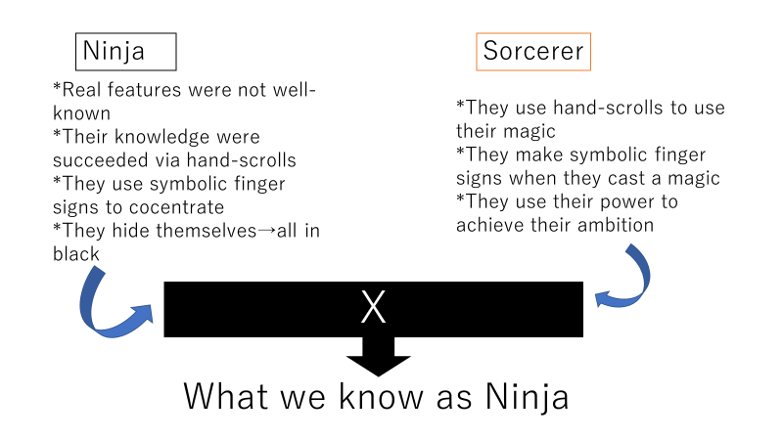

**Figure 10**

It’s also understandable that people fantasized about Ninja gave them such supernatural power, because their activities were kept as secrets and they stayed as mysterious dark troops.

And the merge between Ninja and sorcerers happened also because the real life of Ninja stayed unknown for the people even after the mountains and the Christians were no longer something mysterious.

For the artists, it became much easier to say “he had a supernatural power because he was a Ninja” than to make up some Daoist or a Christian which people no longer felt a magical power.

The trendiest form of performance at the time when the merge happened was live storytelling.

Performers had to interest their audience with dramatic and exciting stories, and of course, with their skills. And Ninja was a suitable motif for storytelling.

Ninja is more free from the communities than a samurai, but they act to achieve their mission, they could do something tricky, and there were enough space for fictional fights since their life were in a mystery.

Discussion 4.3: In comparison to Samurai, Ninja is more internationalized. Since, Vega in *SFII* was created as a Spanish Ninja, and in the famous Hollywood series *007* (*You Only Live Twice*, 1967), James Bond became an instant-made Ninja (in 22pege of the script, you’ll find the conversation: <https://www.scripts.com/script-pdf/23868>). And more examples could be found like the foreign troops named themselves as Ninja

(<https://en.wikipedia.org/wiki/Ninja_(disambiguation)> ). Which factor of Ninja make it easier to create non-Japanese version of Ninja than samurai?