5.1 Female characters in videogames and female warriors (fighters) in fighting games

**Questionnaire 5.1**: First please add five images both of female martial artist characters and male characters to each Padlet wall

(female characters: <https://padlet.com/yukostromeinner/et8jqqh1zmsmdcww>

male characters: <https://padlet.com/yukostromeinner/p5gp6tzwhdoe8mbw> ). You don’t have to choose all from the Japanese characters, but it should contain at least one among five. Or you can also choose the images of the same character to see its development.

I added the first five characters on the wall. Please put also their names and the titles and the years of release.

And then proceed to Questionnaire 5.1().

The representation of female characters in videogames is currently one of the topics which have been actively discussed regarding to different levels of diversity from the 2000s.

Here I give several recent issues as examples.

1. <https://techtalk.currys.co.uk/tv-gaming/gaming/diversity-in-gaming/the-expert-take.html>

2. <https://metro.co.uk/2019/01/30/diversity-in-gaming-isnt-about-pushing-a-politically-correct-agenda-it-challenges-privilege-8407517/>

3. <https://www.gamedesigning.org/gaming/diversity/>

4. <https://www.mcvuk.com/business-news/new-report-into-diversity-in-games-confirms-a-distinct-bias-in-favour-of-the-young-white-straight-male/>

5. <https://www.businessinsider.com/women-in-video-games-2016-7#a-game-with-an-all-male-cast-is-more-approachable-5>

The diversity which they’re talking about could be categorised three different levels, the diversity of the characters in the games, of the developers, and of the targeted audience, and, as you can see in these articles, all three levels are closely related. Because video games are commercial product which developers design them to appeal a certain group of audience and they use their previous successes and failures as a data.

Those articles pointed out that, since the industry is male dominated and male-oriented, the games are also designed for those majorities, and the female bodies tend to be displayed for the gaze of men.

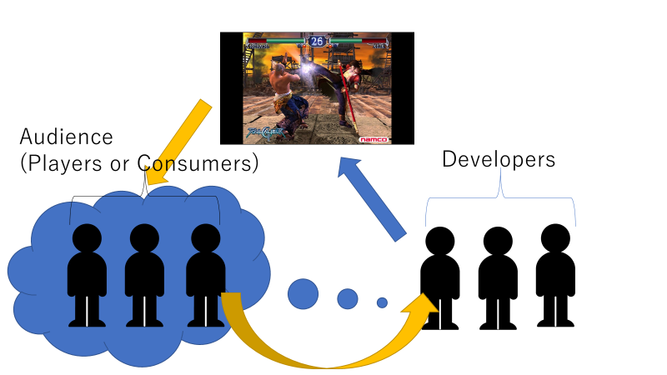

**Figure 1**

There are other perspectives on this matter.

Rachael Hutchinson (2015, the article is available from the library of Edmodo) studied gender stereotypes in Japanese fighting games, Soul Calibur and Tekken series particularly.

Hutchinson pointed out the representation of both genders were “hyper-sexualised”, male characters with extremely muscular body and female characters with hyper-feminized body.

Her main focus was to examine how such stereotypical representations of genders effect on the players and she placed a survey of 55 students.

Among her interviewees, a student speculated the reason why the fighting games tend to represent both gender hyper-sexualized that, since there was absence of character narratives in this genre, such extreme representations were necessary to make each character stand out.

In the beginning of the article, Hutchinson mentioned also her recognition that the characters are basically “constructed as strong and powerful fighters in their own way.”

Looking at those discussions, we can probably realize that there are two different perspectives in this problematic matter, if we see it as a matter of representation of women or female warriors (fighters).

If it was a latter, those character designs should represent an idea of strength and power as Hutchinson mentioned.

In the next section, we’d like to see the historical representations of female warriors in Japan.

**Discussion 5.1**: About the ten images in total which you added to the Padlet walls, why did you choose those images? Did you find any other stereotypical descriptions than gender differences?