5.2 Historical representations of female warriors

Perhaps, the most famous female warrior in Japan is Tomoe-gozen who appears in several war tales regarding to the epic battles between two major samurai clans, Genji and Heike, in the 12th century.

Tomoe was a favourite concubine and a trusted combatant of a powerful general of Genji.

Her strength was described with her splendid skills of archery and riding horse which corresponded to the idea of a competent samurai at the time (as we’ve seen in Week 2), and her fantastic physical strength which was emphasized with a vivid episode that she “twisted off” a head of a male warrior who was also famous for his physical strength.

In addition to her strength, the narratives samely emphasized her beautiful appearance by using the word 美女 (a beautiful woman).

Here I quote an English translation of *Tale of Heike* by Hellen Craig McCullough (1988) in which Tomoe appears.

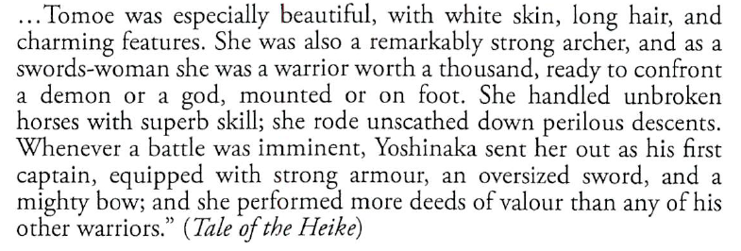

At this point, we still can’t know if it meant that she was strong “and” had a feminine beauty or she was strong “but” had feminine beauty.

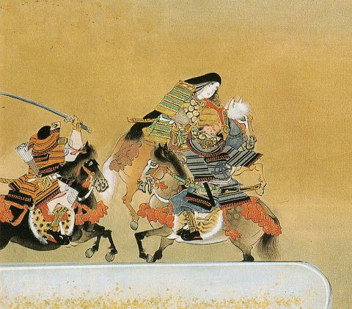

**Figure 2** Image of Tomoe twisting off the head of a samurai in *Heike Monogatari Emaki* (*Illustrated Scroll of Tale of Heike*) created by Tosa Sasuke in early Edo period.

However competent she was and highly praised in the stories, she was not treated equally to the men.

When the general was on a rout, she survived with the general until his army became the last five warriors. But she wasn’t allowed to join his last battle and had to leave the battle field against her will.

The general said to her “Go, quickly. You’re a woman. Run away to anywhere! I would like to die in the battle, and am ready to kill myself when I get caught by our enemies. And it’ll be a shame on me if somebody gossips about me after my death that I was accompanied by a woman at my last.”

And in the visual representations to this day, the strength of Tomoe tends to be emphasized with a contrast with her femininity.

As it can be observed in the examples bellow, she was depicted with her black (or silver in Figure 6) long hair hang down which would be not practical and not wearing a helmet.

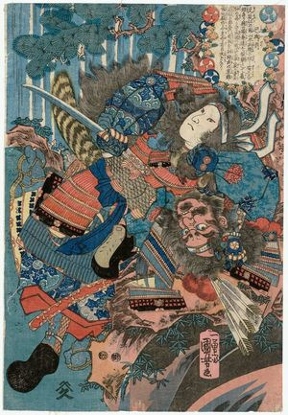

**Figure 3** Image of Tomoe twisting off the head of her opponent by Utagawa Kuniyoshi in 1840

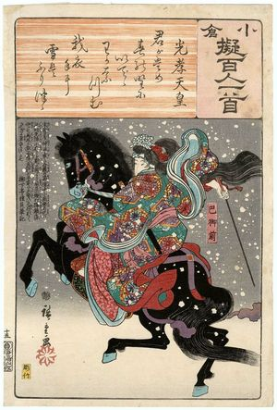

**Figure 4** Image of Tomoe by Ando Hiroshige in 1845-1848.

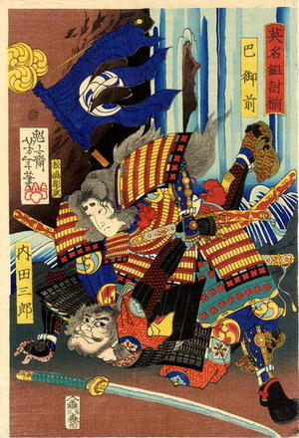

**Figure 5** Image of Tomoe by Tsukioka Yoshitoshi in 1865.

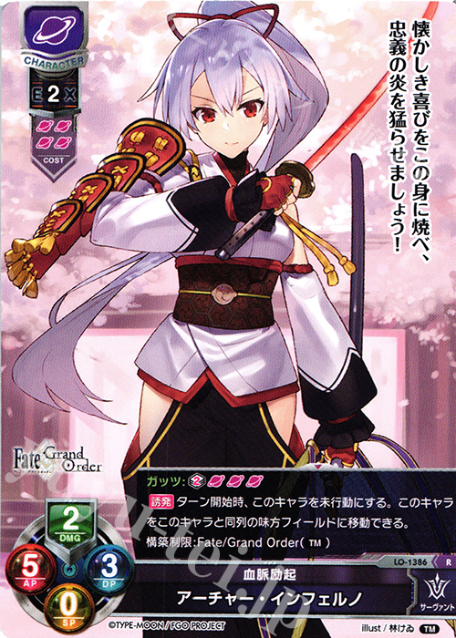

**Figure** **6** Image of Tomoe in the video game *Fate/ Grand Order* (2015). The line in the upper-right says “Let’s burn the fire of loyalty, lighting up myself with the familiar joy.”

In the representations of Tomoe, we’ve seen that her feminine beauty and her strength was treated like a pair, and, particularly in the visual images, the femininity was described more visible even if it looked unpractical in a real fight.

So, perhaps we can say that, the feminine beauty has been included in the idea of strength and power of female warrior in Japan, although it doesn’t mean the femininity provided a higher or equal respect to the female warriors as the male warriors received.

**Discussion 5.2**: If you compare the historical representations of female warriors in your culture with the case of Tomoe, are there some similarities, or some differences be found?