5.3 Social recognition of female martial artists in Japan

Apart from the representation (but it’s not completely irrelevant), how were the female martial artists and the practice of martial arts among women historically perceived in Japan?

Now we see, for example, Judō or Karate matches separated by gender and perceive them as normal.

However, according to Mizoguchi Noriko (2013, in *Sei to Yawara* (*Gender and Yawara*), Tokyo: Kawadeshobō), gender was not definitely separated before the modernization of Judō by Kanō Jigorō.

Mizoguchi introduced two female Jujutsu experts in the end of 19th century who made it their profession, one was a bonesetter just like the Jujutsu master who trained Kanō and another was a head of a dōjō. They also trained their male pupils and the pupils of the both genders were training together.

When all the martial arts were suffered from the collapse of their social status and losing the patronage from samurai, the names of those female experts also appeared on the list of the licensed performance match along with the names of other male martial art experts.



**Figure 7** Image of a performance match of Miyamoto Ohana on 27 May in 1873 depicted by Utagawa Toyokuni IV. And the list of the match in the right.

But this also doesn’t mean the female experts were respected equally to the male counterparts.

In the performance matches of Kenjutsu (sword fighting), there were also female participants.

A Kenjutsu practitioner looking back those matches told that young female fighters were exceptionally welcomed because they could attract more audience and there was a rule that male fighters must let the women win. Later, Kanō also introduced this attitude into his Judō and banned mixed-gender matches to “protect vulnerable women” and put a white line in the female black belts which means they’re “honorary black belts.”

And the weapon which the female fighters were determined to use in the Kenjutsu performances was Naginata, a Japanese glaive.

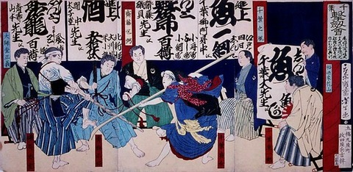

**Figure 8** Image of the performance match of Chiba dōjō in 1873. A woman who holds a Naginata was a daughter of the dōjō and Kenjutsu expert.

Originally, Naginata was used particularly among the monk-warriors in Japanese medieval era, but it started to be recommended for women of samurai families as a form of self-defence and self-development in Edo period when the training methods of martial arts became safer.

Therefore, at the time of the performance matches in the end of 19th century, Naginata was considered as a feminine weapon, although men also practiced Naginata secondary to Kenjutsu.

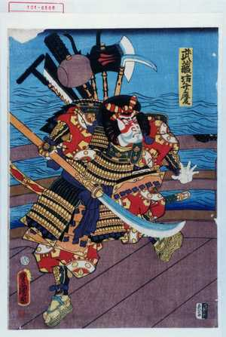

**Figure 9** Image of a depraved monk in the 12th century Benkei holding a Naginata designed by Utagawa Kunisada in 1859.

As the fact that the promoters invited specifically young female participants to the performance matches and made them use Naginata which could define their gender indicates, they were not simply considered as a fighter but they were displayed as sexual objects to the male audience as well.

Other examples which can support this ambiguity of the position of female martial artists are the ways how the mass media have treated them.

In Mizoguchi’s article, she mentioned a news paper articles which reported an incident occurred to a female Judō expert and a bonesetter Matsumoto Nai.

One evening, Matsumoto was assaulted by four ruffians and defeated all of them.

*Hōchi Shinbun* reported this incident shortly with mentioning Matsumo’s beautiful appearance twice as a contradictive feature against her strength, and the illustration also visualised both the incident and her beauty (in Figure10).

From the 1900s, the newspapers and magazines started to use a word 女流 (woman-handed) when they mention female martial artists to distinct the gender more clearly.



**Figure 10** News report on Matsumoto’s achievement in *Hōchi Shinbun* in 1875 (no.551).

The female martial artists which we have discussed so far were in a way “a mainstream” whose specialties and skills were certified by their schools and socially recognised.

There were also martial art practitioners outside of the mainstream in premodern Japan whose matches were excuses to provide some spectacles for the audience.

Whereas Sumō matches between muscled healthy trained male wrestlers were considered sacred so that they even have been dedicated to the gods, the matches between almost naked amateur young women (from 14 to 25 years old), disabled people, and between those minorities and animals were rather considered as a show called “peculiar Sumō”, similar to the circus in the West at that time.

The male professional wrestlers were equally exposed and, apart from the amateurs, there were also professional female Sumō wrestlers who were also almost naked at the matches.

However, peculiar Sumō were banned by the shogunate and the Meiji government many times because they could disturb public morals while the professional Sumō tournaments have not been criticized with the same matter.

It was after the social elites became sensitive with the gaze of the Westerners in the 1890s when the nudity started to be restricted more strictly and female wrestlers were determined to wear uniforms. (The popularity of Sumō also dropped temporary because the appearance could be seen primitive and uncivilized in the Western ideas).

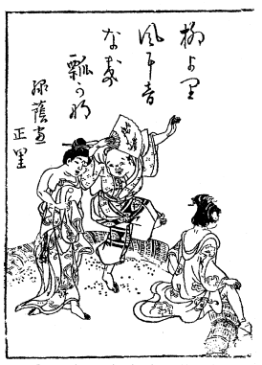

**Discussion 11** Image of “peculiar Sumō” in *Azuma Miyage* (*Souvenir from East*)

We have discussed how the female martial art practitioners had been treated historically.

The appreciation for the physical strength the martial art skills of female warriors (fighters) had changed in time and the controllable and moderate strength became more appreciated in modern Japan. But the way of representation of a female martial artist as a beauty stayed the same.

We still can’t judge if the expression of feminine beauty came out of the idea of strength and power or because it was more favourable for men.

However, we’ve observed that these two factors have been connected already for a long time.

**Discussion 5.3**: Do you think the representation of martial artist characters in video games are equally hyper-sexualised in general, or it is only applied for female characters? And what kind of expectation can be underlying in such character designs? Describe your idea.