6.1 Katana as a popular motif

**Questionnaire 6.1**: Please open the two Padlet wall from last week (female characters: <https://padlet.com/yukostromeinner/et8jqqh1zmsmdcww>

male characters: <https://padlet.com/yukostromeinner/p5gp6tzwhdoe8mbw>). Please add the descriptions of the nationality and the fighting styles to the images you posted. And add two each new characters who fight with fight with sword(s) to the both walls, among them at least one should be a character who fights with **Japanese sword(s)**.

After you added images and descriptions, decide one character which you focus on this week and proceed to Questionnaire6.1

(https://docs.google.com/forms/d/e/1FAIpQLSfI82COOoS2tm9VrD9XwxVrm0T7pozn4I1irncrdSObpMEaUQ/viewform?usp=sf_link). We tried overall observation last week, so let’s review the deeper character analysis this time.

In Japanese pop culture, Katana holds a special position.

In the manga *Bakuman* which was created by the same artists as *DEATH NOTE* (2003-2006) and serialized in the weekly comic magazine *Shōnen Jump* from2009-2012, there is a conversation between two protagonists (Figure 1), Moritaka (with black hair) and Akito(with a glasses), who determined to become a successful manga artist pair of *Shōnen Jump* which serialised some of the most popular mangas in Japan, such as *SLUM DANK, ONE PIECE, NARUTO*.

Since the conversation provides interesting insights about the position of Katana in pop culture, I would like to translate the lines here.

Akito: ……But I found out that popular mangas have something in common.

Moritaka: !

Akito: It’s Katana. Katana is present in such as *NARUTO*, *ONE PIECE*, *BLEACH* and *Gintama*. And there are many other mangas which deal with Katana or some sword-like weapons. They also commonly deal with battles and are set in unrealistic situations.

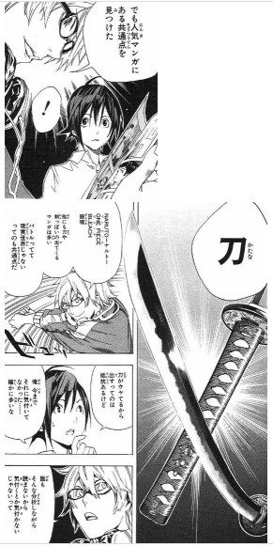

**Figure 1** A scene from *Bakuman*,vol. 3(Obata Takeshi and Ōba Tsugumi, (2009), Tokyo: Shueisha)

Although it was not based on actual statistics, it is true that Katana is a favourite motif of manga which involves battles.

Aside from Japanese manga, we can find heroes who fight with Katana also in Marvel and DC comics, such as Deadpool, Rōnin, Blade, and Psylocke in Marvel universe, and, Katana in DC universe. And Michonne in *Walking Dead*.

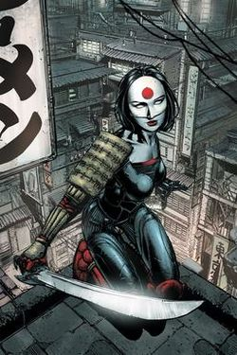

**Figure 2** Image of Katana (2013, depicted by David Finch)

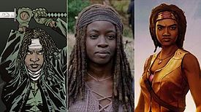

**Figure 3** Michonne in the comics version, TV series, and in the video game

And, in Hollywood movies, we have also Jedi masters in *Star Wars* series (1977-), and The Blide and Cotton Mouse in *Kill Bill* (2003, 2004).

Analysis of the characters will be a topic for the next section, but for now I just wanted to look over the international popularity of Katana as a motif.

In video games also, Katana is usually present even in the games which was set in an Occidental fantasy world. We might assume that it was originated from Japanese developers, however, it was actually a result of “reverse-import.”

In *Final Fantasy* franchise (1987-, developed by Square (now Square Enix)) which is one of the most celebrated JRPG titles, even though the world of the series is set looks Occidental and the characters who use these Katana also tend to have the Western names and body features, Katana appears as the most powerful weapons in the game (especially in the early titles of the series).

The most impressive example would be Sephiroth, an antagonist in *FFVII* with long silver blonde hair, and his gigantic sword Masamune.

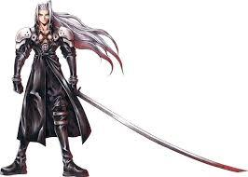

**Figure 4** Image of Sephiroth holding Masamune from *FFVII* (1997)

This combination between Occidental fantasy world and Katana was not an invention of *FF* series.

The early titles of JRPG genre, such as *FF* and *Dragon Quest* series (1986-, developed by Enix (now, Square Enix)) were developed not directly based on a tabletalk role-playing game *Dungeons and Dragons* (1974) but under the huge influence of a Computer RPG *Wizardry* (1981) which was much more successful in Japan than in America where it was originated.

In this game, Katana named “Murasama blade!” (it was corrected to the historical name Muramasa later) appeared as the most powerful weapon exclusive for Samurai class along with an equally powerful weapon Shuriken for Ninja class.

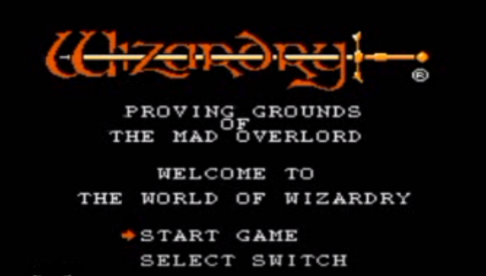

**Figure 5** A play screen of Wizardry (1981)

Originally, Asian or Japanese elements tend to be excluded from the Western fantasies, like you can see for example in *The Lord of the Rings*.

Robert Woodhead, a developer of *Wizardry* series, answered questions about the reason why he introduced Japanese elements in his game that his team was inspired by a trendy novel at the time *Shōgun* (1975) by James Clavell in which the sword Murasama (a misspelling of a cursed sword Muramasa or a legendary but not cursed sword Murasame) appeared as a powerful but cursed weapon and Ninja was present as well. The novel was even adapted into a TV drama in1976, a Broadway musical, and a game in 1986.

From the fact Samurai and Ninja was already present as a playable class in a Computer RPG titles, *Oubliette* (1977) and *Avatar* (1979), we can assume that people in America were already familiar with such Japanese terms and had a certain image of them already.

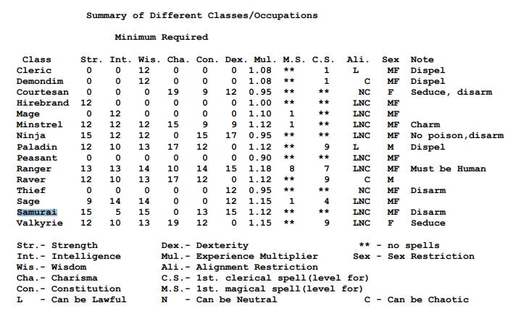

**Figure 6** A page from players’ guide of *Oubliette*

(available from : <http://www.zimlab.com/oubliette/plato/files/Oubliette-Additional-Player-s-Guide-version-1-0-PLATO.pdf> ). In this game, Samurai class can’t be armed with a sword and fights with fists while Ninja could bear a short sword. Probably, Katana was more related to Ninja than Samurai at that time.

In the interviews, Woodhead also repeatedly mentioned his view on the position of the game in the cultural context that *Wizardry* is a piece of chains of culture, because the game was influenced by previous games, novels, movies, and history, and it would also stream into the culture of the next generations. (the interviews are available from (I searched also English interviews but it seems only Japanese interviews are available):

<https://games.app-liv.jp/archives/102885>

and <https://www.4gamer.net/games/044/G004471/20160407001/> )

Perhaps, this can be a shared feeling among the game developers, since Kishimoto Yoshihiro who was a pioneering developer of Action games like Packman told that his source of inspiration is Japanese culture and history. (the one-hour long presentation is available from: <https://www.youtube.com/watch?v=wg2M33wqg7U> )

What we enjoy in the video games should be also related to the cultural and historical context and actually this is the idea which this course is based on.

In the next section, we’ll shortly look over the history of the reception of Japanese swords in the Western culture and consider possible factors which added the characteristics to Katana.

**Discussion 6.1**: In a previous lecture, we discussed possible reasons why close combat with Katana is much more popular in the video games in comparison to mounted archery which historically played more strategical importance.

Did you know that, there are movements to make single-player fighting games more historically accurate and more realistic?

(<https://www.pcgamer.com/how-melee-combat-in-games-compares-to-real-swordfighting/>) Do you think why the binary combat games were not included in this discussion although they both can be categorised as fighting games in a broader definition?