6.2 Until Katana get recognised as a deadly weapon in the West

In the early history, Katana was made of bronze, and not single-edged and curved like what we know as Katana. Bronze got switched by iron and steel by the 5-6th century, however, the blades were still straight and double edged for infantry battles where thrusting was mainly used than cutting.

It was around the 10th century when the curved single-edged swords which were suitable for mounted combat started to be forged. The length of hilt and blades was much longer and the weight was much heavier to take advantage of the height and speed of horses.

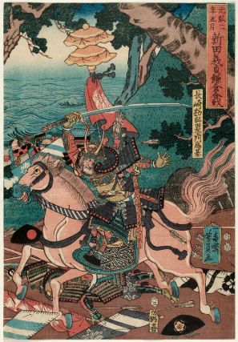

**Figure 7** Image of a warlord in the 14th century Nitta Yoshisada by Utagawa Yoshikazu in 1853. The length of his Katana looks equal to his height. But he was a person who realized the effectiveness of shorter swords (which equals to normal-length swords in later) in guerrilla tactics.

After guns were introduced by Portuguese in the mid-16 century, infantry went back to the position of the main combatant and the sword became shorter and lighter for better portability.

If you take a look at the point of the sword in Figure 7, you can see it’s pretty pointy. This was a characteristic of the swords which were designed for real battles which continuously occurred by the beginning of 17th century.

Until around this period, it was not only Samurai class who were allowed to carry a sword because of the huge need for more combatants.

In the peace of Edo period for around 250 years, for the sake of social stability, carrying a sword was only permitted for Samurai class.

It made Katana a status symbol for Samurai class, at the same time it was a weapon. Thus, the carriers started to pay more attention to the aesthetics of their Katana.

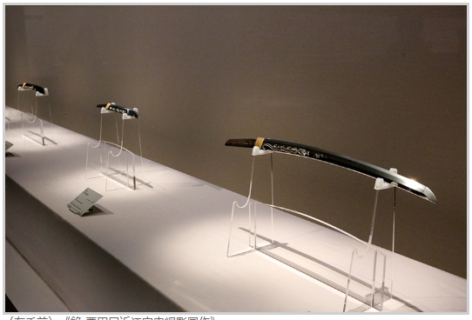

**Figure 8** Photo of an Exhibition of Katana made in Edo period in Nezu Art Museum in Tokyo held in 2015. (you can see that not only the blade but also the accessories were made beautifully from these videos:

<https://www.youtube.com/watch?time_continue=4&v=w4eudqKmvHA&feature=emb_logo>

<https://www.youtube.com/watch?v=pLbeOmhyFJE&feature=emb_title>)

The blades were designed more decorative with the familiar wave patterns on the edge and the less pointy tip.

With the splendid techniques of sword makers and sword accessory artists, Katana became a form of art while it’s still more than enough to serve its original role as a weapon. The edge was deadly sharp.

Katana was also a nice gift to strengthen the connections between one Samurai and another.

In the first encyclopedia of Japan *Things Japanese* (1890) written by an English scholar Basil Hall Chamberlain, all those aspects of Katana, a weapon, a status symbol of Samurai, and an art craft were already mentioned (his explanation is available from the Library and the information system of the University).

But what impressed the Westerners the most at the time was its scary sharpness, as Chamberlain himself said “Japanese swords excel even the vaunted products of Damascus

and Toledo. To cut through a pile of copper coins without nicking the blade is, or was, a common feat.”

There were many incidents that foreigners got severely injured or assassinated by a party of anti-foreign Samurai with Katana in the 1850-1860s.

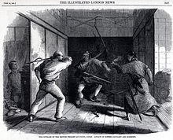

**Figure 9** Image of an attack of Samurai party on British Legation in Edo (now Tokyo) in 1861 published on *London Illustrated News* on October 12, 1861.

The vivid descriptions of the fears of such attacks of Samurai with Katana which the Westerners in Japan felt and the reports of the assassinations in Japan in the newspapers accelerated the image of Katana as a deadly bloody weapon.

It remained as a symbol of negative aspects of Japanese people, greediness, cruelty, and vengeful character, even after Meiji government placed an order of abandoning swords for the former Samurai class in 1877.

And this image was even more emphasized in war propaganda of the allies of the United Nations in WWII, as the title of a book *The Chrysanthemum and the Sword: Patterns of Japanese Culture* (1946) indicates. Chrysanthemum symbolized the positive features of Japanese people while sword symbolized the opposite.

It seems it was in the 1970s when Katana entered into American pop culture.

After the decease of Bruce Lee in 1973, American TV producers and Hollywood were seeking a new fighting hero figure. The social context of the appearance of Bruce Lee in the screen was a movement of Woman’s Liberation from the late 1960s, so the alternative of him must have been from the side of minority like Asians, if it were not for women.

Thus, Ninja who uses acrobatic martial arts, shuriken, and swords slowly became their favourite subject in the 1970s.

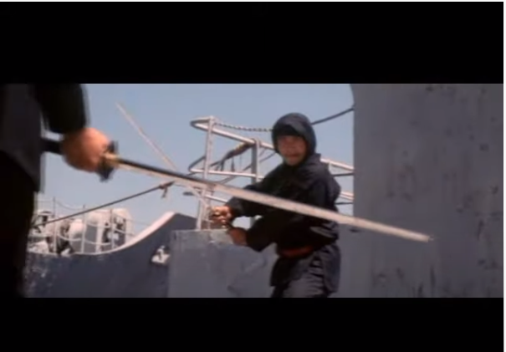

**Figure 10** A scene from *Killer Elite* (1975)

(the scene is taken from: <https://www.youtube.com/watch?v=HgTuubaRD1Y>)

The novel which I mentioned in the previous section *Shōgun* by James Clavell was produced in that trend.

And the later footstep of how those Japanese elements merged with the Western fantasy world was as we’ve seen in the previous section.

**Discussion 6.2**: It is said that *Bushido Blade* (1997, the play screen is available from:

<https://www.youtube.com/watch?time_continue=23&v=7rRFbsihnxo&feature=emb_logo>) is still a masterpiece of fighting games with swords although it’s less acrobatic than the other games

(<https://www.eurogamer.net/articles/2017-03-19-20-years-on-bushido-blade-remains-a-unique-fighting-game>). After watching the play screen(s) of *Bushido Blade*, was it close to what you expect from fighting games or not?