6.3: Character analysis of the fighters who uses Katana

As we’ve seen in the first section, regardless of nationality or gender, there are plenty of characters who fight with Katana.
Can there be common characteristics of them?

Let’s start with analysing Sephiroth from FFVII who I mentioned in the first section.
Sephiroth is anti-hero character who appeared in the game as a mighty soldier and was described as a hero from the start of the game, even the protagonist Cloud also admired him.
He could be considered as a half-Japanese based on the names of his parents although his appearance has more Occidental features.
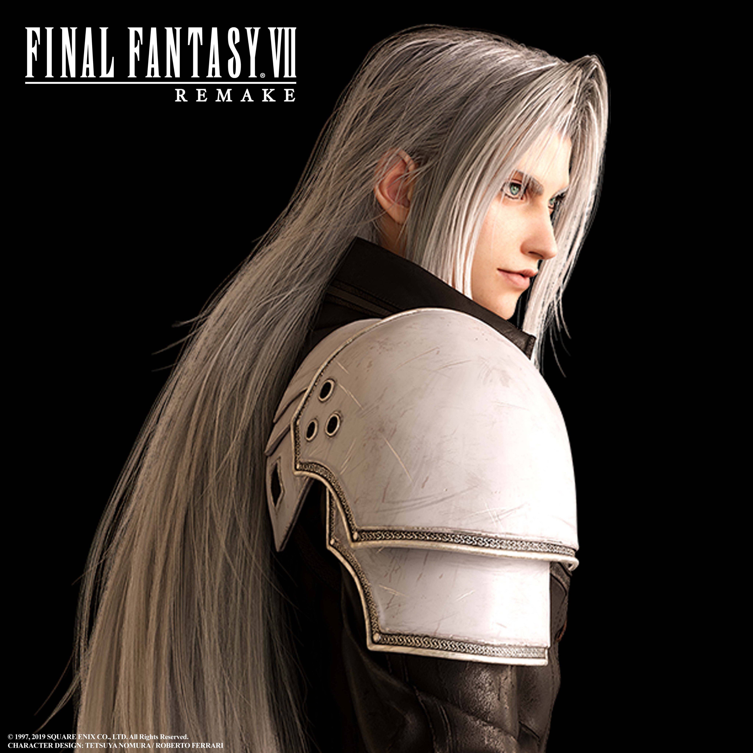
Figure 11 Image of Sephiroth from FF VII Remake (2020)

There is no specific feature in his costume which show a feeling of Japanese except for his sword. His physique is slender build and tall.
His character is cool, rather distant from the people which his black costumes and the tone of the character voice emphasizes, but brave and sometimes show a compassion. At the same time, he has hatred for human being because of a series of tragedies related to his birth.

As far as I seen some of the features of him could be applied for other characters in the other medias who fight with Katana (as the characters in Figure 12 and 13 show), and they could be summarized as following.

1. Katana users tend to have slender build physique
2. they tend to be described as an ambivalent character with a cool or distant aspect and a passion
3. they tend to have experienced tragedies and it made them more distant (or anti-her like)

Especially, the characteristic1 could be related to the previous perceptions of Katana as an extraordinary sharp blade because it can mean that heavy muscles are not needed to fight good with Katana.

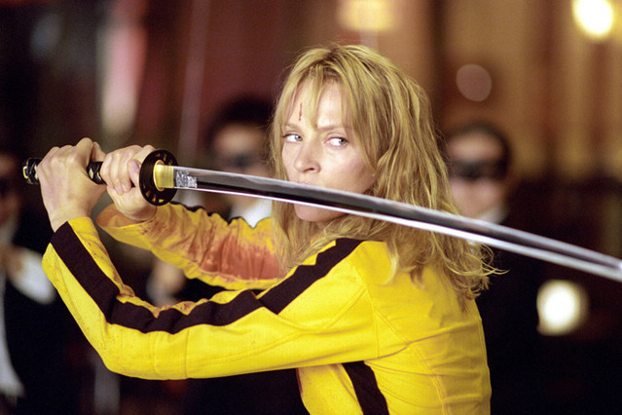
Figure 12 A Scene from Kill Bill ( the fighting scene is available from: https://www.youtube.com/watch?v=uSjS_l3wGu8&t=
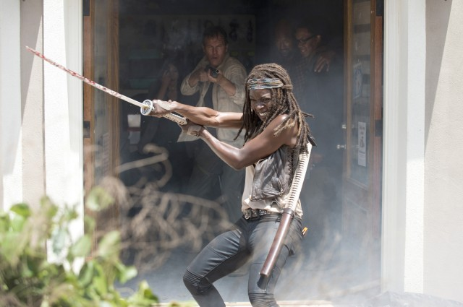
Figure 13 A scene from The Walking Dead
(Michonne’s fighting scene can be seen from: https://www.youtube.com/watch?v=cj8wmFFTKRo )

Discussion 6.3: Try to analyse the character you chose in the Questionnaire 6.1. Does it have something in common with my short analysis? If so, why do they have similar features?

