**INSTRUMENTAL**

S KIM? / ČIME? Putujemo s **Anom**. / Pišemo **olovkom.**

KUDA? Hodamo **gradom**./ Šetamo **ulicom.**

GDJE? PRIJEDLOZI: nad, pod, pred, među Stojimo pred **školom.**

KOLIKO DUGO? **Mjesecima** nisam bio u kinu.

KOJIM DANOM? **Srijedom** igram tenis.

KAKAV?/ S ČIM? Imam kuću s **vrtom**. / Pijem čaj s **limunom**.

1. *Upišite riječi u instrumentalu*

Radim s (poznati književnik) _______________________. Pišem (plavo pero) _____________________. Stojimo pred (moderni hotel) _________________________. Sjedim s ( simpatična studentica) __________________________. Razgovaraju s (svjetski liječnik) __________________. (petak)________________ idem s prijateljima u kino. Imam stan s (veliki balkon) ________________________. Vozimo se (crveni tramvaj) _________________________. Ne vole putovati (avion) _____________________. Na posao idem (trolejbus) _________________. Volim jesti pomfrit s (majoneza) ________________________. Pijemo čaj s (mlijeko) _____________. Mačka je pod (drveni stol) ____________________________. Pas je pred (malo dijete) ____________________. Imamo krov nad (glava) _____________________. Paul se bavi (vrtlarstvo) __________________________. (nedjelja) _________________ idemo na Sljeme. Kutija je pod (dječji krevet) __________________________. Fotografije su na polici nad (računalo) ______________________. Djeca su pred (osnovna škola) ______________________. Tko je pod (bijeli prozor) _____________________. Leti putujemo (Jadranska obala) ______________________. Djed i unuk hodaju (duga ulica) ____________________. Goran je došao (stari kamion) ______________. Idem s (stari prijatelj) ____________________ u kazalište. Dinko se vozi (nova žičara) ________________________. Letimo (žuti balon) ______________________________.

1. *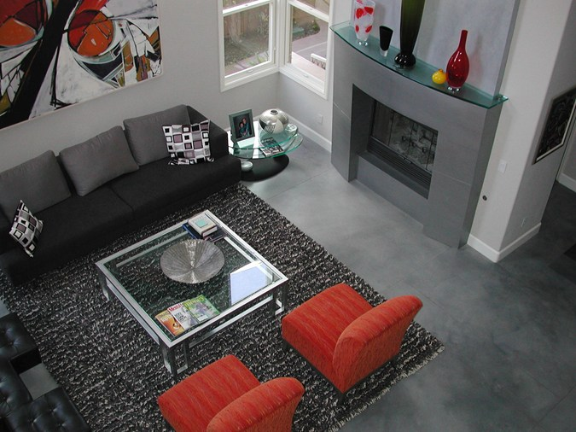Opišite prostoriju. Upotrijebite prijedloge u instrumentalu.*

*Stol je __________________________________________. / Slika je _______________________. /*

*Kamin je ___________________________. / Tepih je _____________________________________ .*