AJL22066, AJL52066 & AJLA22066
PRONUNCIATION VARIETIES OF ENGLISH, Spring 2021
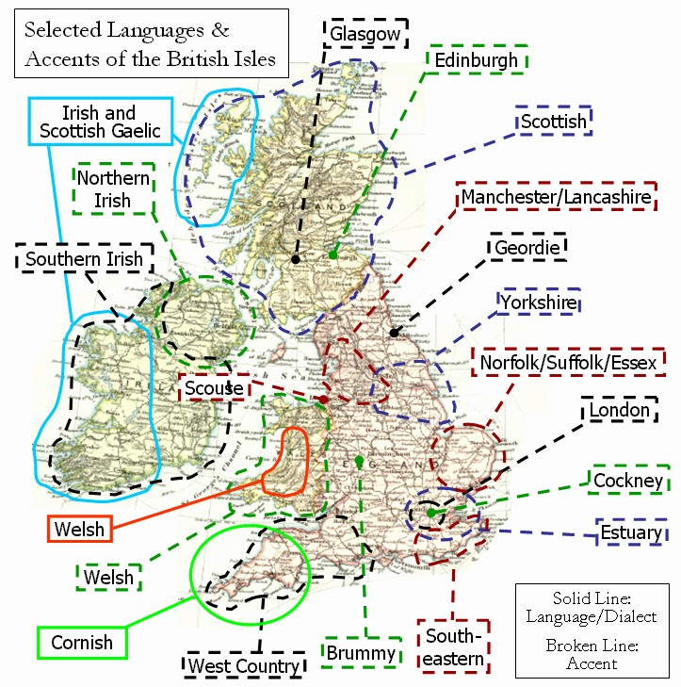

Sessions: Fridays 0800-0945,
Join Zoom Meeting
https://cesnet.zoom.us/j/96925438174

Facilitator: Kateřina Tomková, 2060@mail.muni.cz

Compulsory listening:
J.C.Wells – Accents of English, recordings in IS Study Materials
Collins and Mees – Practical Phonetics and Phonology,
recordings in IS Study Materials, with tapecscipts
Youtube: - ‘The English Language in 24 Accents’
‘A Tour of the British Isles in Accents’
‘One Woman, 17 British Accents’
‘Educating Rita for educational purposes only’
‘Christopher Cazenove in Three Men and a Little Woman’ (=Lady)
Online sources: Sounds Familiar langlit; Accents Archive browse

Literature:
Basic phonetic and sociolinguistic terminology and concepts
Accents of English by J.C.Wells, chapters presented in class
International English by Trudgill / Hannah, chapters presented in class
Accents and dialects for stage and screen by Paul Meier

Requirements:
- Attendance: 3pts/session x 11=max. 33pts
- Final test max. 50pts
- Contributions, up to 17pts

Syllabus
W1 - March 5
Introduction. 3 components of each session: theory, listening, speaking.
Literature. Terminology. Web sources.
6 credits represent 150 hours of work.
Wells’ triangle, Trudgill’s chart and Tomková’s three presentations.
Listening to Tracy Ullman’s sketch “A sociopath goes for a job interview“ and reproducing it in breakout rooms.
HW:
- listen to J.K. Rowling’s commencement speech of 2008, and complete the tapescript in Study Materials which also contains the link to recording;
- The secrets of a posh accent: http://www.theguardian.com/lifeandstyle/video/2014/sep/22/secrets-posh-accent-video-riot-club-vowels
- Compare the smoothing to W. Churchill’s in his Fulton speech of March 4, 1946 coining the phrase “iron curtain“: www.youtube.com/watch?v=S2PUIQpAEAQ
- listen to Tomková’s presentations 1-3

W2 - March 12
0800 - questions, queries, Rowling speech, smoothing in the Guardian recording
and by W. Churchill
0820 - Trudgill's chart, the use of [ˈdʌbɫjəˈdʌbɫjəˈdʌbɫjəˈdɒʔˈtʰaɪpɪtˈɔːg]
Collections of Errors
0830 - Standard British English, GB, RP, upper-RP
0835 - Z. Jelínková - Features of UpperRP
0850 - rec. Meghan+Harry Interview;
prep. for "How to speak during coronavirus" listening and analysis of video /p/, /t/, /k/
0900 - Tracy Ullman's sketch
0905 - rehearsing sketch in BR
0920 - Performing sketch in the main session, conclusion

HW: exploring 2 social varieties in Educating Rita, Anglican vicar stereotype in The Three Men and a Little Lady.
checking channel Eat Sleep Dream English (‘Adele’= check for lapses in terminology) and sketches by T. Ullman (pure enjoyment)
studying ‘Tomková AmE vs. GB suprasegmental behaviours’, see subfolder THEORY

W3 - March 19

0800-0830 – in reference to St. Patrick’s Day, Irish English: St. Patrick Day Song, Irish Girl Blow Up School, White Orange and Green, the
Irish Lidl Song, Famine (Sinéad O’Connor). A phonetic description of the accent using phonetic terminology from Meier.
0830-0900 – in breakout rooms, rehearsing and performing the ‘Sociopath’ sketch (full tapescript in RECORDINGS AND TAPESCRIPTS).
0900-0930 – theory: the historical development of English, the need and rise of the standard, accent vs. dialect, social roles and stereotypes,
Abercrombie (Mariia), Upton (Yurii).
HW: watch sum-up recordings A tour of the British Isles in Accents https://www.youtube.com/watch?v=-8mzWkuOxz8 ,
A tour of the UK and Ireland in accents
One woman, 17 British accents https://www.youtube.com/watch?v=FyyT2jmVPAk

W4 - March 26
Sum-up recordings summed up. RP revisited (PP+P 1, 2), the North-South divide.
My Fair Lady, Adele in Eat Sleep Dream English, Super Duper Jezebel, Honey, Upton.
MLE, Cockney Learn English with Papa TeachMe, The Slobs (Harry Enfield and Chums),
Michelle M., Janet Street-Porter, the recording in PP+P,
Estuary English and SE England
The rhotic SW: Bristol, Hampshire. Funny Welsh Man, Bristol recording from PP+P.

No classes on April 2 – Good Friday and April 9 = Reading Week

W5 - April 16
Revision of SE: Cockney rhyming slang, MLE, Essex Girl jokes, Bristol in PPP
South and North Wales: in Wells, Funny Welsh Man, Reaction, famous Welsh people, an MP, Luke Evans
Midlans: in Wells, Julie Walters: that’s Another Story

W6 - April 23
- Collection of errors: ALTERNATE, DUPLICATE. COUNTIES AND SHIRES.
- Discerning accent(s) in Terry the Odd Job Man (Táňa S.)
- North of England: the historical, economic, industrial, agricultural conditions for accents and dialects
- Scouse-Mersyside (Lucie H.)
- Mancunian-Lancashire
- Yorkshire-Leeds
- Geordie-Tyneside with Durham Instagramer (Mariia M.) 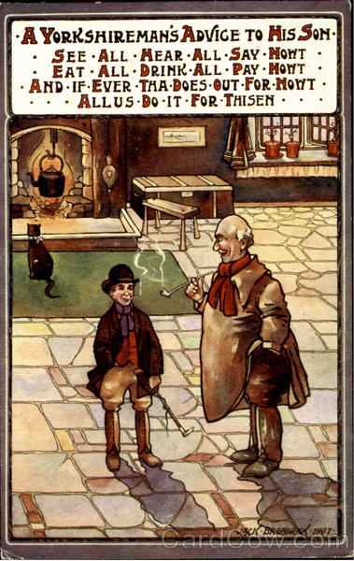
- Northern accents in TV series (Marie S.)

W7 - April 30: THE BROGUE
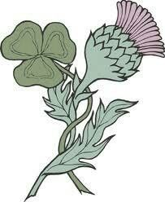

0800 Miscellaneous: Lucie H. presents the BL Archive of Accents
Revision, discerning accents: Ema and Veronika play their speakers' recordings respectively making the class localise their accents
0820 Scottish English: ppt presentations by Ella:
Scottish_accent_made_simple.pptx
http://is.muni.cz/de/462687/mail_prilohy/2021-04-30_09-42-15/Scottish_accent_made_simple.pptx
and Ema: Glaswegian, in Study Materials
Bára's video recommendations
/Trainspotting/

0900 Irish English: presented by KT with video recommendations by Lucie and Ella,
discussion and observations on th-stopping
0920 Northern Irish English=Ulster Scots /Derry Girls; In the Name of the Father/

W8 – May 7
EE accents overseas: - Australia – Waltzing Matilda, Penal Colony, Peter D., young mother, Congress of Radiology.
2 aspects of Cockney DS, close vowels, centring dipththongs, flapping, upspeak.
History and stuff: Australia. Famous people, films. B. Homolková’s findings.
- New Zealand – Amy Walker 21 Accents Aus vs. NZ: enter your pin. D*ck Maintenance.
NZ Airlines commercial.
Aboriginals, Maoris.
recommended by Hana Kovačičová: www.radionz.co.nz/collections/kiwi-accent
- South Africa – the Dutch footprint. Trevor Noah, RK

W9 - May 14
Warm-up: a classic musical piece identified; Tok Pisin Tok Pisin (Papua Nová Guinea) (muni.cz)
Technology prep for final test.
Yurii’s revision compilation video on southern England: https://youtu.be/K3921DbFX1g
Similar for Midlans and the north of England: English varieties Midlands North - YouTube
Celtic varieties: https://youtu.be/KNmJ9V4wDOQ
Foreign and second-language varieties in: - Europe: the Germanic, Romance and Slavic varieties (Yurii, Darya)

W10 - May 21
- India: Rochana Jayasinghe’s ppt
Ondřej Hudec’s recommendations: https://www.youtube.com/watch?v=z7MIyQS9p5E https://www.youtube.com/watch?v=OoF4i77kPak
https://www.youtube.com/watch?v=v9arM_agKFA
Mariia Minaeva’s recs: India coronavirus: 'My city is under siege from Covid' - YouTube
When a Frenchman calls an Indian Call Center : The iRabbit - YouTube

- Africa: Chris James, Top 10 English-speaking countries: Top 10 English Speaking Countries in Africa - YouTube
Klára Klepalová‘ recs: SA “plucking“ intonation: South African Accent Intonation - YouTube
SA vs. AUS, NZ: South African vs. Australian accents - YouTube
Test yourself: Guess the English Accent! - YouTube

MOCK TEST.

W11 - May 28
Feedback of MOCK TEST, CREDIT TEST.

