**Chapter 2: Creation myths**

Spanish part: texts from **Hugo Portela Guarín**, *El Pensamiento de las Aguas de las Montañas* (Coconucos, Guambianos, Paeces, Yanaconas), 2000, Universidad del Cauca, Popayán, Colombia.

***How from One Many were Born:***

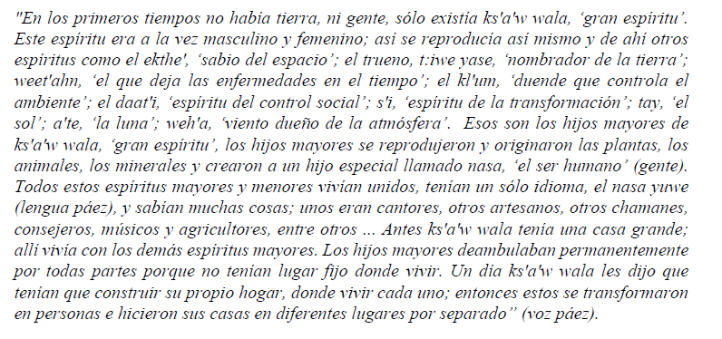

***Conflict with the Sun, Tay***

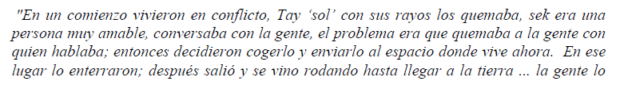

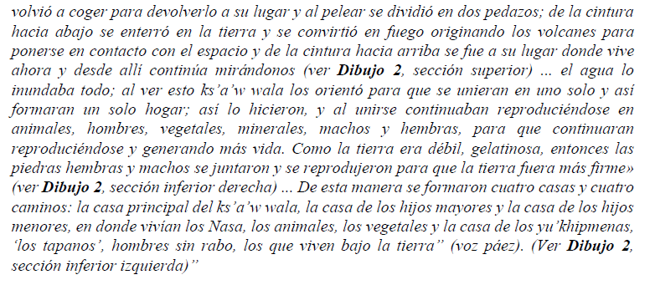

***The World as the Hat***

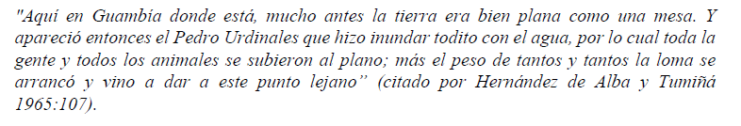

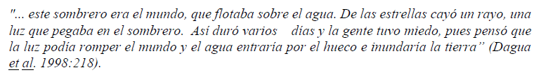

***Water and the Star***

