AJL22066, AJL52066 & AJLA22066
PRONUNCIATION VARIETIES OF ENGLISH, Spring 2022
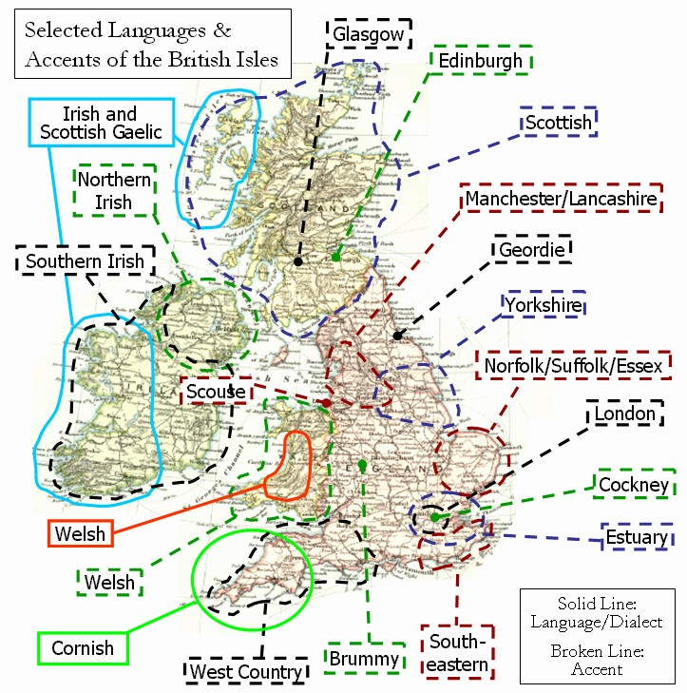

Sessions: Fridays 1000-1140, room G31

Facilitator: Kateřina Tomková, 2060@mail.muni.cz

Compulsory listening:
J.C.Wells – Accents of English, recordings in IS Study Materials
Collins and Mees – Practical Phonetics and Phonology,
recordings in IS Study Materials, with tapecscipts
Youtube: - ‘Eat Sleep Dream English’
‘The English Language in 24 Accents’
‘A Tour of The UK and Ireland in accents’
‘One Woman, 17 British Accents’
‘Educating Rita for educational purposes only’
‘Christopher Cazenove in Three Men and a Little Woman’ (=Lady)
Online sources: Sounds Familiar langlit; Accents Archive browse

Literature:
Basic phonetic and sociolinguistic terminology and concepts
Accents of English by J.C.Wells, chapters presented in class
International English by Trudgill / Hannah, chapters presented in class
Accents and dialects for stage and screen by Paul Meier

Requirements:
- Attendance: 3pts/session x 12=max. 36pts
- Final test max. 50pts
- Contributions, up to 14pts

Syllabus
W1 – February 18
Introduction. 3 components of each session: theory, listening, speaking.
Literature. Terminology. Web sources.
6 credits represent 150 hours of work.
Sting-Russians.

W2 – February 25
Intro: How to Speak During Coronavirus (FUNNY!) - YouTube
Schools of thought: the Prague School, UCL, Sociolinguists. EE standards.
Tools: Wells’ triangle, Trudgill’s chart, Tomková’s three presentations in LM, “howjsay“, „“typeit.org“.
HW: Exploring 2 social varieties in Educating Rita, Anglican vicar stereotype in The Three Men and a Little Lady.
checking channel Eat Sleep Dream English (‘Adele’= check for lapses in terminology) and sketches by T. Ullman (pure enjoyment).
Studying ‘Tomková AmE vs. GB suprasegmental behaviours’ (see subfolder THEORY).
Checking JELINKOVA RPxURP on Study Materials main page.

W3 - March 4

Accents of today as a result of the historical development of English by M. Kräussl.
The sociolinguistics of accents by Čanecký (up to Projecting an image).

HW:
- listen to J.K. Rowling’s commencement speech of 2008, and complete the tapescript in Study Materials which also contains the link to recording;
- The secrets of a posh accent: http://www.theguardian.com/lifeandstyle/video/2014/sep/22/secrets-posh-accent-video-riot-club-vowels
- Compare the smoothing to W. Churchill’s in his Fulton speech of March 4, 1946 coining the phrase “iron curtain“: www.youtube.com/watch?v=S2PUIQpAEAQ
- listen to Tomková’s presentations 1-3

W4 - March 11
Katia Kvinge Weather Forecast.
Segmental and suprasegmental aspects of EE presented and practiced.
The Youglish site (A. Fučková).

W5 - March 18
After St. Patrick’s Day = Celtic accents = the BROGUE. See IRISH CLASS.
Presentation by Ema Bícová: Scottish English; Glaswegian.
A guest appearance by Nate Lindgren on Panjabi Muslim and Sikh speakers.
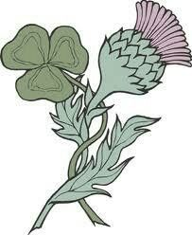

W6 – March 25
South and North Wales: in Wells, Funny Welsh Man, Reaction, famous Welsh people, an MP, Luke Evans.
Sum-up recordings summed up. RP revisited (PP+P 1, 2), the North-South divide.
My Fair Lady, Adele in Eat Sleep Dream English, Super Duper Jezebel, Honey, Upton. MLE, Cockney Learn English with Papa TeachMe, The Slobs (Harry Enfield and Chums), Michelle M., Janet Street-Porter, the recording in PP+P,
Estuary English and SE England
The rhotic SW: Bristol, Hampshire. Funny Welsh Man, Bristol recording from PP+P.
Revision of SE: Cockney rhyming slang, MLE, Essex Girl jokes, Bristol in PPP
Midlans: in Wells, Julie Walters: that’s Another Story

W7 – April 1 – All Fools‘ Day
- Collection of errors: ALTERNATE, DUPLICATE. COUNTIES AND SHIRES.
- Discerning accent(s) in Terry the Odd Job Man (Táňa S.)
- North of England: the historical, economic, industrial, agricultural conditions for accents and dialects
- Scouse-Mersyside
- Mancunian-Lancashire: a paper by Martina E-Z.
- Yorkshire-Leeds
- Geordie-Tyneside with Durham Instagramer (Mariia M.) 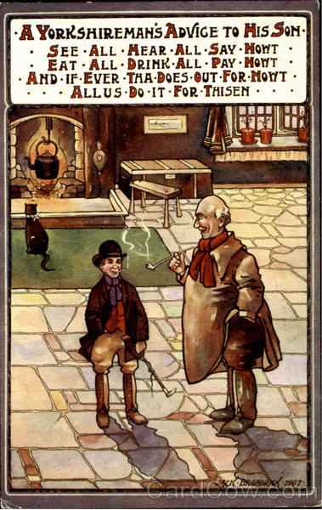

W8 - April 8
NE continued. A paper by Jana Z.

NO CLASS ON APRIL 15 = GOOD FRIDAY.

W9 – April 22
EE accents overseas: - Australia – Waltzing Matilda, Penal Colony, Peter D., young mother, Congress of Radiology.
2 aspects of Cockney DS, close vowels, centring dipththongs, flapping, upspeak.
History and trivia: Australia. Famous people, films. B. Homolková’s findings.
- New Zealand – Amy Walker 21 Accents Aus vs. NZ: enter your pin. D*ck Maintenance.
NZ Airlines commercial.
Aboriginals, Maoris.
recommended by Hana Kovačičová: www.radionz.co.nz/collections/kiwi-accent
- South Africa – the Dutch footprint. Trevor Noah, RK

W10 – April 29
- Discussion with a visitor
- A quiz in discerning accents
- Imperial legacy accents

NO CLASS ON MAY 6 = TUTOR’S MEDICAL APPOINTMENT.
Self-studying Yurii’s revision compilation video on southern England: https://youtu.be/K3921DbFX1g
Similar for Midlans and the north of England: English varieties Midlands North - YouTube
Celtic varieties: https://youtu.be/KNmJ9V4wDOQ

W11 - May 13
- India: Rochana Jayasinghe’s ppt
Ondřej Hudec’s recommendations: https://www.youtube.com/watch?v=z7MIyQS9p5E https://www.youtube.com/watch?v=OoF4i77kPak
https://www.youtube.com/watch?v=v9arM_agKFA
Mariia Minaeva’s recs: India coronavirus: 'My city is under siege from Covid' - YouTube
When a Frenchman calls an Indian Call Center : The iRabbit - YouTube

- Africa: Chris James, Top 10 English-speaking countries: Top 10 English Speaking Countries in Africa - YouTube
Klára Klepalová‘ recs: SA “plucking“ intonation: South African Accent Intonation - YouTube
SA vs. AUS, NZ: South African vs. Australian accents - YouTube
Test yourself: Guess the English Accent! - YouTube

MOCK TEST.

W12 - May 20
Feedback of MOCK TEST, CREDIT TEST.

