**[James Brooks](https://www.artforum.com/print/reviews/196804/james-brooks-71400" \o "James Brooks)**

**Martha Jackson Gallery**

The surfaces of the paintings by James Brooks, at the Martha Jackson Gallery, the product of the past two years, carry the imprint of Pop color and technique like an infection which has dried their skin and hardened it into rigid inexpressiveness. Colors like blue verging on aqua, flesh tan, acid green and black predominate, and Brooks’s paint-handling—which isolates shapes by filling in dark grounds around areas of lighter color—makes the figures and grounds seem not so much the result of drawn or stroked paint as the slightly unsynchronized deposit of color in a silk-screen lithographic stencil process.

In 1961 Brooks expressed dissatisfaction with the kind of painting he had done in the 1950s, which had functioned in terms of the agglomerative. principle of an evenly inflected fabric of figurative incident. “I want to present a more completed painting,” he said. “I would like to absorb the accident. I would like a quieter painting, a painting that is dumber, less articulate, that has fewer interesting parts and less fascination in the working of the parts. I want more meaning for the whole.” The example of “meaning for the whole” which Brooks seems now to be looking at is that of Kelly’s painting of the early 1960s where the distinction between figure and ground was negated by the propulsion of every shape to the surface of the canvas. This equalization of the figurative thrust of every area gave to the best of Kelly’s paintings a self evident wholeness and lucidity which Brooks seems to be trying to achieve. This seems to be the reason for his treatment of the black grounds of the recent paintings as though they were positive areas and accounts as well for the newer compositions like *Diston* and *Cullodon* which locate pockets of imagery at the edges of the canvas. But the paintings that result are minor decorations made up of familiar Brooksian shapes portentously set adrift on an inert black sea.

[**Neil Williams**](https://www.artforum.com/print/reviews/196610/neil-williams-68082)

**Emmerich Gallery**

Neil Williams’s paintings at the Emmerich Gallery exhibit a clear family resemblance to Frank Stella’s work. The shaped, flat canvases, the divisions of the surface into planes and bands of color that respond to the directive of that shape, the plasticity suggested by the direction of the colored surfaces—all would indicate that Stella and Williams share not only a common vocabulary, but also a common vision. But where Stella labors to expel from his paintings any trace of “composition,” of balancing one element off against another, or any intrusion of manifest illusionism, Williams’s pictures are highly composed. Surface decoration is balanced against illusionist depth, areas of color are balanced against one another across a divide of black, and the paintings, for all their modernity, finally read as sophisticated late Cubism.

*Center in Point*, like the other paintings in the gallery, is a shaped canvas from whose surface emanates the sensation of three-dimensional, geometric forms; cubic objects set at oblique angles to the wall seem to inhabit the painting at the same time as they form the decorative surface of the picture. *Center in Point* seems to be composed of a box on the right side, the forward surface of which is banded in violet, blue, yellow and white. The top of the box is formed of a black parallelogram. At the imaginary edge of this box the colored bands bend down to the left and suggest the presence of another box seen in isometric perspective. A black trapezoid again reads as a shadowy opening and a green plane capped with a red plane suggests a flipped-open top. Across the careful divide of black, the high intensity of the red/green area complements the cooler bands of color, which form a tonal succession, from the dark value of the purple to the higher values of the yellow and finally the white.

One is aware here of a use of black that first emerged in Cubist collage. At that time shading was pried from the objects to which it would formerly have given plastic substance. It ironically became a decorative counterpoint to the surfaces it no longer described. Transformed into symbols of three-dimensionality, the areas of shading were expanded into flat shapes which almost attained the weight and presence of objects.

In *Center in Point*, Williams has reintroduced the same ambivalent use of flat black. But as it shifts between an apparent density—as the surface of the picture from which the folded bands of color rise in a playful bas-relief—to a shadowy illusiveness—in back of the flat surface of oblique bands—one senses that decoration is being balanced off against illusion. The two are made to work in relation to one another, making a sensation of wholeness impossible. The fussiness that becomes apparent in Williams’s drive to compose finally gets in the way of one’s experience of the color and scale of the paintings.

—[*Rosalind Krauss*](https://www.artforum.com/contributor/rosalind-krauss)

[**Adolph Gottlieb**](https://www.artforum.com/print/reviews/196605/adolph-gottlieb-72066)

**Marlborough-Gerson Gallery**

The best paintings in Adolph Gottlieb’s recent show at Marlborough-Gerson seemed to be those that recapitulated his way of working in the 1950s, by placing one or two neatly bounded circular forms over a profusion of painterly, ragged shapes at the lower edge of the canvas. *Two Discs* of 1963 is one of these, and *Roman Three #2* (1963) is another, but a work which demonstrates a reduction in Gottlieb’s means, for in this canvas color differentiations are largely eliminated and black oils make the distinctions in facture necessary to determine divisions within the painting’s field. But Gottlieb has also carried this reductive tendency over to the treatment of the shapes themselves. In *Focal*, 1965, the eccentric painterly element of the earlier works is exchanged for a neatly executed square area of color-patches: tube colors applied in long thick strokes on the yellow ground. Instead of centering both the regular circle and the painterly shape along the central vertical axis as the earlier treatment of this motif invariably did, Gottlieb places the circle—a heavily painted green orb with a yellow, atmospheric halo around it—in the center and shifts the composite shape over to the lower right corner of the canvas. In so doing the two elements suggest a relationship to one another that is one of balance: an equilibrium arrived at moreover through a spatial, aerial medium. It appears then, that Gottlieb in giving up the axiality of his composition, since the cohesion of the image is no longer read through an organization dependent on the rationale of the support, reintroduces a rather uncontrollable illusionism into his work.

There is a strange similarity between *Focus*and Kandinsky’s work of the 1920s, where for all the careful geometry of the forms and the deadpan flatness of their execution, one realizes an absolute denial of the fact of the picture support. In *Concerning the Spiritual in Art*, Kandinsky asserted that to limit the picture to its surface was only to give it another material limitation. The picture plane must be destroyed, he felt, to make way for an “ideal” plane. Striving after either an ideal plane or a suggestively illusionistic field no longer seems to yield first-rate paintings. In Gottlieb’s case his more recent works shuttle between a partial illusionism and a partial control over the surface, and seem somehow to have been reduced and weakened in the process.

—[*Rosalind Krauss*](https://www.artforum.com/contributor/rosalind-krauss)

[**Morris Louis**](https://www.artforum.com/print/reviews/196606/morris-louis-76304)

**Andre Emmerich Gallery**

In the ongoing at tempts to chronicle the work of the late Morris Louis, a whole range of critics and historians seem to have fixed on a characterization of his sensibility as fin de siecle. In one of the first articles to categorize Louis’s art in this way, Robert Rosenblum speaks of the “languid, expansive beauty that newly evokes the exquisite hothouse atmosphere of the most precious Art Nouveau gardens,” (*Art International* VII, December 1963) and moves from this association to a reading of the paintings themselves (works from the period 1958–60) totally by means of romantic, vitalist metaphors. The pictures are like butterfly wings or quartz deposits or giant gaseous flames; they move toward the “elemental landscape” that Mr. Rosenblum sees in the late works of Turner and Monet and which he characterizes as symbolist. This initial association between the color veils of Louis and those of Loie Fuller seems to me to be mistaken, but it has been carried, in essays written since Mr. Rosenblum’s to a pitch of irrelevance and inaccuracy that is almost incredible. Daniel Robbins also pushes this thesis (Quadrum 18), backstopping his arguments with other writers’ remarks which presumably support his own. One of these is an observation made by Michael Fried that Louis addressed himself to the problem of creating a work of art that would, without representing or denoting objects, achieve the concreteness, within consciousness, of real objects; such a new form would be as free from the whims of either the artist’s or the viewer’s personality and associations as any other independent object or any “truth” can be. It is obvious that when Mr. Fried designates this desire as Symbolist in kind, he is not coupling Morris Louis with Louis Tiffany and is, in fact, denying that Louis directly represents organic images. Mr. Fried’s analysis of Louis is thus poles apart from the “fin de siecle interpretation” of that painter and seems to me to be the only ten able reading of Louis’s art.

At the Andre Emmerich Gallery, nine previously unshown paintings from 1958–60 are exhibited, giving one a new opportunity to see still more work from the period in question. These extraordinarily beautiful canvases, for all their great diversity in color range and chromatic density, have in common a treatment of the outer vertical edges of the color fields as nearing opacity, beyond which a translucent, lighter stain acts as the highlight of a backlit object. Thus, Louis’s fields from the very beginning assert themselves as self-contained object-worlds, not as illusions of, or metaphors for, organisms previously know or seen. As such, they are located within a tradition of abstraction rather than one of evocative nature symbolism.

—[*Rosalind Krauss*](https://www.artforum.com/contributor/rosalind-krauss)

[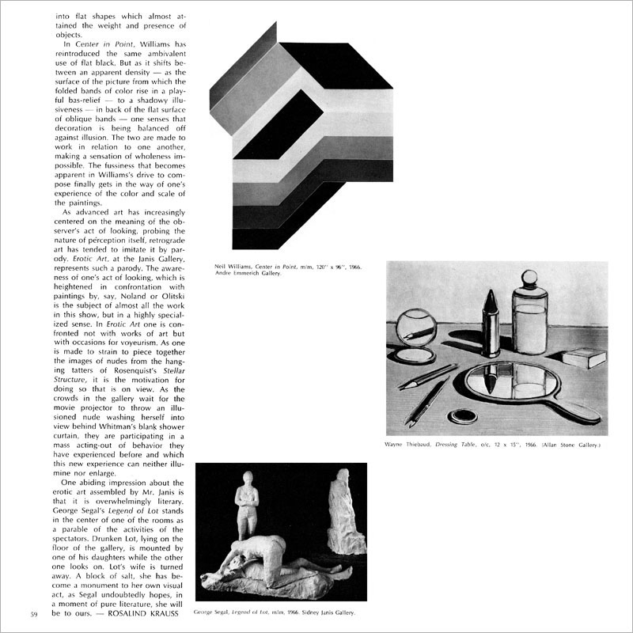](https://www.artforum.com/print/reviews/196610/neil-williams-68082)

This is your last free article for the month. [Subscribe](https://www.artforum.com/subscribe?tid=pws1) for immediate access to this and over five decades of articles fro