[Obrázok, na ktorom je text, snímka obrazovky, monitor, elektronika

Automaticky generovaný popis](https://pipi.com.hr)

[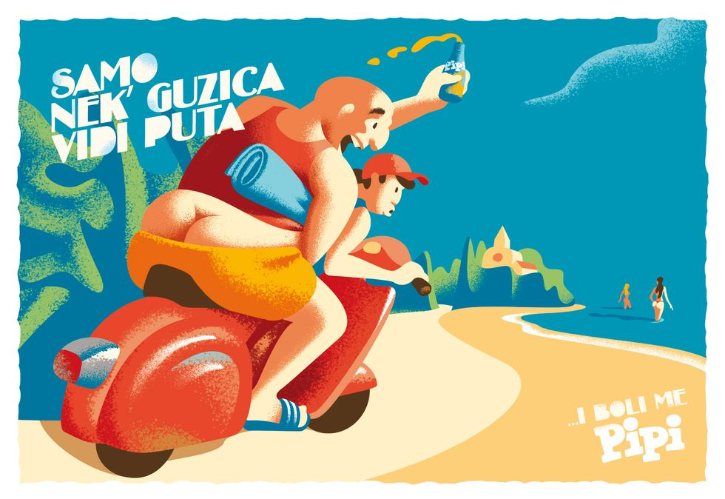](https://www.google.com/url?sa=i&url=https%3A%2F%2Fposlovnipuls.com%2F2018%2F08%2F16%2Fpipi-kampanja-je-hit-ovoga-ljeta-jeste-li-primijetili-njihove-cool-razglednice%2F&psig=AOvVaw3VF3IPoyrtdXJZ6_jFR1Ey&ust=1649609183222000&source=images&cd=vfe&ved=0CAoQjRxqFwoTCOi4r_C3h_cCFQAAAAAdAAAAABAD)