AJL22066
PRONUNCIATION VARIETIES OF ENGLISH, Spring 2023
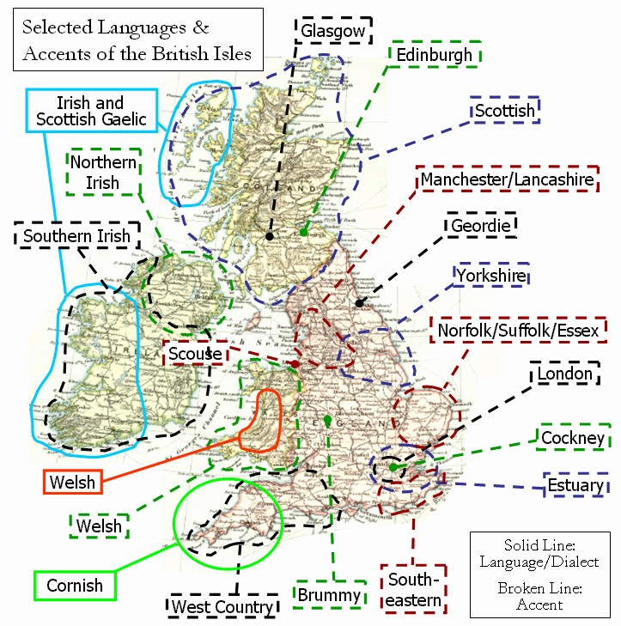

Sessions: Thursdays 1400-1540, room G24

Facilitator: Kateřina Tomková, 2060@mail.muni.cz

Compulsory listening:
J.C.Wells – Accents of English, recordings in IS Study Materials
Collins and Mees – Practical Phonetics and Phonology,
recordings in IS Study Materials, with tapecscipts
Youtube: - ‘Eat Sleep Dream English’
‘The English Language in 24 Accents’
Short, comprehensive ones: ‘A Tour of The UK and Ireland in accents.’ Phil Barker
‘The Weather in Accents’ Katia Kvinge
‘One Woman, 17 British Accents
‘Educating Rita for educational purposes only’
‘Christopher Cazenove in Three Men and a Little Woman’ (=Lady)
Online sources: Sounds Familiar langlit; Speech Accents Archive browse

Literature:
Basic phonetic and sociolinguistic terminology and concepts
Accents of English by J.C.Wells, chapters presented in class
International English by Trudgill / Hannah, chapters presented in class
Accents and dialects for stage and screen by Paul Meier

Requirements:
- Attendance: 3pts/session x 12=max. 36pts
- Final test max. 50pts
- Contributions, up to 14pts

Syllabus
W1 – February 16
A job offer, important dates in February.
Introduction. 3 components of each session: theory, listening, speaking.
Literature. Terminology. Web sources.
6 credits represent 150 hours of work.
Aiden Aslin.

W2 – February 23
- Carnival – Lent – to fast – Easter
- Helen’s project
- Limericks and AI
- RUSSIANS
- Materials and their locations
Intro: How to Speak During Coronavirus (FUNNY!) - YouTube
Schools of thought: the Prague School, UCL, Sociolinguists. EE standards.
Tools: Wells’ triangle, Trudgill’s chart, Tomková’s three presentations in LM, “howjsay“, „“typeit.org“.
HW: Exploring 2 social varieties in Educating Rita, Anglican vicar stereotype in The Three Men and a Little Lady.
checking channel Eat Sleep Dream English (‘Adele’= check for lapses in terminology) and sketches by T. Ullman (pure enjoyment).
Studying ‘Tomková AmE vs. GB suprasegmental behaviours’ (see subfolder THEORY).
Checking JELINKOVA RPxURP on Study Materials main page.

W3 - March 2
Intro of materials continued: typeit.org, howjsay, past presentations in SM, subfolders PRONUNCIATION, TAPESCRIPTS &RECORDINGS, THEORY. Educating Rita.

HW:
- Study The sociolinguistics of accents pptx in THEORY by Čanecký
- listen to J.K. Rowling’s commencement speech of 2008, and complete the tapescript in Study Materials which also contains the link to recording;
- The secrets of a posh accent: http://www.theguardian.com/lifeandstyle/video/2014/sep/22/secrets-posh-accent-video-riot-club-vowels
- Compare the smoothing to W. Churchill’s in his Fulton speech of March 4, 1946 coining the phrase “iron curtain“: www.youtube.com/watch?v=S2PUIQpAEAQ
- listen to Tomková’s presentations 1-2 and 3.

W4 - March 9
Observing a festive day for the Czech Republic.
Call for papers about the history of English: “Cruttenden, A. (2014) Gimson’s Pronunciation“ available online in the Alep book catalogue.
Segmental and suprasegmental aspects of EE presented and
- observed in the Mick Jagger sketch
- practiced on Meier EE exercise in PRONUNCIATION
HW:
- practice reading of the Sociopath sketch tapescript using RP innovations
- check the Youglish site (A. Fučková),
- consider giving a presentation on the historical development of English.

W5 - March 16
- The eve of St. Patrick’s Day = Celtic accents = the BROGUE. See IRISH CLASS and presentation by Ema Bícová: Scottish English; Glaswegian.
- Voice-operated elevator. Gay son (Catherine Tate).
- Sting RUSSIAN Songfacts reaction
- Meier exercise finished.



Recommended by Eliška Pituchová:
Regional Accent Discrimination: https://www.youtube.com/watch?v=i3gyQLgr8m8
How to Speak Dublin: https://www.youtube.com/watch?v=OhdXJrGr1iM
A Kerryman Gives Directions: https://www.youtube.com/watch?v=QvET1-e3aJI
When Irish People Can't Speak Irish: https://www.youtube.com/watch?v=ydSNgr97gSY

W6 – March 23
- Sum-up recordings summed up. RP revisited (PP+P 1, 2), the North-South divide. The standard: Honey 1998, Upton. Examples of posh accents.
- The South-East of England: Cockney, MLE, Estuary, SSBE. My Fair Lady, detecting 2 terminological inaccuracies in Adele in Eat Sleep Dream English, , Learn English with Papa TeachMe, The Slobs (Harry Enfield and Chums), Michelle M., Janet Street-Porter, the recording in PP+P, Essex girl jokes, similarities with AusE and NZE.
- The rhotic SW: Bristol, Hampshire. Funny Welsh Man, Bristol recording from PP+P.

W7 – March 30
- Meier exercise finished
- Collection of errors: ALTERNATE, DUPLICATE. COUNTIES AND SHIRES.
- The South, Midlans and a touch of brogue in one talk show:
- Julie Walters gets fed up with Graham | The Graham Norton Show - BBC - YouTube
- Midlans: in Wells, Julie Walters: that’s Another Story
- Discerning accent(s) in Terry the Odd Job Man (Táňa S).
- North of England: the historical, economic, industrial, agricultural conditions for accents and dialects
- Scouse-Mersyside: Funny liverpool accent of this amazing girl - YouTube
- Kim Cattrall on 'Paul O'Grady Live' - YouTube
- Mancunian-Lancashire: a paper by Martina E-Z.
- Yorkshire-Leeds: Yorkshire Accent - Monologue - YouTube
- Geordie-Tyneside with Durham Instagramer (Mariia M.)
- Wor Geordie - YouTube

- 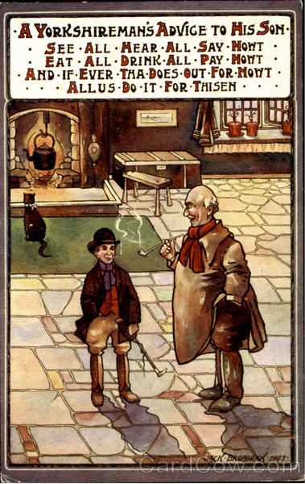
W8 - April 6 – Maunday Thursday, the eve of Good Friday.
- Warning for international students.
- myShakespeare Julius Caesar Lupercalia
- 5 contributors, see Course-Related Instructions, “EE recordings recommendations“
- NE continued. Universality of stresses. Yorkshire airlines, 2 song puzzles.
- The North-South divide, discerning practice using E. Klepáč’s recordings (Journal of English Linguistics https://journals.sagepub.com/doi/pdf/10.1177/00754242211046316)

W9 – April 13
Cultural references test.
New arrivals in “EE recordings recommendations“
Revision material: “Outline of EE varieties by Míša B.“
EE accents overseas.
- Australia – Waltzing Matilda, Penal Colony, Peter D., young mother, Congress of Radiology.
2 aspects of the Cockney Diphthong Shift, close vowels, centring
dipththongs, flapping, upspeak.
History and trivia: Australia. Famous people, films. B. Homolková’s findings.
- New Zealand – Amy Walker 21 Accents Aus vs. NZ: enter your pin. D*ck Maintenance.
NZ Airlines commercial. Aboriginals, Maoris.
Rec. by Hana Kovačičová: www.radionz.co.nz/collections/kiwi-accent
- South Africa – the Dutch footprint. Trevor Noah, RK
If time left, EASTER CLASS IN STRESS, RHYTHM AND INTONATIONpptx

April 20: obligatory Reading Week at the Faculty of Arts, no class but:
Revision using Yurii Chybras’s compilation videos
- on SE: https://youtu.be/K3921DbFX1g
on NE: English varieties Midlands North - YouTube
on Celtic varieties: https://youtu.be/KNmJ9V4wDOQ

W10 – April 27: the Imperial Legacy
- India: Rochana Jayasinghe’s ppt.
Ondřej Hudec’s recommendations: https://www.youtube.com/watch?v=z7MIyQS9p5E
https://www.youtube.com/watch?v=OoF4i77kPak
https://www.youtube.com/watch?v=v9arM_agKFA
Mariia Minaeva’s recs: India coronavirus: 'My city is under siege from Covid' - YouTube
When a Frenchman calls an Indian Call Center : The iRabbit - YouTube

- Africa: Chris James, Top 10 English Speaking Countries in Africa - YouTube
Klára Klepalová‘ recs: SA “plucking“ intonation: South African Accent Intonation - YouTube
SA vs. AUS, NZ: South African vs. Australian accents - YouTube
Test yourself: Guess the English Accent! - YouTube

W11 – May 4
Second-lanuage varieties based on British English

W12 – May 11

Revision:
- Attendance taken asking Qs about phonetic terms
- Compilation of Michael Mc Intyre’s jokes about accents:
https://www.youtube.com/watch?v=lzymb0YJp7E
- Libor’s PRACTICAL EXAMPLES pptx
- new recommendations by Adéla, Jakub, Pavel, Míša H. and Eliška P.

MOCK TEST & immediate feedback.

May 18
Feedback of MOCK TEST, CREDIT TEST.

Tuesday, June 20 – resit, reservations needed, tutor’s office.

