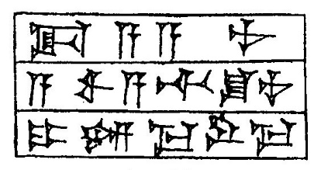

*da-a-a-nu*

*a-wa-a-ti-šu-nu*

*i-im-ma-ru-ma*

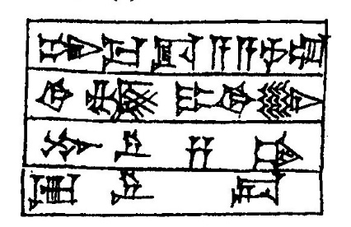

*šum-ma da-a-a-nu-um*

*di-nam i-di-in*

*pu-ru-sà-am*

*ip-ru-ús*

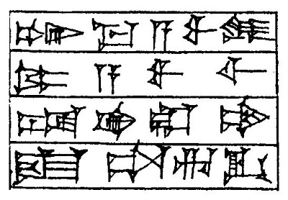

*šum-ma a-wi-lum*

*mār* (DUMU) *a-wi-lim*

*ṣe-eḫ-ra-am*

*iš-ta-ri-iq*

*šum-ma a-wi-lum*

*aš-ša-tam*

*i-ḫu-uz-ma*

*la-a´-bu-um*

*iṣ-ṣa-ba-as-sí*

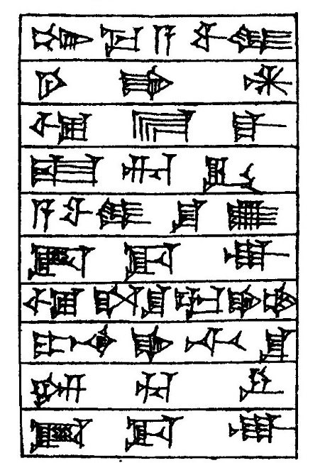

*šum-ma a-wi-lum*

*makkūr* (NÍG.GA) *ilim* (DINGIR)

*ù ekallim* (É.GAL)

*iš-ri-iq*

*a-wi-lum šu-ú*

*id-da-ak*

*ù ša šu-úr-qá-am*

*i-na qá-ti-šu*

*im-ḫu-ru*

*id-da-ak*

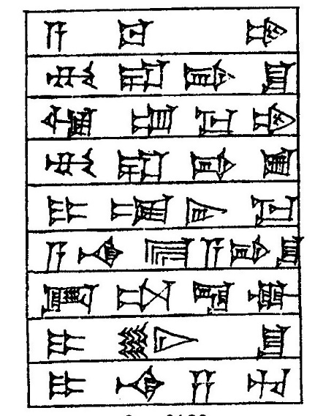

*a-ba-am*

*mu-ra-bi-šu*

*ù um-ma-am*

*mu-ra-bi-sú*

*i-zé-er-ma*

*a-na bīt* (É) *a-bi-šu*

*it-ta-la-ak*

*i-in-šu*

*i-na-sà-ḫu*

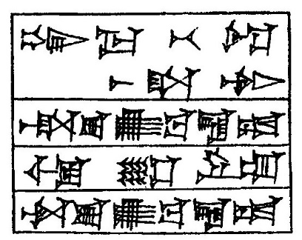

*šum-ma be-el aš-ša-tim*

*aš-ša-sú ú-ba-la-aṭ*

*ù šar-ru-um*

*warassu* (ÌR-*sú*) *ú-ba-la-aṭ*

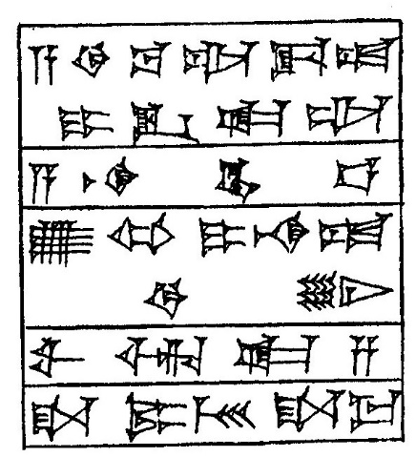

*a-di ba-al-ṭa-at i-ik-ka-al*

*a-na kaspim* (KÙ.BABBAR)

*ú-ul i-na-ad-di-in*

*wa-ar-ka-sà*

*ša mārīšama* (DUMU.MEŠ-*ša-ma*)