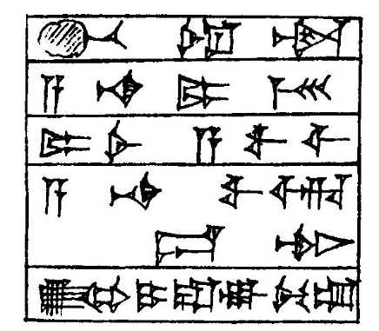

[*b*]*e-el wardim* (ÌR)

*a-na mārī* (DUMU.MEŠ)

*mārat* (DUMU.MUNUS) *a-wi-lim*

*a-na wa-ar-du-tim*

*ú-ul i-ra-ag-gu-um*

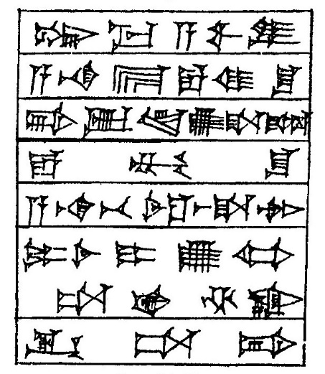

*šum-ma a-wi-lum*

*a-na* *bīt* (É) *e-mi-šu*

*bi-ib-lam ú-ša-bíl*

*e-mu-šu*

*a-na be-el aš-ša-tim*

*mārtī* (DUMU.MUNUS-*i*) *ú-ul ta-aḫ-ḫa-az*

*iq-ta-bi*

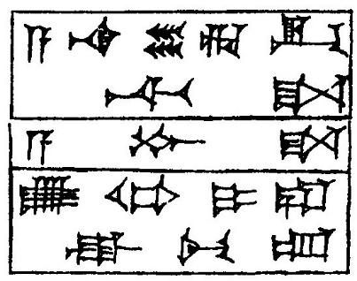

*a-na še-ri-ik-ti-ša*

*a-bu-ša*

*ú-ul i-ra-ag-gu-um*

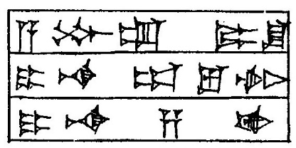

*a-bu-um mārāšu* (DUMU-*šu*)

*i-na ap-lu-tim*

*i-na-sà-aḫ*

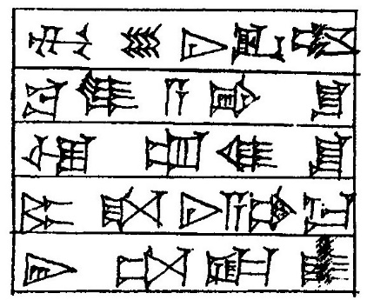

*mu-še-ni-iq-tum*

*ba-lum a-bi-šu*

*ù um-mi-šu*

*māram* (DUMU) *ša-ni-a-am-ma*

*ir-ta-ka-*[*á*]*s*

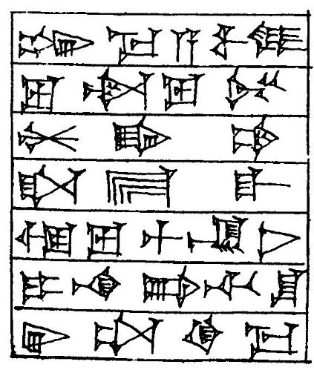

*šum-ma a-wi-lum*

*lu wardam* (ÌR) *lu amtam* (GÉME)

*ḫal-qá-am*

*ša ekallim* (É.GAL)

*ù lu muškênim* (MAŠ.EN.GAG)

*i-na bi-ti-šu*

*ir-ta-qí-ma*

*šum-ma a-wi-lum*

*i-na ma-at*

*nu-ku-úr-tim*

*wardam* (ÌR) *amtam* (GÉME) *ša a-wi-lim*

*iš-ta-am*

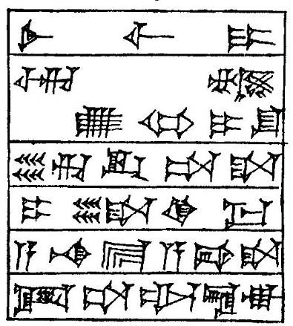

*sinništum* (MUNUS) *ši-i*

*ar-nam ú-ul i-šu*

*še-ri-ik-ta-ša*

*i-le-qé-ma*

*a-na bīt* (É) *a-bi-ša*

*it-ta-al-la-ak*

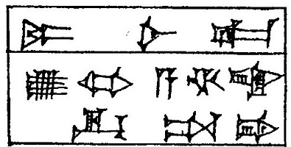

*māratka* (DUMU.MUNUS-*ka*)

*ú-ul a-ḫa-az*

*iq-ta-bi*

*da-a-a-nu*

*wa-ar-ka-at*

*bīt* (É) *mu-ti-ša*

*pa-ni-im*

*i-pár-ra-su-ma*

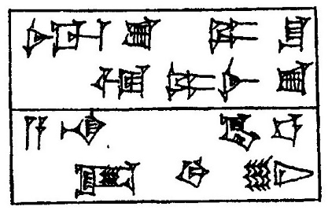

*aššassu* (DAM-*sú*) *mārāšu* (DUMU-*šu*)

*ù mārassu* (DUMU.MUNUS-*sú*)

*a-na kaspim* (KÙ.BBBAR)

*id-di-in*

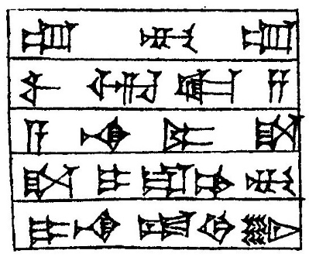

*um-mu-um*

*wa-ar-ka-sà*

*a-na mārīša* (DUMU-*ša*)

*ša i-ra-am-mu*

*i-na-ad-di-in*

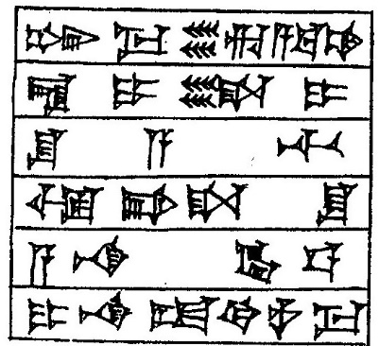

*šum-ma še´am* (ŠE) *ri-a-ba-am*

*la i-le-i*

*šu-a-ti*

*ù bi-ša-šu*

*a-na kaspim* (KÙ.BABBAR)

*i-na-ad-di-nu-ma*

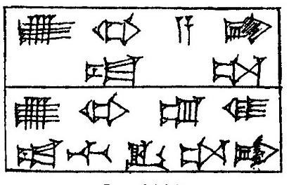

*ú-ul abi at-ta*

*ú-ul um-mi at-ti iq-ta-bi*

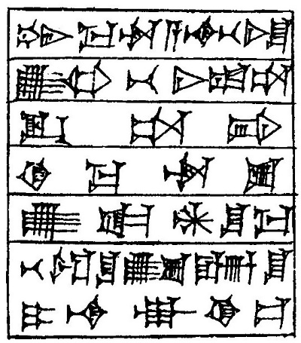

*šum-ma wardum* (ÌR) *a-na be-lí-šu*

*ú-ul be-lí at-ta*

*iq-ta-bi*

*ki-ma warassu* (ÌR-*sú*)

*ú-ka-an-šu-ma*

*be-el-šu ú-zu-un-šu*

*i-na-ak-ki-is*

*šum-ma i-na bi-ti-šu*

*ša pa-ṭa-ri-im*

*i-ba-aš-ši*

*šu-ma ra-ma-an-šu*

*i-pa-aṭ-ṭa-ar*

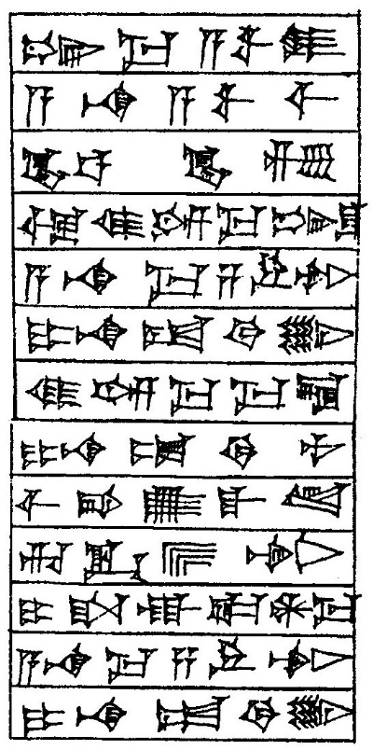

*šum-ma a-wi-lum*

*a-na a-wi-lim*

*kaspam* (KÙ.BABBAR) *ḫurāṣam* (KÙ.GI)

*ù mi-im-ma šum-šu*

*a-na ma-ṣa-ru-tim*

*i-na-ad-di-in*

*mi-im-ma ma-la*

*i-na-ad-di-nu*

*ši-bi ú-kál-lam*

*ri-ik-sa-tim*

*i-ša-ak-ka-an-ma*

*a-na ma-ṣa-ru-tim*

*i-na-ad-di-in*