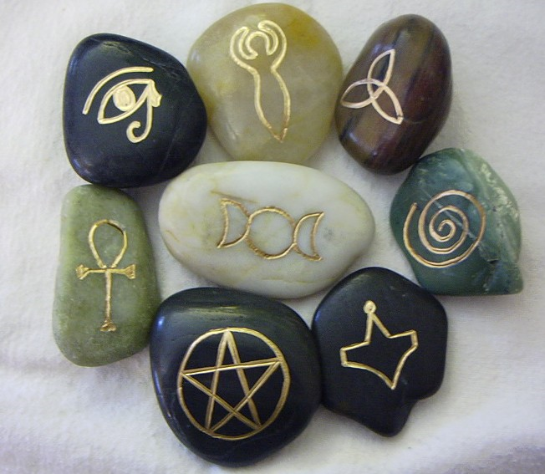

Introduction to Pagan Studies

Adam Anczyk

Department for the Psychology of Religion
Institute of Religious Studies, Jagiellonian University

Contact: adam.anczyk@gmail.com
Short course outline: The course covers some basic aspects of an emerging subdiscipline of Religious Studies, called “Pagan studies”. The phenomenon of contemporary Paganism will be presented and discussed from basic definitions, history of contemporary Paganism or Neo-Paganism ( Romantic revival, Pagan inspirations in Germany in early XX century, history of wicca and druidism) to present an image of the Pagan diaspora all around the world, including cultural peculiarities (Paganism in USA and Europe: similarities and differences). The emphasis will be put not only on the cultural history but also on the psychosocial aspects of the phenomena, therefore during our classes an image of an ordinary member of these movements will emerge. The course will contain many multimedia sources, like presentations, videos and music. All readings will be provided.

Methods of assessment: research project and quiz .

Outcomes: the course aims at providing students with general knowledge about contemporary Paganism; students will acquire knowledge on Paganism in all aspects of the phenomenon – from historical roots to psychological portrait of a follower; also an emphasis will be put on the practical skills: how to conduct a research in the field of New Religious Movements (field research, analysis of the cultural material: movies, fiction etc.).

About the lecturer: Adam Anczyk researcher and lecturer at the Department for the Psychology of Religion in the Institute of Religious Studies, Jagiellonian University and researcher at the Department of Methodology IOMEH. Interested in psychology of religion, psychology of dreams, New Religious Movements, neopaganism (especially contemporary druidry) and methodology of humanities. Teaches at Jagiellonian University (courses: New Religious Movements, Religions of the Far East, Buddhism, Religion and Psychotherapy). He is currently finishing his Ph.D. thesis on contemporary druidism. Enjoys Celtic and ethnic music, literature and poetry.

Requirements for the course:
- Research project
- Attendance and homework (1 absence is allowed, the rest of the absences is to be covered by doing additional tasks, 4 absences or more results in F grade)
- Quiz

Outline of the course

Classes will be divided into 11 meetings, and some empirical exercises done in home.

- The roots of contemporary Paganism: basic definitions, Romantic revival, nationalism and Paganism.

Form: lecture, outline of the course, research project criteria.

- Cultural history of modern witchcraft and wicca.

Form: lecture

Literature: M. Adler, Drawing Down the Moon, p. 39-89.

- Which witch is which?

Form: discussion

Literature: M. Adler, Drawing Down the Moon, p. 90-139.

- Wiccan beliefs and rituals

Form: workshop, participants should find information about wiccan rituals and bring them to the class

Literature: chosen by the participants

- Reconstucting the Past: Pagan movements in Central, Eastern and Northern Europe.

Form: lecture and discussion

Literature:
S. Simpson, Native Faith. Polish Neo-Paganism at the Brink of XXI century (chosen parts)

- The druids of history

Form: lecture

Literature: B. Cunliffe (2010). The Druids.

- The druidic movement.

Form: lecture and discussion

Literature: Bonewits I., Bonewits’s Essential Guide to Druidism, New York 2006 (chosen parts)

- Plurality of belief among contemporary druids.

Literature: Anczyk A. The Image of Druids in Contemporary Paganism: Constructing the Myth

- Paganism in popculture

Form: workshop

Literature:

Clifton C., In the Mists of Avalon: How the Contemporary Paganism Dodges the “Crisis of History” [conference materials], Salt Lake City 2009,

- Why is it so popular? Psychosocial characteristic of contemporary followers of Paganism.

Form: discussion

Literature: Lawrence B. (ed.), Being a Pagan: Druids, Wiccans and Witches Today, New York, 2002 (chosen parts).

- Quiz

Literature

Adler M. Drawing Down the Moon. Witches, Druids, Goddess-worshippers and other Pagans in America. New York 2006.
Anczyk A. The Image of Druids in Contemporary Paganism: Constructing the Myth, in: Neo-Pagan Movements in Central and Eastern Europe, Cracow 2011.
Bonewits I., Bonewits’s Essential Guide to Druidism, New York 2006
Clifton C., In the Mists of Avalon: How the Contemporary Paganism Dodges the “Crisis of History” [conference materials], Salt Lake City 2009.
Davy B., Introduction to Pagan Studies, New York 2006.
Hutton R., Blood and Mistletoe. The History of the Druids in Britain, London 2009.
Hutton R., Triumph of the Moon: A history of Modern Pagan Witchcraft, New York, 2006.
Lawrence B. (ed.), Being a Pagan: Druids, Wiccans and Witches Today, New York, 2002.

