A2 SEMINAR 8

Fine Arts

Task 1 - Vocabulary Quiz
1 A painting featuring an arrangement of inanimate, everyday objects, whether natural objects (flowers, food, wine, etc.) or manufactured items (books, bottles, crockery, etc.). landscape / still life / portrait
2 A person who models, carves, or otherwise fashions three-dimensional representations of clay, stone, metal, wood, etc.. author / painter / sculptor
3 A late 19th-century movement in art that sought to express mystical or abstract ideas through the symbolic use of images. realism / abstraction / symbolism
4 A piece of fabric on which a painting, especially an oil painting, is executed. ink / canvas / bronze
5 The way in which the fundamentals of an artistic work are handled. style / technique / technology
Discussion Questions
1. What’s your favourite style of art? What styles do you dislike?
2. When was the last time you went to an art gallery?
3. What do you have on your walls at home?
4. If you could afford it, what kind of art would you have in your home?
5. What are some of your favourite works of art?

Reading
Task 2 – Look at the titles below and match them to the descriptions of artworks.

- Donatello, David, 1433
- Leonardo da Vinci, Mona Lisa, 1503-1506
- Claude Monet, Waterlily Pond, 1899
- Juan Gris, Glasses, Newspaper and a Bottle of Wine, 1913
- Andy Warhol, Marilyn, 1967
- Christo (Javacheff): The Reichstag Wrapped, 1995

A) This is a massive sculptural work the environmental sculptor created by covering one of the landmarks of Berlin in woven nylon, secured by rope. The temporary transformation of the old parliament building into a work of art was an exciting new way of creating sculpture. By covering it in fabric, the artist drew people’s attention to the sculptural details of the building, while also creating a majestic and mysterious object of beauty. It also served to emphasize the importance of preserving such a historical monument.

B) The artist has used sliced sections of newspaper to create this unusual interpretation of a still life. The objects have been taken whole and then fragmented, painted and glued back together again within the confines of parallel vertical planes in the Cubist technique. The importance of this work lies in its innovative method of portraying different sections of an object simultaneously, while rejecting the conventions of light and shade.
C) The painting is famous all over the world for the enigmatic smile of its subject and for being one of the few paintings by the most esteemed of the Renaissance masters. The identity of the sitter remains unknown, and some debate still rages over whether the figure is indeed a man or a woman, but the painting, with its haunting landscape, rises above this controversy in the quality of its execution. A traditional Renaissance portrait in composition, its beauty lies in the oil painting technique known as sfumato.

D) Shimmering and mingling colours and reflections, this landscape is airy and saturated with light. The author has achieved this effect by covering his canvas with individual brushstrokes of different colours, creating a rich mist of blues, reds, and greens that glint like light on the surface of the water.

E) The actress’s face is presented as an impenetrable mask in bright luminous colours. Published in ten different colour combinations, using the impersonal screen-printing process, the multi-coloured surface portrays her image in a startlingly lurid manner. The author used a publicity still as the basis for this and other pictures of her, presenting us with a frozen image that reinforces the universal power of the most tragic of all Hollywood’s personae.

F) This statue shows the young hero in a dreamy, contemplative mood after slaying Goliath, whose head lies at his feet. The flowing naturalism of the figure’s pose, his shy demeanour, and the sensual surface texture of the bronze combine to bring the statue to life. This ability to instil human emotion in Classical statues was the author’s greatest gift.

Speaking –

Task 3 – use some of the terms and phrases to describe the three pictures by Frida Kahlo:

the artwork is a
landscape / still life / self-portrait / oil painting / printing / sculpture / massive work / masterpiece
the artist used
an exciting new way of / brushstrokes / colours / reflections / technique / texture

the artist drew people’s attention to
details / the sensual / human emotion / composition / pose / process
the artist created
a mysterious object of beauty / a contemplative mood / a traditional portrait / an unusual interpretation
the painting
shows / suggests / represents / suggests / emphasizes

its beauty lies in
colour combinations / quality of its execution / the naturalism / rejecting the conventions

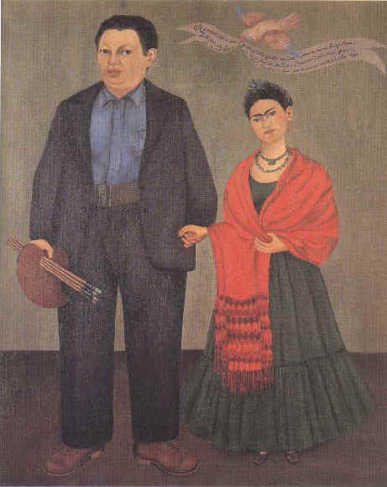
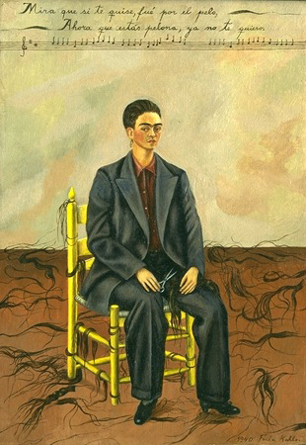
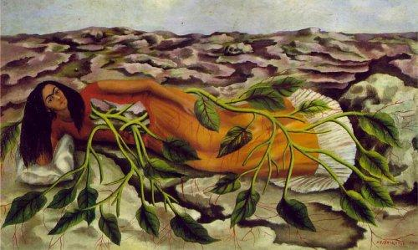

Listening: Listen carefully to three people discussing the three paintings by Frida Kahlo.
Task 5 – fill in the missing words:
A: So this is her ____________– Diego Rivera. She can’t have fallen in love with him for his looks, can she?
B: No, I reckon he ________ have been either very rich or very intelligent.
C: Actually, he was both highly intelligent and very rich. At first, Frida’s father was against her marrying Diego, because he was a _____________, but he finally agreed to it because he couldn’t pay her daughter’s medical expenses anymore. Frida must have paid a fortune on doctors and ______________ over the years.
B: Oh, yes, what a terrible life – first polio and then that awful accident. It’s _____________ she produced so many paintings, isn’t it?
A: Yes, she must have been an ____________ brave woman.
B: But the marriage didn’t work out too well, did it?
C: Well, it had its _______________.

Task 6 - note down the answers:
B: She painted this one with the cropped hair while they were apart, didn’t she?
C: Yes, that’s right.
B: She really looks like a man here. In fact, she looks as if she’s got a moustache! And why is she dressed in a man’s suit?
A: ______________________________________________________________________________________________________________________________________________________________________
C: No,___________________________________________________________________________________________________________________________________________________________________

B: And why did they divorce?
C:_____________________________________________________________________________________________________________________________________________________________
Task 7: How is the text different from what they are actually saying:

A: But they were back together by the time she created “Roots”.
C: Yes, they remarried a year after they separated. She painted this one when her health was beginning to deteriorate. She could have been in a lot of pain.
B: I find this one really depressing. The rocks she’s lying on don’t look very comfortable. I suppose they symbolize her pain.
C: Probably, but actually, if you look at the expression on her face, she is quite calm. I think the green leaves imply hope. In spite of everything, she was a very positive person. The last painting she did was called “Viva la vida – Long Live Life”.
Adapted from: Sue Kay & Vaghan Jones, Inside Out Upper Intermediate Student’s Book, Macmillan Heinemann, Oxford, 2001

Grammar – Comparatives and Superlatives

Presentation 1:
The Venus of Milo is a well-known sculpture in The Louvre.
Monet is better-known than Renoir.
The Mona Lisa is the best-known painting in the world.

Task 8 – Fill in the blanks.
1. Ryman’s Courier II is ____________ painting I’ve ever seen; it’s not a painting at all. (funny)
2. Renoir differed a lot from Monet with a much ____________ range of subject matter and a ____________ response to things seen. (wide, great)
3. “Shockingly mad, ____________ than ever, quite mad,” wrote Horace Walpole in 1785, having seen a picture by Henry Fuseli. (mad)
5. In the painting Anatomy Lesson of Dr Tulp (by Rembrant), the Amsterdam surgeons are ____________ than the dissected corpse before them. (little interesting)
6. ____________ and ____________ genius of the 18th century was Francisco Goya. (long-lived,
influential)
7. Impressionism is often __________ to understand than expressionism. (easy)
8. We managed to buy that painting _________ than we had expected. (cheaply)

Presentation 2:
The more famous the painting, the higher the price will be.

Task 9 – Create sentences using this pattern.
- Age of the paintings – the darkness of their colours
__________________________________________________________
- Number of visitors in the gallery - how much you enjoy the exhibition
__________________________________________________________
- Level of abstraction in art – number of people who appreciate it
__________________________________________________________
- Range of gallery events – Variety of visitors
__________________________________________________________
- Popularity of the artist – media coverage of his/her work
__________________________________________________________

Task 10 – There is one mistake in each of the sentences below. Find and correct it.
- He is not in the littlest interested in fine arts.
- The Rococo painter Boucher, as Watteau, was influenced by Rubens.
- Florentine painters did not have such great feeling for colour like most Venetians had.
- Some artists find that to produce a piece of art is the less part of their work; to sell is the more difficult problem.
- Abstract art doesn’t seek to represent the world around us like realism does.
- This year the art gallery had less visitors than last year.
- Some artists, such like Mozart, lived close to poverty for most of their lives.
- Art is not a life necessity, just as any other luxury.

Reading: Twenty years of The Turner Prize: 1984–2004

1984–90
Just what is the Turner Prize for? The early years of the Prize saw intense debate about exactly how a prize for contemporary visual art should be organised. One of the first issues was the naming of the Prize. Many people were at a loss to know what it had to do with the early nineteenth-century artist JMW Turner. The founders of the Prize, the Tate Gallery's Patrons of New Art, had in fact chosen Turner because he'd wanted to establish a prize for young artists and because, despite being controversial in his own day, he was now seen as one of the greatest British artists. There was also uncertainty about what the Prize was for: was it to acknowledge the work of Britain's most reputable senior artists? Or should it highlight new, up-and-coming talent? There was also some controversy about who was funding the prize, as the first sponsor remained anonymous. Suspicions were raised - was there some hidden commercial interest pulling the strings? More significantly, dissatisfaction with the combative selection process led to the annual shortlist being dropped.

1991–96
The Prize bounced back in 1991. The shortlist, and exhibition of work by shortlisted artists, was reinstated. An age limit was introduced for the first time: now only artists under 50 were eligible, to make it clear that the prize was to highlight outstanding recent work, rather than to reward the achievements of a lifetime. Some thought the jury took this to extremes when the shortlist included three artists under thirty. It was now becoming clear that there was an increasingly wide gap between the condemnation of the critics and the responses of visitors. By 1994 it seemed to have achieved the impossible: establishing a contemporary art event as something of national concern. Damien Hirst's Mother and Child, Divided brought in an unprecedented number of visitors, as well as fuelling a tidal wave of tabloid excitement. Brian Sewell set the tone in 2001 by inviting readers of the Evening Standard to nominate their own shortlist, in an attempt to expose what he saw as the undemocratic nature of the selection process. Once again there were no women on the shortlist. The piece exhibited by the eventual winner, Martin Creed, was widely ridiculed.

2002–05
In 2002 it was Fiona Banner's hand-written 'wordscape' describing a pornographic film that inevitably drew attention from the press. But this year also saw nomination forms being made widely available for the first time, appearing in a national newspaper. It was also the first time that members of the public were invited to leave their comments on boards in the Reading Room. These made it clear that visitors were looking and deciding for themselves. They also showed that Keith Tyson was the public's favourite as well as the jury's. In 2004 the Turner Prize was dominated by serious political ideas reflecting the tense international climate since the war on Iraq. Langlands and Bell's Zardad's Dog, a film of the first capital trial in Kabul since the fall of the Taliban, caught the media's attention when it was withdrawn from the exhibition because it might influence an ongoing trial of an Afghan warlord. The chosen winner was the least controversial aspect of the show. When Jeremy Deller was announced, for once critics, the public and even the bookies all agreed that the right decision had been made.
Adapted from: http://www.tate.org.uk/britain/turnerprize/history/essay.shtm viewed 30.1.2011
Task 11: Decide whether the following statements are true or false:
- The naming of the Prize became an issue because was seen as controversial. T / F
- The first sponsor of the Prize tried to influence the selection process. T / F
- When the age limit was introduced, the shortlist included three artists under thirty. T / F
- Brian Sewell criticised the selection process as something of undemocratic. T / F
- In 2002 members of the public were invited to shortlist the artists. T / F
- The Prize was influenced by political controversies in 2004. T / F

Speaking

Task 12: Discuss the article and the following facts about the Turner Prize:

MEDIUMS & MATERIALS

Of the winners:
- 18% have been nominated for painting
- 32% have been nominated for
sculptures/installations
- 27% have been nominated for mixed media
- 14% have been nominated for film/video
installations
- 9% have been nominated for photography

Some of the most unexpected art materials used in the Turner Prize have included:
- rice
- a bisected cow
- elephant dung
- an unmade bed
- lights switching on and off
- a fully functioning office

THE GENDER DEBATE
- 24% of presenters have been women
- 39% of jurors (excluding Directors) have been women
- 13% of the winners have been women
- From 1984–2007, 108 artists have been shortlisted or commended (including collaborations).
- 31 of these artists (29%) were women

