Seminar 10 – Banking and Medical Help

Banking Discussion Questions
Do you have a student bank account?
What are the differences between a student and regular account? (charges, fees, interest, etc.)
Have you ever lost your bank card?
Have you ever had problems with an ATM?
Have you ever had banking problems (here or abroad)?
Has your bank card ever been misused?
Do you use internet banking?

READING – Read the text below.

HOW TO OPEN A BANK ACCOUNT

1. Find a bank that is convenient (1) for you
2. Make sure it is insured.
3. Find out their fees (2) for checking and savings accounts.
4. Find out what the fees are to use the ATM (3).

In most states, you must be at least 18 years old to open your own account. Banks require the following personal information to open an account:

- your name, address, and telephone number

- your social security number

- picture identification

You may also be asked:

- your mother’s maiden name (4)

- your date of birth (DOB)

- prior (5) addresses of places you have lived

Task 1 Explain the words in italics:

1.

2.

3.

4.

5.
VOCABULARY
ATM
abbreviation of Automated Teller Machine: a machine, usually in a wall outside a bank, from which you can take money out of your bank account using a bank card.
bank balance
the amount of money in a bank account.
I'd like to check my bank balance, please.
bank charges/fees
sums of money paid by a customer for a bank’s services.
bank statement
a printed record of the money put into and removed from a bank account
bounce
when a check cannot be paid or accepted by a bank because of a lack of money in the account:
I had to pay a penalty fee when my check bounced.
cash
(noun) money in the form of notes and coins, rather than checks or credit cards:
Do you have any cash on you?
credit
1. money in your bank account.
I was relieved to see from my statement that my account was in credit
2. a method of paying for goods or services at a later time, usually paying interest as well as the original money.
They decided to buy the car on credit.
credit card
a small plastic card which can be used as a method of payment, the money being taken from you at a later time.
checking account (US) / current account (UK)
a bank account that you can take money from at any time and which usually earns little or no interest.
debit
(a record of) money taken out of a bank account.
The account was in debit at the end of the month (= more money had been spent than was in the account at that time).
debt
money, which is owed to someone else, or the state of owing something:
He managed to pay off his debts in two years.
The firm ran up huge debts.
deposit (US) / pay in (UK)
to put money into a bank account.
If you go to the bank, will you deposit these checks for me?
direct debit
an arrangement for making payments, usually to an organization, in which your bank moves money from your account into the organization's account at regular times:
I pay my electricity bill by direct debit.
expense
when you spend or use money.
Buying a bigger car has proved to be well worth the expense.
We've just had a new garage built at great expense.
insurance
an agreement in which you pay a company money and they pay your costs if you have an accident, injury, etc:
life/health/car/travel insurance
interest
1. money which is charged by a bank or other financial organization for borrowing money.
I got a loan with an interest rate of 10%.
2. money that you earn from keeping your money in an account in a bank or other financial organization.
You should put the money in a savings account where it will earn interest.
loan
a sum of money which is borrowed, often from a bank, and has to be paid back, usually together with an additional amount of money that you have to pay as a charge for borrowing.
She's trying to get a $100 000 loan to start her own business.
overdraft
The act of overdrawing a bank account.
savings account (US) / deposit account (UK)
a bank account in which you usually leave money for a long time and which pays you interest.
standing account (UK)
an instruction to a bank to pay a particular amount of money at regular times from a person's bank account to another bank account (compare direct debit)
tax
(an amount of) money paid to the government, which is based on your income or of the cost of goods or services you have bought:
They're putting up the tax on cigarettes.
withdraw
to take money out of a bank account.

Other useful phrases:

I would like to open an account.
Could you please help me to open an account?
How many specimen signatures do you need?
How much do I have to deposit to open a current account?
I would like a payment card.
Are you a customer of this bank? - Yes, I am. Here is my passbook.
Could you check the balance for me?
I would like to withdraw some money from my account.
How much do you charge for withdrawals?
What is the interest rate?

GAP-FILL – Opening a bank account
Task 2 Complete the dialogue with the following words.

a. which, b. when, c. needed, d. have to, e. fill, f. can
g. want, h. minimum, i. who, j. do k. will l. current

John: Good morning, sir!

Clerk: Good morning! What ……….(1) I do for you?

John: I ………. (2) to open a bank account in your bank.

Clerk: ………. (3) type of account ………. (4) you want to open?

John: I want to open a ………. (5) bank account.

Clerk: Please ………. (6) in this form.

John: How much money is ………. (7) to open the account?

Clerk: You can open an account with the ………. (8) amount of 40 Euros only.

John: ………. (9) you also issue me a payment card?

Clerk: You will get a payment card, and you will ………. (10) maintain a minimum balance
of 40 Euros.

John: Thank you. ………. (11) shall I come to open an account?

Clerk: Come any time between 10 am to 1 pm.
John: Thank you for the information.

Clerk: My pleasure.

Task 3 Read and fill in the gaps in the dialogues with the words from the lists below. Then practise these dialogues in pairs.

Withdrawing Money

A: Could I help you?
B: Yes.I want to .......... (1) some money from my bank account.
A: OK, please fill out a withdrawal .......... (2).The red one.
B: Thanks,I will finish right now.
A: Please show me your card with the slip?
B: Here they are.
A: How much do you want?
B: 100 euros.
A: Give me your ID card and enter your ....... (3).
B: All right.
A: I am sorry, your password is .......... (4). Please try again.
B: I will try it one more time.
A: Ok, success now. Here is your money.
B: Thanks.

password, incorrect, slip, withdraw

Opening an Account

A: Could I help you?
B: Yes, please.I want to ........(1) a new account in your bank, What kind of accounts can I open here?
A: Our bank offers current accounts and ........ (2) accounts for individuals.
B: I want a current account.
A: Please give me your ........ (3) card or passport?
B: Ok. Here you are.
A: Let me see, Jane, I will open a new account for you, please wait a second.
B: Thanks.
A: Jane, your card is ok, here it is.
B: Many thanks .

ID, fixed, open

DISCUSSION
Work in pairs.

- Is the procedure of opening a bank account in your country the same, similar or different from the above?

- Will you open a bank account when you go abroad to study?

- Have you already visited some bank websites to find more information?

GRAMMAR

Below is information you may want to know to open an account.
Task 4 Make questions for these items. Begin the questions with “What is ”.
The first one is done for you. When you are finished, practice asking the questions with a partner.

1. Minimum deposit to open an account
What is the minimum deposit to open an account?
2. Minimum balance required
___________________________________________________________________________
3. Monthly fee
__________________________________________________________________________________
4. Interest earned
__________________________________________________________________________________
5. Cost per check
__________________________________________________________________________________
6. ATM fee
__________________________________________________________________________________
What other questions do you want to ask? Write them here.
______________________________________________________________________________

WRITING

The bank will ask for your personal information to open an account.
Task 6 Write your personal information below.
Then complete the Personal New Account Application.

Name: ____________________________________________
Address: __________________________________________
City: _________________________________ State: ______ Zip: ______________________
Social Security Number (SSN): *
Date of Birth (DOB): _____________
Mother’s maiden name: _________________________
Most recent prior address: _____________________________________________________

*Your social security number is your private identification number. Do not write it here. Do not write it on forms unless it is required, (for example, on legal forms, job applications, citizenship applications, etc.) Do not let anyone steal your social security number. This could become a very serious problem called “identity theft. Now complete the new account application form below.

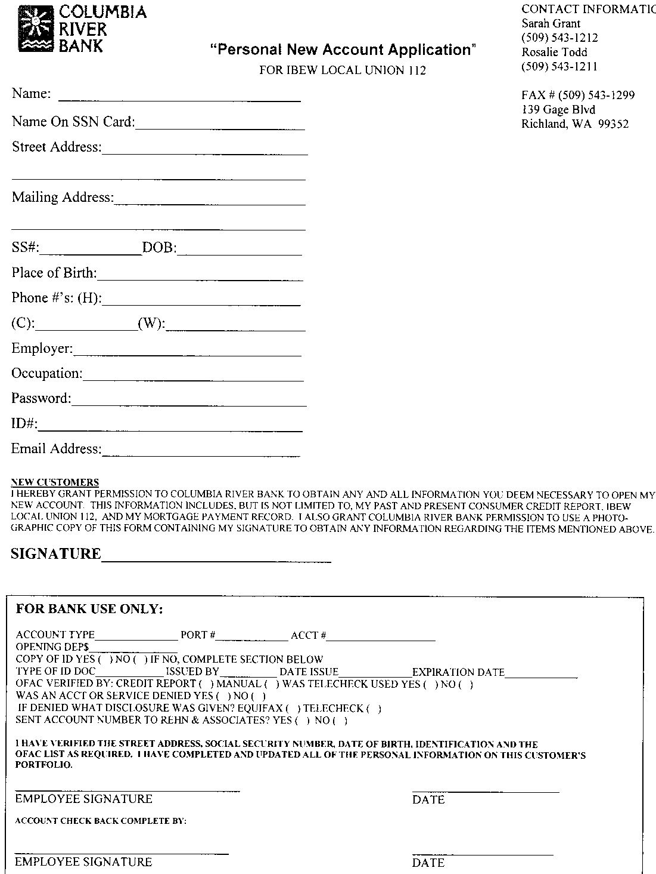

Other Banking Expression and Questions:
- transactions in person / on-line
- navigating in e-banking
- understanding terms and conditions (basic vocabulary – e.g. interest rate, fees, payments, (bank machine) withdrawals/deposits
- arranging a Pre-paid card (local telephone SIM card)
Will my student bank account remain active even after I finish my studies here?
Cash payment vs. card payment
Is there a minimum deposit/amount needed in this account?
Is there a maximum daily/weekly withdrawal limit? How can I set the limits?
To transfer money from ... to...

Medical Help Discussion Questions:

Have you ever needed medical attention while abroad? Or someone you know?
Describe the situation (accident, illness). What happened?
Did you have adequate insurance?

LISTENING
Task 7 Listen to these dialogues and complete the gaps.

At the doctor’s office

Making an appointment
A: I need to make an ……… (1) to see the doctor.
B: What seems to be the problem?
A: I have a ………. (2) that I need a doctor to look at.
B: Do you have a fever with that rash?
A: No, it just ……….(3) a lot.
B: I have ……….(4) on Tuesday or Wednesday. Which would be best for you?
A: I need an appointment on Tuesday.
B: Fine, I am putting you down for 9:00 on that day. Would you like to see Dr. Smith or Dr. Jones?
A: I would like to see Dr. Jones.
B: I can………(5) you with him with no problem. We look forward to seeing you.
http://www.eslfast.com/robot/topics/health/health16.htm

Seeing the doctor
A: I have had some really horrible ……….(1) lately.
B: How long have your headaches been going on?
A: I get headaches ……… (2) , but they have been really bad lately.
B: Any unusual amounts of stress in your life ………. (3) on right now?
A: I am getting ready to take my GRE.
B: Have you been able to sleep ………. (4) hours?
A: It has been hard for me to sleep with a bad headache.
B: Has anything……….(5) you in the head lately?
A: I hit my head on a cupboard door a week ago.
B: Let's ……….(6) you come back in a few days and see how you feel.
http://www.eslfast.com/robot/topics/health/health22.htm

Talking about the problems
A: What brings you to my office today?
B: I've been getting really short of ………. (1), and my coach wanted to have a doctor check me out.
A: Have you had the ………. (2) lately?
B: No, I have been pretty healthy. I just have trouble taking a really ………. (3) breath.
A: Have you ever been tested for ………. (4)?
B: Peaches make me ………. (5), but I don't have any other allergies.
A: Does this happen all the time or maybe a little more in the cold weather?
B: I've noticed that it is worse when I am under stress, like during ……….. (6) week.
A: I feel that you should see a pulmonary specialist to check for ………. (7).
B: I appreciate the ………. (8), doctor.
http://www.eslfast.com/robot/topics/health/health23.htm

Now choose one of the dialogues and practise it with your partner.

VOCABULARY

I have a bad sore throat.
I have a terrible cough.
It hurts when I swallow.
- I’ll have a look at your throat.
-I’ll write you a prescription for some cough syrup.
I have a migraine headache.
I have a rash on my arm.
It’s very itchy.
- Let me look at your arm.
- Here’s a prescription for an ointment.

I have a slight fever.
I have a bad cold.
I have the chills.
I have a stomach-ache.
I feel nauseated.
I am vomiting.
I’ll examine your ears.
- I’m going to give you a prescription for an
antibiotic.
- Here’s a prescription for a pain killer.

Task 8: Match the symptoms.

___1. flu a. sore chest
___2. rash b. can’t swallow
___3. nauseated c. can’t walk
___4. cough d. purple skin
___5. sore throat e. can’t bend
___6. cut finger f. red, itchy skin
___7. sprained ankle g. sneezing
___8. big bruise h. vomiting
___9. back-ache i. fever
___10. cold

READING AND WRITING

When studying at a foreign university, you may also have to fill in a medical form.
Task 9 Look at the form below and look up any words you don’t understand.

HARVARD UNIVERSITY HEALTH SERVICES (HUHS) MEDICAL RECORD IDENTIFICATION

Name: ________________________________________________________________________
Print: Last First Middle
Harvard University I.D. Number, if known: _____________________________
Social Security Number: _______________ Date of Birth: ________________ Sex: _________
Marital Status: [ ] Single [ ] Married [ ] Separated [ ] Divorced [ ] Domestic Partner [ ] Widowed
Partner’s/Spouse’s Full Name: ___________________________________
Local Address (include ZIP code) if known: _______________________
Telephone: _______________
Cell Phone: ______________
Permanent Address (if different): _______________________________ Telephone: _____
Email Address (if we may contact you about administrative issues via email):
Emergency Contact #1:
Name: _________________________
Telephone: (______)______________
Cell Phone: (______)__________________
Relationship: ___________________
Email Address: _____________________
Emergency Contact #2:
Name: ________________________________________
Telephone: (______)_____Cell Phone: (______)___________________
Relationship: ___________________ Email Address: _____________________
Name & Address of Family Physician (if not HUHS): _____________________
Telephone: ___________________________
Have you a previous record at Harvard University Health Services? [ ] Yes [ ] No
If yes, please answer the following so that we can locate your previous chart:
University affiliation at that time: _________________________
If a student, year graduated: _____
If an employee, year terminated: ____________ Date of last HUHS visit, if known:
Date: ___________________ Patient signature: ___________________

Return all forms to:
Harvard University Health Services
Medical Records Department
Attention: C 2017
75 Mt. Auburn Street
Cambridge, MA 02138
H-63 Rev. 03/13

Provide the British English equivalents to the American English terms used above.
ZIP code - _______________
Cell phone - _______________

Explain these terms.
spouse - _______________
affiliation - _______________

