Seminar 3 – Cultural Differences Part 1

What does the map below titled EUROPE ACCORDING TO LUXEMBOURG 2013 tell us?

Discuss this issue with the rest of the group. How do you see the nations shown in the picture?

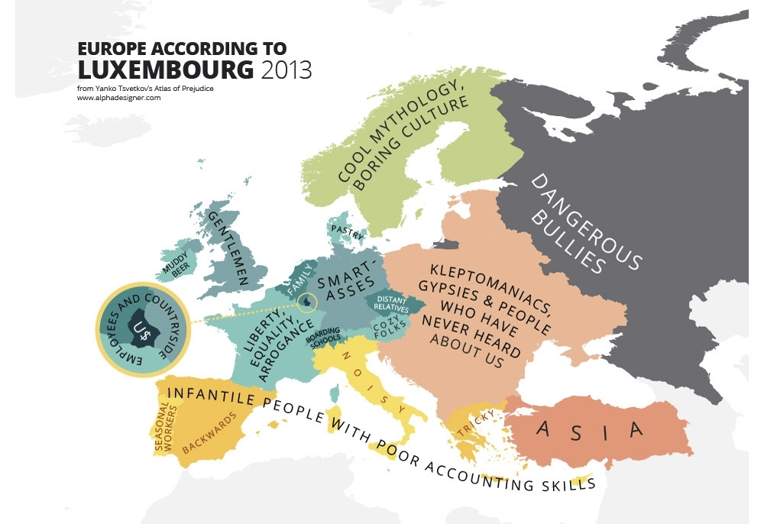
a) Think of examples that you believe represent your country’s culture.
- a book or story - a film
- a painting or sculpture - a sport
- a song or piece of music - a historical event

b) Work in pairs and discuss your ideas. Explain the significance of your choices.

c) Work in groups. Decide what you think is a good definition of ´culture´.

VOCABULARY
Task 1 Complete the missing parts.

Country Nationality
………. German
Portugal ……….
Switzerland ……….
………. Greek
Finland ……….
………. Danish
Poland ……….
Vietnam ……….
………. Spanish
Norway ………

Nationality idioms

English often uses the names of other countries or nationalities in idiomatic expressions. Do you know what each of these idioms mean?
Task 2 Choose the best answer.

1. He can talk for England.
a) He is a good representative of the country.
b) He talks for hours and hours.
c) He can speak English very well

2. They always go Dutch when they eat out.
a) They always go for a Dutch speciality.
b) They never talk when they eat.
c) They always split the bill.

3. It’s all Greek to me.
a) It all reminds me of Greece.
b) I don’t care.
c) I don’t understand at all.

4. Pardon my French but …
a) Sorry, I don’t speak French well.
b) Excuse my swearing.
c) I hope you don’t mind me speaking so long.

READING
Part 1 – Read the text and then do the exercise below.

Learning to cope with culture crashes

The dos and don’ts of travelling abroad are a potential minefield for the unprepared traveller. If you spit in some countries, you could end up in prison. In others, competing is a competitive sport. The Centre for International Briefing has spent 40 years preparing the wary traveller for such pitfalls. What the Centre does is prepare travellers for encounters with new social and business customs worldwide. There are two broad tracks to the training programme. One covers business needs, the other social etiquette.

As for etiquette, greetings, gestures and terms of address are potential hazards abroad. While we are familiar with the short firm handshake in this part of the world, in the Middle East the hand is held in a loose grip for a longer time. In Islamic cultures, showing the soles of your feet is a sign of disrespect and the reason why crossing your legs is seen as offensive.

In Western cultures we believe in empowering people and rewarding them for using initiative, but other cultures operate on the basis of obeying direct orders. In Asian cultures, in a country like Japan, the notion of personal space, which we value so much, simply has no meaning. With a population of 125 million condensed into a narrow strip of land, private space for the Japanese is virtually non-existent.

Tiptoeing through the minefield
Do
- Show an interest in, and at least an elementary knowledge of the country you are visiting
- Learn a few words of the language – it will be seen as a compliment
- Be sensitive to countries which have bigger and better-known neighbours; try not to confuse Belgians with French, Canadians with Americans and New Zealanders with Australians
- Familiarise yourself with the basics of social etiquette - as a starting point, learning how to greet people is very important
Don’t
- Assume you won’t meet any communications problems because you speak English
- Appear too reserved. As Americans are generally more exuberant than Europeans, they may equate reserve with lack of enthusiasm.

Task 3 Match the words from the text with their corresponding definitions.

- a minefield a. formal rules for polite behaviour in society
- a pitfall b. something done in a society because of tradition
- customs c. able to understand others´ feelings
- etiquette d. a situation with hidden dangers
- offensive e. something that expresses admiration
- a compliment f. rude of insulting
- sensitive g. a likely problem

Part 2
Read part of the interview with Marie, a French student, who spent a year in Finland thanks to the Erasmus exchange programme.

Interviewer: What cultural differences between France and Finland struck you?

Marie: First the food was pretty different. For example dairies (cheeses, yoghurts, etc.) are very expensive, so it is customary to drink a glass of milk at lunch and eat bread and butter. But there is no dessert.
The sauna of course is a tradition which is deeply rooted in the Finnish culture. People of all ages go to the sauna, even babies! And everyone is naked. There is a sign at the entrance of public sauna with a crossed-out swimming suit. At the beginning it was quite shocking because in France we are rather shy. Then after the sauna, Finnish people go out and jump into a lake, no matter the season. They are very close to nature.

Many of them live isolated in villages, right in the middle of the forest. One thing you should know before going to Finland and that leads to a very different way of life during the winter, night falls at 3 p.m.! So Finnish people don’t go out much all this time of the year. However, when the spring comes and days are getting longer, it is as if everything came back to life: there are people everywhere sitting outside cafes or restaurants till late.

As for the Finnish people, strictly speaking, I noticed they seemed more calm and reserved at first sight. For instance, you have to keep your distance physically with Finnish people you don’t know well. But once you are close to them, you know you can count on them. We should also be aware that it’s very rude to keep your shoes on when you arrive at someone’s home. At school too, children are always in their socks.

Interviewer: Did incidents or misunderstandings happen to you because of these cultural differences?

Marie: Yes, several did. The Finnish language being completely different from French, there is no way to guess the meaning of the words, which can be troublesome in everyday life. One day for instance I wanted to buy sugar at the supermarket and I realized back home that actually I had bought salt. Also the first time I met my Finnish flat mate, I wanted to greet her with a kiss on the cheeks like we do in France, but I realized she was really embarrassed as she stepped back. I found out later that Finnish people shake hands to greet one another.

Interviewer: What do Finnish people think about French people?

Marie: They think we are true romantics. And they immediately ask us about Paris! But no Finnish has ever judged me on my culture. They are all very open-minded.

Task 4 Answer the following questions.

- Did anything Marie said about the Finnish culture surprise you? If so, what?
- What is the common cultural stereotype of the Finnish in your country?
- What do you know about the cultural differences of the country you would like to study in?

DISCUSSION

Look at the British Council site for an Erasmus student testimonial from an English student visiting the Czech Republic at http://www.britishcouncil.org/erasmus-case-study-jennifer-draxlbauer.htm and discuss.

HOMEWORK: Find another summary of a student who spent a year on Erasmus in the country where you would also like to go. Compare your expectations and their experience and be prepared to lead a short (3-4 minute) discussion in class.

