Seminar 6 – Travelling

DISCUSSION
Have you ever flown before? Did you ever have any problems? Do you have a fear of flying?

READING
Task 1 Read the text and make sure you understand all the words in the text.

The airport is your first stop before leaving on your dream vacation or trip. Generally speaking, you should arrive at the airport with plenty of time to spare. Don't arrive 10 minutes before your plane departs. You can park your car in long-term parking if you are planning to be away for a few days, or you can ask someone to drop you off in the loading zone right in front of the airport terminal. In some cases, you can check your bags there at curb-side, or you might have to go to the check-in counter inside the airport. Many airports now allow you to check in at a computer kiosk, but you will still need to check your bags if you have any. Once you are checked in, you will have to pass through security where they will check your ID and your carry-on bags. You will also need to walk through a metal detector, which will check for illegal items. After you pass through security, you can walk to the gate where you can wait to board your flight. Just wait until they call your section to board. They usually seat first-class passengers and those who need assistance first. Enjoy your flight.

VOCABULARY
Task 2 Complete the sentences below with the best answer

1. The ___________ will be serving food and beverages after the plane reaches its cruising altitude.
A. flight attendants B. pilots C. security officers
2. After the plane lands, you can pick up your luggage at the ______________.
A. boarding area B. baggage claim area C. overhead compartment
3. If the cabin loses pressure during flight, you should put on your _____________ so you can breathe comfortably.
A. seat belt B. life jacket C. oxygen mask

LISTENING AND SPEAKING
Discussion
- What are some of your frustrations when going through an airport? Is there anything you can do personally to minimize these problems? What can airports do to deal with these issues?
- Listen and compare:

Task 3 Listen and choose the best answer from the options below
Listening 1
http://www.dailyesl.com/airport-arrival-talk.htm
Listening 2
http://esl-lab.com/airport/airportrd1.htm

- Who is probably making the announcement?
a) a pilot
b) a flight attendant
c) a ticket agent
d) a ground crew member

- What is the ultimate destination of the flight?
a) Atlanta
b). Miami
c) Caracas
d) Lima

- What change has been announced?
a) the flight number
b) the gate number
c) the arrival time
d) the boarding time

- What are the current weather conditions outside?
a) It´s raining.
b) It´s cloudy.
c) It´s hailing

- What time will the plane depart?
a) 9.50 a.m.
b) 12.15 p.m.
c) 4.05 p.m.
d) 8.45 p.m.

d) It´s windy.

SPEAKING AND FILLING IN FORMS

Your luggage can get lost. What would you do if this happened?

Task 4 Discuss with your partner. Look at the form below.

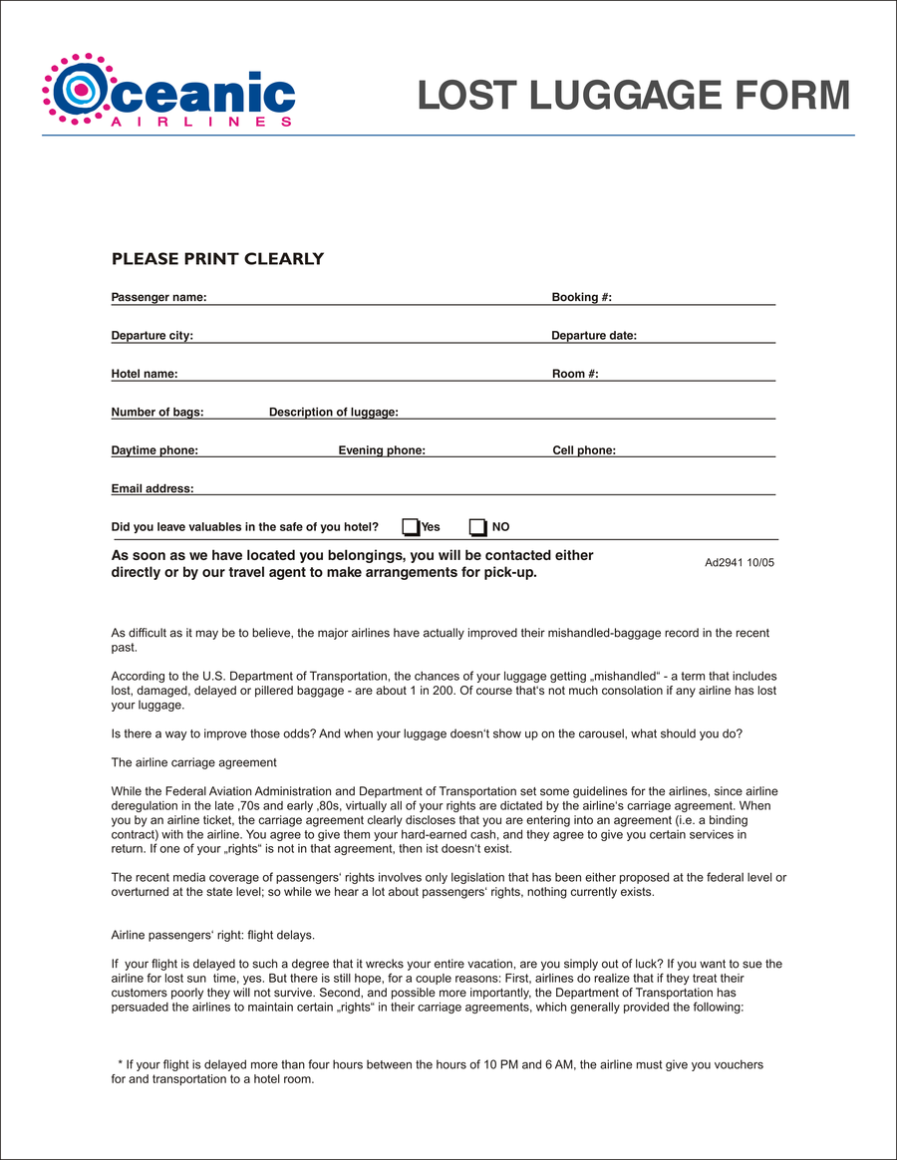

Local transportation pass – useful questions

Where can I catch the shuttle bus?
How many zones does the pass cover?
Where can I get a public transport pass/metro pass/city transit pass?
Which documents do I need for this? Which documents are needed for this?
Do I need a recent photo? What format?

ESSAY WRITING – INTRODUCTIONS AND CONCLUSIONS

An essay introduction offers the reader an overview of the whole essay. It usually includes the following:
- a statement or 'hook' to gain the reader's interest
- contextualízing material providing relevant background information
- the topic and focus of the essay
- the rationale or reason for writing the essay
- an indication of the essay's organization.
It may also be necessary to define any central concepts.
The introduction moves from general to specific information.
By the end, the reader should be clear about what the essay is going to focus on, why, and how.
This specific information is typically expressed in the thesis statement, often the last sentence of an introduction.

Using the Passive to Maintain Focus in the Introduction

Task 5 Rewrite the sentences using the verb phrases in italics in the passive.
Example: We can illustrate the main effects of poverty by looking at those on the lowest
incomes in rich cities.
The main effects of poverty can be illustrated by looking at those on the lowest
incomes in rich cities.

1) Many people often think of power as a dangerous concept.
2) You should note the fact that economic union does not necessarily mean political
union.
3) We can find examples of inequality within cities in both rich and poor countries.
4)This essay makes clear the distinction between government policy and economic
reality.
5) They should take into account social conditions as well as the economic situation.

WRITING A THESIS STATEMENT
Task 6 Read the essay title below and complete the two thesis statements. Use verbs and modal
verbs from the list in the active or passive.

ESSAY TITLE: 'Some traditional subjects, for example history, are becoming less important in
Today’s technology and business oriented world. Universities should therefore focus
on subjects such as engineering which will have the maximum economic impact.’

To what extent do you agree with the above statement?

consider discuss examine expect explain focus on follow look at
provide suggest can may should will
1) Firstly, I (A) __________ the social and economic reasons why it is important to (B) __________ traditional subjects at university; this (C) __________ by an analysis of why sufficient breadth in the university curriculum (D) __________ by a narrow focus on subjects such as engineering.
2) This essay (A) __________ the importance of science, medicine, and technology in today's globalized economy, and (B) __________ the extent to which universities (C) __________ C to reflect this reality, before moving on to (D) __________ some of the long-term implications.

WRITING AN INTRODUCTION

Task 7 Study the essay notes below on the following title.

ESSAY TITLE: 'Most tourists are unlikely to learn very much about the countries they visit' (Full text on p. 213 should be in the ANSWER KEY)

Discuss.

Notes for the whole essay:
Introduction and background
-tourism – mass-market, cheap, a growth industry
- tourists can now go to almost any country
- historical shifts (e.g. Asians visiting Europe and North America more than before)
- cultural and personal perspectives, including attitudes to new cultures

Paragraph 1 (for the argument)
Tourists:
- don't learn the language of the countries they visit
- don't meet locals
- often eat international food / fast food
- don't spend enough time in a country
- don't revisit a country, but go to another new one instead

Paragraph 2 (counter-argument)
Tourists:
- now have unique opportunities
- can learn about new cultures online first
- can meet local people through exchanges and trips
- often want to do something new (e.g. eat new food, experience new cultures)

Conclusion
- despite being a major worldwide industry, many tourists are enthusiastic about learning about the countries they visit
- cultural and personal perspectives are important
- with continued growth in the tourism industry, more learning opportunities exist

Task 8 Write an introduction, including a thesis statement, based on the essay title and notes above.
Write approximately 100 words and make sure your introduction includes:
- a statement or 'hook' to gain the reader's interest
- contextualizing material to provide relevant background information
- the topic and focus of the essay
- the rationale or reason for writing the essay

CRITICAL THINKING

Task 9 Evaluating an introduction
Use the checklist of questions to evaluate your introduction, including the thesis statement.
1) Does the introduction include sufficient contextualizing material?
2) Is the content directly relevant to the essay title?
3) Have you included a rationale or reason for writing the essay?
4) Does the thesis statement add something new?
5) Is the organization, topic and focus of your essay clear to the reader by the end of the introduction?

Read at least two other students' introductions and offer critical feedback.
De Chazal, E. & McCarter, S.; Oxford EAP: A course in English for Academic Purposes, OUP, pp. 60-63.

WRITING CONCLUSIONS

An essay conclusion is the final paragraph. It refers back to the title, thesis statement and the
main points, and presents the reader with a summary of the whole essay. This may include
reference to the main results or findings, and to any limitations. The conclusion may also look
forward by offering predictions, recommendations for further research, or ideas about the
topic for the reader to think about.
De Chazal, E. & McCarter, S.; Oxford EAP: A course in English for Academic Purposes, OUP, pp. 76.

Linking a Conclusion to Other Parts of an Essay
The conclusion to an essay needs to have a clear connection with the title, the introduction, the thesis statement, and the body of the essay.

Task 10 Look at the essay title below and select the three items it asks you to write about in the body of the essay.

ESSAY TITLE: In the modern world, it is not just essential to demonstrate general intelligence, but
to possess social and emotional intelligence. Discuss the relevance of the different typesof intelligence in the field of psychology.

1 the connection between intelligence and experience
2 the relative importance of each type of intelligence
3 the history of theories of intelligence
4 the different types of intelligence

The introduction to an essay includes a thesis statement. This gives information about the topic and focus of the essay, and shows how the essay is organized.

Task 11 Read the introduction below to the essay title above and identify the thesis statement. Then
match the three items you selected in Task 10 to the parts of the thesis statement.

TEXT introduction:
As competition in the workplace increases, with larger numbers of people chasing fewer jobs,
applicants are being assessed not only for their general intelligence, but also their social and
emotional intelligence. Social intelligence can be defined as that area of intelligence that
deals with social skills, and is necessary for psychology professionals to work effectively with
other people. Emotional intelligence is the individual's ability to deal with their own and other
people's emotions - for example, being able to show and recognize empathy, This may also
include intrapersonal intelligence, which concerns self-understanding and self-awareness.
These types of intelligence are now considered very important for people working in a
psychology environment. This essay discusses the two types of intelligence, evaluates their
relative importance, and examines the relevance of each in the field of psychology.

How does the thesis statement a) show the order of discussion in the body of the essay,
and b) give an indication of the contents and order of the conclusion?

Based on the introduction above, predict what you would expect each of the three
body paragraphs in the essay to include by writing suitable topic sentences.

Task 12 Read the features of a conclusion below. Not all of them appear in the conclusion of
all essays. Select four features that might appear in the conclusion to the essay title above.

1 a reference to the title and the introduction, including the thesis statement
2 a reference to the main points in the body of the essay as expressed by the topic sentences
3 a summary of the key points of the essay
4 new information about the key points not covered in the body of the essay
5 suggestions, comments, or recommendations for the future
6 a reference to research carried out
7 a reference to findings or results
8 a statement of any limitations (i.e. the focus) of the discussion
9 a statement of purpose

IDENTIFYING FEATURES OF A CONCLUSION
Task 13 Match each element (A-E) to the relevant sections of the conclusion below.

A a statement of limitations
B a summary and reference to the title / thesis statement
C a reference to findings
D a recommendations for the future
E a reference to research carried out

1 The discussion has shown that social and emotional, including intrapersonal, intelligence have a crucial part to play in the psychology environment. 2 We have considered the role of research on both sides, 3 but it has not been possible to cover all of the latest research. 4 What is clear, however, is that the three types of intelligence can improve job-seekers' chances in the job market. 5 Training in these types of intelligence should be offered not just on psychology courses, but even as early as secondary school with greater allocation of educational investment.
De Chazal, E. & McCarter, S.; Oxford EAP: A course in English for Academic Purposes, OUP, pp. 77.

Task 14 Work with a partner to brainstorm and create a similar outline on the related title: Many foreign students are unlikely to learn very much about the countries they visit. Discuss your ideas in class.(e.g. Think of some conditions/activities that make learning about a culture more effective.)

For homework, write an introduction, 2 topic sentences (for the paragraphs of the body) and a conclusion based on your notes and class discussion. The essay may be related to this topic or to the topic in Task 7 about tourists.

