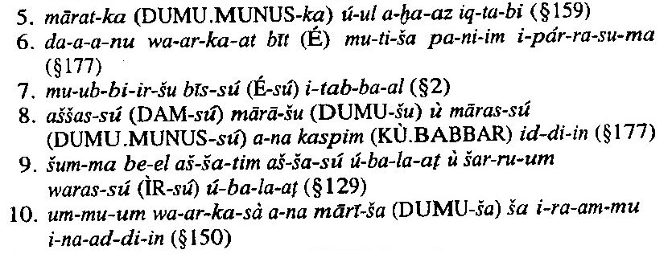

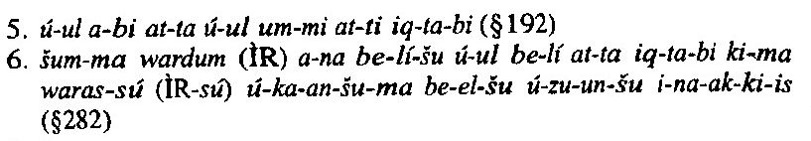

a-na mi-nim šu-ú ip-te
e-li-ja mi-na-am ti-šu-ú
šu-nu ma-an-na pa-al-ḫu-ma
ma-an-nu-um ma-an-na-am i-pa-al

i-na ka-at-tim lu-ba-ra-am at-ta-al-ba-aš-ši
ja-at-tam ú ka-ta ga-gu-um i-de₄
ú-ul ^{D}AMAR.UTU i-li a-li-ja ú-ul ^{D}UTU DINGIR nu-um

