Assignment 1

Set texts:

Vera Schwarcz “The Burden of Memory: The Cultural Revolution and the Holocaust” in China Information Vol. XI, No. 1 (Summer 1996), p. 1-13.
http://cin.sagepub.com/content/11/1/1.full.pdf+html

Liu Binyan/ Perry Link “An Interview with Liu Binyan” in Liu Binyan Two Kinds of Truth. Stories and Reportage from China. Edited by Perry Link, Bloomington: Indiana University Press, 2006, pp. 1-26.

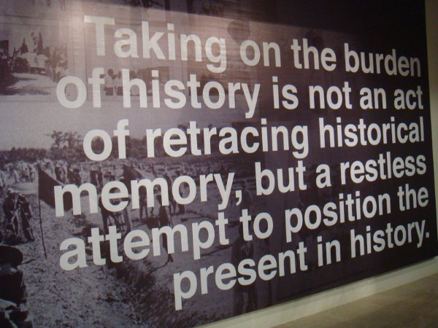
1. Please read the texts carefully. The following questions are supposed to support your understanding of the text.

2. Please answer the following questions (if necessary with the help of further sources)
very short but concise:

a) Give a short biographical sketch of Ba Jin

b) What does the author highlight as the main differences between the Holocaust and the Cultural Revolution?

c) Look up the Chinese characters for chòu lǎo jiǔ (stinking nine). What does it refer to?

d) Look up the Chinese characters for niúguǐ​ shèshén (ox-devils and snake spirits), niúpéng (ox-pens)

e) In their working-through of a traumatic past, how does Jean Amery’s approach differ from Zheng Yi’s?

f) The two poets Bei Dao and Paul Celan have both written about a traumatic past. How does their “worldview” differ?

g) What are your thoughts about the interview with Liu Binyan? Which Chinese writer/ artist/ intellectual would you like to interview? For what reason?

