Assignment 2

Set texts:

Susanne Weigelin-Schwiedrzik “Producing Cultural Memory in the PRC. On the Role of Historiography, Literature and Film in the Context of Writing China’s 20th Century History”

Zhang Yigong 张一弓 ”The Story of Criminal Li Tongzhong” 犯人李铜钟的故事 Collected works of Zhang Yigong 张一弓集Huaxia wenyi chubanshe, 1986, p. 1-48.

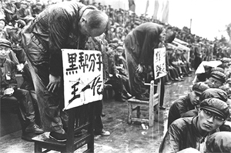
1. Please read the text carefully. The following questions are supposed to support your understanding of the first text.

2. Write a short bio on Feng Jicai 冯骥才

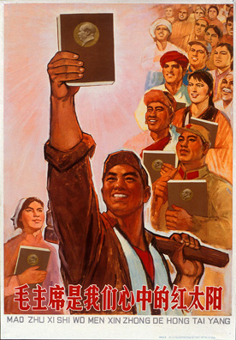
3. Write a short bio on Mo Yan 莫言

4. How does the author describe the function of the hermetic system of party historiography? What does it lead to?

5. What is meant with „De-Maofication of party history“?

6. How do „cultural memory“ and „communicative memory“ differ according to Jan Assmann?

7. How does literature come in when historiography has become disfunktional?

