## **Youth subculture**

*http://ilearn.careerforce.org.nz/mod/page/view.php?id=874*

|  |  |
| --- | --- |
|  | A [**subculture**](http://ilearn.careerforce.org.nz/mod/glossary/showentry.php?eid=221&displayformat=dictionary) is a group of people who make themselves different from mainstream society in some way. It could be through their [beliefs](http://ilearn.careerforce.org.nz/mod/glossary/showentry.php?eid=216&displayformat=dictionary), the way they dress, what they do, the way they talk or the music they listen to. |

There are many [subcultures](http://ilearn.careerforce.org.nz/mod/glossary/showentry.php?eid=221&displayformat=dictionary) that exist within [youth culture](http://ilearn.careerforce.org.nz/mod/glossary/showentry.php?eid=225&displayformat=dictionary). They have characteristics that make themselves different but they are still part of youth [culture](http://ilearn.careerforce.org.nz/mod/glossary/showentry.php?eid=217&displayformat=dictionary) as a whole.

Examples of common types of subcultures include:

* music-based, for example, hip hop or heavy metal.
* religious-based, for example, Christian or Muslim.
* gender and sexual identity, for example, [LGBT](http://en.wikipedia.org/wiki/LGBT) or intersex.
* [fandoms](http://en.wikipedia.org/wiki/Fandom), for example, Beliebers (fans of Justin Bieber) or Twihards (fans of the Twilight series).
* sports, for example, rugby or fishing.
* games, for example, [LARP (live action role playing)](http://en.wikipedia.org/wiki/LARP) or [Minecraft](http://en.wikipedia.org/wiki/Minecraft).
* style, for example, steampunk or cosplay.
* gangs, for example, Bloods or Killer Beez.
* clubs, for example, youth group or [Girl Guides](http://en.wikipedia.org/wiki/Girl_guides).

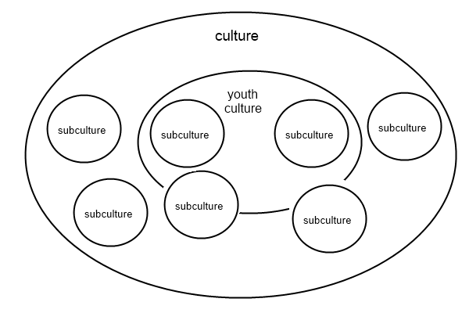Subcultures may be part of youth culture, but there are also many subcultures that attract both, young people and adults. There are also subcultures that attract mostly older adults, for example, those based around interests like playing bridge, line dancing or belonging to the [RSA](http://www.rsa.org.nz/).

This diagram shows how subcultures and youth culture may (or may not) overlap.

## **Life cycle of a subculture**

Lloyd Martin (2002) has suggested that many (but not all) youth subcultures have a life cycle that they go through. This life cycle shows how subcultures grow and are identified by the wider community.

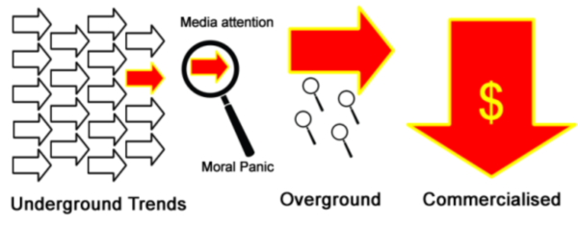Youth subcultures often start off as **underground trends**, that is, things young people do with their friends in small groups. Many of these underground trends never catch on widely and they are eventually forgotten. Sometimes youth subcultures appear weird, different or visible enough that they capture **media attention**. Often a **moral panic** develops around the subculture. Adults become concerned that the subculture might threaten the social order. This media attention means that more people hear about the subculture and the moral panic around it may make it more appealing to young people as a way of stating their difference from their families. It also may mean that **stereotypes** of people in the subculture and **negative labels** are developed. As more people join the subculture, it becomes an **overground** trend.

Finally, the last stage of the subculture's development is when businesses and organisations work out how to make money from the subculture or use it for publicity. At this stage, fashion elements from the subculture can be purchased at almost any store. Subcultural language and terms get **commercialised**, picked up by the general public and are used by advertisers to sell things. This attention means more people are attracted to the subculture, but it becomes much less cool. It eventually is absorbed into mainstream culture.

### **Influence of social media**

These days, social media (such as Tumblr, YouTube, Facebook and Twitter) may mean subcultures and trends can move through this life cycle very quickly. For example, the [Harlem shake](http://en.wikipedia.org/wiki/Harlem_Shake_%28meme%29) trend started on 2 February 2013 when a group posted a video on YouTube of themselves doing a dance to a song called Harlem Shake by Baauer. By 11 February there were 12,000 versions of the video on YouTube. On 13 February, it was declared "murder[ed]" by *Atlantic Monthly* after being on the mainstream *Today* show in the United States - possibly prematurely as the video reached 1 billion views on 24 March.

**Youth subculture and identity**

*http://ilearn.careerforce.org.nz/mod/book/view.php?id=1135&chapterid=296*

Young people can identify with a [subculture](http://ilearn.careerforce.org.nz/mod/glossary/showentry.php?eid=221&displayformat=dictionary) on a number of different levels.

Lloyd Martin developed a useful framework to help us think about the levels of identification a young person might have with a subculture:

|  |  |  |
| --- | --- | --- |
| **Level of involvement** | **Behaviours** | **Identity** |
| Consumption (involving most young people) | * May also participate in other [subcultures](http://ilearn.careerforce.org.nz/mod/glossary/showentry.php?eid=221&displayformat=dictionary) * Likes the cloned, commercialised brands of the [culture](http://ilearn.careerforce.org.nz/mod/glossary/showentry.php?eid=217&displayformat=dictionary), including clothes and music | * Mainstream or ethnic culture remains their main source of identity |
| [Value](http://ilearn.careerforce.org.nz/mod/glossary/showentry.php?eid=222&displayformat=dictionary) | * Rejection of over-commercialisation * Distinctions of status based on 'insider' knowledge | * The subculture has become a source of cultural capital * Mainstream options are not rejected |
| Lifestyle (involving only a few young people) | * Reduced mainstream options * High level of expertise * Attempted career options within the subculture | * Subculture is main source of identity * Local status as trendsetter within the subculture |

*Source: Martin, L. (2002). The Invisible Table. New Zealand: Dunmore Press.*

By identifying and being 'good at' a subculture, a young person can gain status and respect within the subculture. The knowledge and skills a young person has within their subculture is called their **cultural capital**.

Belonging to a subculture meets many of the needs of young people. The Circle of Courage is an indigenous model of positive youth development. Look at the diagram of the circle of courage and think about the ways in which identifying with a subculture can meet the needs of young people.

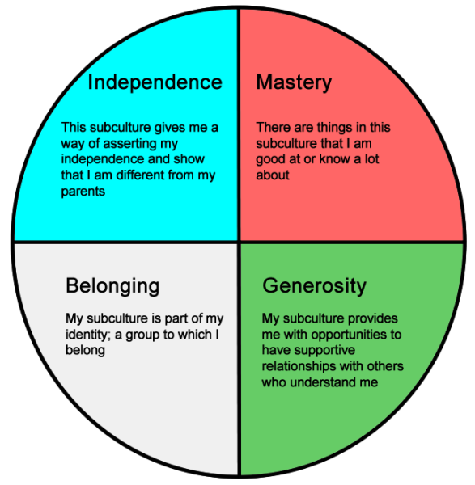On the downside, young people in a subculture may experience negative labelling, stereotyping and discrimination from others in the community. While often overstated in the media, some youth subcultures, such as gangs, do participate in dangerous, unlawful or risk-taking [behaviour](http://ilearn.careerforce.org.nz/mod/glossary/showentry.php?eid=215&displayformat=dictionary) which may cause problems for both the young person and the wider community.

# Characteristics of youth culture

A [culture](http://ilearn.careerforce.org.nz/mod/glossary/showentry.php?eid=217&displayformat=dictionary) or [subculture](http://ilearn.careerforce.org.nz/mod/glossary/showentry.php?eid=221&displayformat=dictionary) can be identified by its characteristics.

**Age** refers to the range and average age of the people in a subculture.

[Subcultures](http://ilearn.careerforce.org.nz/mod/glossary/showentry.php?eid=221&displayformat=dictionary) may attract a wide or narrow range of ages. For example, the rugby subculture attracts people of all ages whereas members of a subculture such as the Killer Beez gang tend to be in their teens or early twenties.

The ages of people in the subculture might change over time, with members either getting younger or older. For example, a 2011 study found the average age of a gamer is now 30 and has been playing games for 12 years. When a subculture starts attracting a lot of adults or children, it may begin to be seen as uncool or unappealing to young people.

[**Behaviours**](http://ilearn.careerforce.org.nz/mod/glossary/showentry.php?eid=215&displayformat=dictionary) are what people in a subculture do. They may include social and individual activities, events, traditions and ways of relating to one another.

For example, in a church youth group, members may make a promise not to have sex, drink or take drugs. They promise to participate in bible study and fun social games and activities together as a group. They will start and end sessions with a prayer and share testimonies with each other.

**Art** refers to the creative works that people in a subculture make. It can include **visual arts** (like graffiti, drawings, models, crafts and videos) and **performing arts** (like dance, theatre and music).

Some arts, such as graffiti, headbanging or tattoos, may be viewed negatively by others in society. Art can provide ways for people in a subculture to express their subcultural identity creatively and become well-known within the subculture.

**Fashion** is a popular way of dressing among a particular group of people.

Fashion is a way a subcultural group can identify themselves as a group that is distinct from others. Fashion can be used to quickly show others (inside and outside the subculture) that you identify as a member of the group. Fashion can include clothing (styles and brands), footwear, jewellery, accessories, body art (makeup, piercings and tattoos) and hairstyles.

For some subcultures, fashion is the most important part of their subculture. For example, people in the Cosplay subculture dress up as characters from their favourite anime, comics or television programmes.

**Language** is used to communicate with other people inside and outside the subculture. It includes spoken and written language and covers words, phrases, acronyms, ways of speaking, body language and gestures.

Language specific to a subculture can include slang, giving words different meanings, acronyms and technical language. Using language correctly in a subculture is important – using a word incorrectly can mean social death!

Over time, words from a subculture may be absorbed into the mainstream or change in meaning. Often once a word gets used too widely, an alternative, less-used (and therefore cooler) word is picked up instead.

Some subcultures provide their own dictionaries or glossaries to help new members to up to speed. For example, there is a specific dictionary for World of Warcraft players. In it, there is:

* slang, for example, a lowbie is a character of low level.
* words with different meanings, for example, camping means waiting for a player or mob to spawn, appear or resurrect, then to kill them.
* acronyms, for example, WTT means "want to trade".
* technical language, for example, a patch is an update to game content.

**Music** is very important to many subcultures. Some subcultures are based around music – think about music genres (categories) such as hip-hop, reggae and heavy metal. Music can be a way of communicating the [values](http://ilearn.careerforce.org.nz/mod/glossary/showentry.php?eid=222&displayformat=dictionary) and [ideas](http://ilearn.careerforce.org.nz/mod/glossary/showentry.php?eid=219&displayformat=dictionary) of the subculture. Artists and groups tend to be associated with certain subcultures. For example, in the late 1990s and early 2000s, Snoop Dogg was associated with Crips gang.

Besides the visible or external ways subcultures mark themselves as different from other groups, there can be internal differences for those people who are more committed to or identify more deeply with the subculture. Internal differences include ideas, [philosophies](http://ilearn.careerforce.org.nz/mod/glossary/showentry.php?eid=220&displayformat=dictionary), values, [beliefs](http://ilearn.careerforce.org.nz/mod/glossary/showentry.php?eid=216&displayformat=dictionary) and [world views](http://ilearn.careerforce.org.nz/mod/glossary/showentry.php?eid=223&displayformat=dictionary). There is some overlap in meaning between these terms; for example, your [world view](http://ilearn.careerforce.org.nz/mod/glossary/showentry.php?eid=223&displayformat=dictionary) includes all your ideas, beliefs, values and philosophies you hold about the world and how you should live your life.

An [**idea**](http://ilearn.careerforce.org.nz/mod/glossary/showentry.php?eid=219&displayformat=dictionary) is a thought, concept or opinion.

Subcultures may have different ideas around what is exciting to do and what gives you status. For example, skaters may risk injury by practising jumps and tricks on their skateboard many times. Being able to perform these skills and tricks provides them with cultural capital, but this might not be as appreciated outside their subculture by other members of society.

A [**philosophy**](http://ilearn.careerforce.org.nz/mod/glossary/showentry.php?eid=220&displayformat=dictionary) is a group of ideas that shows how we think about people and the world. A philosophy reflects what we believe is important and shows how we think about youth work.

Some subcultures hold different philosophies from mainstream society. For example, ethical vegans believe that using animals for food or other purposes is wrong and that animals should have more rights. They do not eat meat or use animal products because of the pain caused to animals and feel that the harvesting or industrial farming of animals is environmentally damaging and unsustainable.

A [**value**](http://ilearn.careerforce.org.nz/mod/glossary/showentry.php?eid=222&displayformat=dictionary) is a quality of someone's [behaviour](http://ilearn.careerforce.org.nz/mod/glossary/showentry.php?eid=215&displayformat=dictionary) or character that is seen as good.

In the steampunk subculture, where science fiction is crossed with the Victorian era, people value creativity, ingenuity, Victorian styles, and a do it yourself' approach to making costumes, crafts and works of fiction and art.

A **belief** is something that someone thinks (or believes) is true.

Some subcultures are defined by their beliefs. For example, Anarchists believe that all forms of government are bad and should be done away with.

A **world view** is the way someone sees and thinks about the world.

A person's world view includes their ideas, values, beliefs and philosophies and will affect their behaviour. For example, a gang member's world view may be that the world is a place of conflict and that their gang is like a family that they owe their loyalty to. They may have set ideas about the roles of women and men and appropriate ways of interacting with others. This world view will influence their behaviour towards other people, both inside and outside the gang.

# The evolution of youth culture over time

[Cultures](http://ilearn.careerforce.org.nz/mod/glossary/showentry.php?eid=217&displayformat=dictionary) don't always stay the same. Their characteristics gradually change until eventually they have developed or evolved into a new [subculture](http://ilearn.careerforce.org.nz/mod/glossary/showentry.php?eid=221&displayformat=dictionary). We call this **evolution**.

The most important sources of information when finding out important events in a subculture are not from the internet or a book, but from the young people you work with. This isn't to say that the internet and books won't be useful when creating a timeline of events - they will be - but young people themselves can let you know what events are the most important to them.

By making an effort to understand more about the important events and history of youth cultures and [subcultures](http://ilearn.careerforce.org.nz/mod/glossary/showentry.php?eid=221&displayformat=dictionary), youth workers can:

* see beyond the labels or stereotypes of young people.
* show respect towards young people by acknowledging their cultural capital.
* build connections with young people through learning from them and sharing knowledge.
* support young people's sense of mastery and identity by showing an interest in their lives and expertise.
* enhance our abilities to communicate with and understand the young people we work with.
* understand how subcultures change and evolve over time, as well as similarities and differences in our [world views](http://ilearn.careerforce.org.nz/mod/glossary/showentry.php?eid=223&displayformat=dictionary) and experiences to the world for young people today.