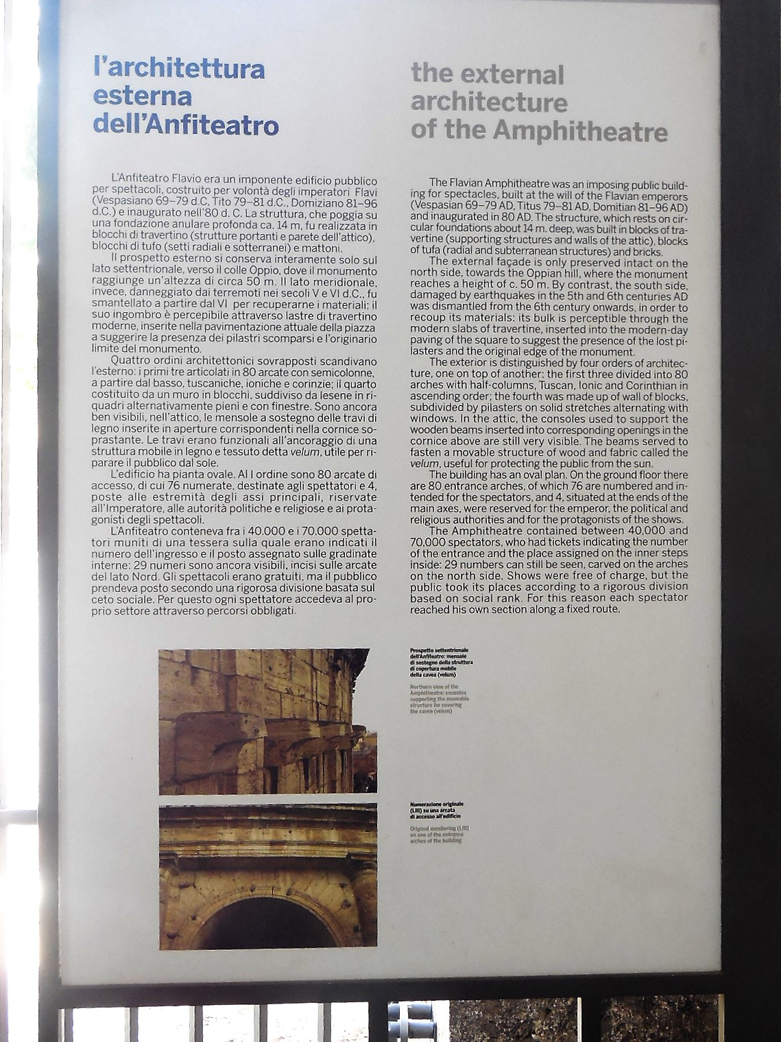

**the external**

**architecture**

**of the amphitheatre**

The Flavian Amphitheatre was an imposing public build- ing for spectacles built at the will of Flavian emperors (Vespian 69-79 AD, Titus 79-81 AD, Domitian 81-96 AD) and inaugurated m 80 AD. The structure, which rests on circular foundations about 14 m. deep, was built in blocks of travertine (supporting structures and walls of the attic), blocks of tufa (radial and subterranean structures) and bricks.

The external facade is only preserved intact on the north side, towards the Oppian hill, where the monument reaches a height of c. 50 m. By contrast, the south side, damaged by earthquakes in the 5th and 6th centuries AD was dismantled from the 6th century onwards, in order to recoup its materials: its bulk is perceptible through the

modern slabs of travertine, inserted into the modern-day paving of the square to suggest the presence of the lost pilasters and the original edge of the monument.

The exterior is distinguished by four orders of architecture, one on top of another: the first three divided into 80 archers with half-columns, Tuscan, Ionic and Corinthian in ascending order; the fourth was made up of wall of blocks subdivided by pilasters on solid stretches alternating with

windows. In the attic, the consoles used to support the

wooden beams Inserted into corresponding openings in the cornice above are still very visible. The beams served to fasten a movable structure of wood and fabric called the *velum*, useful for protecting the public from the sun.

The building has an oval plan. On the ground floor there

are 80 entrance arches, of which 76 are numbered and in·

tended for the spectators, and 4. situated at the ends of the main axes, were reserved for the emperor, the political and religious authorities and for the protagonists of the shows.

The Amphitheatre contained between 40,000 and

70,000 spectators, who had tickets indicating the number

of the entrance and the place assigned on the inner steps

inside: 29 numbers can still be seen, carved on the arches

on the north side. Shows were free of charge, but the

public took its places according to a rigorous division

based on social rank. For this reason each spectator

reached his own section along a fixed route.