**An Imposing Spectacle!**

**Twenty centuries ago emperors set up an Amphitheatre for people’s distraction**

Entry was free, but people had to get tickets to know which entrance to use and where to sit on the steps inside. And, of course, people could only enter the area meant for their social class. You can still see 29 numbers that mark places on some entrance arches. Did you know that there are 80 arches on each floor? 76 of them were for ordinary people and the remaining four were for the emperor and other VIPs.

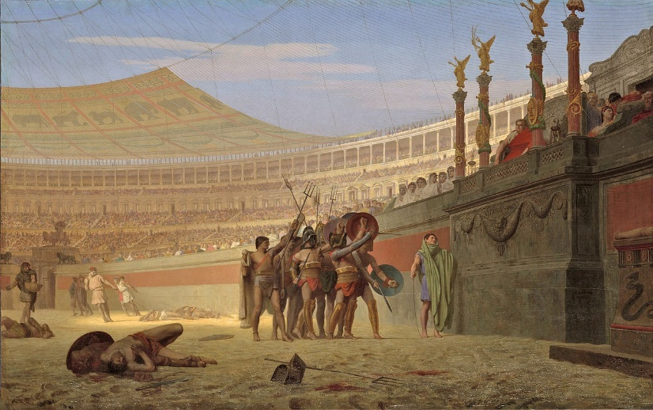When crowded, the spot would feel like a big football stadium today.

Four thriving centuries passed before earthquakes struck! But you can see how this place looked thanks to white stone markers on the floor. Imagine, foundations as deep as five floor house are hidden underground!