# **Ludwig Wittgenstein: *Tractatus Logico-Philosophicus***

* The sense of the book: **what can be said at all can be said clearly, and what we cannot talk about we must pass over in silence**.
  + It is *not* a personal maxim like “Be silent about matters you don’t know much about!”
* The aim is to draw a **limit** to the expression of thoughts. What is beyond this limit is non-sense.
* “My work consists of two parts, the one presented here plus all that I have *not* written. And it is precisely this second part that is the important point. For the ethical gets its limit drawn from the inside, as it were, by my book”.

## The main sentences of the Tractatus

1. The world is everything that is the case.

2. What is the case, the fact, is the existence of atomic facts.

3. **The logical picture** of the facts is the thought.

4. The thought is the significant proposition.

5. Propositions are truth-functions of elementary propositions. (An elementary proposition is a truth-function of itself.)

6. The general form of truth-function is: [, , N()]. This is the general form of proposition.

7. Whereof one cannot speak, thereof one must be silent.

**Ontology 🡨 Picture Theory 🡪 Language/Logic**

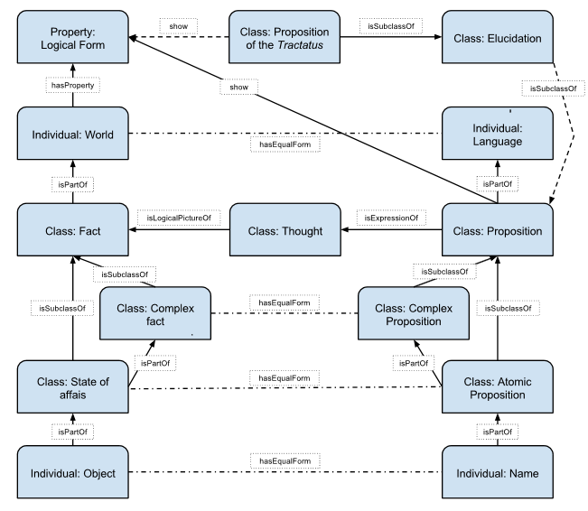

## Ontology of logical atomism

1.1 The world is the totality of facts, not of things.

What are (logical) atoms in logical atomism?

* Russell: individuals
* Wittgenstein: atomic facts = states of affairs

## The Picture Theory

4.014 A gramophone record, the musical idea, the written notes, and the soundwaves, all stand to one another in the same **internal relation** of depicting that holds between language and the world.

4.0141 There is a **general rule** by means of which the musician can obtain the symphony from the score, and which makes it possible to derive the symphony from the groove on the gramophone record, and, using the first rule, to derive the score again. That is what constitutes the inner similarity between these things which seem to be constructed in such entirely different ways. And that rule is the law of **projection** which projects the symphony into the language of musical notation. It is the rule for translating this language into the language of gramophone records.

## Logic

* The logic introduced in the TLP is equivalent to **first-order predicate calculus**.
* It uses only one logical connective – generalized Sheffer stroke (neither *x 1* nor *x2*):
  + N*(x1, x2, x3,…*)= *x1*| *x2* | *x3*| … = not *x1* and not *x2* and not *x3* …
  + N*(x1, x2, x3,…*) is true if and only if all *x1, x2, x3,…* are false.
  + All logical constants can be defined from N() = N*(x1, x2, x3,…*).
  + Generality is introduced by allowing infinite formulas. That is the meaning of .
* 6 The general form of a truth-function is [, , N()].
* 6.001 What this says is just that every proposition is a result of successive applications to elementary propositions of the operation N().

## Saying – Showing

* 4.1212 What *can* be shown, *cannot* be said.
* Two parts of the TLP
  + What can be said: facts expressed by propositions
  + What can be shown:
    - the pictorial/logical form
    - the meaning of signs, sense of a proposition
    - the logic of facts, logical relations
    - the form of a proposition / of reality, the limits of language, that there are laws of nature, the sentences of the TLP itself
    - that there is no soul, the truth of solipsism, the ethics, the aesthetics, the mystical – the meaning of life

## The Nature of Philosophy

* Philosophy is not a doctrine, but an activity…
* … of combating non-sense… (4.0031 All philosophy is a ‘critique of language’.)
* … which leads to drawing a **limit** to the expression of thoughts.

6.53 The correct method in philosophy would really be the following: to say nothing except what can be said ... – i.e. something that has nothing to do with philosophy – and then, whenever someone else wanted to say something metaphysical, to demonstrate to him that he had failed to give a meaning to certain signs in his propositions. Although it would not be satisfying to the other person – he would not have the feeling that we were teaching him philosophy – *this* method would be the only strictly correct one.

## The Ladder

* The metaphor of a ladder is about applying the limit of sense elaborated in the TLP on the claims of TLP itself.
* Many of the claims of TLP lie beyond the limit of sense, i.e. they are non-sense.

6.54 My propositions serve as elucidations in the following way: anyone who understands me eventually recognizes them as nonsensical, when he has used them – as steps – to climb up beyond them. (He must, so to speak, throw away the ladder after he has climbed it.) ... He must transcend these propositions, and then he will see the world aright.

**The traditional reading:** The TLP is an attempt to convey something ineffable, i.e. something that lies beyond the limit of sense by using language that is nonsensical, but nevertheless, it is **illuminating nonsense**.

**The new/resolute reading:** The goal of the TLP is to combat our temptation to express something ineffable. There is, however, nothing ineffable. The aim is, thus, therapeutic. The TLP presents sentences that appear to make sense. Its lesson consists in realizing that these sentences are nevertheless **plain nonsense**.

## Further Reading

* James Conant, “The Method of the Tractatus”. In Reck, E. G. ed., *From Frege to Wittgenstein, Perspectives on Early Analytic Philosophy*. Oxford University Press, 2002.
* Marie McGinn, *Elucidating the Tractatus: Wittgenstein's Early Philosophy of Logic and Language*, Oxford University Press, 2006.
* **Michael Morris, *Routledge Philosophy Guidebook to Wittgenstein and the Tractatus*, Routledge, 2008.**